1965 to 1999 STM Models

Charles J. Gomez, Harshvardhan Singh

2023-08-30

library(stringr)  
library(ggplot2)  
library(wordcloud)  
library(stm)  
  
#Read csv file  
data = read.csv("preprocessed_data_Jul14.csv")  
  
# Define the publication intervals  
pub_intervals <- c("pub_interval_1995_1999",  
 "pub_interval_1985_1994", "pub_interval_1975_1984", "pub_interval_1965_1974") #,"pub_interval_1900_1964", "pub_interval_1824_1899")  
  
  
# Define K values for each interval  
K_values <- c(44, 45, 43, 40) #16,2  
  
  
   
# Filter data for the publication interval 1995 to 1999  
data_filtered <- data[data[["pub_interval_1995_1999"]] == 1, ]  
  
# Save the original title data for future use  
data_filtered$original_concatenated_title_abstract <- data_filtered$concatenated_title_abstract  
  
#pre-processing the titles using textProcessor from the stm package  
processed_text <- textProcessor(data_filtered$concatenated_title_abstract, metadata = data_filtered)

## Building corpus...   
## Converting to Lower Case...   
## Removing punctuation...   
## Removing stopwords...   
## Removing numbers...   
## Stemming...   
## Creating Output...

# Further prepare the data by removing low-frequency terms  
out_text <- prepDocuments(processed_text$documents, processed_text$vocab, processed_text$meta)

## Removing 4825 of 17035 terms (4825 of 597903 tokens) due to frequency   
## Your corpus now has 7217 documents, 12210 terms and 593078 tokens.

docs_text <- out_text$documents  
vocab_text <- out_text$vocab  
meta_text <- out_text$meta  
  
  
#Prepare data  
plotRemoved(processed_text$documents, lower.thresh = seq(1, 200, by = 100))

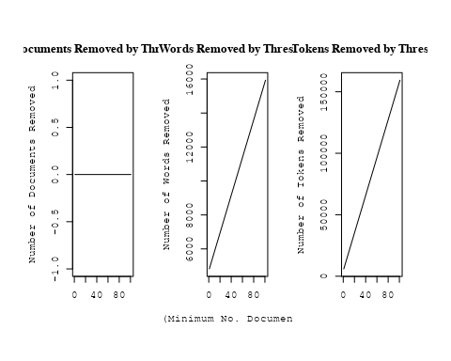

out_text <- prepDocuments(processed_text$documents, processed_text$vocab, processed_text$meta, lower.thresh = 8)

## Removing 13203 of 17035 terms (32020 of 597903 tokens) due to frequency   
## Your corpus now has 7217 documents, 3832 terms and 565883 tokens.

# Initialize an empty formula string  
prevalence_formula_str <- "~US "  
  
  
# Add each country variable to the formula string  
for (i in 10:27) {  
 prevalence_formula_str <- paste(prevalence_formula_str, "+", names(data)[i])  
}  
  
  
# Convert the string to a formula  
prevalence_formula <- as.formula(prevalence_formula_str)  
print(prevalence_formula)

## ~US + IN + DE + CH + GB + CN + FR + IT + RU + CA + NL + AU +   
## JP + ES + IL + Americas + Europe + Africa + AsiaAndOceania

# Run STM model  
Research_topics <- stm(documents = out_text$documents,   
 vocab = out_text$vocab,   
 K = 44,   
 prevalence = prevalence_formula,   
 data = out_text$meta,   
 init.type = "Spectral",  
 max.em.its = 1000,  
 gamma.prior = 'L1')

## Beginning Spectral Initialization   
## Calculating the gram matrix...  
## Finding anchor words...  
## ............................................  
## Recovering initialization...  
## ......................................  
## Initialization complete.  
## ....................................................................................................  
## Completed E-Step (8 seconds).   
## Completed M-Step.   
## Completing Iteration 1 (approx. per word bound = -6.761)   
## ....................................................................................................  
## Completed E-Step (8 seconds).   
## Completed M-Step.   
## Completing Iteration 2 (approx. per word bound = -6.512, relative change = 3.674e-02)   
## ....................................................................................................  
## Completed E-Step (7 seconds).   
## Completed M-Step.   
## Completing Iteration 3 (approx. per word bound = -6.454, relative change = 8.999e-03)   
## ....................................................................................................  
## Completed E-Step (6 seconds).   
## Completed M-Step.   
## Completing Iteration 4 (approx. per word bound = -6.430, relative change = 3.707e-03)   
## ....................................................................................................  
## Completed E-Step (6 seconds).   
## Completed M-Step.   
## Completing Iteration 5 (approx. per word bound = -6.417, relative change = 1.994e-03)   
## Topic 1: measur, time, observ, model, predict   
## Topic 2: star, publish, high-resolut, tauri, avail   
## Topic 3: galaxi, halo, model, dark, disk   
## Topic 4: sourc, observ, detect, flux, comet   
## Topic 5: accret, disk, hole, black, rate   
## Topic 6: remnant, supernova, ejecta, shock, explos   
## Topic 7: galaxi, hole, black, mass, merger   
## Topic 8: galaxi, redshift, luminos, line, sampl   
## Topic 9: map, spectrum, background, use, data   
## Topic 10: star, format, galaxi, ngc, popul   
## Topic 11: survey, galaxi, redshift, sampl, field   
## Topic 12: dwarf, white, period, x-ray, mass   
## Topic 13: cluster, globular, star, center, galaxi   
## Topic 14: lens, len, gravit, quasar, imag   
## Topic 15: energi, cosmic, ray, acceler, particl   
## Topic 16: dwarf, object, mass, age, cluster   
## Topic 17: light, curv, type, supernova, sne   
## Topic 18: galaxi, group, cluster, mass, gas   
## Topic 19: variabl, distanc, cepheid, use, obtain   
## Topic 20: absorpt, line, spectra, featur, spectral   
## Topic 21: burst, gamma-ray, supernova, grb, observ   
## Topic 22: radio, jet, sourc, observ, emiss   
## Topic 23: rotat, star, mode, wave, neutron   
## Topic 24: solar, flare, magnet, observ, coron   
## Topic 25: line, emiss, maser, sourc, observ   
## Topic 26: shell, shock, galact, emiss, remnant   
## Topic 27: dust, galaxi, observ, emiss, metal   
## Topic 28: star, distanc, metal, mag, giant   
## Topic 29: cloud, molecular, gas, line, emiss   
## Topic 30: model, cluster, mass, cosmolog, use   
## Topic 31: galaxi, nuclei, activ, starburst, agn   
## Topic 32: galaxi, ellipt, dwarf, distribut, central   
## Topic 33: energi, burst, observ, model, gamma-ray   
## Topic 34: abund, star, model, metal, stellar   
## Topic 35: x-ray, emiss, kev, observ, rosat   
## Topic 36: disk, gas, format, galaxi, mass   
## Topic 37: grain, abund, interstellar, isotop, solar   
## Topic 38: orbit, binari, planet, mass, system   
## Topic 39: univers, densiti, structur, cosmolog, background   
## Topic 40: nebula, wind, planetari, imag, bipolar   
## Topic 41: model, use, simul, calcul, effect   
## Topic 42: telescop, line, space, spectra, observ   
## Topic 43: pulsar, magnet, field, neutron, polar   
## Topic 44: mass, sourc, stellar, core, compact   
## ....................................................................................................  
## Completed E-Step (6 seconds).   
## Completed M-Step.   
## Completing Iteration 6 (approx. per word bound = -6.409, relative change = 1.210e-03)   
## ....................................................................................................  
## Completed E-Step (6 seconds).   
## Completed M-Step.   
## Completing Iteration 7 (approx. per word bound = -6.404, relative change = 8.085e-04)   
## ....................................................................................................  
## Completed E-Step (5 seconds).   
## Completed M-Step.   
## Completing Iteration 8 (approx. per word bound = -6.400, relative change = 5.784e-04)   
## ....................................................................................................  
## Completed E-Step (5 seconds).   
## Completed M-Step.   
## Completing Iteration 9 (approx. per word bound = -6.398, relative change = 4.421e-04)   
## ....................................................................................................  
## Completed E-Step (5 seconds).   
## Completed M-Step.   
## Completing Iteration 10 (approx. per word bound = -6.395, relative change = 3.715e-04)   
## Topic 1: measur, time, observ, variat, model   
## Topic 2: star, neutron, tauri, publish, high-resolut   
## Topic 3: halo, galaxi, dark, model, disk   
## Topic 4: sourc, observ, flux, detect, comet   
## Topic 5: accret, disk, hole, black, rate   
## Topic 6: supernova, remnant, explos, ejecta, shock   
## Topic 7: galaxi, hole, black, mass, merger   
## Topic 8: galaxi, redshift, luminos, quasar, sampl   
## Topic 9: map, background, use, spectrum, data   
## Topic 10: star, format, galaxi, popul, rate   
## Topic 11: survey, galaxi, redshift, sampl, field   
## Topic 12: dwarf, period, white, mass, observ   
## Topic 13: cluster, globular, age, galaxi, center   
## Topic 14: lens, len, gravit, event, imag   
## Topic 15: energi, cosmic, ray, acceler, particl   
## Topic 16: dwarf, object, mass, age, brown   
## Topic 17: light, curv, type, supernova, sne   
## Topic 18: galaxi, group, cluster, mass, gas   
## Topic 19: distanc, variabl, cepheid, obtain, use   
## Topic 20: line, absorpt, spectra, featur, spectrum   
## Topic 21: burst, gamma-ray, grb, observ, grbs   
## Topic 22: radio, jet, sourc, observ, quasar   
## Topic 23: rotat, mode, wave, neutrino, convect   
## Topic 24: solar, flare, magnet, observ, coron   
## Topic 25: emiss, line, maser, observ, veloc   
## Topic 26: shell, shock, galact, emiss, filament   
## Topic 27: dust, galaxi, extinct, observ, emiss   
## Topic 28: distanc, metal, star, giant, age   
## Topic 29: cloud, molecular, gas, line, region   
## Topic 30: model, cosmolog, mass, distribut, cluster   
## Topic 31: galaxi, ngc, nuclei, activ, seyfert   
## Topic 32: galaxi, ellipt, distribut, dwarf, central   
## Topic 33: energi, observ, model, spectral, electron   
## Topic 34: abund, metal, model, star, observ   
## Topic 35: x-ray, emiss, kev, observ, rosat   
## Topic 36: disk, gas, format, mass, form   
## Topic 37: grain, abund, interstellar, isotop, solar   
## Topic 38: orbit, binari, planet, system, companion   
## Topic 39: univers, densiti, cosmolog, structur, baryon   
## Topic 40: nebula, wind, planetari, imag, ring   
## Topic 41: model, use, simul, calcul, effect   
## Topic 42: telescop, space, line, hubbl, spectra   
## Topic 43: pulsar, magnet, field, polar, neutron   
## Topic 44: stellar, mass, compact, report, detect   
## ....................................................................................................  
## Completed E-Step (5 seconds).   
## Completed M-Step.   
## Completing Iteration 11 (approx. per word bound = -6.393, relative change = 2.989e-04)   
## ....................................................................................................  
## Completed E-Step (5 seconds).   
## Completed M-Step.   
## Completing Iteration 12 (approx. per word bound = -6.392, relative change = 2.658e-04)   
## ....................................................................................................  
## Completed E-Step (5 seconds).   
## Completed M-Step.   
## Completing Iteration 13 (approx. per word bound = -6.390, relative change = 2.214e-04)   
## ....................................................................................................  
## Completed E-Step (6 seconds).   
## Completed M-Step.   
## Completing Iteration 14 (approx. per word bound = -6.389, relative change = 1.945e-04)   
## ....................................................................................................  
## Completed E-Step (6 seconds).   
## Completed M-Step.   
## Completing Iteration 15 (approx. per word bound = -6.388, relative change = 1.707e-04)   
## Topic 1: measur, time, variat, observ, use   
## Topic 2: star, neutron, tauri, stellar, publish   
## Topic 3: halo, galaxi, dark, matter, observ   
## Topic 4: sourc, flux, observ, detect, object   
## Topic 5: accret, disk, hole, black, rate   
## Topic 6: supernova, remnant, explos, ejecta, shock   
## Topic 7: galaxi, hole, black, mass, merger   
## Topic 8: galaxi, redshift, luminos, quasar, sampl   
## Topic 9: map, background, use, data, emiss   
## Topic 10: format, star, galaxi, popul, rate   
## Topic 11: survey, galaxi, redshift, sampl, field   
## Topic 12: period, dwarf, white, mass, observ   
## Topic 13: cluster, globular, ngc, age, galaxi   
## Topic 14: lens, len, gravit, event, imag   
## Topic 15: energi, ray, acceler, cosmic, particl   
## Topic 16: dwarf, mass, object, age, white   
## Topic 17: light, type, curv, supernova, sne   
## Topic 18: galaxi, group, cluster, mass, gas   
## Topic 19: distanc, variabl, cepheid, obtain, use   
## Topic 20: line, absorpt, spectra, featur, emiss   
## Topic 21: burst, gamma-ray, grb, afterglow, grbs   
## Topic 22: radio, jet, sourc, observ, quasar   
## Topic 23: rotat, mode, wave, turbul, convect   
## Topic 24: solar, flare, magnet, observ, coron   
## Topic 25: emiss, line, maser, veloc, observ   
## Topic 26: shock, shell, galact, structur, emiss   
## Topic 27: dust, extinct, galaxi, emiss, observ   
## Topic 28: distanc, age, giant, metal, red   
## Topic 29: cloud, molecular, gas, region, line   
## Topic 30: model, cosmolog, distribut, use, mass   
## Topic 31: galaxi, ngc, activ, seyfert, nuclei   
## Topic 32: galaxi, ellipt, distribut, central, dwarf   
## Topic 33: energi, observ, electron, spectral, model   
## Topic 34: abund, metal, model, ratio, observ   
## Topic 35: x-ray, emiss, kev, observ, soft   
## Topic 36: disk, gas, format, mass, spiral   
## Topic 37: grain, abund, interstellar, isotop, solar   
## Topic 38: orbit, binari, planet, system, companion   
## Topic 39: univers, densiti, cosmolog, structur, baryon   
## Topic 40: wind, nebula, planetari, outflow, imag   
## Topic 41: model, use, calcul, effect, simul   
## Topic 42: telescop, space, hubbl, imag, observ   
## Topic 43: pulsar, magnet, field, polar, neutron   
## Topic 44: stellar, compact, mass, report, probabl   
## ....................................................................................................  
## Completed E-Step (6 seconds).   
## Completed M-Step.   
## Completing Iteration 16 (approx. per word bound = -6.387, relative change = 1.408e-04)   
## ....................................................................................................  
## Completed E-Step (6 seconds).   
## Completed M-Step.   
## Completing Iteration 17 (approx. per word bound = -6.386, relative change = 1.388e-04)   
## ....................................................................................................  
## Completed E-Step (6 seconds).   
## Completed M-Step.   
## Completing Iteration 18 (approx. per word bound = -6.385, relative change = 1.088e-04)   
## ....................................................................................................  
## Completed E-Step (6 seconds).   
## Completed M-Step.   
## Completing Iteration 19 (approx. per word bound = -6.385, relative change = 9.600e-05)   
## ....................................................................................................  
## Completed E-Step (6 seconds).   
## Completed M-Step.   
## Completing Iteration 20 (approx. per word bound = -6.384, relative change = 8.956e-05)   
## Topic 1: measur, time, variat, observ, use   
## Topic 2: star, neutron, tauri, stellar, low-mass   
## Topic 3: halo, galaxi, dark, matter, observ   
## Topic 4: sourc, flux, observ, detect, object   
## Topic 5: accret, disk, hole, rate, black   
## Topic 6: supernova, remnant, explos, ejecta, age   
## Topic 7: galaxi, hole, black, mass, merger   
## Topic 8: galaxi, redshift, luminos, quasar, sampl   
## Topic 9: map, background, cosmic, emiss, use   
## Topic 10: format, star, galaxi, popul, rate   
## Topic 11: survey, galaxi, sampl, redshift, field   
## Topic 12: period, observ, dwarf, nova, white   
## Topic 13: cluster, globular, ngc, age, luminos   
## Topic 14: lens, gravit, len, event, imag   
## Topic 15: energi, ray, acceler, particl, cosmic   
## Topic 16: dwarf, mass, object, white, age   
## Topic 17: light, type, curv, supernova, sne   
## Topic 18: galaxi, group, cluster, mass, gas   
## Topic 19: distanc, variabl, cepheid, obtain, project   
## Topic 20: line, absorpt, spectra, featur, emiss   
## Topic 21: burst, gamma-ray, grb, afterglow, grbs   
## Topic 22: radio, jet, sourc, observ, optic   
## Topic 23: rotat, mode, wave, turbul, convect   
## Topic 24: solar, flare, magnet, observ, coron   
## Topic 25: emiss, line, maser, veloc, observ   
## Topic 26: shock, shell, galact, structur, medium   
## Topic 27: dust, extinct, galaxi, emiss, observ   
## Topic 28: age, distanc, giant, metal, red   
## Topic 29: cloud, molecular, gas, region, densiti   
## Topic 30: model, distribut, cosmolog, use, paramet   
## Topic 31: galaxi, ngc, seyfert, activ, nuclei   
## Topic 32: galaxi, ellipt, distribut, central, spiral   
## Topic 33: energi, observ, electron, spectral, model   
## Topic 34: abund, metal, model, ratio, observ   
## Topic 35: x-ray, emiss, kev, observ, soft   
## Topic 36: disk, gas, format, mass, bar   
## Topic 37: grain, interstellar, abund, isotop, composit   
## Topic 38: orbit, binari, planet, system, companion   
## Topic 39: univers, densiti, cosmolog, structur, baryon   
## Topic 40: wind, nebula, outflow, planetari, ring   
## Topic 41: model, use, calcul, effect, simul   
## Topic 42: telescop, space, hubbl, imag, observ   
## Topic 43: magnet, pulsar, field, polar, emiss   
## Topic 44: stellar, compact, mass, probabl, estim   
## ....................................................................................................  
## Completed E-Step (6 seconds).   
## Completed M-Step.   
## Completing Iteration 21 (approx. per word bound = -6.384, relative change = 7.775e-05)   
## ....................................................................................................  
## Completed E-Step (6 seconds).   
## Completed M-Step.   
## Completing Iteration 22 (approx. per word bound = -6.383, relative change = 7.218e-05)   
## ....................................................................................................  
## Completed E-Step (6 seconds).   
## Completed M-Step.   
## Completing Iteration 23 (approx. per word bound = -6.383, relative change = 6.482e-05)   
## ....................................................................................................  
## Completed E-Step (6 seconds).   
## Completed M-Step.   
## Completing Iteration 24 (approx. per word bound = -6.382, relative change = 5.667e-05)   
## ....................................................................................................  
## Completed E-Step (6 seconds).   
## Completed M-Step.   
## Completing Iteration 25 (approx. per word bound = -6.382, relative change = 6.614e-05)   
## Topic 1: measur, time, variat, observ, data   
## Topic 2: star, neutron, tauri, low-mass, upper   
## Topic 3: halo, galaxi, dark, matter, satellit   
## Topic 4: sourc, flux, observ, detect, object   
## Topic 5: accret, disk, hole, rate, black   
## Topic 6: supernova, remnant, explos, ejecta, age   
## Topic 7: galaxi, hole, black, mass, merger   
## Topic 8: galaxi, redshift, luminos, quasar, sampl   
## Topic 9: map, background, cosmic, emiss, galact   
## Topic 10: format, star, galaxi, popul, rate   
## Topic 11: survey, sampl, object, field, deep   
## Topic 12: period, observ, state, nova, frequenc   
## Topic 13: cluster, globular, ngc, age, luminos   
## Topic 14: lens, gravit, len, event, imag   
## Topic 15: energi, ray, particl, acceler, cosmic   
## Topic 16: dwarf, mass, white, object, age   
## Topic 17: light, type, curv, supernova, sne   
## Topic 18: galaxi, group, cluster, mass, gas   
## Topic 19: distanc, variabl, cepheid, obtain, project   
## Topic 20: line, absorpt, spectra, emiss, featur   
## Topic 21: burst, gamma-ray, grb, afterglow, grbs   
## Topic 22: radio, jet, sourc, observ, optic   
## Topic 23: rotat, mode, wave, turbul, convect   
## Topic 24: solar, flare, magnet, observ, coron   
## Topic 25: emiss, line, veloc, maser, observ   
## Topic 26: shock, shell, structur, galact, medium   
## Topic 27: dust, extinct, galaxi, emiss, infrar   
## Topic 28: age, distanc, giant, metal, red   
## Topic 29: cloud, molecular, gas, region, densiti   
## Topic 30: model, distribut, cosmolog, use, paramet   
## Topic 31: galaxi, ngc, seyfert, activ, nuclei   
## Topic 32: galaxi, ellipt, spiral, distribut, central   
## Topic 33: energi, electron, spectral, observ, model   
## Topic 34: abund, metal, model, ratio, observ   
## Topic 35: x-ray, emiss, kev, observ, soft   
## Topic 36: disk, gas, bar, format, mass   
## Topic 37: grain, abund, interstellar, isotop, composit   
## Topic 38: orbit, binari, planet, system, companion   
## Topic 39: univers, densiti, cosmolog, structur, baryon   
## Topic 40: wind, nebula, outflow, planetari, ring   
## Topic 41: model, use, calcul, effect, simul   
## Topic 42: telescop, space, hubbl, imag, observ   
## Topic 43: magnet, field, pulsar, polar, psr   
## Topic 44: stellar, mass, compact, limit, young   
## ....................................................................................................  
## Completed E-Step (6 seconds).   
## Completed M-Step.   
## Completing Iteration 26 (approx. per word bound = -6.382, relative change = 5.839e-05)   
## ....................................................................................................  
## Completed E-Step (6 seconds).   
## Completed M-Step.   
## Completing Iteration 27 (approx. per word bound = -6.381, relative change = 4.394e-05)   
## ....................................................................................................  
## Completed E-Step (6 seconds).   
## Completed M-Step.   
## Completing Iteration 28 (approx. per word bound = -6.381, relative change = 5.633e-05)   
## ....................................................................................................  
## Completed E-Step (6 seconds).   
## Completed M-Step.   
## Completing Iteration 29 (approx. per word bound = -6.381, relative change = 4.720e-05)   
## ....................................................................................................  
## Completed E-Step (6 seconds).   
## Completed M-Step.   
## Completing Iteration 30 (approx. per word bound = -6.380, relative change = 4.529e-05)   
## Topic 1: measur, time, variat, data, use   
## Topic 2: star, neutron, tauri, low-mass, approxim   
## Topic 3: halo, galaxi, dark, matter, satellit   
## Topic 4: sourc, flux, detect, observ, object   
## Topic 5: accret, disk, hole, rate, black   
## Topic 6: supernova, remnant, explos, ejecta, age   
## Topic 7: galaxi, hole, black, mass, merger   
## Topic 8: galaxi, redshift, luminos, quasar, sampl   
## Topic 9: map, background, cosmic, emiss, galact   
## Topic 10: format, galaxi, star, popul, rate   
## Topic 11: survey, sampl, object, deep, field   
## Topic 12: period, observ, state, frequenc, nova   
## Topic 13: cluster, globular, age, luminos, ngc   
## Topic 14: lens, gravit, len, event, microlens   
## Topic 15: energi, ray, particl, acceler, cosmic   
## Topic 16: dwarf, white, mass, object, age   
## Topic 17: light, type, curv, supernova, sne   
## Topic 18: galaxi, group, cluster, mass, gas   
## Topic 19: distanc, variabl, cepheid, obtain, project   
## Topic 20: line, absorpt, spectra, emiss, featur   
## Topic 21: burst, gamma-ray, grb, afterglow, grbs   
## Topic 22: radio, jet, sourc, observ, optic   
## Topic 23: rotat, mode, wave, turbul, convect   
## Topic 24: solar, flare, magnet, observ, coron   
## Topic 25: emiss, veloc, maser, line, observ   
## Topic 26: shock, shell, structur, medium, galact   
## Topic 27: dust, extinct, galaxi, emiss, infrar   
## Topic 28: age, distanc, giant, metal, red   
## Topic 29: cloud, molecular, gas, region, densiti   
## Topic 30: model, distribut, cosmolog, predict, paramet   
## Topic 31: galaxi, ngc, seyfert, activ, nuclei   
## Topic 32: galaxi, ellipt, spiral, central, distribut   
## Topic 33: energi, electron, spectral, model, observ   
## Topic 34: abund, metal, model, ratio, chemic   
## Topic 35: x-ray, emiss, kev, observ, soft   
## Topic 36: disk, gas, bar, format, spiral   
## Topic 37: grain, isotop, abund, composit, interstellar   
## Topic 38: orbit, binari, planet, system, companion   
## Topic 39: univers, densiti, cosmolog, structur, baryon   
## Topic 40: wind, nebula, outflow, planetari, ring   
## Topic 41: model, use, calcul, effect, simul   
## Topic 42: telescop, space, hubbl, imag, observ   
## Topic 43: magnet, field, pulsar, polar, psr   
## Topic 44: stellar, mass, compact, limit, young   
## ....................................................................................................  
## Completed E-Step (6 seconds).   
## Completed M-Step.   
## Completing Iteration 31 (approx. per word bound = -6.380, relative change = 4.088e-05)   
## ....................................................................................................  
## Completed E-Step (6 seconds).   
## Completed M-Step.   
## Completing Iteration 32 (approx. per word bound = -6.380, relative change = 3.120e-05)   
## ....................................................................................................  
## Completed E-Step (6 seconds).   
## Completed M-Step.   
## Completing Iteration 33 (approx. per word bound = -6.380, relative change = 4.178e-05)   
## ....................................................................................................  
## Completed E-Step (6 seconds).   
## Completed M-Step.   
## Completing Iteration 34 (approx. per word bound = -6.379, relative change = 4.310e-05)   
## ....................................................................................................  
## Completed E-Step (6 seconds).   
## Completed M-Step.   
## Completing Iteration 35 (approx. per word bound = -6.379, relative change = 3.560e-05)   
## Topic 1: measur, time, variat, data, use   
## Topic 2: star, neutron, tauri, low-mass, approxim   
## Topic 3: halo, galaxi, dark, matter, satellit   
## Topic 4: sourc, flux, detect, observ, object   
## Topic 5: accret, disk, hole, rate, black   
## Topic 6: supernova, remnant, explos, ejecta, age   
## Topic 7: hole, galaxi, black, merger, tidal   
## Topic 8: galaxi, redshift, luminos, quasar, sampl   
## Topic 9: map, background, cosmic, emiss, galact   
## Topic 10: format, galaxi, star, popul, rate   
## Topic 11: survey, object, sampl, deep, field   
## Topic 12: period, observ, state, frequenc, nova   
## Topic 13: cluster, globular, age, luminos, ngc   
## Topic 14: lens, gravit, len, event, microlens   
## Topic 15: energi, ray, particl, acceler, cosmic   
## Topic 16: dwarf, white, mass, age, object   
## Topic 17: light, type, curv, supernova, sne   
## Topic 18: group, galaxi, cluster, mass, gas   
## Topic 19: distanc, variabl, cepheid, obtain, project   
## Topic 20: line, absorpt, emiss, spectra, featur   
## Topic 21: burst, gamma-ray, grb, afterglow, grbs   
## Topic 22: radio, jet, sourc, observ, optic   
## Topic 23: rotat, mode, wave, turbul, convect   
## Topic 24: solar, flare, magnet, observ, coron   
## Topic 25: emiss, veloc, maser, observ, line   
## Topic 26: shock, shell, structur, medium, region   
## Topic 27: dust, extinct, galaxi, infrar, emiss   
## Topic 28: age, distanc, giant, metal, red   
## Topic 29: cloud, gas, molecular, region, densiti   
## Topic 30: model, distribut, cosmolog, paramet, data   
## Topic 31: galaxi, ngc, seyfert, activ, nuclei   
## Topic 32: galaxi, ellipt, spiral, central, distribut   
## Topic 33: energi, electron, spectral, model, spectrum   
## Topic 34: abund, metal, model, ratio, chemic   
## Topic 35: x-ray, emiss, kev, observ, soft   
## Topic 36: disk, gas, bar, spiral, format   
## Topic 37: grain, isotop, abund, composit, model   
## Topic 38: orbit, binari, planet, system, companion   
## Topic 39: univers, densiti, cosmolog, structur, baryon   
## Topic 40: wind, nebula, outflow, planetari, ring   
## Topic 41: model, use, calcul, effect, result   
## Topic 42: telescop, space, imag, hubbl, observ   
## Topic 43: magnet, field, pulsar, polar, psr   
## Topic 44: mass, stellar, limit, object, young   
## ....................................................................................................  
## Completed E-Step (6 seconds).   
## Completed M-Step.   
## Completing Iteration 36 (approx. per word bound = -6.379, relative change = 3.626e-05)   
## ....................................................................................................  
## Completed E-Step (6 seconds).   
## Completed M-Step.   
## Completing Iteration 37 (approx. per word bound = -6.379, relative change = 3.101e-05)   
## ....................................................................................................  
## Completed E-Step (6 seconds).   
## Completed M-Step.   
## Completing Iteration 38 (approx. per word bound = -6.379, relative change = 3.600e-05)   
## ....................................................................................................  
## Completed E-Step (6 seconds).   
## Completed M-Step.   
## Completing Iteration 39 (approx. per word bound = -6.378, relative change = 3.100e-05)   
## ....................................................................................................  
## Completed E-Step (6 seconds).   
## Completed M-Step.   
## Completing Iteration 40 (approx. per word bound = -6.378, relative change = 2.928e-05)   
## Topic 1: measur, time, data, use, variat   
## Topic 2: star, neutron, tauri, low-mass, approxim   
## Topic 3: halo, galaxi, dark, matter, veloc   
## Topic 4: sourc, flux, detect, observ, object   
## Topic 5: accret, disk, hole, rate, black   
## Topic 6: supernova, remnant, explos, ejecta, age   
## Topic 7: hole, black, galaxi, tidal, merger   
## Topic 8: galaxi, redshift, luminos, quasar, sampl   
## Topic 9: background, map, cosmic, emiss, galact   
## Topic 10: format, galaxi, star, popul, rate   
## Topic 11: survey, object, sampl, deep, field   
## Topic 12: period, observ, state, frequenc, variabl   
## Topic 13: cluster, globular, age, luminos, ngc   
## Topic 14: lens, gravit, len, event, microlens   
## Topic 15: energi, ray, particl, cosmic, acceler   
## Topic 16: dwarf, white, mass, age, object   
## Topic 17: light, type, curv, supernova, sne   
## Topic 18: group, galaxi, cluster, gas, mass   
## Topic 19: distanc, variabl, cepheid, obtain, project   
## Topic 20: line, absorpt, emiss, spectra, featur   
## Topic 21: burst, gamma-ray, grb, afterglow, grbs   
## Topic 22: radio, jet, sourc, observ, optic   
## Topic 23: rotat, mode, wave, turbul, convect   
## Topic 24: solar, flare, magnet, observ, coron   
## Topic 25: emiss, veloc, maser, observ, sourc   
## Topic 26: shock, shell, structur, medium, region   
## Topic 27: dust, extinct, galaxi, infrar, emiss   
## Topic 28: age, distanc, giant, metal, red   
## Topic 29: cloud, gas, molecular, region, densiti   
## Topic 30: model, distribut, cosmolog, paramet, data   
## Topic 31: galaxi, ngc, seyfert, activ, nuclei   
## Topic 32: galaxi, ellipt, spiral, central, distribut   
## Topic 33: energi, electron, spectral, model, spectrum   
## Topic 34: abund, metal, model, ratio, chemic   
## Topic 35: x-ray, emiss, kev, observ, soft   
## Topic 36: disk, gas, bar, spiral, format   
## Topic 37: grain, isotop, composit, abund, model   
## Topic 38: orbit, binari, planet, system, companion   
## Topic 39: univers, densiti, cosmolog, structur, baryon   
## Topic 40: wind, nebula, outflow, planetari, ring   
## Topic 41: model, use, calcul, effect, result   
## Topic 42: telescop, space, imag, hubbl, observ   
## Topic 43: magnet, field, pulsar, polar, psr   
## Topic 44: mass, stellar, limit, object, estim   
## ....................................................................................................  
## Completed E-Step (6 seconds).   
## Completed M-Step.   
## Completing Iteration 41 (approx. per word bound = -6.378, relative change = 2.126e-05)   
## ....................................................................................................  
## Completed E-Step (6 seconds).   
## Completed M-Step.   
## Completing Iteration 42 (approx. per word bound = -6.378, relative change = 3.767e-05)   
## ....................................................................................................  
## Completed E-Step (6 seconds).   
## Completed M-Step.   
## Completing Iteration 43 (approx. per word bound = -6.378, relative change = 2.871e-05)   
## ....................................................................................................  
## Completed E-Step (6 seconds).   
## Completed M-Step.   
## Completing Iteration 44 (approx. per word bound = -6.377, relative change = 2.875e-05)   
## ....................................................................................................  
## Completed E-Step (6 seconds).   
## Completed M-Step.   
## Completing Iteration 45 (approx. per word bound = -6.377, relative change = 2.887e-05)   
## Topic 1: measur, data, time, use, variat   
## Topic 2: star, neutron, tauri, low-mass, approxim   
## Topic 3: halo, galaxi, dark, matter, veloc   
## Topic 4: sourc, flux, detect, observ, object   
## Topic 5: accret, disk, hole, rate, black   
## Topic 6: supernova, remnant, explos, ejecta, age   
## Topic 7: hole, black, galaxi, tidal, merger   
## Topic 8: galaxi, redshift, luminos, quasar, sampl   
## Topic 9: background, map, cosmic, emiss, microwav   
## Topic 10: format, galaxi, star, popul, rate   
## Topic 11: survey, object, sampl, deep, field   
## Topic 12: period, observ, state, frequenc, variabl   
## Topic 13: cluster, globular, age, luminos, galact   
## Topic 14: lens, gravit, len, event, microlens   
## Topic 15: energi, ray, particl, cosmic, acceler   
## Topic 16: dwarf, white, mass, age, object   
## Topic 17: light, type, curv, supernova, sne   
## Topic 18: group, galaxi, cluster, gas, mass   
## Topic 19: distanc, variabl, cepheid, obtain, project   
## Topic 20: line, emiss, absorpt, spectra, featur   
## Topic 21: burst, gamma-ray, grb, afterglow, grbs   
## Topic 22: radio, jet, sourc, observ, optic   
## Topic 23: rotat, mode, wave, turbul, convect   
## Topic 24: solar, flare, magnet, coron, observ   
## Topic 25: emiss, veloc, maser, observ, sourc   
## Topic 26: shock, shell, structur, medium, region   
## Topic 27: dust, extinct, galaxi, infrar, emiss   
## Topic 28: age, distanc, giant, metal, red   
## Topic 29: cloud, gas, molecular, region, densiti   
## Topic 30: model, distribut, cosmolog, paramet, predict   
## Topic 31: galaxi, ngc, seyfert, activ, nuclei   
## Topic 32: galaxi, ellipt, spiral, central, surfac   
## Topic 33: energi, electron, spectral, model, spectrum   
## Topic 34: abund, metal, ratio, model, chemic   
## Topic 35: x-ray, emiss, kev, observ, soft   
## Topic 36: disk, gas, bar, spiral, format   
## Topic 37: grain, isotop, composit, abund, model   
## Topic 38: binari, orbit, planet, system, companion   
## Topic 39: univers, densiti, cosmolog, structur, baryon   
## Topic 40: wind, nebula, outflow, planetari, ring   
## Topic 41: model, use, calcul, effect, result   
## Topic 42: telescop, space, imag, hubbl, observ   
## Topic 43: magnet, field, pulsar, polar, psr   
## Topic 44: mass, stellar, limit, object, estim   
## ....................................................................................................  
## Completed E-Step (6 seconds).   
## Completed M-Step.   
## Completing Iteration 46 (approx. per word bound = -6.377, relative change = 2.567e-05)   
## ....................................................................................................  
## Completed E-Step (6 seconds).   
## Completed M-Step.   
## Completing Iteration 47 (approx. per word bound = -6.377, relative change = 1.153e-05)   
## ....................................................................................................  
## Completed E-Step (6 seconds).   
## Completed M-Step.   
## Completing Iteration 48 (approx. per word bound = -6.377, relative change = 4.813e-05)   
## ....................................................................................................  
## Completed E-Step (6 seconds).   
## Completed M-Step.   
## Completing Iteration 49 (approx. per word bound = -6.377, relative change = 2.676e-05)   
## ....................................................................................................  
## Completed E-Step (5 seconds).   
## Completed M-Step.   
## Completing Iteration 50 (approx. per word bound = -6.376, relative change = 3.535e-05)   
## Topic 1: measur, data, use, time, variat   
## Topic 2: star, neutron, tauri, low-mass, young   
## Topic 3: halo, galaxi, dark, matter, veloc   
## Topic 4: sourc, flux, detect, observ, object   
## Topic 5: accret, disk, hole, rate, black   
## Topic 6: supernova, remnant, explos, ejecta, age   
## Topic 7: hole, galaxi, black, tidal, merger   
## Topic 8: redshift, galaxi, luminos, quasar, sampl   
## Topic 9: background, map, cosmic, emiss, microwav   
## Topic 10: format, galaxi, star, popul, rate   
## Topic 11: survey, object, sampl, deep, field   
## Topic 12: period, observ, state, frequenc, variabl   
## Topic 13: cluster, globular, age, luminos, galact   
## Topic 14: lens, gravit, len, event, microlens   
## Topic 15: energi, ray, particl, cosmic, acceler   
## Topic 16: dwarf, white, cool, object, age   
## Topic 17: light, type, curv, supernova, sne   
## Topic 18: group, galaxi, cluster, gas, local   
## Topic 19: distanc, variabl, cepheid, obtain, project   
## Topic 20: line, emiss, absorpt, spectra, featur   
## Topic 21: burst, gamma-ray, grb, afterglow, observ   
## Topic 22: radio, jet, sourc, observ, optic   
## Topic 23: rotat, mode, wave, turbul, convect   
## Topic 24: solar, flare, magnet, coron, observ   
## Topic 25: emiss, veloc, maser, observ, sourc   
## Topic 26: shock, shell, structur, medium, region   
## Topic 27: dust, extinct, galaxi, infrar, emiss   
## Topic 28: age, distanc, giant, metal, lmc   
## Topic 29: cloud, gas, molecular, region, densiti   
## Topic 30: model, distribut, cosmolog, paramet, predict   
## Topic 31: galaxi, ngc, seyfert, activ, nuclei   
## Topic 32: galaxi, ellipt, spiral, surfac, central   
## Topic 33: energi, electron, spectral, model, spectrum   
## Topic 34: abund, metal, ratio, model, chemic   
## Topic 35: x-ray, emiss, kev, observ, soft   
## Topic 36: disk, gas, bar, spiral, format   
## Topic 37: grain, isotop, composit, abund, model   
## Topic 38: binari, orbit, planet, system, companion   
## Topic 39: univers, densiti, cosmolog, structur, baryon   
## Topic 40: wind, nebula, outflow, planetari, ring   
## Topic 41: model, calcul, use, effect, result   
## Topic 42: telescop, space, imag, hubbl, observ   
## Topic 43: magnet, field, pulsar, polar, psr   
## Topic 44: mass, stellar, limit, object, distribut   
## ....................................................................................................  
## Completed E-Step (5 seconds).   
## Completed M-Step.   
## Completing Iteration 51 (approx. per word bound = -6.376, relative change = 2.929e-05)   
## ....................................................................................................  
## Completed E-Step (5 seconds).   
## Completed M-Step.   
## Completing Iteration 52 (approx. per word bound = -6.376, relative change = 2.943e-05)   
## ....................................................................................................  
## Completed E-Step (5 seconds).   
## Completed M-Step.   
## Completing Iteration 53 (approx. per word bound = -6.376, relative change = 2.621e-05)   
## ....................................................................................................  
## Completed E-Step (5 seconds).   
## Completed M-Step.   
## Completing Iteration 54 (approx. per word bound = -6.376, relative change = 1.244e-05)   
## ....................................................................................................  
## Completed E-Step (5 seconds).   
## Completed M-Step.   
## Completing Iteration 55 (approx. per word bound = -6.375, relative change = 3.224e-05)   
## Topic 1: measur, data, use, time, variat   
## Topic 2: star, neutron, tauri, young, low-mass   
## Topic 3: halo, dark, galaxi, matter, veloc   
## Topic 4: sourc, flux, detect, observ, object   
## Topic 5: accret, disk, hole, rate, black   
## Topic 6: supernova, remnant, explos, ejecta, age   
## Topic 7: hole, galaxi, black, tidal, merger   
## Topic 8: redshift, galaxi, luminos, quasar, sampl   
## Topic 9: background, map, cosmic, emiss, microwav   
## Topic 10: format, galaxi, star, popul, rate   
## Topic 11: survey, object, sampl, deep, field   
## Topic 12: period, observ, variabl, frequenc, state   
## Topic 13: cluster, globular, age, luminos, galact   
## Topic 14: lens, gravit, len, event, microlens   
## Topic 15: energi, ray, particl, cosmic, acceler   
## Topic 16: dwarf, white, cool, brown, object   
## Topic 17: light, type, curv, supernova, sne   
## Topic 18: group, galaxi, cluster, gas, local   
## Topic 19: distanc, variabl, cepheid, obtain, project   
## Topic 20: line, emiss, absorpt, spectra, featur   
## Topic 21: burst, gamma-ray, grb, afterglow, observ   
## Topic 22: radio, jet, sourc, observ, optic   
## Topic 23: rotat, mode, wave, turbul, convect   
## Topic 24: solar, flare, magnet, coron, observ   
## Topic 25: emiss, veloc, maser, observ, sourc   
## Topic 26: shock, shell, structur, region, medium   
## Topic 27: dust, extinct, galaxi, grain, infrar   
## Topic 28: age, distanc, giant, metal, lmc   
## Topic 29: cloud, gas, molecular, region, densiti   
## Topic 30: model, distribut, cosmolog, paramet, predict   
## Topic 31: galaxi, ngc, seyfert, activ, nuclei   
## Topic 32: galaxi, ellipt, spiral, surfac, bright   
## Topic 33: energi, electron, spectral, model, spectrum   
## Topic 34: abund, metal, ratio, model, chemic   
## Topic 35: x-ray, emiss, kev, observ, soft   
## Topic 36: disk, gas, bar, spiral, inner   
## Topic 37: grain, isotop, abund, composit, model   
## Topic 38: binari, orbit, planet, system, companion   
## Topic 39: univers, densiti, cosmolog, structur, baryon   
## Topic 40: wind, nebula, outflow, planetari, ring   
## Topic 41: model, calcul, use, effect, result   
## Topic 42: telescop, space, imag, hubbl, hst   
## Topic 43: magnet, field, pulsar, polar, psr   
## Topic 44: mass, stellar, limit, object, distribut   
## ....................................................................................................  
## Completed E-Step (5 seconds).   
## Completed M-Step.   
## Completing Iteration 56 (approx. per word bound = -6.375, relative change = 2.183e-05)   
## ....................................................................................................  
## Completed E-Step (5 seconds).   
## Completed M-Step.   
## Completing Iteration 57 (approx. per word bound = -6.375, relative change = 2.236e-05)   
## ....................................................................................................  
## Completed E-Step (5 seconds).   
## Completed M-Step.   
## Completing Iteration 58 (approx. per word bound = -6.375, relative change = 2.134e-05)   
## ....................................................................................................  
## Completed E-Step (5 seconds).   
## Completed M-Step.   
## Completing Iteration 59 (approx. per word bound = -6.375, relative change = 2.233e-05)   
## ....................................................................................................  
## Completed E-Step (5 seconds).   
## Completed M-Step.   
## Completing Iteration 60 (approx. per word bound = -6.375, relative change = 2.125e-05)   
## Topic 1: measur, data, use, time, variat   
## Topic 2: star, neutron, young, tauri, low-mass   
## Topic 3: halo, dark, galaxi, matter, veloc   
## Topic 4: sourc, flux, detect, observ, object   
## Topic 5: accret, disk, hole, rate, black   
## Topic 6: supernova, remnant, explos, ejecta, age   
## Topic 7: hole, galaxi, black, tidal, merger   
## Topic 8: redshift, galaxi, luminos, quasar, sampl   
## Topic 9: background, map, cosmic, emiss, microwav   
## Topic 10: format, galaxi, star, popul, rate   
## Topic 11: survey, object, sampl, deep, field   
## Topic 12: period, observ, variabl, frequenc, state   
## Topic 13: cluster, globular, age, luminos, galact   
## Topic 14: lens, gravit, len, event, microlens   
## Topic 15: energi, ray, particl, cosmic, acceler   
## Topic 16: dwarf, white, cool, brown, object   
## Topic 17: light, type, curv, supernova, sne   
## Topic 18: group, cluster, galaxi, gas, local   
## Topic 19: distanc, variabl, cepheid, obtain, project   
## Topic 20: line, emiss, absorpt, spectra, featur   
## Topic 21: burst, gamma-ray, grb, afterglow, observ   
## Topic 22: radio, jet, sourc, observ, optic   
## Topic 23: rotat, mode, wave, turbul, convect   
## Topic 24: solar, flare, magnet, observ, coron   
## Topic 25: emiss, veloc, maser, observ, sourc   
## Topic 26: shock, shell, structur, region, medium   
## Topic 27: dust, extinct, grain, infrar, galaxi   
## Topic 28: age, distanc, giant, metal, lmc   
## Topic 29: cloud, gas, molecular, region, densiti   
## Topic 30: model, distribut, cosmolog, paramet, predict   
## Topic 31: galaxi, ngc, seyfert, activ, nuclei   
## Topic 32: galaxi, ellipt, spiral, surfac, bright   
## Topic 33: energi, electron, spectral, model, spectrum   
## Topic 34: abund, metal, ratio, chemic, model   
## Topic 35: x-ray, emiss, kev, observ, soft   
## Topic 36: disk, gas, bar, spiral, inner   
## Topic 37: grain, isotop, abund, composit, model   
## Topic 38: binari, orbit, planet, system, companion   
## Topic 39: univers, densiti, cosmolog, structur, baryon   
## Topic 40: wind, nebula, outflow, planetari, ring   
## Topic 41: model, calcul, use, effect, result   
## Topic 42: telescop, space, imag, hubbl, hst   
## Topic 43: magnet, field, pulsar, polar, psr   
## Topic 44: mass, stellar, limit, distribut, object   
## ....................................................................................................  
## Completed E-Step (5 seconds).   
## Completed M-Step.   
## Completing Iteration 61 (approx. per word bound = -6.375, relative change = 1.944e-05)   
## ....................................................................................................  
## Completed E-Step (5 seconds).   
## Completed M-Step.   
## Completing Iteration 62 (approx. per word bound = -6.375, relative change = 1.747e-05)   
## ....................................................................................................  
## Completed E-Step (5 seconds).   
## Completed M-Step.   
## Completing Iteration 63 (approx. per word bound = -6.374, relative change = 1.707e-05)   
## ....................................................................................................  
## Completed E-Step (5 seconds).   
## Completed M-Step.   
## Completing Iteration 64 (approx. per word bound = -6.374, relative change = 1.640e-05)   
## ....................................................................................................  
## Completed E-Step (5 seconds).   
## Completed M-Step.   
## Completing Iteration 65 (approx. per word bound = -6.374, relative change = 1.602e-05)   
## Topic 1: measur, data, use, time, variat   
## Topic 2: star, neutron, young, tauri, low-mass   
## Topic 3: halo, dark, galaxi, matter, veloc   
## Topic 4: sourc, flux, detect, observ, object   
## Topic 5: accret, disk, hole, rate, black   
## Topic 6: supernova, remnant, explos, ejecta, age   
## Topic 7: hole, galaxi, black, tidal, merger   
## Topic 8: redshift, galaxi, luminos, quasar, sampl   
## Topic 9: background, map, cosmic, emiss, microwav   
## Topic 10: format, galaxi, star, popul, rate   
## Topic 11: survey, object, sampl, deep, field   
## Topic 12: period, observ, variabl, frequenc, state   
## Topic 13: cluster, globular, age, luminos, galact   
## Topic 14: lens, gravit, len, event, microlens   
## Topic 15: energi, ray, particl, cosmic, acceler   
## Topic 16: dwarf, white, cool, brown, object   
## Topic 17: light, type, curv, supernova, sne   
## Topic 18: group, cluster, galaxi, gas, local   
## Topic 19: distanc, variabl, cepheid, project, obtain   
## Topic 20: line, emiss, absorpt, spectra, featur   
## Topic 21: burst, gamma-ray, grb, afterglow, observ   
## Topic 22: radio, jet, sourc, observ, optic   
## Topic 23: rotat, mode, wave, turbul, convect   
## Topic 24: solar, flare, magnet, observ, coron   
## Topic 25: emiss, veloc, maser, observ, sourc   
## Topic 26: shock, shell, structur, region, medium   
## Topic 27: dust, extinct, grain, infrar, emiss   
## Topic 28: age, distanc, giant, metal, lmc   
## Topic 29: cloud, gas, molecular, region, densiti   
## Topic 30: model, cosmolog, distribut, paramet, predict   
## Topic 31: galaxi, ngc, seyfert, activ, nuclei   
## Topic 32: galaxi, ellipt, spiral, surfac, bright   
## Topic 33: energi, electron, spectral, model, spectrum   
## Topic 34: abund, metal, ratio, chemic, model   
## Topic 35: x-ray, emiss, kev, observ, soft   
## Topic 36: disk, gas, bar, spiral, inner   
## Topic 37: grain, isotop, abund, composit, model   
## Topic 38: binari, orbit, planet, system, companion   
## Topic 39: univers, densiti, structur, cosmolog, baryon   
## Topic 40: wind, nebula, outflow, planetari, ring   
## Topic 41: model, calcul, use, effect, result   
## Topic 42: telescop, space, imag, hubbl, hst   
## Topic 43: magnet, field, pulsar, polar, psr   
## Topic 44: mass, stellar, limit, distribut, object   
## ....................................................................................................  
## Completed E-Step (5 seconds).   
## Completed M-Step.   
## Completing Iteration 66 (approx. per word bound = -6.374, relative change = 1.709e-05)   
## ....................................................................................................  
## Completed E-Step (5 seconds).   
## Completed M-Step.   
## Completing Iteration 67 (approx. per word bound = -6.374, relative change = 1.740e-05)   
## ....................................................................................................  
## Completed E-Step (5 seconds).   
## Completed M-Step.   
## Completing Iteration 68 (approx. per word bound = -6.374, relative change = 1.642e-05)   
## ....................................................................................................  
## Completed E-Step (5 seconds).   
## Completed M-Step.   
## Completing Iteration 69 (approx. per word bound = -6.374, relative change = 1.333e-05)   
## ....................................................................................................  
## Completed E-Step (5 seconds).   
## Completed M-Step.   
## Completing Iteration 70 (approx. per word bound = -6.374, relative change = 1.358e-05)   
## Topic 1: measur, data, use, estim, time   
## Topic 2: star, neutron, young, tauri, massiv   
## Topic 3: halo, dark, galaxi, matter, veloc   
## Topic 4: sourc, flux, detect, observ, object   
## Topic 5: accret, disk, hole, rate, black   
## Topic 6: supernova, remnant, explos, ejecta, age   
## Topic 7: hole, black, galaxi, tidal, merger   
## Topic 8: redshift, galaxi, luminos, quasar, sampl   
## Topic 9: background, map, cosmic, emiss, microwav   
## Topic 10: format, galaxi, star, popul, rate   
## Topic 11: survey, object, sampl, deep, field   
## Topic 12: period, observ, variabl, frequenc, state   
## Topic 13: cluster, globular, age, luminos, galact   
## Topic 14: lens, gravit, len, event, microlens   
## Topic 15: energi, ray, particl, cosmic, acceler   
## Topic 16: dwarf, white, cool, brown, object   
## Topic 17: light, type, curv, supernova, sne   
## Topic 18: group, cluster, galaxi, gas, local   
## Topic 19: distanc, variabl, cepheid, project, obtain   
## Topic 20: line, emiss, absorpt, spectra, featur   
## Topic 21: burst, gamma-ray, grb, afterglow, observ   
## Topic 22: radio, jet, sourc, observ, optic   
## Topic 23: rotat, mode, wave, turbul, convect   
## Topic 24: solar, flare, magnet, observ, coron   
## Topic 25: emiss, maser, veloc, observ, sourc   
## Topic 26: shock, shell, structur, region, medium   
## Topic 27: dust, extinct, grain, infrar, emiss   
## Topic 28: age, distanc, giant, metal, lmc   
## Topic 29: cloud, gas, molecular, region, densiti   
## Topic 30: model, cosmolog, distribut, predict, densiti   
## Topic 31: galaxi, ngc, seyfert, activ, nuclei   
## Topic 32: galaxi, ellipt, spiral, surfac, bright   
## Topic 33: energi, electron, spectral, model, spectrum   
## Topic 34: abund, metal, ratio, chemic, observ   
## Topic 35: x-ray, emiss, kev, observ, soft   
## Topic 36: disk, gas, bar, spiral, inner   
## Topic 37: grain, isotop, abund, composit, solar   
## Topic 38: binari, orbit, planet, system, companion   
## Topic 39: univers, densiti, structur, cosmolog, baryon   
## Topic 40: wind, nebula, outflow, planetari, ring   
## Topic 41: model, calcul, use, effect, result   
## Topic 42: telescop, space, imag, hubbl, hst   
## Topic 43: magnet, field, pulsar, polar, psr   
## Topic 44: mass, stellar, limit, distribut, object   
## ....................................................................................................  
## Completed E-Step (5 seconds).   
## Completed M-Step.   
## Completing Iteration 71 (approx. per word bound = -6.374, relative change = 1.455e-05)   
## ....................................................................................................  
## Completed E-Step (5 seconds).   
## Completed M-Step.   
## Completing Iteration 72 (approx. per word bound = -6.374, relative change = 1.339e-05)   
## ....................................................................................................  
## Completed E-Step (5 seconds).   
## Completed M-Step.   
## Completing Iteration 73 (approx. per word bound = -6.373, relative change = 1.021e-05)   
## ....................................................................................................  
## Completed E-Step (5 seconds).   
## Completed M-Step.   
## Completing Iteration 74 (approx. per word bound = -6.373, relative change = 1.168e-05)   
## ....................................................................................................  
## Completed E-Step (5 seconds).   
## Completed M-Step.   
## Model Converged

# Plot the STM model summary  
plot(Research_topics, type = "summary", xlim = c(0, 0.3))

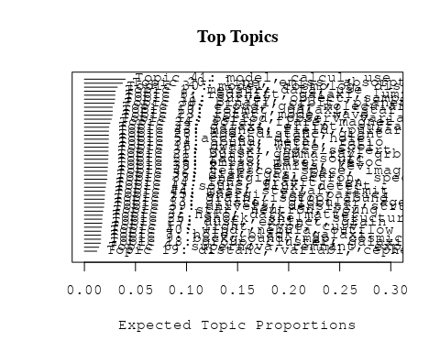

# Print the top 10 labels for each topic  
topic_labels <- labelTopics(Research_topics, n=10)  
print(topic_labels)

## Topic 1 Top Words:  
## Highest Prob: measur, data, use, estim, determin, time, result, observ, variat, obtain   
## FREX: measur, techniqu, variat, scintil, data, precis, error, method, analysi, uncertainti   
## Lift: stella, decorrel, document, refract, superior, titan, exemplifi, scintil, occult, homolog   
## Score: measur, scintil, lag, method, error, stella, delay, variat, data, ital   
## Topic 2 Top Words:  
## Highest Prob: star, neutron, young, tauri, massiv, low-mass, approxim, envelop, myr, associ   
## FREX: tauri, star, neutron, pre-main-sequ, dot, low-mass, orioni, myr, young, high-mass   
## Lift: ukirt, pms, aeb, vega-lik, cttss, dot, tauri, orioni, pre-main-sequ, herbig   
## Score: star, neutron, tauri, young, pre-main-sequ, low-mass, myr, envelop, ukirt, orioni   
## Topic 3 Top Words:  
## Highest Prob: halo, dark, matter, galaxi, veloc, satellit, galact, observ, within, potenti   
## FREX: halo, dark, satellit, matter, milki, mass--light, n-bodi, lsb, potenti, way   
## Lift: disentangl, apocentr, halo-lik, hsb, phase-spac, dark-matt, lsb, halo, dark, satellit   
## Score: halo, dark, matter, lsb, galaxi, mass--light, hsb, satellit, orbit, disentangl   
## Topic 4 Top Words:  
## Highest Prob: sourc, flux, detect, observ, object, variabl, discoveri, report, observatori, emiss   
## FREX: sourc, egret, comet, lac, lacerta, discoveri, markarian, blazar, flux, gamma   
## Lift: hale-bopp, meteor, shoemaker-levi, lacerta, lac, egret, unidentifi, markarian, intermitt, comet   
## Score: sourc, egret, meteor, comet, gamma-ray, lacerta, tev, blazar, lac, vhe   
## Topic 5 Top Words:  
## Highest Prob: accret, disk, hole, rate, black, disc, flow, model, radius, can   
## FREX: accret, disc, advection-domin, adaf, thin, black, hole, kerr, precess, viscos   
## Lift: adaf, perman, kerr, advection-domin, disc, fallback, accret, spun, liber, advect   
## Score: accret, black, hole, disk, disc, adaf, advection-domin, viscos, flow, viscous   
## Topic 6 Top Words:  
## Highest Prob: supernova, remnant, explos, ejecta, age, expans, snr, model, energi, distanc   
## FREX: remnant, snr, explos, supernova, ejecta, cas, snrs, expans, explod, cassiopeia   
## Lift: cassiopeia, sedov, kepler, pulsar-pow, snr, finger, remnant, middle-ag, shell-typ, core-collaps   
## Score: supernova, remnant, explos, snr, ejecta, snrs, kepler, finger, vela, age   
## Topic 7 Top Words:  
## Highest Prob: hole, black, galaxi, tidal, merger, disrupt, merg, interact, can, rate   
## FREX: disrupt, tidal, ital, coalesc, black, hole, merger, merg, encount, debri   
## Lift: articl, hole-neutron, magorrian, mbh, bhs, stellar-mass, coalesc, harass, copyright, disrupt   
## Score: black, hole, tidal, merger, galaxi, ital, articl, disrupt, coalesc, merg   
## Topic 8 Top Words:  
## Highest Prob: redshift, galaxi, luminos, quasar, sampl, function, densiti, high-redshift, system, high   
## FREX: redshift, high-redshift, qsos, quasar, qso, absorb, luminos, rest-fram, lyα, dlas   
## Lift: canada-fr, cnoc, oii, zem, dlas, campana, las, zab, cfrs, boroson   
## Score: redshift, galaxi, quasar, qsos, high-redshift, oii, lyα, qso, luminos, dlas   
## Topic 9 Top Words:  
## Highest Prob: background, map, cosmic, emiss, microwav, galact, use, infrar, observ, sky   
## FREX: map, microwav, background, dirb, cmb, foreground, cobe, zodiac, cib, anisotropi   
## Lift: zodiac, cmbr, dirb, dmr, ipd, photograph, cobedirb, fira, four-year, radiomet   
## Score: cib, dirb, cmb, microwav, background, map, cosmic, cobe, ipd, zodiac   
## Topic 10 Top Words:  
## Highest Prob: format, galaxi, star, popul, rate, evolut, histori, model, observ, form   
## FREX: format, histori, imf, popul, sfr, star-form, scenario, earli, epoch, rate   
## Lift: journal, sfr, sfrs, single-burst, salpet, upturn, imf, metal-fre, galaxy-s, recogniz   
## Score: format, galaxi, star, imf, starburst, sfr, histori, popul, journal, evolut   
## Topic 11 Top Words:  
## Highest Prob: survey, object, sampl, deep, field, optic, select, use, present, count   
## FREX: survey, deep, count, select, catalog, area, sky, mji, classif, complet   
## Lift: zwicki, sloan, beam-, digit, arcmin, sub-mm, commiss, survey, redshift-depend, co-ad   
## Score: survey, catalog, zwicki, count, deep, photometr, sampl, hdf, object, sky   
## Topic 12 Top Words:  
## Highest Prob: period, observ, variabl, frequenc, state, oscil, pulsat, nova, outburst, day   
## FREX: pulsat, qpos, qpo, outburst, oscil, nova, quasi-period, grs, period, cyg   
## Lift: aquila, qpo, beat-frequ, kilohertz, lmxbs, porb, sge, time-seri, atol, beat   
## Score: pulsat, oscil, nova, outburst, qpos, qpo, period, quasi-period, variabl, eclips   
## Topic 13 Top Words:  
## Highest Prob: cluster, globular, age, luminos, galact, young, veloc, similar, ngc, result   
## FREX: globular, cluster, rich, segreg, old, environ, destruct, abel, fornax, ostrik   
## Lift: onc, quintuplet, segreg, straggler, bcg, cluster, ostrik, globular, therein, refurbish   
## Score: cluster, globular, quintuplet, ngc, fornax, age, abel, onc, young, segreg   
## Topic 14 Top Words:  
## Highest Prob: lens, gravit, len, event, microlens, sourc, imag, can, detect, observ   
## FREX: lens, len, microlens, macho, gravit, magnif, arc, event, degeneraci, astrometr   
## Lift: disjoint, four-imag, magnifi, point-mass, len, lens, microlens, high-magnif, magnif, macho   
## Score: lens, len, microlens, macho, gravit, magnif, event, arc, imag, disjoint   
## Topic 15 Top Words:  
## Highest Prob: energi, ray, particl, cosmic, acceler, galact, cosmic-ray, observ, proton, gamma-ray   
## FREX: cosmic-ray, proton, charg, ray, particl, acceler, positron, mev, gev, cosmic   
## Lift: air, flys, ultra-high-energi, know, shower, charg, pion, biolog, positron, cosmic-ray   
## Score: ray, cosmic-ray, cosmic, acceler, particl, proton, gev, gamma-ray, mev, charg   
## Topic 16 Top Words:  
## Highest Prob: dwarf, white, cool, brown, object, age, observ, temperatur, model, mass   
## FREX: brown, white, dwarf, lithium, substellar, pleiad, teff, cool, evolutionari, track   
## Lift: lithium, baraff, dantona, bergeron, roqu, coolest, collision-induc, mazzitelli, brown, mwd   
## Score: dwarf, white, brown, pleiad, substellar, lithium, teff, cool, age, hyad   
## Topic 17 Top Words:  
## Highest Prob: light, type, curv, supernova, sne, observ, maximum, optic, can, model   
## FREX: sne, curv, light, type, maximum, declin, absolut, light-curv, progenitor, shape   
## Lift: sne, ubvri, aperiod, curv, sub-chandrasekhar, light, well-observ, light-curv, unobserv, press   
## Score: curv, sne, light, supernova, type, light-curv, ubvri, progenitor, day, absolut   
## Topic 18 Top Words:  
## Highest Prob: group, cluster, galaxi, gas, local, veloc, temperatur, profil, mass, mpc   
## FREX: group, intraclust, mpc, virial, poor, coma, virgo, subclust, rich, local   
## Lift: hickson, intragroup, mond, wat, subclust, group, galaxy-galaxi, icm, intraclust, luminosity-temperatur   
## Score: cluster, group, galaxi, mpc, subclust, intragroup, intraclust, virial, gas, coma   
## Topic 19 Top Words:  
## Highest Prob: distanc, variabl, cepheid, project, obtain, direct, photometri, use, galaxi, avail   
## FREX: cepheid, deb, distanc, eclips, frame, project, variabl, calibr, photometri, period-luminos   
## Lift: fullparti, michigan-dartmouth-mit, anonym, deb, dophot, ftp, kron-cousin, ladder—m, m—use, nonperiod   
## Score: cepheid, deb, variabl, eclips, distanc, period-luminos, ladder—m, fullparti, michigan-dartmouth-mit, photometri   
## Topic 20 Top Words:  
## Highest Prob: line, emiss, absorpt, spectra, featur, width, spectrum, continuum, profil, spectral   
## FREX: line, width, absorpt, iii, broad, spectra, featur, sight, balmer, continuum   
## Lift: bal, deni, egp, balqso, micromet, aromat, doublet, line, high-ion, bond   
## Score: line, absorpt, emiss, continuum, spectra, bal, ioniz, width, pah, spectrum   
## Topic 21 Top Words:  
## Highest Prob: burst, gamma-ray, grb, afterglow, observ, grbs, time, energi, optic, γray   
## FREX: grb, afterglow, grbs, burst, bats, firebal, gamma-ray, γray, blast, box   
## Lift: bats, afterglow, berkeley, grb, grbs, firebal, sgrs, burst, blast-wav, concurr   
## Score: burst, grb, afterglow, gamma-ray, grbs, firebal, bats, γray, blast, berkeley   
## Topic 22 Top Words:  
## Highest Prob: radio, jet, sourc, observ, optic, emiss, quasar, vla, ghz, consist   
## FREX: radio, jet, vla, gps, ghz, radio-loud, vlbi, radio-quiet, free-fre, align   
## Lift: gps, merlin, css, hotspot, westerbork, rqqs, radio-galaxi, radio--opt, parsec-scal, radio   
## Score: radio, jet, vla, quasar, ghz, gps, rqqs, vlba, sourc, hotspot   
## Topic 23 Top Words:  
## Highest Prob: rotat, mode, wave, turbul, convect, instabl, core, simul, gravit, energi   
## FREX: mode, turbul, convect, wave, instabl, unstabl, nonlinear, vortic, neutrino, alfven   
## Lift: kelvin-helmholtz, magnetoson, pariti, proto-neutron, r-mode, superfluid, vortex, vortic, non-rot, helioseism   
## Score: convect, mode, turbul, neutrino, instabl, wave, r-mode, rotat, vortic, alfven   
## Topic 24 Top Words:  
## Highest Prob: solar, flare, magnet, observ, coron, activ, region, flux, sun, loop   
## FREX: coron, flare, loop, tube, reconnect, chromospher, corona, sun, sunspot, solar   
## Lift: granul, soho, sumer, arcad, coron, eit, lasco, magnetogram, plage, postflar   
## Score: flare, coron, magnet, loop, reconnect, solar, tube, chromospher, corona, sunspot   
## Topic 25 Top Words:  
## Highest Prob: emiss, maser, veloc, observ, sourc, center, detect, continuum, sgr, ghz   
## FREX: maser, sgr, water, ghz, continuum, millimet, center, mhz, diamet, spot   
## Lift: maser, methanol, single-dish, ultracompact, double-peak, circinus, southwest, choh, atca, sws   
## Score: maser, methanol, ghz, sgr, emiss, water, continuum, hco, vla, mhz   
## Topic 26 Top Words:  
## Highest Prob: shock, shell, structur, region, medium, interact, emiss, filament, galact, expand   
## FREX: shell, shock, filament, front, expand, pressur, northern, revers, bubbl, bow   
## Lift: bilater, lism, quasi-perpendicular, shell-lik, preshock, bow, peripheri, faraday, shell, upstream   
## Score: shock, shell, bilater, filament, thread, front, bow, snrs, medium, ambient   
## Topic 27 Top Words:  
## Highest Prob: dust, extinct, grain, infrar, emiss, galaxi, optic, ira, observ, interstellar   
## FREX: dust, extinct, far-infrar, submillimet, fir, ira, silic, dusti, grain, scuba   
## Lift: dust--ga, scuba, bolomet, common-us, dropout, isocam, dust--met, prepar, submillimetr, dust   
## Score: dust, grain, extinct, far-infrar, submillimet, ira, fir, silic, scuba, infrar   
## Topic 28 Top Words:  
## Highest Prob: age, distanc, giant, metal, lmc, red, mag, branch, gyr, hipparco   
## FREX: hipparco, lmc, branch, feh, gyr, parallax, color-magnitud, magellan, red, diagram   
## Lift: baad, v-r, gratton, hipparco, mim, stanek, zahb, ggcs, reid, udalski   
## Score: hipparco, lmc, feh, parallax, branch, age, color-magnitud, metal, gyr, globular   
## Topic 29 Top Words:  
## Highest Prob: cloud, gas, molecular, region, densiti, ioniz, observ, core, temperatur, ratio   
## FREX: molecular, cloud, cm-, hcn, gas, molecul, ioniz, dens, orion, column   
## Lift: hcn, vlsr, coj, irc, pdr, photon-domin, tmc-, monoxid, stratospher, msolar   
## Score: molecular, cloud, gas, ioniz, hcn, pdr, cm-, molecul, column, orion   
## Topic 30 Top Words:  
## Highest Prob: model, cosmolog, distribut, densiti, predict, scale, paramet, function, power, observ   
## FREX: bias, cosmolog, cdm, statist, flat, gaussian, constant, paramet, model, scale   
## Lift: einstein-d, mock, quintess, scale-fre, omegam, pairwis, semi-analyt, non-gaussian, redshift-spac, cdm   
## Score: cosmolog, cdm, bias, model, univers, matter, einstein-d, simul, function, power   
## Topic 31 Top Words:  
## Highest Prob: galaxi, ngc, seyfert, activ, nuclei, starburst, agn, nucleus, luminos, region   
## FREX: seyfert, agn, liner, nucleus, nuclei, ngc, starburst, activ, nuclear, ultralumin   
## Lift: ulig, liner, balmer-lin, buri, seyfert, lir, nonstellar, arp, ulirg, agn   
## Score: seyfert, ngc, agn, galaxi, starburst, liner, nuclei, nucleus, ultralumin, ulig   
## Topic 32 Top Words:  
## Highest Prob: galaxi, ellipt, surfac, bright, spiral, ngc, distribut, central, luminos, early-typ   
## FREX: ellipt, early-typ, spiral, irregular, gcs, galaxi, surfac, bright, ugc, late-typ   
## Lift: des, lopsided, mlv, bcds, cuspi, boxi, lopsid, arcsec-, ellipt, gcs   
## Score: galaxi, ellipt, bcds, spiral, ngc, gcs, early-typ, ugc, merger, lopsid   
## Topic 33 Top Words:  
## Highest Prob: energi, electron, spectral, model, spectrum, radiat, photon, observ, synchrotron, emiss   
## FREX: synchrotron, electron, compton, photon, high-energi, power-law, index, relativist, lag, energi   
## Lift: hard--soft, hxr, ssc, self-compton, νfν, synchrotron, x-rayγray, load, compton, bremsstrahlung   
## Score: synchrotron, compton, electron, relativist, photon, tev, γray, energi, high-energi, puls   
## Topic 34 Top Words:  
## Highest Prob: abund, metal, ratio, chemic, observ, model, element, region, solar, evolut   
## FREX: abund, chemic, metal, oxygen, enrich, dex, element, w-r, nitrogen, iron   
## Lift: bhb, metal-defici, w-r, aro, heh, hii, nitrogen, opal, low-metal, sbs   
## Score: abund, metal, chemic, w-r, oxygen, enrich, dex, element, metal-poor, feh   
## Topic 35 Top Words:  
## Highest Prob: x-ray, emiss, kev, observ, soft, hard, luminos, rosat, asca, compon   
## FREX: soft, kev, x-ray, rosat, hard, asca, erg, pspc, hri, band   
## Lift: raymond–smith, shortfal, hri, position-sensit, rosat, raymond-smith, asca, soft, kev, x-ray   
## Score: x-ray, kev, rosat, asca, soft, hard, emiss, pspc, erg, hri   
## Topic 36 Top Words:  
## Highest Prob: disk, gas, bar, spiral, inner, ring, observ, model, rotat, kinemat   
## FREX: bar, disk, arm, edge-, spiral, ring, inner, lane, kinemat, inclin   
## Lift: supershel, lindblad, inside-, self-regul, counterrot, bar, arm, toomr, noncircular, edge-   
## Score: disk, bar, spiral, ring, gas, arm, counterrot, edge-, lane, self-regul   
## Topic 37 Top Words:  
## Highest Prob: grain, isotop, abund, composit, solar, model, element, rate, mix, chemic   
## FREX: isotop, reaction, composit, meteorit, burn, carbon, mix, grain, nucleosynthesi, r-process   
## Lift: alal, carbon-rich, chondrit, dredge-, graphit, presolar, primit, r-process, abstract—, flame   
## Score: grain, isotop, meteorit, abund, flame, reaction, nucleosynthesi, chemic, r-process, agb   
## Topic 38 Top Words:  
## Highest Prob: binari, orbit, planet, system, companion, veloc, eccentr, period, giant, mass   
## FREX: planet, eccentr, companion, belt, orbit, binari, planetesim, kuiper, jupit, migrat   
## Lift: peg, gas-giant, jupiter-mass, oort, planetesim, pluto, uranus, belt, crb, planet   
## Score: planet, binari, orbit, eccentr, companion, planetesim, belt, jupit, extrasolar, kuiper   
## Topic 39 Top Words:  
## Highest Prob: univers, densiti, structur, cosmolog, baryon, lyα, forest, observ, background, intergalact   
## FREX: forest, reioniz, baryon, intergalact, univers, lyα, igm, cosmolog, primordi, fluctuat   
## Lift: forest, reioniz, sheetlik, fan, gunn-peterson, lya, sightlin, bispectrum, fractal, jean   
## Score: forest, reioniz, baryon, lyα, univers, cosmolog, igm, intergalact, damp, fan   
## Topic 40 Top Words:  
## Highest Prob: wind, nebula, outflow, planetari, bipolar, ring, central, structur, circumstellar, model   
## FREX: wind, nebula, bipolar, pne, outflow, collim, planetari, mass-loss, equatori, lobe   
## Lift: pne, hydrogen-defici, hourglass, proto-planetari, wind, nebula, post-agb, bipolar, pns, herbig-haro   
## Score: nebula, wind, outflow, bipolar, pne, planetari, ring, collim, jet, circumstellar   
## Topic 41 Top Words:  
## Highest Prob: model, calcul, use, effect, result, paramet, present, includ, comput, simul   
## FREX: code, comput, equat, calcul, solut, analyt, approach, condit, formula, problem   
## Lift: partit, flexibl, fokker-planck, implement, code, minkowski, nlte, formula, treat, arbitrari   
## Score: equat, code, analyt, solut, simul, calcul, hydrodynam, comput, method, numer   
## Topic 42 Top Words:  
## Highest Prob: telescop, space, imag, hubbl, hst, observ, resolut, camera, spectrograph, obtain   
## FREX: space, spectrograph, wfpc, hst, telescop, camera, hubbl, ghrs, goddard, ground-bas   
## Lift: post-hb, shuttl, -orbit, foc, aurora, nicmo, fos, stis, goddard, astro-   
## Score: hubbl, telescop, hst, imag, spectrograph, space, camera, wfpc, goddard, ghrs   
## Topic 43 Top Words:  
## Highest Prob: magnet, field, pulsar, polar, psr, emiss, millisecond, puls, strength, neutron   
## FREX: pulsar, psr, polar, magnet, millisecond, field, puls, magnetospher, strength, drift   
## Lift: dipolar, pulsar, magnetar, polar-cap, ruderman, sutherland, zeeman, high-field, psr, unpuls   
## Score: pulsar, magnet, polar, psr, millisecond, field, puls, magnetar, magnetospher, neutron   
## Topic 44 Top Words:  
## Highest Prob: mass, stellar, limit, distribut, object, estim, function, deriv, upper, consist   
## FREX: stellar, mass, limit, upper, function, estim, distribut, lower, object, initi   
## Lift: serpen, stellar, mass, upper, limit, bound, other, date, overton, null   
## Score: mass, stellar, serpen, function, object, limit, upper, core, initi, estim

# Match the processed documents with the original titles  
matched_titles <- out_text$meta$original_concatenated_title_abstract  
  
# Print top 5 documents for each topic  
top_docs <- findThoughts(Research_topics, texts = matched_titles, n = 5)$docs[[1]]  
print(top_docs)

## [1] "Long-Term Scintillation Studies of Pulsars. I. Observations and Basic Results We report long-term scintillation observations of 18 pulsars in the dispersion measure range 3-35 pc cm-3 carried out from 1993 January to 1995 August using the Ooty Radio Telescope at 327 MHz. These observations were made with the aim of studying refractive effects in pulsar scintillation and obtaining reliable estimates of diffractive and refractive scintillation properties. Dynamic scintillation spectra of pulsars were regularly monitored at 10-90 epochs spanning 100-1000 days. Significant changes are observed in the dynamic spectra over timescales as short as a few days. Large-amplitude fluctuations are observed in quantities such as decorrelation bandwidth, scintillation timescale, drift rate, and flux density. Several pulsars show organized features, such as drifting bands in a highly pronounced manner. For some pulsars, gradual and systematic variations are seen in the drift rate of patterns that undergo several sign reversals during the observing time spans. Anomalous behavior, such as persistent drifts lasting over many months, is seen for PSRs B0834+06 and B1919+21. Four pulsars were studied for 2-4 well-separated observing sessions, each lasting over ~100 days. In some cases, significant variations are seen in the average scintillation properties and/or flux densities between successive observing sessions. From our data, we have been able to obtain more accurate and reliable estimates of scintillation properties and flux densities than those from the earlier observations by averaging out the fluctuations due to refractive scintillation effects. These measurements are used to derive parameters such as the strength of scattering and scintillation speeds. The scintillation speed estimates are found to be reasonably good indicators of proper-motion speeds of pulsars. The present measurements are compared with earlier measurements and the long-term stability of scintillation properties and flux densities is discussed."   
## [2] "Long-Term Scintillation Studies of Pulsars: I. Observations and Basic Results We report long-term scintillation observations of 18 pulsars in the dispersion measure range 3-35 pc cm-3 carried out from 1993 January to 1995 August using the Ooty Radio Telescope at 327 MHz. These observations were made with the aim of studying refractive effects in pulsar scintillation and obtaining reliable estimates of diffractive and refractive scintillation properties. Dynamic scintillation spectra of pulsars were regularly monitored at 10-90 epochs spanning 100-1000 days. Significant changes are observed in the dynamic spectra over timescales as short as a few days. Large-amplitude fluctuations are observed in quantities such as decorrelation bandwidth, scintillation timescale, drift rate, and flux density. Several pulsars show organized features, such as drifting bands in a highly pronounced manner. For some pulsars, gradual and systematic variations are seen in the drift rate of patterns that undergo several sign reversals during the observing time spans. Anomalous behavior, such as persistent drifts lasting over many months, is seen for PSRs B0834+06 and B1919+21. Four pulsars were studied for 2-4 well-separated observing sessions, each lasting over ~100 days. In some cases, significant variations are seen in the average scintillation properties and/or flux densities between successive observing sessions. From our data, we have been able to obtain more accurate and reliable estimates of scintillation properties and flux densities than those from the earlier observations by averaging out the fluctuations due to refractive scintillation effects. These measurements are used to derive parameters such as the strength of scattering and scintillation speeds. The scintillation speed estimates are found to be reasonably good indicators of proper-motion speeds of pulsars. The present measurements are compared with earlier measurements and the long-term stability of scintillation properties and flux densities is discussed."   
## [3] "Long-Term Scintillation Studies of Pulsars: I. Observations and Basic Results We report long-term scintillation observations of 18 pulsars in the dispersion measure range 3-35 pc cm-3 carried out from 1993 January to 1995 August using the Ooty Radio Telescope at 327 MHz. These observations were made with the aim of studying refractive effects in pulsar scintillation and obtaining reliable estimates of diffractive and refractive scintillation properties. Dynamic scintillation spectra of pulsars were regularly monitored at 10-90 epochs spanning 100-1000 days. Significant changes are observed in the dynamic spectra over timescales as short as a few days. Large-amplitude fluctuations are observed in quantities such as decorrelation bandwidth, scintillation timescale, drift rate, and flux density. Several pulsars show organized features, such as drifting bands in a highly pronounced manner. For some pulsars, gradual and systematic variations are seen in the drift rate of patterns that undergo several sign reversals during the observing time spans. Anomalous behavior, such as persistent drifts lasting over many months, is seen for PSRs B0834+06 and B1919+21. Four pulsars were studied for 2-4 well-separated observing sessions, each lasting over ~100 days. In some cases, significant variations are seen in the average scintillation properties and/or flux densities between successive observing sessions. From our data, we have been able to obtain more accurate and reliable estimates of scintillation properties and flux densities than those from the earlier observations by averaging out the fluctuations due to refractive scintillation effects. These measurements are used to derive parameters such as the strength of scattering and scintillation speeds. The scintillation speed estimates are found to be reasonably good indicators of proper-motion speeds of pulsars. The present measurements are compared with earlier measurements and the long-term stability of scintillation properties and flux densities is discussed."   
## [4] "Long-Term Scintillation Studies of Pulsars: II. Refractive Effects and the Spectrum of Plasma Density Fluctuations Refractive scintillation effects in pulsars are powerful techniques for discriminating between different models proposed for the electron density fluctuation spectrum in the interstellar medium. Data from our long-term scintillation study of 18 pulsars in the dispersion measure range 3-35 pc cm-3 (Paper I) are used to investigate two important observable effects of refractive scintillation, viz., (1) modulations of diffractive scintillation observables and flux density, and (2) drifting bands in dynamic scintillation spectra. Our data provide simultaneous measurements of decorrelation bandwidth, scintillation timescale, flux density, and drift rate of patterns. The observed modulations of the first three are compared with the available theoretical predictions, and constraints are placed on the power spectrum of plasma density fluctuations. The measured modulation indices are found to be larger than predicted by a Kolmogorov form of density spectrum. The properties of the drift rate of patterns along with the diffractive scintillation parameters have been used to estimate independently the slope of the density power spectrum, which is found to be consistent with a Kolmogorov form for several pulsars. The contradictory results from these two independent methods of constraining the electron density spectrum are not reconcilable with the simple theoretical models based on power-law forms of density spectrum. Our observations show anomalous scintillation behavior such as persistent drifting bands for some pulsars. This can be interpreted as an excess power in the low wavenumber range (~10-12 to 10-13 m-1) compared to the Kolmogorov expectations, or the existence of localized density structures. The results from our observations are discussed in combination with those from earlier studies in an attempt to understand the overall nature of the density spectrum. The emerging picture is a Kolmogorov-like spectrum (??11/3) in the wavenumber range ~10-6 m-1 to ~10-11 m-1, which either steepens or has a bump near ~10-12 to 10-13 m-1. The accumulated data also suggest the existence of discrete density structures along some lines of sight. We also discuss the possible implications of our results for the theoretical models."  
## [5] "Long-Term Scintillation Studies of Pulsars. II. Refractive Effects and the Spectrum of Plasma Density Fluctuations Refractive scintillation effects in pulsars are powerful techniques for discriminating between different models proposed for the electron density fluctuation spectrum in the interstellar medium. Data from our long-term scintillation study of 18 pulsars in the dispersion measure range 3-35 pc cm-3 (Paper I) are used to investigate two important observable effects of refractive scintillation, viz., (1) modulations of diffractive scintillation observables and flux density, and (2) drifting bands in dynamic scintillation spectra. Our data provide simultaneous measurements of decorrelation bandwidth, scintillation timescale, flux density, and drift rate of patterns. The observed modulations of the first three are compared with the available theoretical predictions, and constraints are placed on the power spectrum of plasma density fluctuations. The measured modulation indices are found to be larger than predicted by a Kolmogorov form of density spectrum. The properties of the drift rate of patterns along with the diffractive scintillation parameters have been used to estimate independently the slope of the density power spectrum, which is found to be consistent with a Kolmogorov form for several pulsars. The contradictory results from these two independent methods of constraining the electron density spectrum are not reconcilable with the simple theoretical models based on power-law forms of density spectrum. Our observations show anomalous scintillation behavior such as persistent drifting bands for some pulsars. This can be interpreted as an excess power in the low wavenumber range (~10-12 to 10-13 m-1) compared to the Kolmogorov expectations, or the existence of localized density structures. The results from our observations are discussed in combination with those from earlier studies in an attempt to understand the overall nature of the density spectrum. The emerging picture is a Kolmogorov-like spectrum (??11/3) in the wavenumber range ~10-6 m-1 to ~10-11 m-1, which either steepens or has a bump near ~10-12 to 10-13 m-1. The accumulated data also suggest the existence of discrete density structures along some lines of sight. We also discuss the possible implications of our results for the theoretical models."

# Find and plot the key "thoughts" or documents for selected topics  
thoughts6 <- findThoughts(Research_topics, texts = matched_titles, n = 3, topics = 6)$docs[[1]]  
thoughts18 <- findThoughts(Research_topics, texts = matched_titles, n = 3, topics = 18)$docs[[1]]  
par(mfrow = c(1, 2), mar = c(0.5, 0.5, 1, 0.5))  
plotQuote(thoughts6, width = 30, main = "Topic 6")  
plotQuote(thoughts18, width = 30, main = "Topic 18")

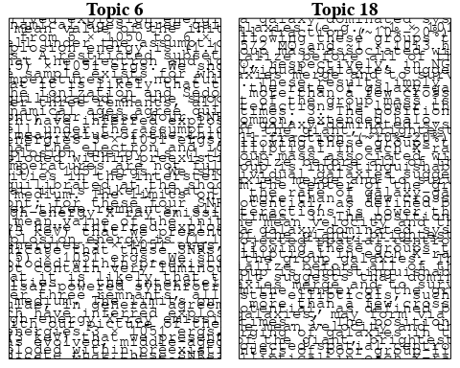

# Calculate and plot the correlation between topics  
mod.out.corr <- topicCorr(Research_topics)  
plot(mod.out.corr, cex = 1.5)  
  
  
# For each topic  
for (topic_num in 1:44) {  
 # Plot the word cloud  
 cloud(Research_topics, topic = topic_num, scale = c(2, 0.25))  
}

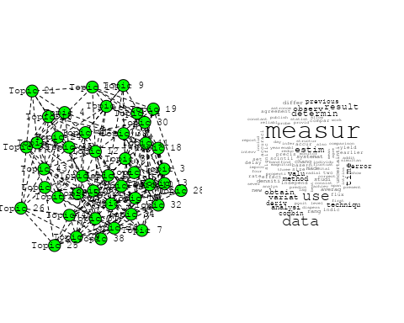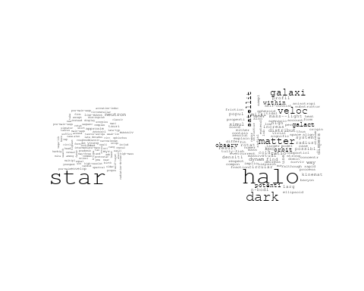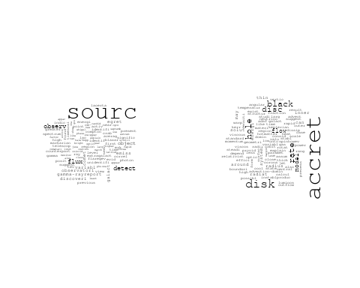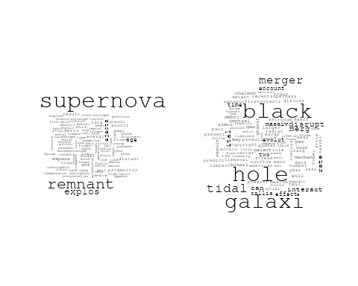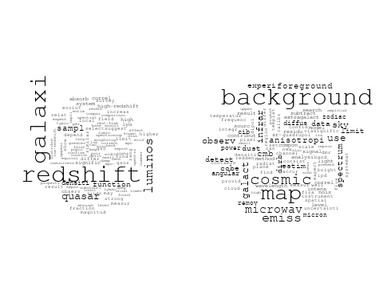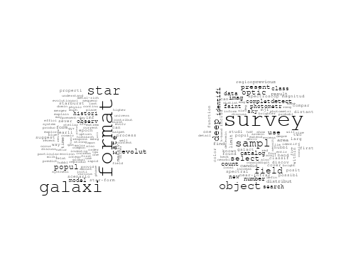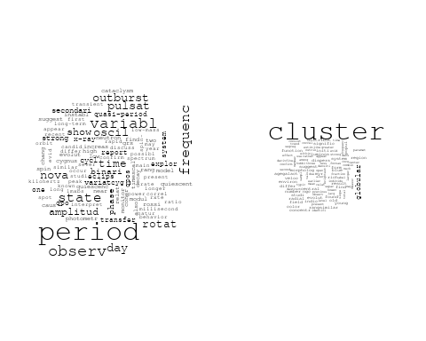

## Warning in wordcloud::wordcloud(words = vocab, freq = vec, max.words =  
## max.words, : energi could not be fit on page. It will not be plotted.

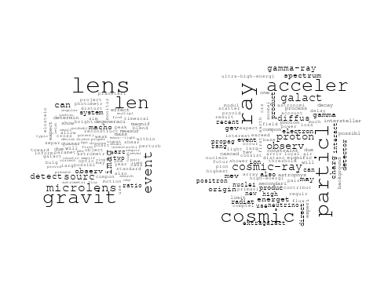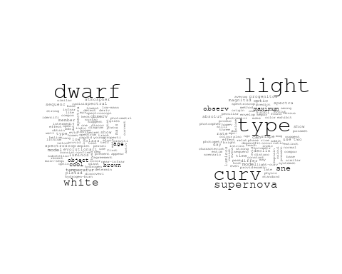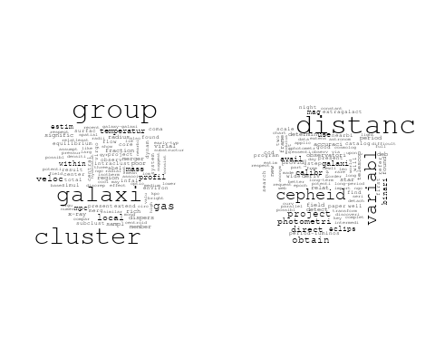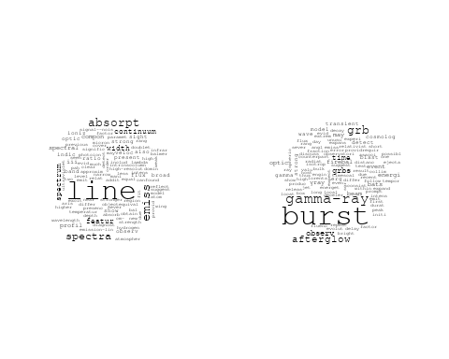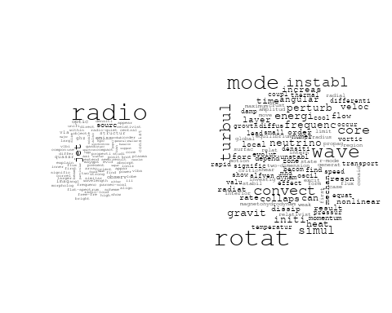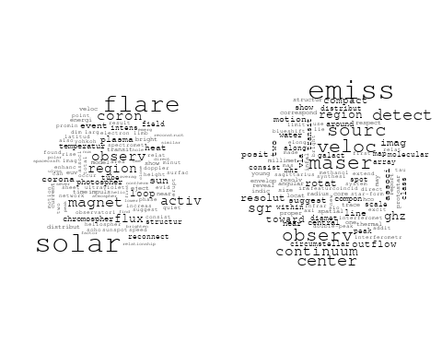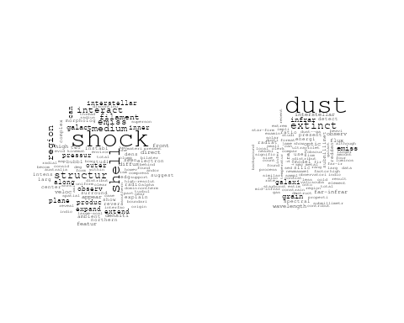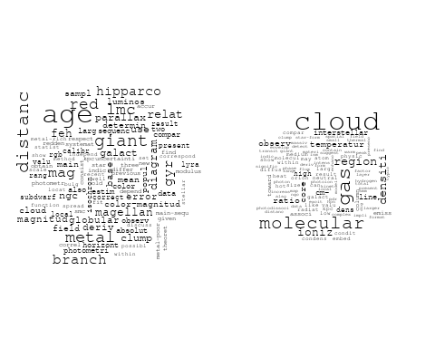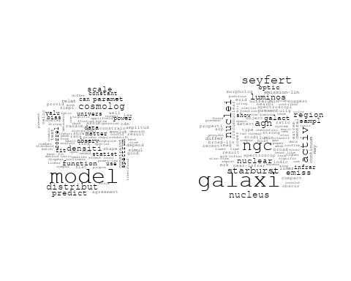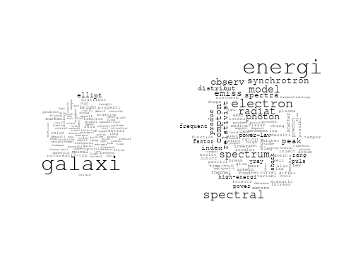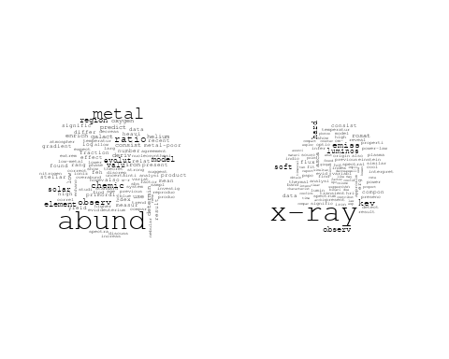

## Warning in wordcloud::wordcloud(words = vocab, freq = vec, max.words =  
## max.words, : composit could not be fit on page. It will not be plotted.

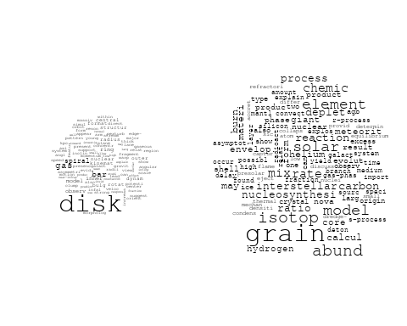

## Warning in wordcloud::wordcloud(words = vocab, freq = vec, max.words =  
## max.words, : structur could not be fit on page. It will not be plotted.

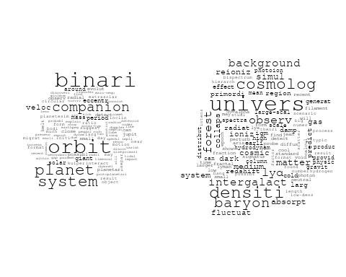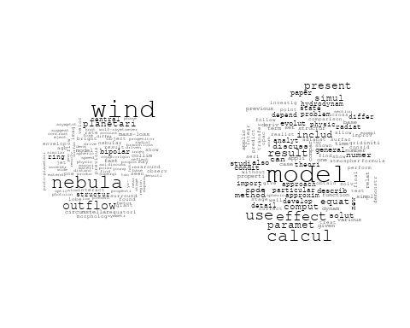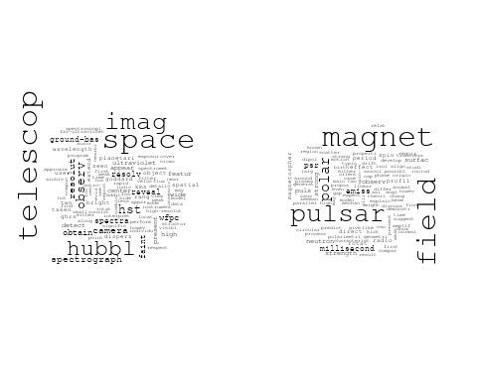

# Get the topic proportions for each document  
topic_proportions <- Research_topics$theta  
  
# Find the index of the topic with the highest proportion for each document  
# This will be the topic that each document is most likely to belong to  
max_topic_idx <- apply(topic_proportions, 1, which.max)  
  
# Add this as a new column to your data  
data_filtered$topic <- max_topic_idx  
  
  
  
# Create function to generate histogram  
make_histogram <- function(country_code) {  
   
 # Filter data for country with contribution of 100  
 data_100 <- data_filtered[data_filtered[[country_code]] == 100,]  
   
 # Filter data for country with contribution not equal to 0  
 data_not_0 <- data_filtered[data_filtered[[country_code]] != 0,]  
   
 # Make the first histogram  
 hist_100 <- ggplot(data_100, aes(x = topic)) +  
 geom_histogram(binwidth = 1, fill = "blue", color = "black") +  
 xlab("Topic") +  
 ylab("Count") +  
 ggtitle(paste(country_code, "Independent Contribution"))  
   
 # Make the second histogram  
 hist_not_0 <- ggplot(data_not_0, aes(x = topic)) +  
 geom_histogram(binwidth = 1, fill = "blue", color = "black") +  
 xlab("Topic") +  
 ylab("Count") +  
 ggtitle(paste(country_code, "Contributions (with collaboration)"))  
   
 # Return list of plots  
 return(list(hist_100, hist_not_0))  
}

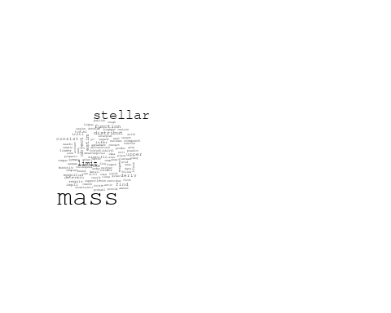

plots <- make_histogram("US")  
print(plots[[1]])

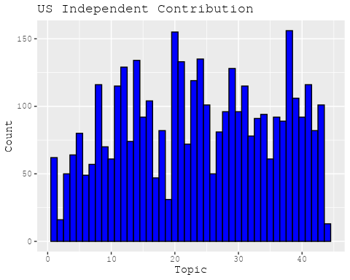

print(plots[[2]])

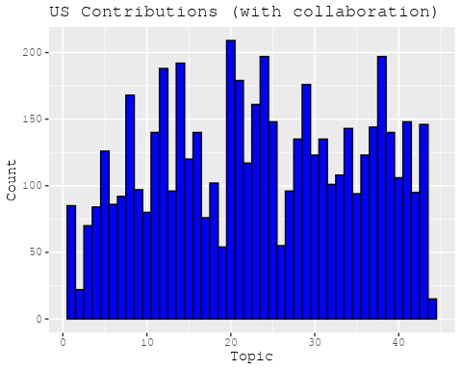

plots <- make_histogram("GB")  
print(plots[[1]])

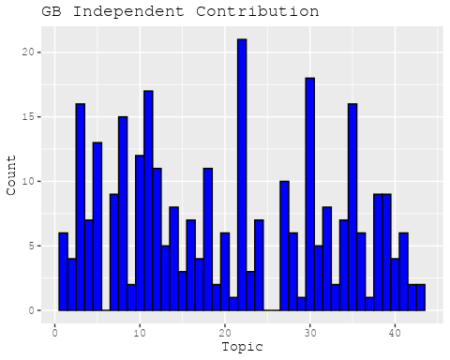

print(plots[[2]])

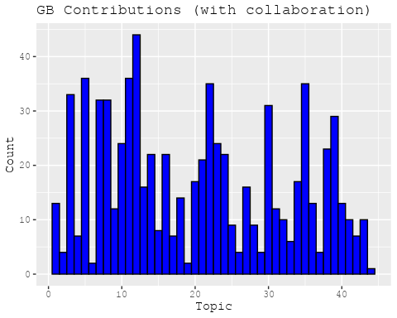

plots <- make_histogram("DE")  
print(plots[[1]])

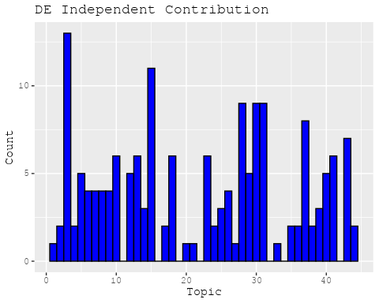

print(plots[[2]])

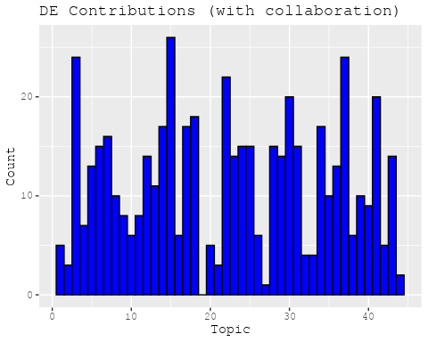

plots <- make_histogram("IT")  
print(plots[[1]])

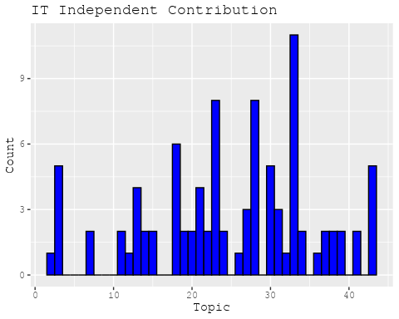

print(plots[[2]])

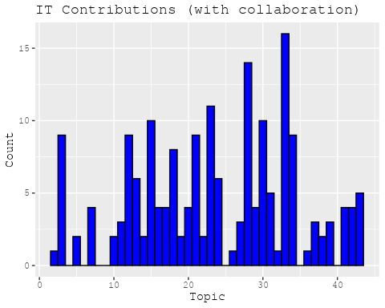

plots <- make_histogram("AU")  
print(plots[[1]])

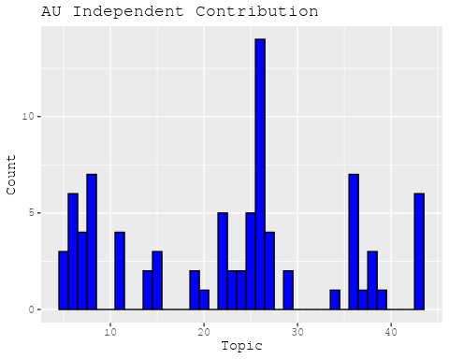

print(plots[[2]])

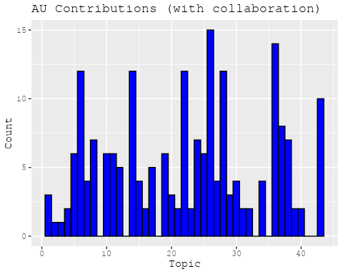

plots <- make_histogram("CA")  
print(plots[[1]])

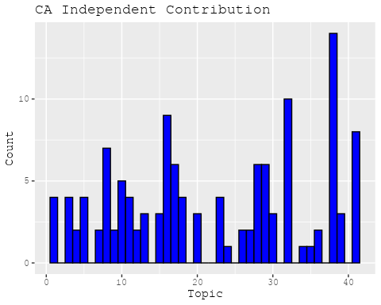

print(plots[[2]])

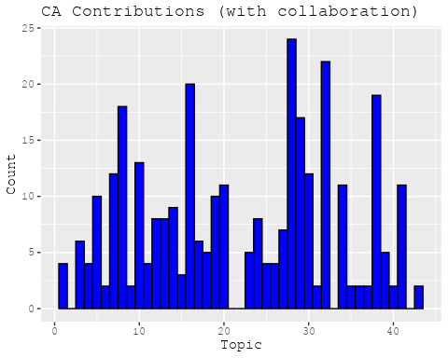

plots <- make_histogram("JP")  
print(plots[[1]])

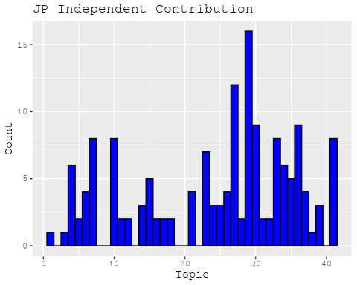

print(plots[[2]])

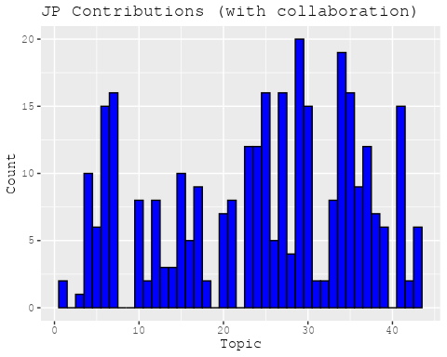

plots <- make_histogram("CN")  
print(plots[[1]])

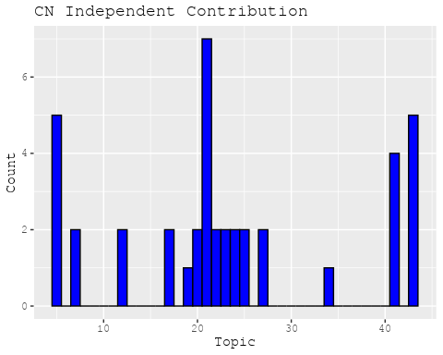

print(plots[[2]])

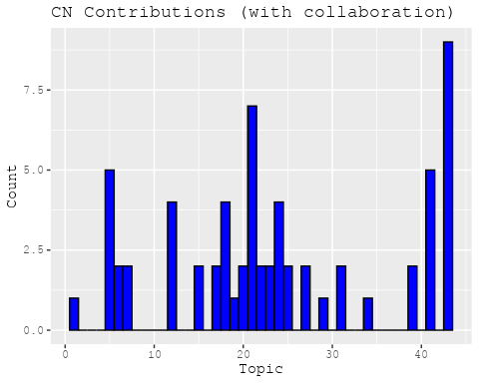

plots <- make_histogram("NL")  
print(plots[[1]])

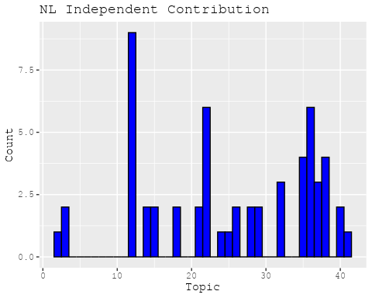

print(plots[[2]])

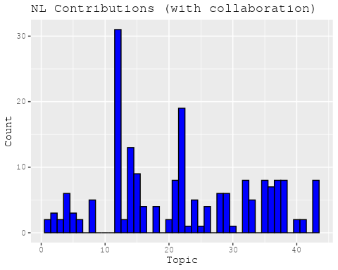

plots <- make_histogram("FR")  
print(plots[[1]])

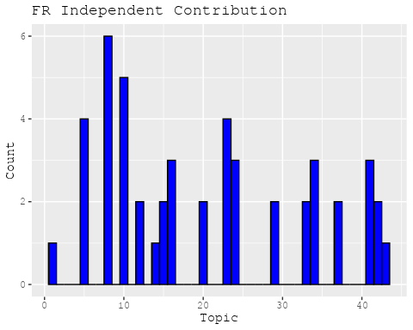

print(plots[[2]])

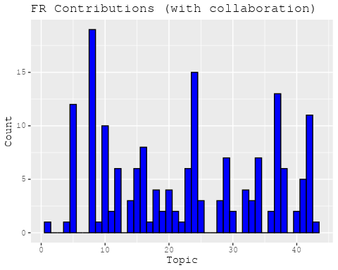

plots <- make_histogram("RU")  
print(plots[[1]])

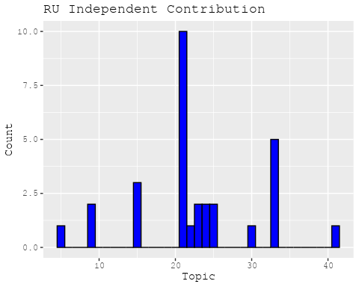

print(plots[[2]])

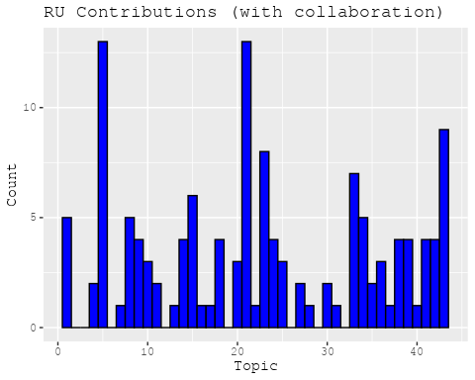

plots <- make_histogram("ES")  
print(plots[[1]])

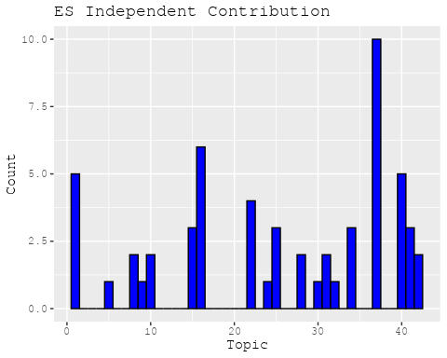

print(plots[[2]])

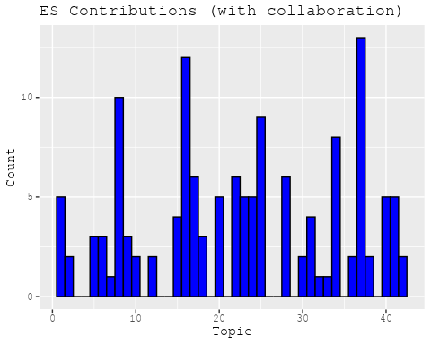

plots <- make_histogram("IN")  
print(plots[[1]])

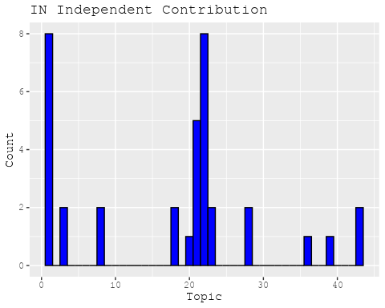

print(plots[[2]])

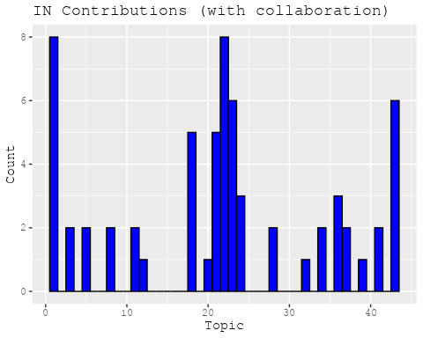

plots <- make_histogram("IL")  
print(plots[[1]])

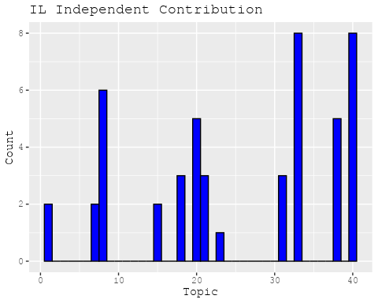

print(plots[[2]])

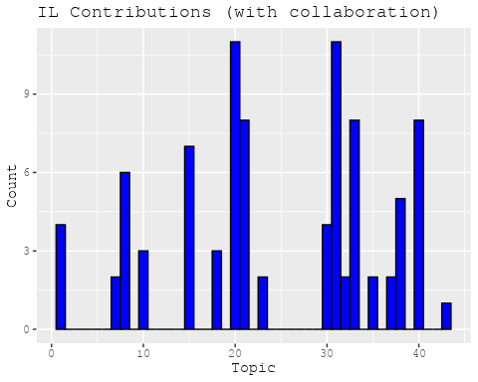

plots <- make_histogram("CH")  
print(plots[[1]])

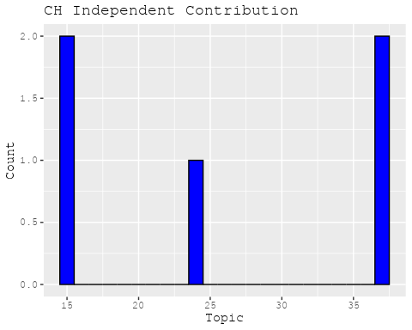

print(plots[[2]])

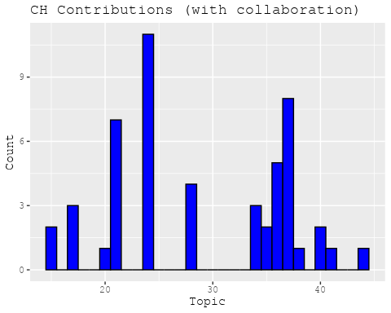

plots <- make_histogram("Americas")  
print(plots[[1]])

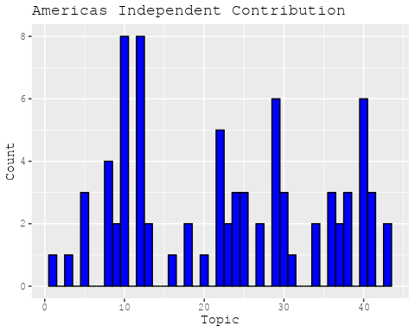

print(plots[[2]])

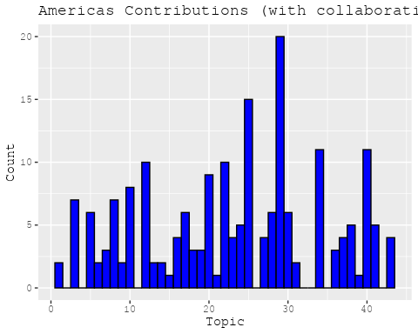

plots <- make_histogram("Europe")  
print(plots[[1]])

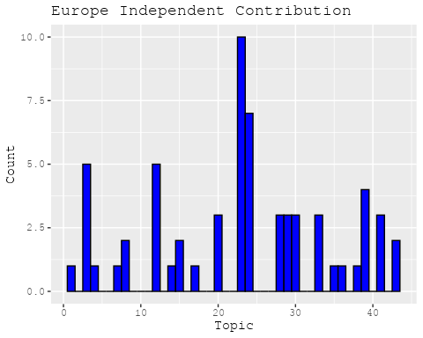

print(plots[[2]])

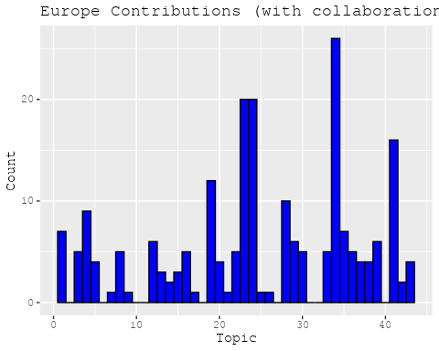

plots <- make_histogram("Africa")  
print(plots[[1]])

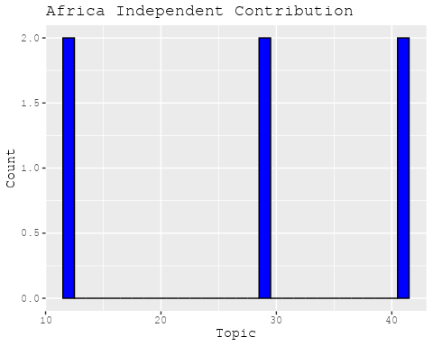

print(plots[[2]])

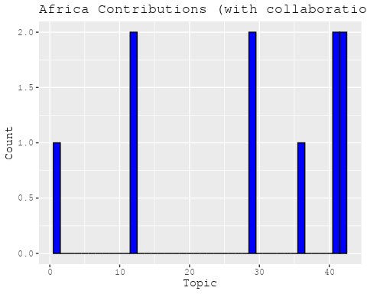

plots <- make_histogram("AsiaAndOceania")  
print(plots[[1]])

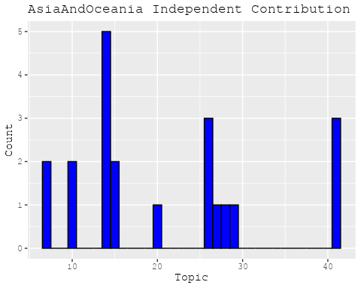

print(plots[[2]])

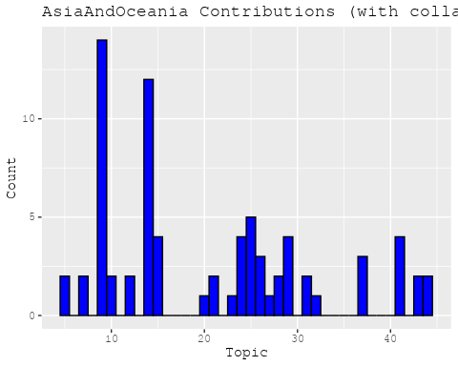

# Filter data for the publication interval 1985 to 1994  
data_filtered <- data[data[["pub_interval_1985_1994"]] == 1, ]  
  
# Save the original title data for future use  
data_filtered$original_concatenated_title_abstract <- data_filtered$concatenated_title_abstract  
  
#pre-processing the titles using textProcessor from the stm package  
processed_text <- textProcessor(data_filtered$concatenated_title_abstract, metadata = data_filtered)

## Building corpus...   
## Converting to Lower Case...   
## Removing punctuation...   
## Removing stopwords...   
## Removing numbers...   
## Stemming...   
## Creating Output...

# Further prepare the data by removing low-frequency terms  
out_text <- prepDocuments(processed_text$documents, processed_text$vocab, processed_text$meta)

## Removing 3813 of 11037 terms (3813 of 210117 tokens) due to frequency   
## Your corpus now has 3398 documents, 7224 terms and 206304 tokens.

docs_text <- out_text$documents  
vocab_text <- out_text$vocab  
meta_text <- out_text$meta  
  
  
#Prepare data  
plotRemoved(processed_text$documents, lower.thresh = seq(1, 200, by = 100))

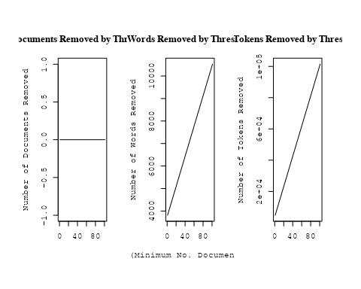

out_text <- prepDocuments(processed_text$documents, processed_text$vocab, processed_text$meta, lower.thresh = 8)

## Removing 8645 of 11037 terms (19062 of 210117 tokens) due to frequency   
## Your corpus now has 3398 documents, 2392 terms and 191055 tokens.

# Initialize an empty formula string  
prevalence_formula_str <- "~US "  
  
  
# Add each country variable to the formula string  
for (i in 10:27) {  
 prevalence_formula_str <- paste(prevalence_formula_str, "+", names(data)[i])  
}  
  
  
# Convert the string to a formula  
prevalence_formula <- as.formula(prevalence_formula_str)  
print(prevalence_formula)

## ~US + IN + DE + CH + GB + CN + FR + IT + RU + CA + NL + AU +   
## JP + ES + IL + Americas + Europe + Africa + AsiaAndOceania

# Run STM model  
Research_topics <- stm(documents = out_text$documents,   
 vocab = out_text$vocab,   
 K = 45,   
 prevalence = prevalence_formula,   
 data = out_text$meta,   
 init.type = "Spectral",  
 max.em.its = 1000,  
 gamma.prior = 'L1')

## Beginning Spectral Initialization   
## Calculating the gram matrix...  
## Finding anchor words...  
## .............................................  
## Recovering initialization...  
## .......................  
## Initialization complete.  
## ......................................................................................................  
## Completed E-Step (3 seconds).   
## Completed M-Step.   
## Completing Iteration 1 (approx. per word bound = -6.601)   
## ......................................................................................................  
## Completed E-Step (3 seconds).   
## Completed M-Step.   
## Completing Iteration 2 (approx. per word bound = -6.375, relative change = 3.427e-02)   
## ......................................................................................................  
## Completed E-Step (3 seconds).   
## Completed M-Step.   
## Completing Iteration 3 (approx. per word bound = -6.315, relative change = 9.371e-03)   
## ......................................................................................................  
## Completed E-Step (2 seconds).   
## Completed M-Step.   
## Completing Iteration 4 (approx. per word bound = -6.289, relative change = 4.141e-03)   
## ......................................................................................................  
## Completed E-Step (2 seconds).   
## Completed M-Step.   
## Completing Iteration 5 (approx. per word bound = -6.275, relative change = 2.197e-03)   
## Topic 1: ray, univers, cosmic, gamma, cosmic-ray   
## Topic 2: polar, ring, astronom, astronomi, observatori   
## Topic 3: dwarf, white, star, evolut, model   
## Topic 4: ngc, format, star, rate, region   
## Topic 5: infrar, emiss, micron, observ, ira   
## Topic 6: cluster, les, star, sequenc, photometri   
## Topic 7: star, dust, object, around, cloud   
## Topic 8: observ, emiss, profil, ultraviolet, model   
## Topic 9: burst, gamma-ray, energi, sourc, model   
## Topic 10: observ, remnant, supernova, measur, data   
## Topic 11: galaxi, spiral, luminos, ellipt, format   
## Topic 12: disk, accret, model, inner, gas   
## Topic 13: x-ray, intens, observ, rate, detect   
## Topic 14: galaxi, luminos, nebula, function, sampl   
## Topic 15: mass, solar, star, observ, binari   
## Topic 16: imag, telescop, quasar, space, lens   
## Topic 17: magnet, field, flux, strength, wind   
## Topic 18: solar, flare, coron, electron, observ   
## Topic 19: veloc, rotat, kms, radial, dispers   
## Topic 20: hole, black, gravit, mass, collaps   
## Topic 21: cloud, molecular, gas, region, outflow   
## Topic 22: abund, interstellar, ratio, transit, element   
## Topic 23: interact, wave, shock, energi, particl   
## Topic 24: sourc, radio, optic, observ, posit   
## Topic 25: variabl, period, observ, star, variat   
## Topic 26: star, region, stellar, sgr, show   
## Topic 27: activ, nuclei, nucleus, seyfert, x-ray   
## Topic 28: extinct, type, method, distanc, supernova   
## Topic 29: satellit, spectra, model, eclips, observ   
## Topic 30: cluster, galaxi, distribut, x-ray, redshift   
## Topic 31: emiss, grain, dust, band, featur   
## Topic 32: background, cosmic, scale, model, anisotropi   
## Topic 33: star, neutron, tauri, rate, stellar   
## Topic 34: line, emiss, absorpt, quasar, spectra   
## Topic 35: color, x-ray, metal, abund, differ   
## Topic 36: shock, jet, ice, astrophys, bow   
## Topic 37: comet, observ, neptun, voyag, june   
## Topic 38: mode, oscil, frequenc, instabl, energi   
## Topic 39: galaxi, gas, model, cool, evolut   
## Topic 40: x-ray, pulsar, burst, puls, time   
## Topic 41: binari, system, orbit, pulsar, star   
## Topic 42: wind, nova, supernova, explos, mass   
## Topic 43: theori, physic, observ, solar, model   
## Topic 44: shock, radiat, wind, model, line   
## Topic 45: observ, emiss, radio-select, optic, present   
## ......................................................................................................  
## Completed E-Step (2 seconds).   
## Completed M-Step.   
## Completing Iteration 6 (approx. per word bound = -6.266, relative change = 1.361e-03)   
## ......................................................................................................  
## Completed E-Step (2 seconds).   
## Completed M-Step.   
## Completing Iteration 7 (approx. per word bound = -6.261, relative change = 9.136e-04)   
## ......................................................................................................  
## Completed E-Step (2 seconds).   
## Completed M-Step.   
## Completing Iteration 8 (approx. per word bound = -6.256, relative change = 6.704e-04)   
## ......................................................................................................  
## Completed E-Step (2 seconds).   
## Completed M-Step.   
## Completing Iteration 9 (approx. per word bound = -6.253, relative change = 4.983e-04)   
## ......................................................................................................  
## Completed E-Step (2 seconds).   
## Completed M-Step.   
## Completing Iteration 10 (approx. per word bound = -6.251, relative change = 3.920e-04)   
## Topic 1: ray, cosmic, gamma, univers, cosmic-ray   
## Topic 2: polar, ring, astronom, astronomi, observatori   
## Topic 3: dwarf, white, star, evolut, model   
## Topic 4: ngc, format, star, nucleus, nuclear   
## Topic 5: emiss, infrar, micron, ira, observ   
## Topic 6: cluster, les, des, photometri, branch   
## Topic 7: star, dust, object, cloud, nearbi   
## Topic 8: observ, emiss, profil, ultraviolet, model   
## Topic 9: burst, gamma-ray, energi, model, sourc   
## Topic 10: remnant, observ, supernova, measur, data   
## Topic 11: galaxi, spiral, ellipt, luminos, format   
## Topic 12: disk, accret, inner, model, galact   
## Topic 13: x-ray, intens, observ, detect, correl   
## Topic 14: luminos, sampl, nebula, function, galaxi   
## Topic 15: mass, solar, star, observ, core   
## Topic 16: imag, telescop, quasar, lens, space   
## Topic 17: magnet, field, flux, strength, turbul   
## Topic 18: solar, flare, coron, electron, observ   
## Topic 19: veloc, rotat, kms, radial, dispers   
## Topic 20: hole, black, gravit, collaps, mass   
## Topic 21: cloud, molecular, gas, region, outflow   
## Topic 22: abund, interstellar, transit, ratio, densiti   
## Topic 23: wave, shock, interact, energi, particl   
## Topic 24: sourc, radio, optic, observ, posit   
## Topic 25: variabl, period, variat, observ, day   
## Topic 26: star, region, sgr, stellar, show   
## Topic 27: activ, nuclei, seyfert, agn, x-ray   
## Topic 28: extinct, type, method, distanc, use   
## Topic 29: satellit, eclips, spectra, model, observ   
## Topic 30: cluster, galaxi, distribut, x-ray, globular   
## Topic 31: grain, featur, dust, band, emiss   
## Topic 32: background, cosmic, scale, model, anisotropi   
## Topic 33: star, neutron, tauri, rotat, rate   
## Topic 34: line, absorpt, emiss, quasar, optic   
## Topic 35: color, x-ray, differ, metal, stellar   
## Topic 36: jet, shock, structur, bow, ice   
## Topic 37: comet, neptun, observ, voyag, atmospher   
## Topic 38: mode, frequenc, oscil, instabl, solar   
## Topic 39: galaxi, gas, cool, model, evolut   
## Topic 40: x-ray, pulsar, burst, puls, time   
## Topic 41: system, binari, orbit, pulsar, period   
## Topic 42: nova, wind, supernova, explos, outburst   
## Topic 43: theori, physic, model, observ, discuss   
## Topic 44: wind, model, radiat, shock, calcul   
## Topic 45: observ, present, optic, object, found   
## ......................................................................................................  
## Completed E-Step (2 seconds).   
## Completed M-Step.   
## Completing Iteration 11 (approx. per word bound = -6.249, relative change = 3.419e-04)   
## ......................................................................................................  
## Completed E-Step (2 seconds).   
## Completed M-Step.   
## Completing Iteration 12 (approx. per word bound = -6.247, relative change = 3.023e-04)   
## ......................................................................................................  
## Completed E-Step (2 seconds).   
## Completed M-Step.   
## Completing Iteration 13 (approx. per word bound = -6.245, relative change = 2.885e-04)   
## ......................................................................................................  
## Completed E-Step (2 seconds).   
## Completed M-Step.   
## Completing Iteration 14 (approx. per word bound = -6.243, relative change = 2.558e-04)   
## ......................................................................................................  
## Completed E-Step (2 seconds).   
## Completed M-Step.   
## Completing Iteration 15 (approx. per word bound = -6.242, relative change = 2.344e-04)   
## Topic 1: ray, cosmic, gamma, cosmic-ray, univers   
## Topic 2: polar, ring, astronom, astronomi, observatori   
## Topic 3: dwarf, white, model, evolut, observ   
## Topic 4: ngc, format, nucleus, central, star   
## Topic 5: emiss, infrar, micron, ira, wavelength   
## Topic 6: cluster, les, des, branch, photometri   
## Topic 7: star, object, dust, cloud, larg   
## Topic 8: observ, emiss, profil, ultraviolet, line   
## Topic 9: burst, gamma-ray, energi, model, sourc   
## Topic 10: remnant, supernova, observ, measur, data   
## Topic 11: galaxi, spiral, ellipt, format, luminos   
## Topic 12: disk, accret, inner, model, rate   
## Topic 13: x-ray, observ, kev, intens, soft   
## Topic 14: sampl, luminos, function, nebula, galaxi   
## Topic 15: mass, solar, star, observ, estim   
## Topic 16: imag, telescop, lens, quasar, gravit   
## Topic 17: field, magnet, flux, strength, turbul   
## Topic 18: solar, flare, coron, observ, electron   
## Topic 19: veloc, radial, kms, dispers, rotat   
## Topic 20: hole, black, gravit, collaps, mass   
## Topic 21: cloud, molecular, gas, region, outflow   
## Topic 22: abund, interstellar, transit, ratio, densiti   
## Topic 23: wave, shock, particl, energi, interact   
## Topic 24: sourc, radio, optic, observ, posit   
## Topic 25: variabl, period, variat, observ, day   
## Topic 26: star, region, sgr, stellar, show   
## Topic 27: activ, nuclei, seyfert, agn, galact   
## Topic 28: method, extinct, type, use, distanc   
## Topic 29: satellit, eclips, spectra, model, observ   
## Topic 30: cluster, galaxi, distribut, globular, group   
## Topic 31: featur, grain, band, dust, emiss   
## Topic 32: background, scale, cosmic, model, anisotropi   
## Topic 33: star, neutron, rotat, rate, tauri   
## Topic 34: line, absorpt, quasar, emiss, redshift   
## Topic 35: color, differ, metal, stellar, abund   
## Topic 36: jet, shock, structur, bow, ice   
## Topic 37: comet, neptun, observ, voyag, uranus   
## Topic 38: mode, frequenc, oscil, instabl, solar   
## Topic 39: gas, cool, galaxi, model, format   
## Topic 40: pulsar, burst, time, puls, x-ray   
## Topic 41: system, binari, orbit, pulsar, companion   
## Topic 42: supernova, nova, explos, envelop, wind   
## Topic 43: theori, physic, model, discuss, effect   
## Topic 44: wind, model, radiat, calcul, equat   
## Topic 45: observ, object, present, optic, ref   
## ......................................................................................................  
## Completed E-Step (2 seconds).   
## Completed M-Step.   
## Completing Iteration 16 (approx. per word bound = -6.241, relative change = 2.250e-04)   
## ......................................................................................................  
## Completed E-Step (2 seconds).   
## Completed M-Step.   
## Completing Iteration 17 (approx. per word bound = -6.239, relative change = 2.183e-04)   
## ......................................................................................................  
## Completed E-Step (2 seconds).   
## Completed M-Step.   
## Completing Iteration 18 (approx. per word bound = -6.238, relative change = 2.087e-04)   
## ......................................................................................................  
## Completed E-Step (2 seconds).   
## Completed M-Step.   
## Completing Iteration 19 (approx. per word bound = -6.237, relative change = 1.934e-04)   
## ......................................................................................................  
## Completed E-Step (2 seconds).   
## Completed M-Step.   
## Completing Iteration 20 (approx. per word bound = -6.236, relative change = 1.735e-04)   
## Topic 1: ray, cosmic, gamma, cosmic-ray, univers   
## Topic 2: polar, astronom, ring, astronomi, observatori   
## Topic 3: dwarf, white, model, evolut, observ   
## Topic 4: ngc, nucleus, format, central, nuclear   
## Topic 5: emiss, infrar, micron, ira, dust   
## Topic 6: cluster, les, des, branch, photometri   
## Topic 7: star, object, cloud, larg, nearbi   
## Topic 8: observ, emiss, profil, line, ultraviolet   
## Topic 9: burst, gamma-ray, energi, model, sourc   
## Topic 10: remnant, supernova, observ, measur, data   
## Topic 11: galaxi, spiral, ellipt, format, popul   
## Topic 12: disk, accret, inner, model, rate   
## Topic 13: x-ray, observ, kev, soft, data   
## Topic 14: sampl, luminos, function, nebula, galaxi   
## Topic 15: mass, solar, estim, low, observ   
## Topic 16: imag, telescop, lens, gravit, quasar   
## Topic 17: field, magnet, flux, strength, rotat   
## Topic 18: solar, flare, coron, observ, electron   
## Topic 19: veloc, radial, kms, dispers, distribut   
## Topic 20: hole, black, gravit, collaps, mass   
## Topic 21: cloud, molecular, gas, region, outflow   
## Topic 22: abund, interstellar, transit, ratio, densiti   
## Topic 23: shock, wave, particl, energi, interact   
## Topic 24: sourc, radio, optic, observ, posit   
## Topic 25: variabl, period, variat, observ, day   
## Topic 26: star, region, sgr, show, stellar   
## Topic 27: activ, nuclei, seyfert, agn, galact   
## Topic 28: method, extinct, use, type, distanc   
## Topic 29: satellit, eclips, secondari, model, spectra   
## Topic 30: cluster, galaxi, distribut, globular, group   
## Topic 31: featur, grain, band, dust, micromet   
## Topic 32: background, scale, cosmic, model, univers   
## Topic 33: star, rotat, neutron, stellar, rate   
## Topic 34: line, absorpt, quasar, emiss, redshift   
## Topic 35: color, differ, metal, abund, stellar   
## Topic 36: jet, shock, structur, bow, ice   
## Topic 37: comet, observ, neptun, atmospher, voyag   
## Topic 38: mode, frequenc, oscil, instabl, solar   
## Topic 39: gas, cool, model, galaxi, format   
## Topic 40: pulsar, burst, time, puls, radio   
## Topic 41: system, binari, orbit, companion, pulsar   
## Topic 42: supernova, nova, explos, envelop, shell   
## Topic 43: model, physic, theori, discuss, present   
## Topic 44: wind, model, radiat, equat, calcul   
## Topic 45: observ, object, properti, optic, present   
## ......................................................................................................  
## Completed E-Step (2 seconds).   
## Completed M-Step.   
## Completing Iteration 21 (approx. per word bound = -6.235, relative change = 1.663e-04)   
## ......................................................................................................  
## Completed E-Step (2 seconds).   
## Completed M-Step.   
## Completing Iteration 22 (approx. per word bound = -6.234, relative change = 1.554e-04)   
## ......................................................................................................  
## Completed E-Step (2 seconds).   
## Completed M-Step.   
## Completing Iteration 23 (approx. per word bound = -6.233, relative change = 1.412e-04)   
## ......................................................................................................  
## Completed E-Step (2 seconds).   
## Completed M-Step.   
## Completing Iteration 24 (approx. per word bound = -6.232, relative change = 1.417e-04)   
## ......................................................................................................  
## Completed E-Step (2 seconds).   
## Completed M-Step.   
## Completing Iteration 25 (approx. per word bound = -6.231, relative change = 1.396e-04)   
## Topic 1: ray, cosmic, gamma, cosmic-ray, energi   
## Topic 2: polar, astronom, ring, astronomi, observatori   
## Topic 3: dwarf, white, model, evolut, observ   
## Topic 4: ngc, nucleus, central, format, nuclear   
## Topic 5: emiss, infrar, micron, ira, dust   
## Topic 6: cluster, les, des, branch, photometri   
## Topic 7: star, object, cloud, larg, nearbi   
## Topic 8: emiss, observ, line, spectra, profil   
## Topic 9: burst, gamma-ray, energi, model, sourc   
## Topic 10: remnant, supernova, observ, shell, measur   
## Topic 11: galaxi, spiral, ellipt, format, popul   
## Topic 12: disk, accret, inner, model, rate   
## Topic 13: x-ray, observ, kev, soft, data   
## Topic 14: sampl, luminos, function, nebula, survey   
## Topic 15: mass, solar, estim, low, observ   
## Topic 16: imag, telescop, lens, gravit, quasar   
## Topic 17: field, magnet, flux, strength, rotat   
## Topic 18: solar, flare, coron, observ, electron   
## Topic 19: veloc, radial, kms, dispers, galact   
## Topic 20: hole, black, gravit, collaps, dynam   
## Topic 21: cloud, molecular, gas, region, line   
## Topic 22: abund, transit, interstellar, ratio, densiti   
## Topic 23: shock, wave, particl, energi, acceler   
## Topic 24: sourc, radio, optic, observ, posit   
## Topic 25: variabl, period, variat, observ, day   
## Topic 26: star, region, sgr, angl, show   
## Topic 27: activ, nuclei, seyfert, agn, galact   
## Topic 28: method, extinct, use, distanc, deriv   
## Topic 29: satellit, secondari, eclips, primari, model   
## Topic 30: cluster, galaxi, distribut, group, globular   
## Topic 31: grain, featur, band, dust, micromet   
## Topic 32: background, cosmic, scale, model, univers   
## Topic 33: star, rotat, neutron, stellar, rate   
## Topic 34: line, absorpt, quasar, emiss, redshift   
## Topic 35: color, differ, metal, abund, age   
## Topic 36: jet, shock, structur, bow, tail   
## Topic 37: comet, observ, neptun, jupit, atmospher   
## Topic 38: mode, frequenc, oscil, instabl, energi   
## Topic 39: gas, cool, model, galaxi, medium   
## Topic 40: pulsar, time, burst, puls, radio   
## Topic 41: system, binari, orbit, companion, period   
## Topic 42: supernova, nova, envelop, explos, outburst   
## Topic 43: model, physic, theori, discuss, present   
## Topic 44: wind, model, radiat, equat, flow   
## Topic 45: object, properti, observ, shown, optic   
## ......................................................................................................  
## Completed E-Step (2 seconds).   
## Completed M-Step.   
## Completing Iteration 26 (approx. per word bound = -6.230, relative change = 1.187e-04)   
## ......................................................................................................  
## Completed E-Step (2 seconds).   
## Completed M-Step.   
## Completing Iteration 27 (approx. per word bound = -6.229, relative change = 1.191e-04)   
## ......................................................................................................  
## Completed E-Step (2 seconds).   
## Completed M-Step.   
## Completing Iteration 28 (approx. per word bound = -6.229, relative change = 1.323e-04)   
## ......................................................................................................  
## Completed E-Step (2 seconds).   
## Completed M-Step.   
## Completing Iteration 29 (approx. per word bound = -6.228, relative change = 1.133e-04)   
## ......................................................................................................  
## Completed E-Step (2 seconds).   
## Completed M-Step.   
## Completing Iteration 30 (approx. per word bound = -6.227, relative change = 1.126e-04)   
## Topic 1: ray, cosmic, gamma, cosmic-ray, energi   
## Topic 2: polar, astronom, ring, astronomi, observatori   
## Topic 3: dwarf, white, model, evolut, observ   
## Topic 4: ngc, nucleus, central, format, nuclear   
## Topic 5: emiss, infrar, micron, ira, dust   
## Topic 6: cluster, les, des, branch, photometri   
## Topic 7: star, object, cloud, larg, nearbi   
## Topic 8: emiss, line, observ, spectra, ultraviolet   
## Topic 9: burst, gamma-ray, energi, sourc, model   
## Topic 10: remnant, supernova, observ, shell, measur   
## Topic 11: galaxi, spiral, ellipt, format, popul   
## Topic 12: disk, accret, inner, model, rate   
## Topic 13: x-ray, observ, emiss, kev, spectral   
## Topic 14: sampl, luminos, function, nebula, survey   
## Topic 15: mass, solar, estim, low, massiv   
## Topic 16: imag, telescop, lens, gravit, quasar   
## Topic 17: field, magnet, flux, strength, rotat   
## Topic 18: solar, flare, coron, observ, event   
## Topic 19: veloc, radial, kms, galact, dispers   
## Topic 20: hole, black, gravit, collaps, neutron   
## Topic 21: cloud, molecular, gas, region, line   
## Topic 22: abund, transit, interstellar, densiti, ratio   
## Topic 23: shock, wave, energi, particl, acceler   
## Topic 24: sourc, radio, optic, observ, posit   
## Topic 25: variabl, period, variat, observ, day   
## Topic 26: star, region, sgr, angl, nebula   
## Topic 27: activ, nuclei, seyfert, agn, galact   
## Topic 28: method, use, extinct, distanc, deriv   
## Topic 29: satellit, secondari, eclips, primari, model   
## Topic 30: cluster, galaxi, distribut, group, globular   
## Topic 31: grain, featur, band, dust, micromet   
## Topic 32: background, cosmic, scale, univers, model   
## Topic 33: star, rotat, stellar, neutron, rate   
## Topic 34: line, absorpt, quasar, emiss, redshift   
## Topic 35: color, differ, metal, abund, age   
## Topic 36: jet, shock, structur, bow, tail   
## Topic 37: comet, observ, neptun, jupit, atmospher   
## Topic 38: mode, frequenc, oscil, instabl, energi   
## Topic 39: cool, gas, model, medium, galaxi   
## Topic 40: pulsar, time, puls, radio, neutron   
## Topic 41: binari, system, orbit, companion, period   
## Topic 42: supernova, nova, envelop, explos, type   
## Topic 43: model, physic, discuss, theori, present   
## Topic 44: wind, model, radiat, equat, flow   
## Topic 45: object, properti, shown, observ, polar   
## ......................................................................................................  
## Completed E-Step (2 seconds).   
## Completed M-Step.   
## Completing Iteration 31 (approx. per word bound = -6.227, relative change = 1.108e-04)   
## ......................................................................................................  
## Completed E-Step (2 seconds).   
## Completed M-Step.   
## Completing Iteration 32 (approx. per word bound = -6.226, relative change = 1.144e-04)   
## ......................................................................................................  
## Completed E-Step (2 seconds).   
## Completed M-Step.   
## Completing Iteration 33 (approx. per word bound = -6.225, relative change = 1.191e-04)   
## ......................................................................................................  
## Completed E-Step (2 seconds).   
## Completed M-Step.   
## Completing Iteration 34 (approx. per word bound = -6.224, relative change = 1.202e-04)   
## ......................................................................................................  
## Completed E-Step (2 seconds).   
## Completed M-Step.   
## Completing Iteration 35 (approx. per word bound = -6.224, relative change = 1.075e-04)   
## Topic 1: ray, cosmic, cosmic-ray, gamma, energi   
## Topic 2: polar, astronom, ring, astronomi, observatori   
## Topic 3: dwarf, white, model, observ, evolut   
## Topic 4: ngc, nucleus, central, format, nuclear   
## Topic 5: emiss, infrar, micron, ira, dust   
## Topic 6: cluster, les, des, branch, photometri   
## Topic 7: star, cloud, object, larg, nearbi   
## Topic 8: line, emiss, spectra, observ, ultraviolet   
## Topic 9: burst, gamma-ray, energi, sourc, model   
## Topic 10: remnant, supernova, observ, shell, region   
## Topic 11: galaxi, spiral, ellipt, format, popul   
## Topic 12: disk, accret, inner, model, rate   
## Topic 13: x-ray, emiss, observ, kev, spectral   
## Topic 14: sampl, luminos, function, nebula, survey   
## Topic 15: mass, solar, estim, massiv, low   
## Topic 16: imag, telescop, lens, gravit, quasar   
## Topic 17: field, magnet, flux, strength, rotat   
## Topic 18: solar, flare, coron, observ, event   
## Topic 19: veloc, radial, kms, galact, distribut   
## Topic 20: hole, black, gravit, collaps, neutron   
## Topic 21: cloud, molecular, gas, region, line   
## Topic 22: abund, transit, interstellar, densiti, ratio   
## Topic 23: shock, wave, energi, particl, acceler   
## Topic 24: sourc, radio, optic, observ, posit   
## Topic 25: variabl, period, variat, observ, day   
## Topic 26: star, region, sgr, angl, circumstellar   
## Topic 27: activ, nuclei, seyfert, galact, agn   
## Topic 28: method, use, distanc, extinct, deriv   
## Topic 29: satellit, secondari, eclips, primari, model   
## Topic 30: cluster, distribut, galaxi, group, globular   
## Topic 31: grain, featur, band, micromet, dust   
## Topic 32: background, cosmic, scale, univers, model   
## Topic 33: star, rotat, stellar, rate, neutron   
## Topic 34: line, absorpt, quasar, redshift, emiss   
## Topic 35: color, differ, metal, age, abund   
## Topic 36: jet, structur, shock, bow, relativist   
## Topic 37: comet, observ, neptun, jupit, atmospher   
## Topic 38: mode, frequenc, oscil, instabl, energi   
## Topic 39: cool, gas, model, medium, evolut   
## Topic 40: pulsar, time, puls, radio, neutron   
## Topic 41: system, binari, orbit, companion, period   
## Topic 42: supernova, nova, envelop, explos, type   
## Topic 43: model, physic, discuss, theori, present   
## Topic 44: wind, model, radiat, equat, flow   
## Topic 45: object, properti, polar, optic, lac   
## ......................................................................................................  
## Completed E-Step (2 seconds).   
## Completed M-Step.   
## Completing Iteration 36 (approx. per word bound = -6.223, relative change = 9.402e-05)   
## ......................................................................................................  
## Completed E-Step (2 seconds).   
## Completed M-Step.   
## Completing Iteration 37 (approx. per word bound = -6.223, relative change = 9.466e-05)   
## ......................................................................................................  
## Completed E-Step (2 seconds).   
## Completed M-Step.   
## Completing Iteration 38 (approx. per word bound = -6.222, relative change = 8.001e-05)   
## ......................................................................................................  
## Completed E-Step (2 seconds).   
## Completed M-Step.   
## Completing Iteration 39 (approx. per word bound = -6.222, relative change = 7.344e-05)   
## ......................................................................................................  
## Completed E-Step (2 seconds).   
## Completed M-Step.   
## Completing Iteration 40 (approx. per word bound = -6.221, relative change = 7.605e-05)   
## Topic 1: ray, cosmic, cosmic-ray, gamma, energi   
## Topic 2: astronom, ring, astronomi, observatori, observ   
## Topic 3: dwarf, white, model, observ, evolut   
## Topic 4: ngc, nucleus, central, format, nuclear   
## Topic 5: emiss, infrar, micron, ira, dust   
## Topic 6: cluster, les, des, branch, photometri   
## Topic 7: star, cloud, larg, nearbi, microlens   
## Topic 8: line, emiss, spectra, observ, ultraviolet   
## Topic 9: burst, gamma-ray, sourc, energi, model   
## Topic 10: remnant, supernova, shell, observ, region   
## Topic 11: galaxi, spiral, ellipt, format, popul   
## Topic 12: disk, accret, inner, model, rate   
## Topic 13: x-ray, emiss, observ, kev, spectral   
## Topic 14: sampl, luminos, function, survey, nebula   
## Topic 15: mass, solar, estim, massiv, low   
## Topic 16: imag, telescop, lens, gravit, quasar   
## Topic 17: field, magnet, flux, strength, rotat   
## Topic 18: solar, flare, coron, observ, event   
## Topic 19: veloc, galact, kms, radial, distribut   
## Topic 20: hole, black, gravit, neutron, collaps   
## Topic 21: cloud, molecular, gas, region, line   
## Topic 22: abund, interstellar, transit, densiti, ratio   
## Topic 23: shock, wave, energi, particl, acceler   
## Topic 24: sourc, radio, observ, posit, optic   
## Topic 25: variabl, period, variat, observ, day   
## Topic 26: star, region, sgr, circumstellar, angl   
## Topic 27: activ, nuclei, seyfert, galact, agn   
## Topic 28: use, method, distanc, data, determin   
## Topic 29: satellit, secondari, eclips, primari, model   
## Topic 30: cluster, distribut, galaxi, group, globular   
## Topic 31: grain, featur, band, micromet, dust   
## Topic 32: background, cosmic, scale, univers, model   
## Topic 33: star, rotat, stellar, rate, tauri   
## Topic 34: line, absorpt, quasar, redshift, emiss   
## Topic 35: color, age, metal, differ, abund   
## Topic 36: jet, structur, shock, bow, relativist   
## Topic 37: comet, observ, neptun, jupit, atmospher   
## Topic 38: mode, frequenc, oscil, instabl, energi   
## Topic 39: cool, gas, model, medium, evolut   
## Topic 40: pulsar, time, puls, radio, neutron   
## Topic 41: system, binari, orbit, companion, period   
## Topic 42: supernova, nova, envelop, explos, type   
## Topic 43: model, physic, discuss, theori, present   
## Topic 44: wind, model, radiat, equat, flow   
## Topic 45: object, polar, properti, optic, lac   
## ......................................................................................................  
## Completed E-Step (2 seconds).   
## Completed M-Step.   
## Completing Iteration 41 (approx. per word bound = -6.221, relative change = 6.885e-05)   
## ......................................................................................................  
## Completed E-Step (2 seconds).   
## Completed M-Step.   
## Completing Iteration 42 (approx. per word bound = -6.220, relative change = 6.230e-05)   
## ......................................................................................................  
## Completed E-Step (2 seconds).   
## Completed M-Step.   
## Completing Iteration 43 (approx. per word bound = -6.220, relative change = 5.517e-05)   
## ......................................................................................................  
## Completed E-Step (2 seconds).   
## Completed M-Step.   
## Completing Iteration 44 (approx. per word bound = -6.220, relative change = 5.245e-05)   
## ......................................................................................................  
## Completed E-Step (2 seconds).   
## Completed M-Step.   
## Completing Iteration 45 (approx. per word bound = -6.219, relative change = 5.128e-05)   
## Topic 1: ray, cosmic, cosmic-ray, gamma, energi   
## Topic 2: astronom, ring, astronomi, observatori, observ   
## Topic 3: dwarf, white, model, observ, evolut   
## Topic 4: ngc, nucleus, central, nuclear, core   
## Topic 5: emiss, infrar, micron, dust, ira   
## Topic 6: cluster, les, des, branch, photometri   
## Topic 7: star, cloud, larg, nearbi, microlens   
## Topic 8: line, emiss, spectra, observ, ultraviolet   
## Topic 9: burst, gamma-ray, sourc, energi, model   
## Topic 10: remnant, supernova, shell, observ, emiss   
## Topic 11: galaxi, spiral, ellipt, format, popul   
## Topic 12: disk, accret, inner, rate, model   
## Topic 13: x-ray, emiss, observ, kev, spectral   
## Topic 14: sampl, luminos, function, survey, nebula   
## Topic 15: mass, solar, estim, massiv, low   
## Topic 16: imag, telescop, lens, gravit, quasar   
## Topic 17: field, magnet, flux, strength, rotat   
## Topic 18: solar, flare, coron, observ, event   
## Topic 19: veloc, galact, kms, radial, distribut   
## Topic 20: hole, black, gravit, neutron, collaps   
## Topic 21: cloud, molecular, gas, region, line   
## Topic 22: abund, interstellar, transit, densiti, ratio   
## Topic 23: shock, wave, energi, particl, acceler   
## Topic 24: sourc, radio, observ, posit, optic   
## Topic 25: variabl, period, variat, observ, day   
## Topic 26: star, region, circumstellar, sgr, nebula   
## Topic 27: activ, nuclei, seyfert, galact, agn   
## Topic 28: use, method, data, distanc, measur   
## Topic 29: secondari, satellit, eclips, primari, model   
## Topic 30: cluster, distribut, galaxi, group, globular   
## Topic 31: grain, featur, band, micromet, dust   
## Topic 32: background, cosmic, scale, univers, model   
## Topic 33: star, stellar, rotat, rate, tauri   
## Topic 34: line, absorpt, quasar, redshift, emiss   
## Topic 35: color, age, metal, abund, differ   
## Topic 36: jet, structur, shock, bow, relativist   
## Topic 37: comet, observ, neptun, jupit, atmospher   
## Topic 38: mode, frequenc, oscil, instabl, energi   
## Topic 39: cool, gas, model, medium, evolut   
## Topic 40: pulsar, time, puls, radio, neutron   
## Topic 41: system, binari, orbit, companion, period   
## Topic 42: supernova, nova, envelop, type, explos   
## Topic 43: model, physic, discuss, theori, present   
## Topic 44: wind, model, radiat, equat, flow   
## Topic 45: object, polar, optic, properti, lac   
## ......................................................................................................  
## Completed E-Step (2 seconds).   
## Completed M-Step.   
## Completing Iteration 46 (approx. per word bound = -6.219, relative change = 5.187e-05)   
## ......................................................................................................  
## Completed E-Step (2 seconds).   
## Completed M-Step.   
## Completing Iteration 47 (approx. per word bound = -6.219, relative change = 4.801e-05)   
## ......................................................................................................  
## Completed E-Step (2 seconds).   
## Completed M-Step.   
## Completing Iteration 48 (approx. per word bound = -6.218, relative change = 4.090e-05)   
## ......................................................................................................  
## Completed E-Step (2 seconds).   
## Completed M-Step.   
## Model Converged

# Plot the STM model summary  
plot(Research_topics, type = "summary", xlim = c(0, 0.3))

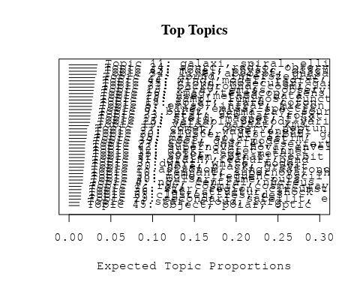

# Print the top 10 labels for each topic  
topic_labels <- labelTopics(Research_topics, n=10)  
print(topic_labels)

## Topic 1 Top Words:  
## Highest Prob: ray, cosmic, cosmic-ray, gamma, energi, observ, particl, sourc, experi, new   
## FREX: cosmic-ray, ray, cosmic, gamma, nucleosynthesi, big, korff, unseen, experi, neutrino   
## Lift: korff, unseen, serg, cosmic-ray, balloon, bang, ray, big, tev, nucleosynthesi   
## Score: ray, unseen, cosmic, cosmic-ray, gamma, korff, nucleosynthesi, neutrino, serg, particl   
## Topic 2 Top Words:  
## Highest Prob: astronom, ring, astronomi, observatori, observ, first, catalogu, tabl, sun, one   
## FREX: astronom, astronomi, catalogu, centuri, ring, longitud, tabl, name, coordin, observatori   
## Lift: centuri, depart, goal, astronom, astronomi, institut, book, parallax, lunar, catalogu   
## Score: astronom, depart, ring, astronomi, catalogu, centuri, book, research, longitud, scienc   
## Topic 3 Top Words:  
## Highest Prob: dwarf, white, model, observ, evolut, pulsat, period, cool, rate, lithium   
## FREX: white, dwarf, pulsat, lithium, deplet, evolutionari, standard, secular, grid, horizontal-branch   
## Lift: secular, white, lithium, dwarf, horizontal-branch, subdwarf, lyra, asteroseismolog, pulsat, teff   
## Score: dwarf, white, secular, lithium, pulsat, horizontal-branch, deplet, brown, metal-poor, lyra   
## Topic 4 Top Words:  
## Highest Prob: ngc, central, nucleus, nuclear, core, kpc, starburst, imag, format, approxim   
## FREX: ngc, nucleus, starburst, arp, unresolv, kpc, central, nuclear, h-alpha, journal   
## Lift: journal, ngc, arp, long-slit, unresolv, owen, high-mass, valley, nucleus, starlight   
## Score: ngc, journal, nucleus, arp, starburst, central, unresolv, kpc, nuclear, h-alpha   
## Topic 5 Top Words:  
## Highest Prob: emiss, infrar, micron, dust, ira, wavelength, optic, observ, far-infrar, luminos   
## FREX: infrar, micron, ira, far-infrar, dust, fir, wavelength, emiss, -micron, ultralumin   
## Lift: kuiper, markarian, ultralumin, infrar, fir, far-infrar, micron, airborn, ira, nir   
## Score: micron, ira, infrar, dust, far-infrar, kuiper, emiss, fir, -micron, wavelength   
## Topic 6 Top Words:  
## Highest Prob: cluster, les, des, branch, photometri, sequenc, diagram, blue, globular, star   
## FREX: les, dan, des, sont, est, pour, branch, une, diagram, horizont   
## Lift: dan, densit, dune, est, etoil, galactiqu, les, que, sont, ces   
## Score: les, etoil, des, cluster, dan, sont, est, pour, une, globular   
## Topic 7 Top Words:  
## Highest Prob: star, cloud, larg, nearbi, microlens, matter, halo, magellan, faint, event   
## FREX: microlens, nearbi, magellan, main-sequ, faint, million, durat, bodi, brown, matter   
## Lift: debri, budget, percentag, degrad, hydrogen-burn, microlens, sustain, phi, twelv, magellan   
## Score: debri, microlens, star, magellan, cloud, brown, nearbi, main-sequ, halo, dwarf   
## Topic 8 Top Words:  
## Highest Prob: line, emiss, spectra, observ, ultraviolet, profil, temperatur, flux, region, iue   
## FREX: ultraviolet, iue, spectra, profil, h-alpha, euv, line, cygni, maser, temperatur   
## Lift: rai, euv, cygni, iue, ultraviolet, campaign, maser, ghrs, h-alpha, goddard   
## Score: line, ultraviolet, rai, spectra, iue, emiss, h-alpha, euv, profil, cygni   
## Topic 9 Top Words:  
## Highest Prob: burst, gamma-ray, sourc, energi, model, radiat, distribut, compton, photon, gamma   
## FREX: gamma-ray, burst, compton, burster, photon, bats, γray, mev, gamma, relativist   
## Lift: firebal, γray, burster, gamma-ray, positron, bats, annihil, gro, burst, oss   
## Score: burst, gamma-ray, firebal, bats, compton, burster, gamma, γray, mev, ray   
## Topic 10 Top Words:  
## Highest Prob: remnant, supernova, shell, observ, emiss, region, snrs, snr, filament, model   
## FREX: remnant, snrs, shell, snr, supernova, superbubbl, filament, echo, progenitor, kepler   
## Lift: snrs, earliest, echo, remnant, snr, kepler, superbubbl, imageri, shell, hit   
## Score: remnant, supernova, earliest, shell, snrs, snr, superbubbl, filament, kepler, echo   
## Topic 11 Top Words:  
## Highest Prob: galaxi, spiral, ellipt, format, popul, bright, surfac, morpholog, blue, strong   
## FREX: spiral, galaxi, ellipt, popul, merger, arm, morpholog, normal, format, nearbi   
## Lift: grand, gas-rich, spiral, ellipt, galaxi, arm, early-typ, star-form, merger, irregular   
## Score: galaxi, grand, spiral, ellipt, merger, arm, format, star-form, nearbi, popul   
## Topic 12 Top Words:  
## Highest Prob: disk, accret, inner, rate, model, outer, exp, region, can, infal   
## FREX: accret, disk, inner, infal, stream, onto, orioni, outer, massyr, thin   
## Lift: warp, accret, disk, orioni, innermost, keplerian, massyr, postul, viscous, stream   
## Score: disk, accret, warp, orioni, infal, inner, viscous, viscos, outburst, stream   
## Topic 13 Top Words:  
## Highest Prob: x-ray, emiss, observ, kev, spectral, soft, data, hard, optic, spectrum   
## FREX: x-ray, soft, kev, einstein, hard, rosat, spectral, flash, power-law, observatori   
## Lift: flash, ginga, ipc, einstein, soft, rosat, x-ray, heao, kev, pks   
## Score: x-ray, flash, kev, soft, hard, einstein, rosat, emiss, pks, ginga   
## Topic 14 Top Words:  
## Highest Prob: sampl, luminos, function, survey, correl, nebula, flux, densiti, select, use   
## FREX: sampl, function, luminos, survey, nebula, select, correl, complet, count, planetari   
## Lift: candl, flux-limit, sampl, cfa, function, count, nebula, select, luminos, -band   
## Score: sampl, candl, luminos, nebula, survey, function, redshift, planetari, ira, correl   
## Topic 15 Top Words:  
## Highest Prob: mass, solar, estim, massiv, low, exp, central, found, rang, observ   
## FREX: mass, solar, massiv, estim, infer, evolutionari, agb, radius, low, initi   
## Lift: mass-luminos, mass, agb, isochron, msub, neighborhood, gcu, deform, polarimetr, solar   
## Score: mass, mass-luminos, solar, agb, massiv, brown, main-sequ, evolutionari, cyg, exp   
## Topic 16 Top Words:  
## Highest Prob: imag, telescop, lens, gravit, quasar, space, observ, len, hubbl, hst   
## FREX: lens, imag, telescop, len, hst, space, hubbl, camera, arcsec, gravit   
## Lift: automat, aberr, magnif, len, lens, arcsecond, snapshot, imag, hst, telescop   
## Score: imag, lens, len, quasar, automat, telescop, hst, microlens, gravit, camera   
## Topic 17 Top Words:  
## Highest Prob: field, magnet, flux, strength, rotat, current, turbul, can, shear, surfac   
## FREX: magnet, field, shear, dynamo, sheet, reconnect, strength, turbul, tube, mhd   
## Lift: cross-sect, magnet, reconnect, tube, dynamo, toroid, field, equipartit, vector, shear   
## Score: magnet, field, cross-sect, dynamo, reconnect, shear, tube, turbul, sheet, mhd   
## Topic 18 Top Words:  
## Highest Prob: solar, flare, coron, observ, event, electron, corona, region, heat, loop   
## FREX: flare, coron, corona, impuls, solar, loop, interplanetari, event, sun, chromospher   
## Lift: geomagnet, flare, impuls, corona, coron, ise, interplanetari, magnetogram, limb, smm   
## Score: flare, coron, solar, geomagnet, impuls, corona, microwav, loop, event, interplanetari   
## Topic 19 Top Words:  
## Highest Prob: veloc, galact, kms, radial, distribut, dispers, halo, rotat, densiti, kinemat   
## FREX: veloc, kms, radial, dispers, kinemat, halo, bulg, radius, galact, motion   
## Lift: galactocentr, veloc, kinemat, kms, dispers, mass--light, bulg, radial, famili, transvers   
## Score: veloc, galactocentr, kms, dispers, halo, radial, kinemat, bulg, rotat, galact   
## Topic 20 Top Words:  
## Highest Prob: hole, black, gravit, neutron, collaps, dynam, will, form, format, evolut   
## FREX: black, hole, collaps, coalesc, gravit, neutron, dynam, cusp, will, ligo   
## Lift: ligo, coalesc, newtonian, black, hole, friction, laser, schwarzschild, cusp, neutron-star   
## Score: black, hole, ligo, neutron, collaps, gravit, coalesc, cusp, momentum, newtonian   
## Topic 21 Top Words:  
## Highest Prob: cloud, molecular, gas, region, line, emiss, galact, associ, outflow, ioniz   
## FREX: molecular, cloud, gas, outflow, warm, bipolar, clump, high-veloc, photodissoci, dens   
## Lift: taurus, molecular, photodissoci, c-o, cloud, bipolar, warm, high-veloc, fine-structur, hco   
## Score: molecular, cloud, taurus, gas, outflow, line, photodissoci, fine-structur, bipolar, ioniz   
## Topic 22 Top Words:  
## Highest Prob: abund, interstellar, transit, densiti, ratio, temperatur, element, ioniz, column, hydrogen   
## FREX: transit, abund, reaction, column, atom, element, speci, interstellar, excit, hydrogen   
## Lift: deuterium, hcn, ion-molecul, chemistri, monoxid, orion-kl, hyperfin, irc, sio, reaction   
## Score: abund, deuterium, reaction, speci, transit, interstellar, ion, chemistri, molecul, column   
## Topic 23 Top Words:  
## Highest Prob: shock, wave, energi, particl, acceler, electron, interact, collis, plasma, proton   
## FREX: shock, wave, alfven, collis, acceler, particl, proton, propag, electron, kinet   
## Lift: etr, fermi, preshock, alfven, collisionless, coulomb, blast, postshock, inject, shock   
## Score: shock, wave, acceler, particl, proton, alfven, etr, electron, collis, plasma   
## Topic 24 Top Words:  
## Highest Prob: sourc, radio, observ, posit, optic, vla, ghz, map, new, compact   
## FREX: radio, vla, sourc, vlbi, ghz, map, posit, array, compact, nontherm   
## Lift: fade, vlbi, vla, mas, radio, multifrequ, aquarii, mji, ghz, flat-spectrum   
## Score: radio, sourc, fade, ghz, vla, vlbi, map, mji, catalog, compact   
## Topic 25 Top Words:  
## Highest Prob: variabl, period, variat, observ, day, light, chang, curv, amplitud, show   
## FREX: variabl, day, variat, cataclysm, amplitud, period, photometr, chang, cycl, lag   
## Lift: suspect, short-term, variabl, lag, cataclysm, mid-, day, aql, doppler, leo   
## Score: variabl, suspect, period, day, cataclysm, variat, amplitud, curv, cepheid, lag   
## Topic 26 Top Words:  
## Highest Prob: star, region, circumstellar, nebula, sgr, angl, show, four, planetari, stellar   
## FREX: sgr, ori, circumstellar, supergi, angl, trapezium, peculiar, ultracompact, four, align   
## Lift: sagittarius, trapezium, ori, ultracompact, sgr, defici, preserv, supergi, nebulos, coeval   
## Score: sagittarius, star, sgr, ori, trapezium, circumstellar, nebula, ultracompact, planetari, supergi   
## Topic 27 Top Words:  
## Highest Prob: activ, nuclei, seyfert, galact, agn, ioniz, continuum, model, nucleus, photoion   
## FREX: agn, seyfert, nuclei, activ, photoion, broad-lin, continuum, emission-lin, tori, ioniz   
## Lift: bare, narrow-lin, tori, agn, liner, seyfert, broad-lin, line-emit, nuclei, low-luminos   
## Score: seyfert, agn, nuclei, activ, bare, nucleus, liner, photoion, ioniz, tori   
## Topic 28 Top Words:  
## Highest Prob: use, method, data, measur, distanc, determin, deriv, extinct, valu, relat   
## FREX: method, extinct, distanc, techniqu, bump, agreement, error, calibr, deriv, determin   
## Lift: sne, bump, extinct, calibr, method, varianc, eb-v, techniqu, agreement, orthogon   
## Score: sne, extinct, method, bump, cepheid, calibr, error, distanc, measur, techniqu   
## Topic 29 Top Words:  
## Highest Prob: secondari, satellit, eclips, primari, model, observ, light, bright, event, appear   
## FREX: secondari, primari, eclips, satellit, pluto, occult, algol, dip, albedo, reflect   
## Lift: pluto, secondari, dip, aqr, primari, eclips, mutual, algol, satellit, two-temperatur   
## Score: pluto, eclips, secondari, satellit, occult, primari, algol, albedo, dip, event   
## Topic 30 Top Words:  
## Highest Prob: cluster, distribut, galaxi, group, globular, virgo, model, core, mpc, larg   
## FREX: cluster, virgo, group, globular, abel, mpc, rich, peculiar, concentr, fornax   
## Lift: abel, virgo, cluster, void, rich, group, omegasub, globular, algorithm, compel   
## Score: cluster, abel, globular, virgo, galaxi, group, fornax, mpc, rich, peculiar   
## Topic 31 Top Words:  
## Highest Prob: grain, featur, band, micromet, interstellar, dust, spectra, emiss, micron, pah   
## FREX: grain, micromet, pah, band, silic, featur, cm-, graphit, hydrocarbon, carbon   
## Lift: carbonac, silic, aromat, polycycl, graphit, pah, zodiac, grain, micromet, hydrocarbon   
## Score: grain, micromet, zodiac, pah, graphit, hydrocarbon, micron, silic, ice, dust   
## Topic 32 Top Words:  
## Highest Prob: background, cosmic, scale, univers, model, fluctuat, anisotropi, microwav, structur, densiti   
## FREX: background, anisotropi, fluctuat, microwav, univers, cosmic, string, cobe, omega, cmb   
## Lift: cmb, string, anisotropi, radiomet, background, cobe, cbr, omega, fluctuat, superclust   
## Score: string, cosmic, anisotropi, background, microwav, cobe, univers, cmb, fluctuat, cosmolog   
## Topic 33 Top Words:  
## Highest Prob: star, stellar, rotat, rate, tauri, format, angular, low-mass, young, sequenc   
## FREX: star, tauri, low-mass, rotat, stellar, angular, nake, loss, sequenc, rate   
## Lift: nake, tauri, star, aur, pre-main, taurus-auriga, myr, tau, herbig, low-mass   
## Score: star, nake, tauri, rotat, low-mass, taurus-auriga, sequenc, stellar, rate, momentum   
## Topic 34 Top Words:  
## Highest Prob: line, absorpt, quasar, redshift, continuum, emiss, forbidden, broad, optic, present   
## FREX: absorpt, forbidden, ly-alpha, broad, qsos, quasar, redshift, line, absorb, qso   
## Lift: vii, absorption-lin, h-beta, ly-alpha, quasi-stellar, qsos, forbidden, semiforbidden, absorpt, lyman-alpha   
## Score: quasar, line, absorpt, forbidden, vii, redshift, ly-alpha, qsos, qso, damp   
## Topic 35 Top Words:  
## Highest Prob: color, age, metal, abund, differ, stellar, popul, type, spectral, indic   
## FREX: metal, color, age, pleiad, hyad, popul, abund, differ, member, gyr   
## Lift: b-v, pleiad, feh, hyad, metal-rich, h-r, metal, gyr, flatter, age   
## Score: b-v, pleiad, hyad, color, metal, abund, age, metal-rich, fornax, dwarf   
## Topic 36 Top Words:  
## Highest Prob: jet, structur, shock, bow, relativist, motion, axi, collim, tail, observ   
## FREX: jet, bow, collim, tail, lobe, axi, relativist, knot, heliospher, reson   
## Lift: bow, highlight, jet, collim, deflect, lobe, tail, amorph, heliospher, knot   
## Score: jet, highlight, bow, shock, relativist, collim, axi, cometari, lobe, tail   
## Topic 37 Top Words:  
## Highest Prob: comet, observ, neptun, jupit, atmospher, voyag, uranus, ring, plasma, near   
## FREX: neptun, comet, uranus, jupit, voyag, june, saturn, halley, magnetospher, planet   
## Lift: ionospher, june, triton, neptun, halley, saturn, jovian, uranus, closest, voyag   
## Score: june, comet, neptun, uranus, voyag, jupit, halley, saturn, triton, cometari   
## Topic 38 Top Words:  
## Highest Prob: mode, frequenc, oscil, instabl, energi, solar, convect, wave, p-mode, perturb   
## FREX: mode, oscil, p-mode, frequenc, acoust, instabl, nonlinear, growth, perturb, damp   
## Lift: axial, p-mode, acoust, oscil, mode, g-mode, latitudin, disturb, top, split   
## Score: mode, oscil, axial, p-mode, frequenc, acoust, instabl, damp, wave, convect   
## Topic 39 Top Words:  
## Highest Prob: cool, gas, model, medium, evolut, hot, can, format, observ, galaxi   
## FREX: cool, medium, merg, gas, ism, scenario, hot, igm, pressur, intergalact   
## Lift: gunn-peterson, supernova-driven, igm, intraclust, era, inflow, protogalact, denser, intergalact, cool   
## Score: supernova-driven, cool, gas, igm, merg, ism, intraclust, galaxi, neutrino, intergalact   
## Topic 40 Top Words:  
## Highest Prob: pulsar, time, puls, neutron, radio, psr, millisecond, frequenc, observ, period   
## FREX: pulsar, puls, psr, millisecond, arriv, spin-, delay, neutron, scintil, time   
## Lift: ablat, puls, pulsar, glitch, psr, vela, grbs, clock, millisecond, spin-   
## Score: pulsar, puls, psr, ablat, millisecond, neutron, eclips, radio, spin-, grbs   
## Topic 41 Top Words:  
## Highest Prob: system, binari, orbit, companion, period, observ, log, result, close, may   
## FREX: binari, orbit, log, system, companion, tidal, eccentr, inclin, singl, transfer   
## Lift: log, binari, orbit, cvn, eccentr, companion, system, roch, symbiot, sin   
## Score: log, binari, orbit, companion, system, period, eccentr, cvn, symbiot, tidal   
## Topic 42 Top Words:  
## Highest Prob: supernova, nova, envelop, type, explos, outburst, core, light, evolut, phase   
## FREX: nova, explos, envelop, outburst, burn, ejecta, mix, supernova, eject, co-   
## Lift: avec, thermonuclear, radioact, nova, explos, ignit, ni-, co-, explod, homolog   
## Score: avec, nova, supernova, explos, outburst, envelop, burn, ejecta, collaps, co-   
## Topic 43 Top Words:  
## Highest Prob: model, physic, discuss, theori, present, provid, general, describ, will, use   
## FREX: theori, physic, problem, review, discuss, test, attent, understand, astrophys, particular   
## Lift: mention, mathemat, chaotic, special, aspect, progress, review, attent, theori, issu   
## Score: mention, theori, astrophys, problem, review, physic, test, express, analyt, discuss   
## Topic 44 Top Words:  
## Highest Prob: wind, model, radiat, equat, flow, calcul, effect, numer, solut, use   
## FREX: wind, equat, solut, code, hydrodynam, flow, solv, numer, radiat, driven   
## Lift: redistribut, code, solv, wind, equat, time-depend, non-lt, solut, mass-loss, explicit   
## Score: wind, redistribut, equat, flow, hydrodynam, radiat, solut, code, pressur, protostellar   
## Topic 45 Top Words:  
## Highest Prob: object, polar, optic, properti, percent, lac, observ, expect, shown, larg   
## FREX: polar, object, lac, percent, properti, consider, lacerta, optic, expect, angl   
## Lift: radio-select, lac, lacerta, polar, object, blazar, violent, consider, prefer, undergon   
## Score: polar, object, radio-select, lac, lacerta, blazar, optic, angl, properti, percent

# Match the processed documents with the original titles  
matched_titles <- out_text$meta$original_concatenated_title_abstract  
  
# Print top 5 documents for each topic  
top_docs <- findThoughts(Research_topics, texts = matched_titles, n = 5)$docs[[1]]  
print(top_docs)

## [1] "Gamma Ray Astrophysics: Development and Future Prospects Serge Korff's broad research activities did not include an active involvement in gamma ray astrophysics. However, his work did have tremendous influence on the field. Several of his students became active researchers in the field, including Bob Haymes, Steve Holt, Bill Reidy and Bill Sandie. Bob Haymes was one of the pioneers of observational gamma ray astronomy. His group at Rice University achieved many of the initial detections of gamma ray sources, and also provided a training ground for a large number of students and research associates who have continued active careers in the field. Korff's research was related to the successful development of gamma ray astrophysics in other ways. Since gamma rays can penetrate only the upper fraction of a percent of the atmosphere, almost all of the initial results in the nascent field came from balloon-borne experiments. The success of these early observations were due in large part to the development of high-altitude ballooning techniques pioneered by the cosmicray physics community, and to the experimental techniques which were also developed there, many of which were quickly adopted by the early gamma ray researchers. Early results obtained in the midto late 1960s were remarkable indeed, and included observations of galactic sources such as the Crab nebula1j2 and its pulsar3 and Cygnus X-l,e5 the black hole candidate, whose variability was first recognized from a series of hard x-ray balloon observations.6 Early results also included the detection of hard x-rays from Centaurus A? and observations of the diffuse background in hard x-rays8 and lower energy gamma rays? Many of the results obtained by Korff and his colleagues were of great importance to the gamma ray community. These included the latitudinal variation of the cosmic rays, which suggested that gamma ray measurements be undertaken from high rigidity sites. Also, the understanding of the production of neutrons in the atmosphere and in instruments was important, for these were and remain a major source of background in gamma ray instrumentation. The early observations of the diffuse back-"  
## [2] "Gamma Ray Astrophysics: Development and Future Prospects Serge Korff's broad research activities did not include an active involvement in gamma ray astrophysics. However, his work did have tremendous influence on the field. Several of his students became active researchers in the field, including Bob Haymes, Steve Holt, Bill Reidy and Bill Sandie. Bob Haymes was one of the pioneers of observational gamma ray astronomy. His group at Rice University achieved many of the initial detections of gamma ray sources, and also provided a training ground for a large number of students and research associates who have continued active careers in the field. Korff's research was related to the successful development of gamma ray astrophysics in other ways. Since gamma rays can penetrate only the upper fraction of a percent of the atmosphere, almost all of the initial results in the nascent field came from balloon-borne experiments. The success of these early observations were due in large part to the development of high-altitude ballooning techniques pioneered by the cosmicray physics community, and to the experimental techniques which were also developed there, many of which were quickly adopted by the early gamma ray researchers. Early results obtained in the midto late 1960s were remarkable indeed, and included observations of galactic sources such as the Crab nebula1j2 and its pulsar3 and Cygnus X-l,e5 the black hole candidate, whose variability was first recognized from a series of hard x-ray balloon observations.6 Early results also included the detection of hard x-rays from Centaurus A? and observations of the diffuse background in hard x-rays8 and lower energy gamma rays? Many of the results obtained by Korff and his colleagues were of great importance to the gamma ray community. These included the latitudinal variation of the cosmic rays, which suggested that gamma ray measurements be undertaken from high rigidity sites. Also, the understanding of the production of neutrons in the atmosphere and in instruments was important, for these were and remain a major source of background in gamma ray instrumentation. The early observations of the diffuse back-"  
## [3] "The Dark Matter in the Universe and the Origin of Cosmic Radiation In 1912, the Austrian physicist Victor Hess, using data on cosmic rays from balloon flights, proved conclusively that these rays are not generated in the earth or in the earths atmosphere but originate in outer space.' Hess won the Nobel Prize for his discovery, but this was just the beginning of cosmic ray research, which then grew r a ~ i d l y . ~ , ~ By the 1940s, the body of cosmic ray observations taken at high altitudes over the entire surface of the earth had proved conclusively that the primary cosmic rays are charged particles, mostly protons, with a small heavy nuclei component. In the early 1930s, Serge Korff had done experimental work in optics and had published a basic paper on optical dispersion with Gregory Breit4; that paper is a tribute to Korff and a mark of his skill as a theoretician as well as an experimentalist. It also marked the end of his work in optics, for at about that time, he launched his career as a cosmic ray physicist, a fruitful and happy choice for Korff, who contributed significantly to this branch of physics. At this point, the rapidly growing body of cosmic ray data gave no hint as to the correct theory, or indeed to any theory, of the origin of cosmic rays. The field has remained much the same since then, for in spite of a vast amount of data, there is no adequate theory of their origin. We therefore dedicate this paper, in which we present a model for the origin of cosmic rays, to the memory of Serge Korff. An acceptable theory of the origin of cosmic rays must account for the following observed features5:"   
## [4] "The Dark Matter in the Universe and the Origin of Cosmic Radiation In 1912, the Austrian physicist Victor Hess, using data on cosmic rays from balloon flights, proved conclusively that these rays are not generated in the earth or in the earths atmosphere but originate in outer space.' Hess won the Nobel Prize for his discovery, but this was just the beginning of cosmic ray research, which then grew r a ~ i d l y . ~ , ~ By the 1940s, the body of cosmic ray observations taken at high altitudes over the entire surface of the earth had proved conclusively that the primary cosmic rays are charged particles, mostly protons, with a small heavy nuclei component. In the early 1930s, Serge Korff had done experimental work in optics and had published a basic paper on optical dispersion with Gregory Breit4; that paper is a tribute to Korff and a mark of his skill as a theoretician as well as an experimentalist. It also marked the end of his work in optics, for at about that time, he launched his career as a cosmic ray physicist, a fruitful and happy choice for Korff, who contributed significantly to this branch of physics. At this point, the rapidly growing body of cosmic ray data gave no hint as to the correct theory, or indeed to any theory, of the origin of cosmic rays. The field has remained much the same since then, for in spite of a vast amount of data, there is no adequate theory of their origin. We therefore dedicate this paper, in which we present a model for the origin of cosmic rays, to the memory of Serge Korff. An acceptable theory of the origin of cosmic rays must account for the following observed features5:"   
## [5] "A Novel Approach to Gamma‐Ray and Neutrino Astroparticle Physics There has been great excitement recently in the field of high-energy astrophysics. At both VHE (100 GeV-I0 TeV) and UHE (100 TeV-I0 PeV) energies, y rays have been observed from several sources including Cygnus X-3 and, most recently, Hercules X-I . ’ In particular, the detection of Hercules X-1 provides the most compelling evidence to date for the existence of sources, as well as of new particle physics, a t UHE energies; the source has been detected independently by three groups and an anomalously large number of muons have accompanied the air showers detected from the source. It seems that X-ray binary sources provide a unique environment for the acceleration of particles to extremely high energies. Yet, there remain several unsolved questions about these sources, including y-ray production at the source and its interaction in the atmosphere. The acceleration mechanism at the source is unknown, although it is speculated that the X-ray binary accelerates hadrons that interact with a “beam-dump” to produce neutral pions that then decay into photons. Perhaps the only truly convincing evidence of this process would be the detection of the high-energy u’s that must accompany the photons if they are produced in this way. Correlated observations of both v’s and y rays from the same or similar sources would also aid in understanding the acceleration mechanism. The number of muons in the air showers from these sources, expected to be more than an order of magnitude less than in hadronic air showers, seems to be comparable to that in hadronic air showers. This implies the presence of new physics beyond the standard model of particle physics. Crudely speaking, the anomalous number of muons could be due to either a new interaction of a known particle or an as-yet-undetected new particle. If it is a new interaction of a known particle, then, below some threshold energy, that interaction"

# Find and plot the key "thoughts" or documents for selected topics  
thoughts6 <- findThoughts(Research_topics, texts = matched_titles, n = 3, topics = 6)$docs[[1]]  
thoughts18 <- findThoughts(Research_topics, texts = matched_titles, n = 3, topics = 18)$docs[[1]]  
par(mfrow = c(1, 2), mar = c(0.5, 0.5, 1, 0.5))  
plotQuote(thoughts6, width = 30, main = "Topic 6")  
plotQuote(thoughts18, width = 30, main = "Topic 18")

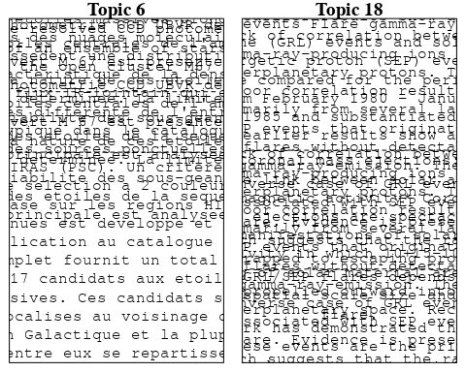

# Calculate and plot the correlation between topics  
mod.out.corr <- topicCorr(Research_topics)  
plot(mod.out.corr, cex = 1.5)  
  
  
# For each topic  
for (topic_num in 1:45) {  
 # Plot the word cloud  
 cloud(Research_topics, topic = topic_num, scale = c(2, 0.25))  
}

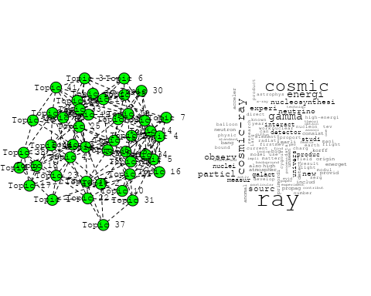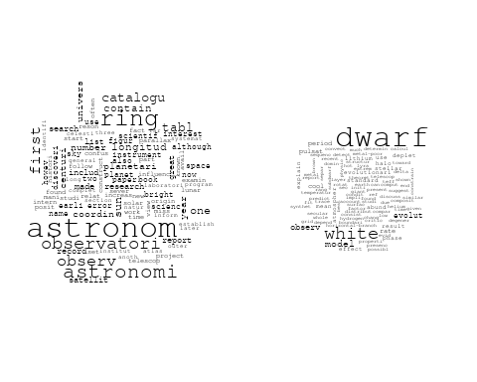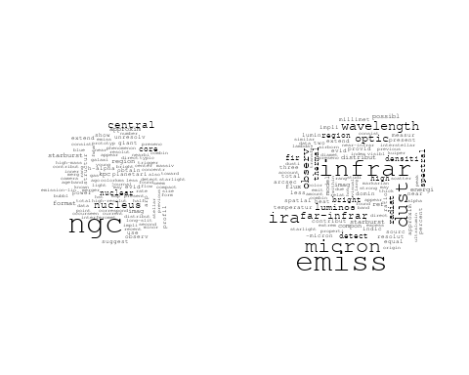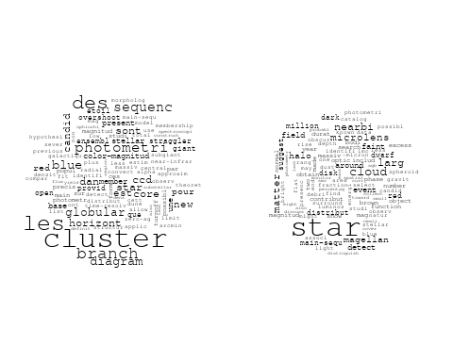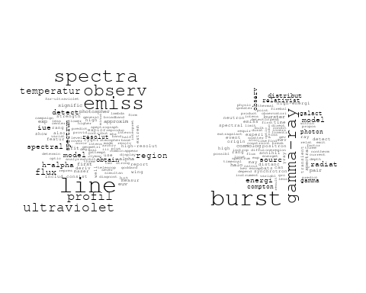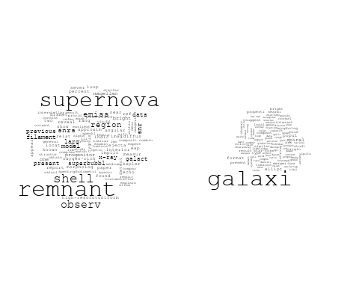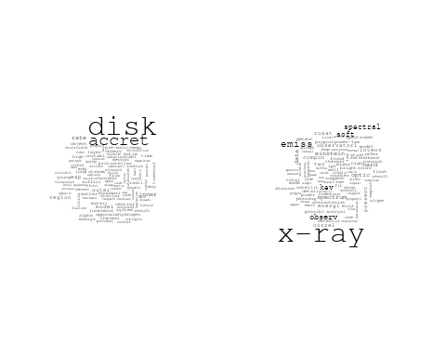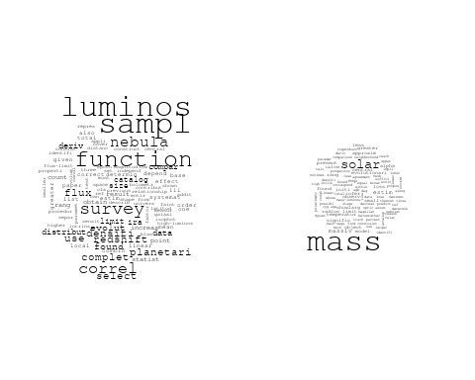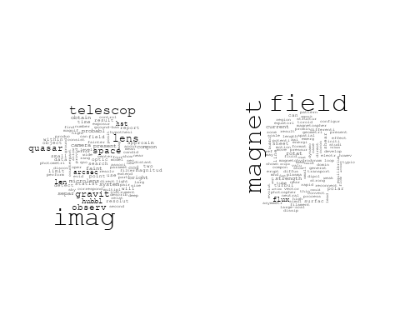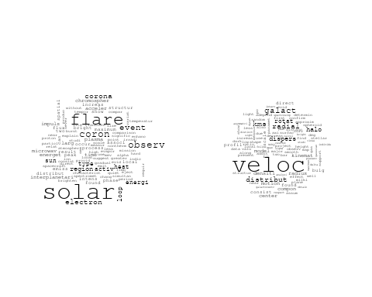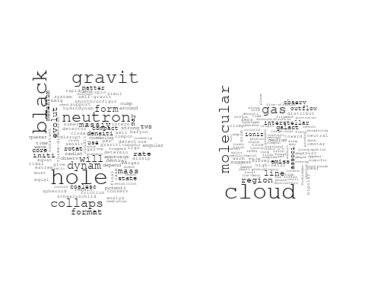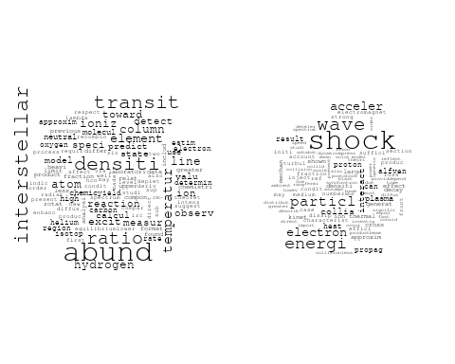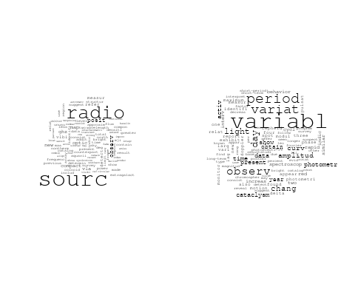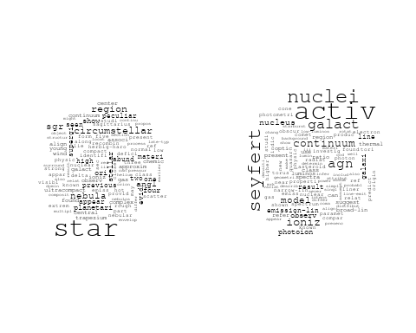

## Warning in wordcloud::wordcloud(words = vocab, freq = vec, max.words =  
## max.words, : measur could not be fit on page. It will not be plotted.

## Warning in wordcloud::wordcloud(words = vocab, freq = vec, max.words =  
## max.words, : method could not be fit on page. It will not be plotted.

## Warning in wordcloud::wordcloud(words = vocab, freq = vec, max.words =  
## max.words, : satellit could not be fit on page. It will not be plotted.

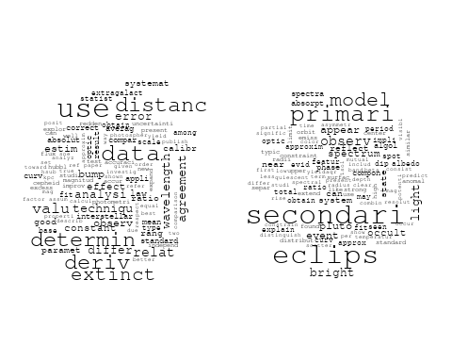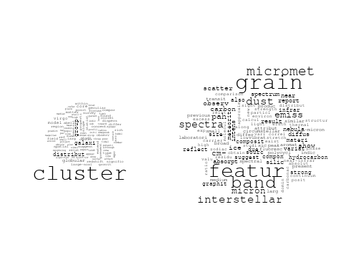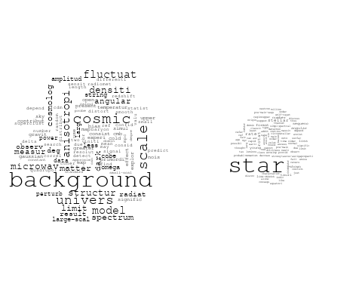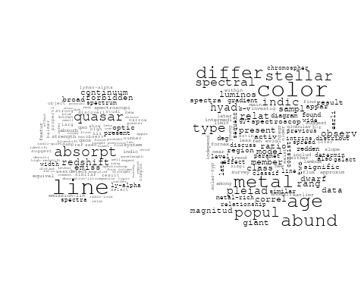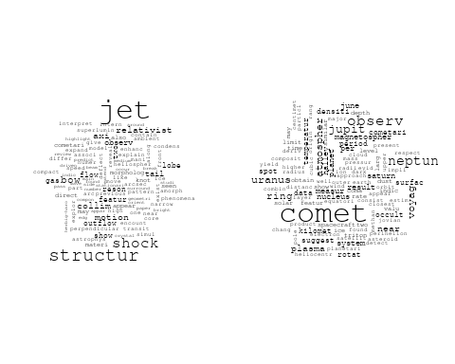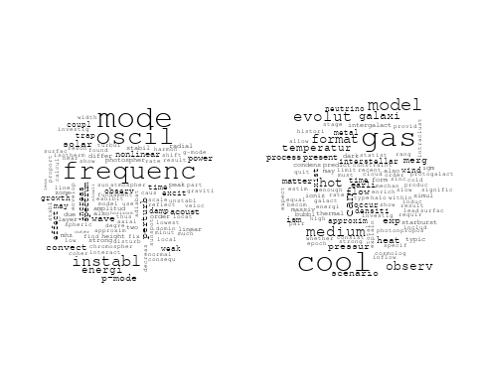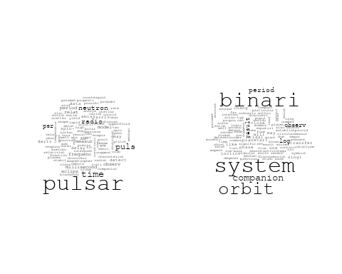

## Warning in wordcloud::wordcloud(words = vocab, freq = vec, max.words =  
## max.words, : present could not be fit on page. It will not be plotted.

## Warning in wordcloud::wordcloud(words = vocab, freq = vec, max.words =  
## max.words, : model could not be fit on page. It will not be plotted.

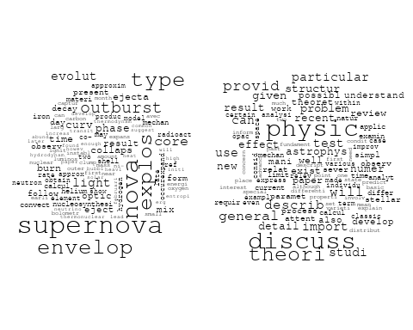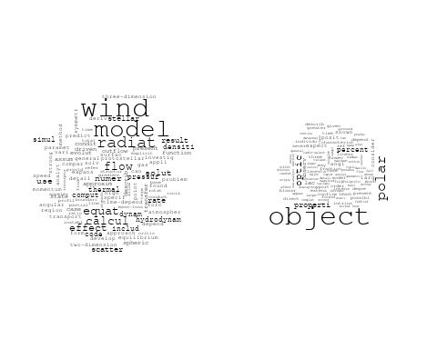

# Get the topic proportions for each document  
topic_proportions <- Research_topics$theta  
  
# Find the index of the topic with the highest proportion for each document  
# This will be the topic that each document is most likely to belong to  
max_topic_idx <- apply(topic_proportions, 1, which.max)  
  
# Add this as a new column to your data  
data_filtered$topic <- max_topic_idx  
  
  
  
# Create function to generate histogram  
make_histogram <- function(country_code) {  
   
 # Filter data for country with contribution of 100  
 data_100 <- data_filtered[data_filtered[[country_code]] == 100,]  
   
 # Filter data for country with contribution not equal to 0  
 data_not_0 <- data_filtered[data_filtered[[country_code]] != 0,]  
   
 # Make the first histogram  
 hist_100 <- ggplot(data_100, aes(x = topic)) +  
 geom_histogram(binwidth = 1, fill = "blue", color = "black") +  
 xlab("Topic") +  
 ylab("Count") +  
 ggtitle(paste(country_code, "Independent Contribution"))  
   
 # Make the second histogram  
 hist_not_0 <- ggplot(data_not_0, aes(x = topic)) +  
 geom_histogram(binwidth = 1, fill = "blue", color = "black") +  
 xlab("Topic") +  
 ylab("Count") +  
 ggtitle(paste(country_code, "Contributions (with collaboration)"))  
   
 # Return list of plots  
 return(list(hist_100, hist_not_0))  
}

plots <- make_histogram("US")  
print(plots[[1]])

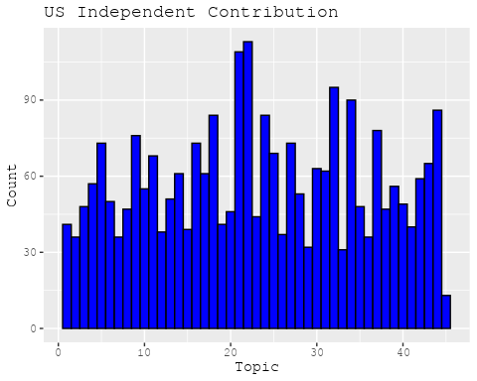

print(plots[[2]])

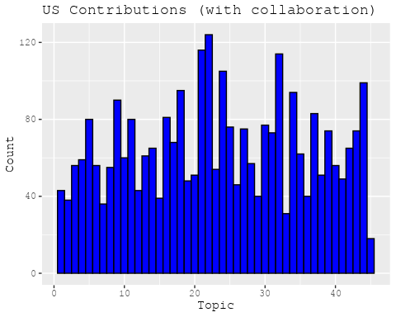

plots <- make_histogram("GB")  
print(plots[[1]])

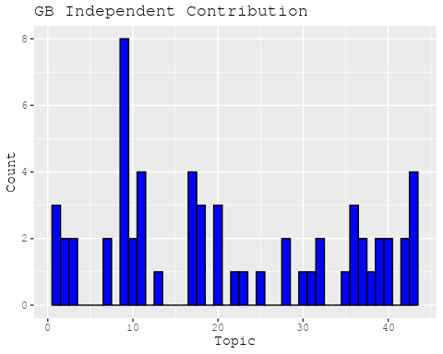

print(plots[[2]])

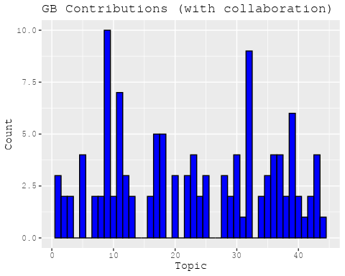

plots <- make_histogram("DE")  
print(plots[[1]])

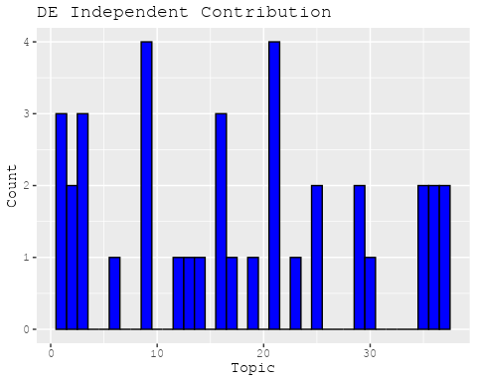

print(plots[[2]])

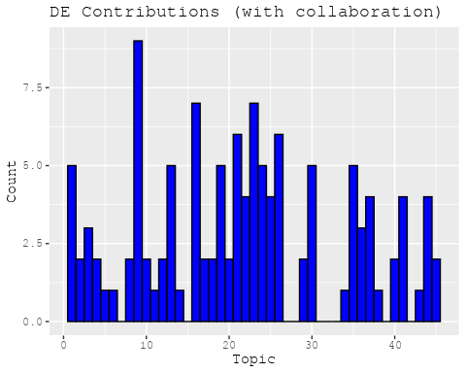

plots <- make_histogram("IT")  
print(plots[[1]])

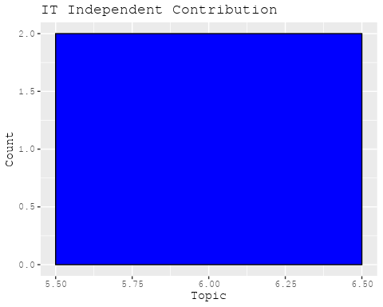

print(plots[[2]])

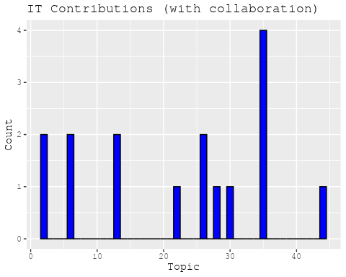

plots <- make_histogram("AU")  
print(plots[[1]])

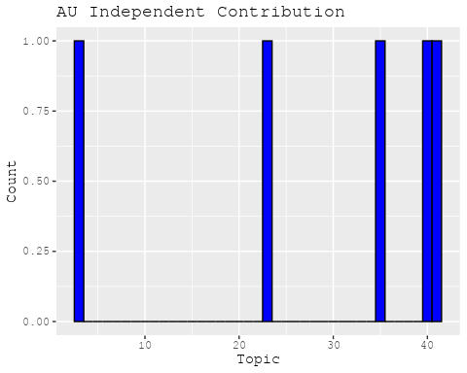

print(plots[[2]])

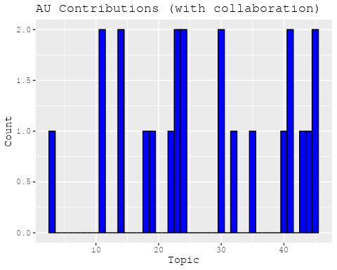

plots <- make_histogram("CA")  
print(plots[[1]])

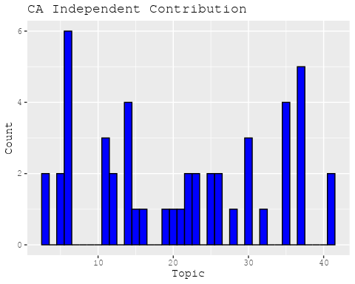

print(plots[[2]])

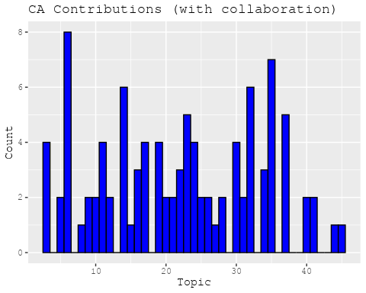

plots <- make_histogram("JP")  
print(plots[[1]])

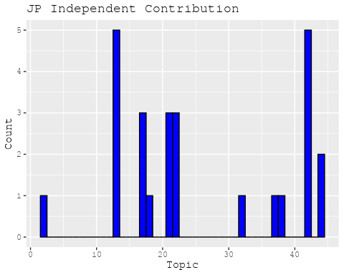

print(plots[[2]])

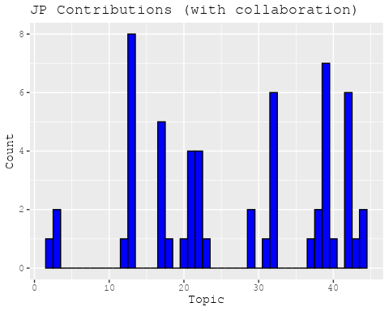

plots <- make_histogram("CN")  
print(plots[[1]])

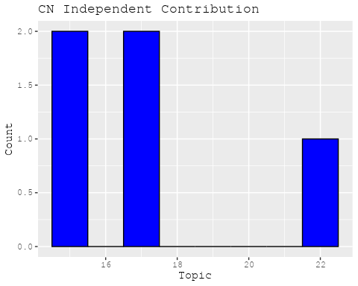

print(plots[[2]])

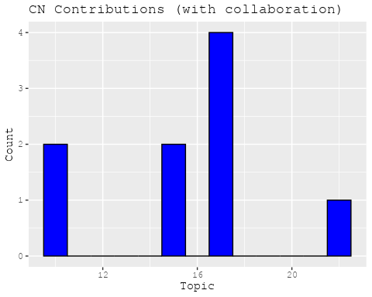

plots <- make_histogram("NL")  
print(plots[[1]])

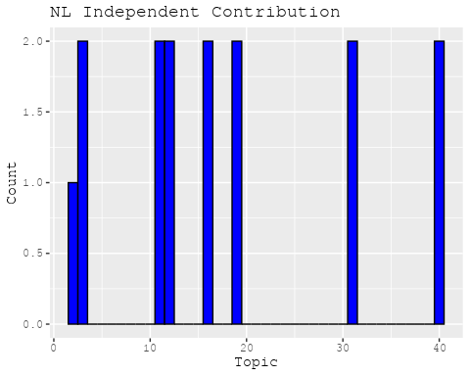

print(plots[[2]])

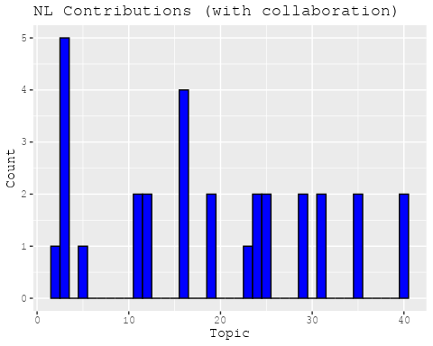

plots <- make_histogram("FR")  
print(plots[[1]])

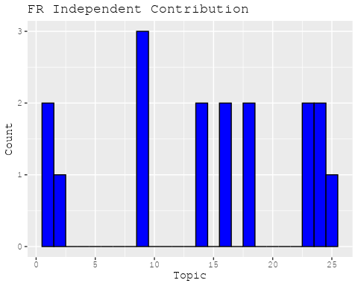

print(plots[[2]])

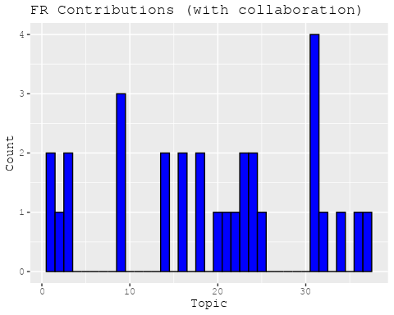

plots <- make_histogram("RU")  
print(plots[[1]])

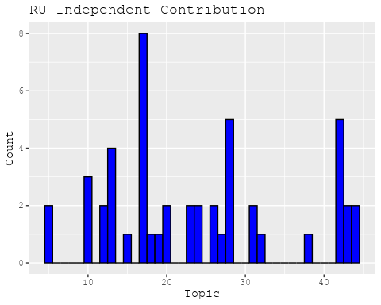

print(plots[[2]])

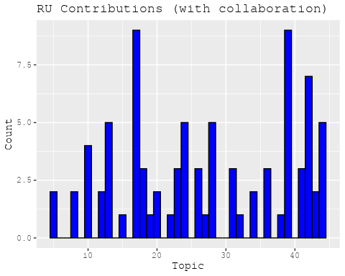

plots <- make_histogram("ES")  
print(plots[[1]])

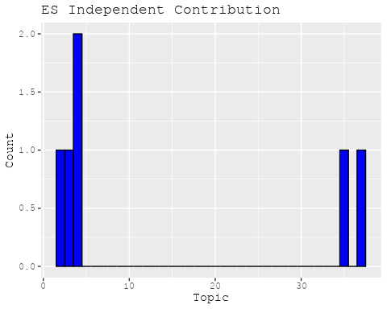

print(plots[[2]])

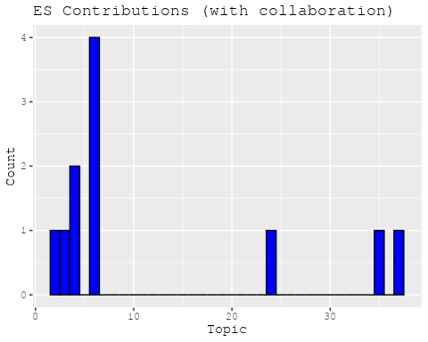

plots <- make_histogram("IN")  
print(plots[[1]])

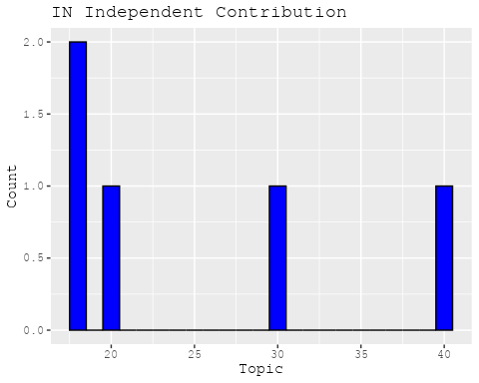

print(plots[[2]])

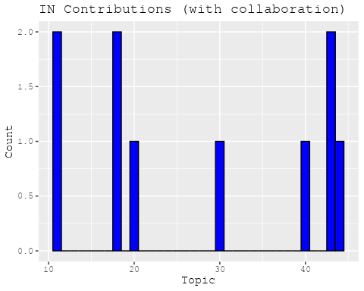

plots <- make_histogram("IL")  
print(plots[[1]])

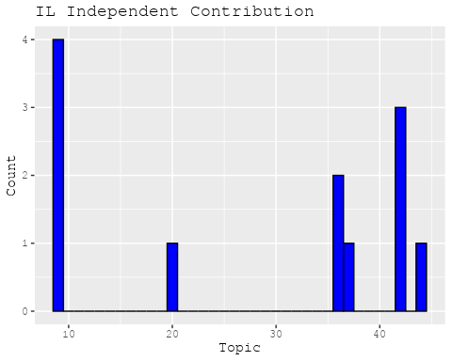

print(plots[[2]])

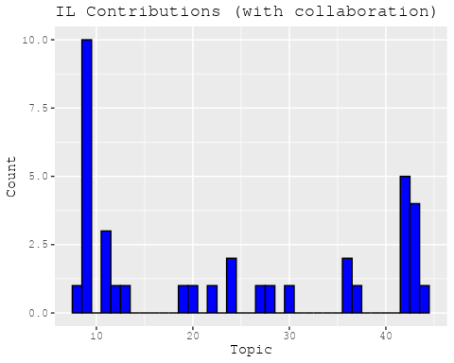

plots <- make_histogram("CH")  
print(plots[[1]])

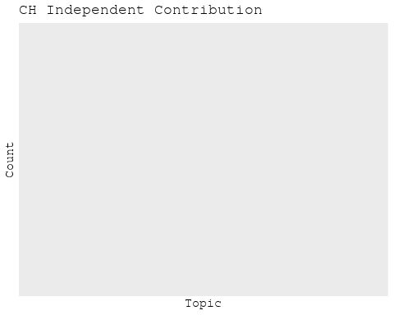

print(plots[[2]])

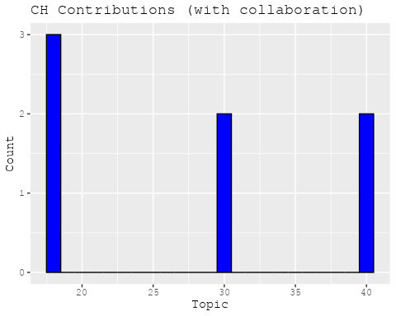

plots <- make_histogram("Americas")  
print(plots[[1]])

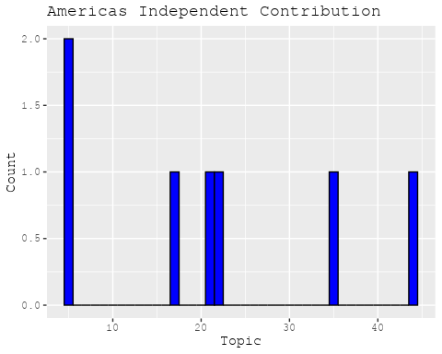

print(plots[[2]])

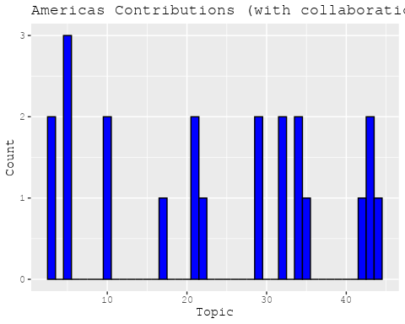

plots <- make_histogram("Europe")  
print(plots[[1]])

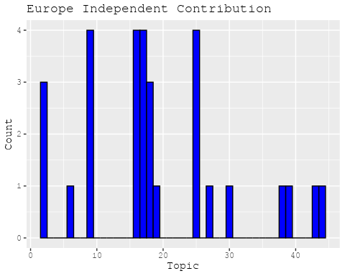

print(plots[[2]])

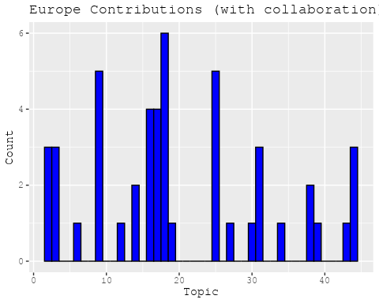

plots <- make_histogram("Africa")  
print(plots[[1]])

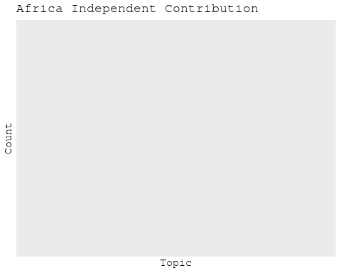

print(plots[[2]])

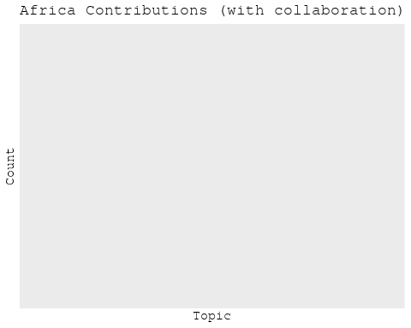

plots <- make_histogram("AsiaAndOceania")  
print(plots[[1]])



print(plots[[2]])

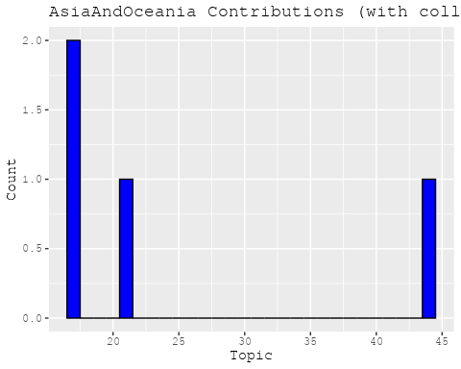

# Filter data for the publication interval 1975 to 1984  
data_filtered <- data[data[["pub_interval_1975_1984"]] == 1, ]  
  
# Save the original title data for future use  
data_filtered$original_concatenated_title_abstract <- data_filtered$concatenated_title_abstract  
  
#pre-processing the titles using textProcessor from the stm package  
processed_text <- textProcessor(data_filtered$concatenated_title_abstract, metadata = data_filtered)

## Building corpus...   
## Converting to Lower Case...   
## Removing punctuation...   
## Removing stopwords...   
## Removing numbers...   
## Stemming...   
## Creating Output...

# Further prepare the data by removing low-frequency terms  
out_text <- prepDocuments(processed_text$documents, processed_text$vocab, processed_text$meta)

## Removing 2783 of 7936 terms (2783 of 113428 tokens) due to frequency   
## Your corpus now has 1842 documents, 5153 terms and 110645 tokens.

docs_text <- out_text$documents  
vocab_text <- out_text$vocab  
meta_text <- out_text$meta  
  
  
#Prepare data  
plotRemoved(processed_text$documents, lower.thresh = seq(1, 200, by = 100))

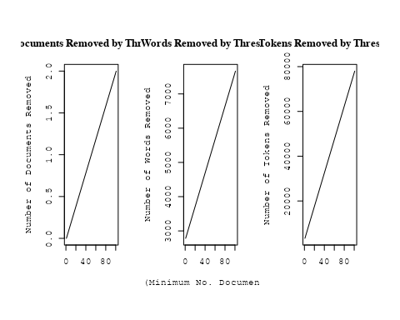

out_text <- prepDocuments(processed_text$documents, processed_text$vocab, processed_text$meta, lower.thresh = 8)

## Removing 6206 of 7936 terms (13722 of 113428 tokens) due to frequency   
## Your corpus now has 1842 documents, 1730 terms and 99706 tokens.

# Initialize an empty formula string  
prevalence_formula_str <- "~US "  
  
  
# Add each country variable to the formula string  
for (i in 10:27) {  
 prevalence_formula_str <- paste(prevalence_formula_str, "+", names(data)[i])  
}  
  
  
# Convert the string to a formula  
prevalence_formula <- as.formula(prevalence_formula_str)  
print(prevalence_formula)

## ~US + IN + DE + CH + GB + CN + FR + IT + RU + CA + NL + AU +   
## JP + ES + IL + Americas + Europe + Africa + AsiaAndOceania

# Run STM model  
Research_topics <- stm(documents = out_text$documents,   
 vocab = out_text$vocab,   
 K = 43,   
 prevalence = prevalence_formula,   
 data = out_text$meta,   
 init.type = "Spectral",  
 max.em.its = 1000,  
 gamma.prior = 'L1')

## Beginning Spectral Initialization   
## Calculating the gram matrix...  
## Finding anchor words...  
## ...........................................  
## Recovering initialization...  
## .................  
## Initialization complete.  
## ......................................................................................................  
## Completed E-Step (1 seconds).   
## Completed M-Step.   
## Completing Iteration 1 (approx. per word bound = -6.400)   
## ......................................................................................................  
## Completed E-Step (1 seconds).   
## Completed M-Step.   
## Completing Iteration 2 (approx. per word bound = -6.170, relative change = 3.592e-02)   
## ......................................................................................................  
## Completed E-Step (1 seconds).   
## Completed M-Step.   
## Completing Iteration 3 (approx. per word bound = -6.101, relative change = 1.105e-02)   
## ......................................................................................................  
## Completed E-Step (1 seconds).   
## Completed M-Step.   
## Completing Iteration 4 (approx. per word bound = -6.070, relative change = 5.136e-03)   
## ......................................................................................................  
## Completed E-Step (1 seconds).   
## Completed M-Step.   
## Completing Iteration 5 (approx. per word bound = -6.052, relative change = 2.911e-03)   
## Topic 1: uniqu, magnitud, nebula, disk, near   
## Topic 2: relat, abund, measur, veloc, use   
## Topic 3: astronomi, telescop, use, structur, time   
## Topic 4: transit, observ, temperatur, line, region   
## Topic 5: planet, uranus, saturn, meteorit, observ   
## Topic 6: background, cosmolog, densiti, radiat, evolut   
## Topic 7: predict, data, model, profil, fit   
## Topic 8: plane, densiti, solar, distanc, veloc   
## Topic 9: star, neutron, mass, stellar, accret   
## Topic 10: pulsar, x-ray, kev, energi, observ   
## Topic 11: ray, cosmic, energi, gamma, cosmic-ray   
## Topic 12: implic, flare, microwav, background, observ   
## Topic 13: radio, sourc, optic, observ, jet   
## Topic 14: orbit, ring, disk, satellit, saturn   
## Topic 15: x-ray, star, flare, emiss, soft   
## Topic 16: star, interstellar, observ, line, hydrogen   
## Topic 17: sourc, detect, nebula, cloud, survey   
## Topic 18: sup, approx, cmsup, densiti, ssup   
## Topic 19: quasar, object, observ, variabl, x-ray   
## Topic 20: binari, system, period, mass, companion   
## Topic 21: comet, dust, observ, product, tail   
## Topic 22: galaxi, cluster, luminos, format, bright   
## Topic 23: calcul, rate, radiat, excit, temperatur   
## Topic 24: rotat, convect, veloc, effect, star   
## Topic 25: x-ray, sourc, cluster, emiss, observ   
## Topic 26: energi, electron, radiat, distribut, model   
## Topic 27: magnet, coron, loop, energi, field   
## Topic 28: observ, compon, sourc, rang, period   
## Topic 29: star, will, orion, nebula, observ   
## Topic 30: cloud, gas, molecular, interstellar, densiti   
## Topic 31: mass, gravit, hole, disk, model   
## Topic 32: line, emiss, veloc, region, iii   
## Topic 33: solar, observ, variat, period, measur   
## Topic 34: line, observ, spectra, model, intens   
## Topic 35: nebula, motion, observ, spiral, intern   
## Topic 36: emiss, region, sourc, far-infrar, map   
## Topic 37: burst, x-ray, observ, sourc, time   
## Topic 38: field, magnet, solar, region, model   
## Topic 39: micron, spectra, infrar, observ, atmospher   
## Topic 40: supernova, shock, wave, remnant, explos   
## Topic 41: star, luminos, stellar, type, emiss   
## Topic 42: voyag, jupit, plasma, observ, magnetospher   
## Topic 43: hercul, contain, galaxi, cluster, depth   
## ......................................................................................................  
## Completed E-Step (1 seconds).   
## Completed M-Step.   
## Completing Iteration 6 (approx. per word bound = -6.042, relative change = 1.669e-03)   
## ......................................................................................................  
## Completed E-Step (1 seconds).   
## Completed M-Step.   
## Completing Iteration 7 (approx. per word bound = -6.036, relative change = 1.011e-03)   
## ......................................................................................................  
## Completed E-Step (1 seconds).   
## Completed M-Step.   
## Completing Iteration 8 (approx. per word bound = -6.032, relative change = 7.087e-04)   
## ......................................................................................................  
## Completed E-Step (1 seconds).   
## Completed M-Step.   
## Completing Iteration 9 (approx. per word bound = -6.028, relative change = 5.905e-04)   
## ......................................................................................................  
## Completed E-Step (1 seconds).   
## Completed M-Step.   
## Completing Iteration 10 (approx. per word bound = -6.026, relative change = 4.558e-04)   
## Topic 1: uniqu, disk, magnitud, nebula, near   
## Topic 2: relat, abund, measur, veloc, ratio   
## Topic 3: telescop, astronomi, time, new, astronom   
## Topic 4: transit, temperatur, observ, region, sub   
## Topic 5: planet, saturn, uranus, observ, jupit   
## Topic 6: background, cosmolog, densiti, univers, radiat   
## Topic 7: predict, model, data, profil, fit   
## Topic 8: plane, solar, densiti, distanc, veloc   
## Topic 9: star, mass, neutron, stellar, evolut   
## Topic 10: pulsar, kev, x-ray, energi, observ   
## Topic 11: ray, cosmic, energi, particl, gamma   
## Topic 12: flare, solar, implic, x-ray, microwav   
## Topic 13: radio, sourc, optic, observ, jet   
## Topic 14: ring, orbit, disk, satellit, saturn   
## Topic 15: x-ray, star, emiss, flare, soft   
## Topic 16: star, interstellar, observ, line, hydrogen   
## Topic 17: sourc, detect, nebula, survey, supernova   
## Topic 18: sup, approx, cmsup, ssup, densiti   
## Topic 19: quasar, object, variabl, observ, power   
## Topic 20: binari, system, period, mass, companion   
## Topic 21: comet, dust, observ, product, nucleus   
## Topic 22: galaxi, cluster, luminos, format, spiral   
## Topic 23: calcul, rate, radiat, estim, model   
## Topic 24: rotat, convect, veloc, effect, instabl   
## Topic 25: x-ray, sourc, cluster, emiss, observ   
## Topic 26: electron, distribut, energi, model, radiat   
## Topic 27: coron, loop, magnet, energi, heat   
## Topic 28: observ, compon, sourc, measur, data   
## Topic 29: star, will, orion, maser, nebula   
## Topic 30: cloud, gas, molecular, interstellar, densiti   
## Topic 31: mass, disk, gravit, hole, model   
## Topic 32: line, emiss, veloc, region, observ   
## Topic 33: solar, observ, period, variat, rotat   
## Topic 34: line, observ, spectra, region, intens   
## Topic 35: nebula, motion, spiral, intern, observ   
## Topic 36: emiss, region, sourc, far-infrar, infrar   
## Topic 37: burst, x-ray, event, observ, sourc   
## Topic 38: field, magnet, solar, region, gauss   
## Topic 39: micron, spectra, atmospher, infrar, observ   
## Topic 40: supernova, wave, shock, remnant, explos   
## Topic 41: star, luminos, stellar, type, wind   
## Topic 42: voyag, jupit, magnetospher, observ, plasma   
## Topic 43: contain, hercul, galaxi, structur, depth   
## ......................................................................................................  
## Completed E-Step (1 seconds).   
## Completed M-Step.   
## Completing Iteration 11 (approx. per word bound = -6.023, relative change = 4.008e-04)   
## ......................................................................................................  
## Completed E-Step (1 seconds).   
## Completed M-Step.   
## Completing Iteration 12 (approx. per word bound = -6.021, relative change = 3.625e-04)   
## ......................................................................................................  
## Completed E-Step (1 seconds).   
## Completed M-Step.   
## Completing Iteration 13 (approx. per word bound = -6.019, relative change = 3.135e-04)   
## ......................................................................................................  
## Completed E-Step (1 seconds).   
## Completed M-Step.   
## Completing Iteration 14 (approx. per word bound = -6.017, relative change = 2.944e-04)   
## ......................................................................................................  
## Completed E-Step (1 seconds).   
## Completed M-Step.   
## Completing Iteration 15 (approx. per word bound = -6.016, relative change = 2.719e-04)   
## Topic 1: uniqu, disk, circular, star, nebula   
## Topic 2: relat, measur, abund, veloc, valu   
## Topic 3: telescop, astronomi, new, time, astronom   
## Topic 4: transit, temperatur, observ, region, coron   
## Topic 5: planet, saturn, jupit, observ, albedo   
## Topic 6: background, cosmolog, densiti, univers, radiat   
## Topic 7: model, predict, data, profil, use   
## Topic 8: solar, densiti, plane, distanc, veloc   
## Topic 9: star, mass, neutron, stellar, evolut   
## Topic 10: pulsar, kev, x-ray, observ, energi   
## Topic 11: ray, cosmic, particl, energi, acceler   
## Topic 12: flare, x-ray, solar, hard, observ   
## Topic 13: radio, sourc, optic, observ, jet   
## Topic 14: ring, orbit, satellit, disk, saturn   
## Topic 15: x-ray, star, emiss, soft, observ   
## Topic 16: star, interstellar, observ, hydrogen, line   
## Topic 17: sourc, detect, nebula, supernova, survey   
## Topic 18: sup, approx, cmsup, ssup, densiti   
## Topic 19: quasar, object, variabl, observ, power   
## Topic 20: binari, system, period, observ, companion   
## Topic 21: comet, dust, observ, product, nucleus   
## Topic 22: galaxi, cluster, luminos, format, bright   
## Topic 23: calcul, rate, radiat, estim, model   
## Topic 24: rotat, convect, veloc, effect, instabl   
## Topic 25: x-ray, sourc, cluster, emiss, observ   
## Topic 26: electron, distribut, energi, model, radiat   
## Topic 27: coron, loop, heat, energi, magnet   
## Topic 28: observ, compon, sourc, measur, rang   
## Topic 29: star, will, maser, orion, observ   
## Topic 30: cloud, gas, molecular, interstellar, densiti   
## Topic 31: mass, disk, accret, gravit, model   
## Topic 32: line, emiss, veloc, observ, region   
## Topic 33: solar, observ, period, variat, rotat   
## Topic 34: line, observ, spectra, intens, region   
## Topic 35: nebula, motion, intern, spiral, observ   
## Topic 36: emiss, region, sourc, infrar, far-infrar   
## Topic 37: burst, x-ray, event, sourc, observ   
## Topic 38: field, magnet, region, solar, line   
## Topic 39: spectra, micron, atmospher, infrar, featur   
## Topic 40: supernova, shock, wave, explos, remnant   
## Topic 41: star, luminos, type, stellar, wind   
## Topic 42: voyag, jupit, magnetospher, plasma, observ   
## Topic 43: hercul, contain, galaxi, structur, cluster   
## ......................................................................................................  
## Completed E-Step (1 seconds).   
## Completed M-Step.   
## Completing Iteration 16 (approx. per word bound = -6.014, relative change = 2.621e-04)   
## ......................................................................................................  
## Completed E-Step (1 seconds).   
## Completed M-Step.   
## Completing Iteration 17 (approx. per word bound = -6.013, relative change = 2.364e-04)   
## ......................................................................................................  
## Completed E-Step (1 seconds).   
## Completed M-Step.   
## Completing Iteration 18 (approx. per word bound = -6.012, relative change = 2.098e-04)   
## ......................................................................................................  
## Completed E-Step (1 seconds).   
## Completed M-Step.   
## Completing Iteration 19 (approx. per word bound = -6.010, relative change = 1.856e-04)   
## ......................................................................................................  
## Completed E-Step (1 seconds).   
## Completed M-Step.   
## Completing Iteration 20 (approx. per word bound = -6.009, relative change = 1.613e-04)   
## Topic 1: uniqu, disk, circular, star, near   
## Topic 2: relat, measur, valu, veloc, abund   
## Topic 3: telescop, astronomi, new, imag, time   
## Topic 4: transit, temperatur, region, observ, coron   
## Topic 5: planet, saturn, jupit, observ, mix   
## Topic 6: background, cosmolog, densiti, univers, radiat   
## Topic 7: model, predict, data, profil, use   
## Topic 8: solar, densiti, plane, wind, veloc   
## Topic 9: star, mass, neutron, stellar, loss   
## Topic 10: pulsar, kev, x-ray, observ, energi   
## Topic 11: ray, particl, cosmic, energi, acceler   
## Topic 12: flare, x-ray, solar, hard, observ   
## Topic 13: radio, sourc, optic, observ, jet   
## Topic 14: ring, orbit, satellit, saturn, disk   
## Topic 15: x-ray, star, emiss, soft, detect   
## Topic 16: star, interstellar, observ, hydrogen, copernicus   
## Topic 17: sourc, detect, nebula, survey, supernova   
## Topic 18: sup, approx, cmsup, ssup, densiti   
## Topic 19: quasar, object, variabl, observ, power   
## Topic 20: binari, system, period, observ, companion   
## Topic 21: comet, dust, observ, product, nucleus   
## Topic 22: galaxi, cluster, luminos, format, spiral   
## Topic 23: calcul, rate, radiat, estim, model   
## Topic 24: rotat, convect, veloc, effect, instabl   
## Topic 25: x-ray, sourc, cluster, emiss, observ   
## Topic 26: electron, distribut, energi, model, radiat   
## Topic 27: coron, loop, heat, energi, flux   
## Topic 28: observ, compon, sourc, measur, rang   
## Topic 29: star, will, maser, orion, observ   
## Topic 30: cloud, gas, molecular, interstellar, densiti   
## Topic 31: disk, accret, mass, model, gravit   
## Topic 32: line, emiss, veloc, observ, continuum   
## Topic 33: solar, observ, period, variat, rotat   
## Topic 34: line, observ, spectra, intens, ratio   
## Topic 35: nebula, motion, spiral, intern, observ   
## Topic 36: emiss, region, sourc, infrar, far-infrar   
## Topic 37: burst, event, x-ray, sourc, observ   
## Topic 38: field, magnet, region, solar, line   
## Topic 39: spectra, micron, atmospher, infrar, featur   
## Topic 40: supernova, shock, wave, explos, remnant   
## Topic 41: star, luminos, type, stellar, wind   
## Topic 42: voyag, jupit, magnetospher, plasma, observ   
## Topic 43: hercul, galaxi, contain, structur, cluster   
## ......................................................................................................  
## Completed E-Step (1 seconds).   
## Completed M-Step.   
## Completing Iteration 21 (approx. per word bound = -6.008, relative change = 1.706e-04)   
## ......................................................................................................  
## Completed E-Step (1 seconds).   
## Completed M-Step.   
## Completing Iteration 22 (approx. per word bound = -6.007, relative change = 1.538e-04)   
## ......................................................................................................  
## Completed E-Step (1 seconds).   
## Completed M-Step.   
## Completing Iteration 23 (approx. per word bound = -6.007, relative change = 1.416e-04)   
## ......................................................................................................  
## Completed E-Step (1 seconds).   
## Completed M-Step.   
## Completing Iteration 24 (approx. per word bound = -6.006, relative change = 1.400e-04)   
## ......................................................................................................  
## Completed E-Step (1 seconds).   
## Completed M-Step.   
## Completing Iteration 25 (approx. per word bound = -6.005, relative change = 1.259e-04)   
## Topic 1: uniqu, disk, circular, star, near   
## Topic 2: relat, measur, valu, veloc, mean   
## Topic 3: telescop, astronomi, imag, new, time   
## Topic 4: transit, temperatur, region, observ, solar   
## Topic 5: planet, saturn, jupit, observ, solar   
## Topic 6: background, cosmolog, densiti, univers, radiat   
## Topic 7: model, predict, data, profil, use   
## Topic 8: solar, wind, densiti, plane, veloc   
## Topic 9: star, mass, neutron, stellar, loss   
## Topic 10: pulsar, kev, observ, x-ray, energi   
## Topic 11: ray, particl, cosmic, energi, acceler   
## Topic 12: flare, x-ray, hard, solar, observ   
## Topic 13: radio, sourc, optic, observ, jet   
## Topic 14: ring, orbit, satellit, saturn, disk   
## Topic 15: x-ray, star, emiss, soft, detect   
## Topic 16: star, interstellar, observ, hydrogen, copernicus   
## Topic 17: nebula, detect, sourc, survey, supernova   
## Topic 18: sup, approx, cmsup, ssup, densiti   
## Topic 19: quasar, object, variabl, observ, luminos   
## Topic 20: binari, system, period, observ, companion   
## Topic 21: comet, dust, observ, product, nucleus   
## Topic 22: galaxi, cluster, luminos, format, spiral   
## Topic 23: calcul, rate, radiat, estim, result   
## Topic 24: rotat, convect, veloc, effect, instabl   
## Topic 25: x-ray, sourc, cluster, emiss, observ   
## Topic 26: electron, energi, distribut, model, spectrum   
## Topic 27: coron, loop, heat, energi, flux   
## Topic 28: observ, compon, sourc, measur, rang   
## Topic 29: star, will, maser, orion, observ   
## Topic 30: cloud, gas, molecular, interstellar, region   
## Topic 31: accret, disk, model, gravit, hole   
## Topic 32: line, emiss, continuum, observ, absorpt   
## Topic 33: solar, observ, period, variat, rotat   
## Topic 34: line, observ, intens, spectra, ratio   
## Topic 35: nebula, intern, spiral, motion, observ   
## Topic 36: emiss, region, sourc, infrar, far-infrar   
## Topic 37: burst, event, x-ray, sourc, observ   
## Topic 38: field, magnet, region, line, solar   
## Topic 39: spectra, micron, atmospher, featur, infrar   
## Topic 40: supernova, shock, wave, explos, remnant   
## Topic 41: star, luminos, type, stellar, wind   
## Topic 42: voyag, jupit, magnetospher, observ, plasma   
## Topic 43: hercul, galaxi, contain, cluster, structur   
## ......................................................................................................  
## Completed E-Step (1 seconds).   
## Completed M-Step.   
## Completing Iteration 26 (approx. per word bound = -6.004, relative change = 1.261e-04)   
## ......................................................................................................  
## Completed E-Step (1 seconds).   
## Completed M-Step.   
## Completing Iteration 27 (approx. per word bound = -6.004, relative change = 1.086e-04)   
## ......................................................................................................  
## Completed E-Step (1 seconds).   
## Completed M-Step.   
## Completing Iteration 28 (approx. per word bound = -6.003, relative change = 1.028e-04)   
## ......................................................................................................  
## Completed E-Step (1 seconds).   
## Completed M-Step.   
## Completing Iteration 29 (approx. per word bound = -6.002, relative change = 9.958e-05)   
## ......................................................................................................  
## Completed E-Step (1 seconds).   
## Completed M-Step.   
## Completing Iteration 30 (approx. per word bound = -6.002, relative change = 1.068e-04)   
## Topic 1: uniqu, disk, circular, star, near   
## Topic 2: relat, measur, valu, distanc, veloc   
## Topic 3: telescop, astronomi, imag, new, time   
## Topic 4: transit, temperatur, region, observ, solar   
## Topic 5: planet, saturn, jupit, observ, solar   
## Topic 6: background, cosmolog, densiti, univers, radiat   
## Topic 7: model, predict, data, profil, use   
## Topic 8: solar, wind, densiti, plane, veloc   
## Topic 9: star, mass, neutron, stellar, loss   
## Topic 10: pulsar, kev, observ, x-ray, energi   
## Topic 11: ray, particl, cosmic, energi, acceler   
## Topic 12: flare, x-ray, hard, solar, observ   
## Topic 13: radio, sourc, optic, observ, jet   
## Topic 14: ring, orbit, satellit, saturn, disk   
## Topic 15: x-ray, star, emiss, soft, detect   
## Topic 16: interstellar, star, observ, hydrogen, copernicus   
## Topic 17: nebula, detect, planetari, supernova, survey   
## Topic 18: sup, approx, cmsup, ssup, densiti   
## Topic 19: quasar, object, variabl, observ, luminos   
## Topic 20: binari, system, period, observ, companion   
## Topic 21: comet, dust, observ, product, nucleus   
## Topic 22: galaxi, cluster, luminos, format, spiral   
## Topic 23: calcul, rate, radiat, estim, result   
## Topic 24: rotat, convect, effect, veloc, instabl   
## Topic 25: x-ray, sourc, cluster, emiss, observ   
## Topic 26: electron, energi, model, distribut, spectrum   
## Topic 27: coron, loop, heat, energi, flux   
## Topic 28: observ, compon, sourc, measur, vlbi   
## Topic 29: star, will, maser, orion, observ   
## Topic 30: cloud, gas, molecular, interstellar, region   
## Topic 31: accret, disk, model, gravit, hole   
## Topic 32: line, emiss, continuum, absorpt, observ   
## Topic 33: solar, observ, period, variat, rotat   
## Topic 34: line, observ, intens, ratio, spectra   
## Topic 35: nebula, intern, spiral, motion, observ   
## Topic 36: emiss, region, sourc, infrar, far-infrar   
## Topic 37: burst, event, x-ray, sourc, observ   
## Topic 38: field, magnet, region, line, solar   
## Topic 39: spectra, atmospher, micron, featur, observ   
## Topic 40: supernova, shock, explos, remnant, wave   
## Topic 41: star, luminos, type, stellar, wind   
## Topic 42: voyag, jupit, magnetospher, observ, plasma   
## Topic 43: hercul, galaxi, cluster, contain, superclust   
## ......................................................................................................  
## Completed E-Step (1 seconds).   
## Completed M-Step.   
## Completing Iteration 31 (approx. per word bound = -6.001, relative change = 1.022e-04)   
## ......................................................................................................  
## Completed E-Step (1 seconds).   
## Completed M-Step.   
## Completing Iteration 32 (approx. per word bound = -6.001, relative change = 9.352e-05)   
## ......................................................................................................  
## Completed E-Step (1 seconds).   
## Completed M-Step.   
## Completing Iteration 33 (approx. per word bound = -6.000, relative change = 8.686e-05)   
## ......................................................................................................  
## Completed E-Step (1 seconds).   
## Completed M-Step.   
## Completing Iteration 34 (approx. per word bound = -6.000, relative change = 7.588e-05)   
## ......................................................................................................  
## Completed E-Step (1 seconds).   
## Completed M-Step.   
## Completing Iteration 35 (approx. per word bound = -5.999, relative change = 6.424e-05)   
## Topic 1: uniqu, disk, circular, star, near   
## Topic 2: relat, measur, valu, distanc, veloc   
## Topic 3: telescop, astronomi, imag, new, time   
## Topic 4: temperatur, transit, region, coron, solar   
## Topic 5: planet, saturn, jupit, observ, solar   
## Topic 6: background, cosmolog, densiti, univers, radiat   
## Topic 7: model, predict, data, profil, use   
## Topic 8: wind, solar, densiti, veloc, plane   
## Topic 9: star, mass, neutron, stellar, loss   
## Topic 10: pulsar, kev, observ, energi, x-ray   
## Topic 11: ray, cosmic, particl, energi, acceler   
## Topic 12: flare, x-ray, hard, solar, observ   
## Topic 13: radio, sourc, optic, observ, jet   
## Topic 14: ring, orbit, satellit, saturn, disk   
## Topic 15: x-ray, star, emiss, soft, detect   
## Topic 16: interstellar, star, hydrogen, observ, copernicus   
## Topic 17: nebula, detect, planetari, supernova, survey   
## Topic 18: sup, approx, cmsup, ssup, densiti   
## Topic 19: quasar, object, variabl, observ, luminos   
## Topic 20: binari, system, period, companion, observ   
## Topic 21: comet, dust, observ, product, nucleus   
## Topic 22: galaxi, cluster, luminos, format, spiral   
## Topic 23: calcul, rate, radiat, estim, result   
## Topic 24: rotat, convect, effect, veloc, instabl   
## Topic 25: x-ray, sourc, cluster, emiss, observ   
## Topic 26: electron, energi, model, spectrum, distribut   
## Topic 27: coron, loop, heat, energi, wave   
## Topic 28: observ, compon, sourc, measur, vlbi   
## Topic 29: star, will, maser, orion, observ   
## Topic 30: cloud, gas, molecular, interstellar, region   
## Topic 31: accret, disk, model, hole, gravit   
## Topic 32: line, emiss, continuum, absorpt, observ   
## Topic 33: solar, observ, period, variat, rotat   
## Topic 34: line, observ, intens, ratio, spectra   
## Topic 35: nebula, intern, spiral, motion, observ   
## Topic 36: emiss, region, sourc, infrar, far-infrar   
## Topic 37: burst, event, x-ray, sourc, observ   
## Topic 38: field, magnet, region, line, surfac   
## Topic 39: spectra, atmospher, featur, micron, observ   
## Topic 40: supernova, shock, explos, remnant, wave   
## Topic 41: star, type, luminos, stellar, chromospher   
## Topic 42: voyag, jupit, magnetospher, observ, plasma   
## Topic 43: hercul, galaxi, cluster, superclust, contain   
## ......................................................................................................  
## Completed E-Step (1 seconds).   
## Completed M-Step.   
## Completing Iteration 36 (approx. per word bound = -5.999, relative change = 6.253e-05)   
## ......................................................................................................  
## Completed E-Step (1 seconds).   
## Completed M-Step.   
## Completing Iteration 37 (approx. per word bound = -5.998, relative change = 6.207e-05)   
## ......................................................................................................  
## Completed E-Step (1 seconds).   
## Completed M-Step.   
## Completing Iteration 38 (approx. per word bound = -5.998, relative change = 5.309e-05)   
## ......................................................................................................  
## Completed E-Step (1 seconds).   
## Completed M-Step.   
## Completing Iteration 39 (approx. per word bound = -5.998, relative change = 5.667e-05)   
## ......................................................................................................  
## Completed E-Step (1 seconds).   
## Completed M-Step.   
## Completing Iteration 40 (approx. per word bound = -5.997, relative change = 6.179e-05)   
## Topic 1: uniqu, disk, circular, star, near   
## Topic 2: relat, measur, distanc, valu, veloc   
## Topic 3: telescop, astronomi, imag, new, one   
## Topic 4: temperatur, transit, region, coron, solar   
## Topic 5: planet, saturn, observ, jupit, solar   
## Topic 6: background, cosmolog, densiti, univers, radiat   
## Topic 7: model, predict, data, profil, observ   
## Topic 8: wind, solar, densiti, veloc, plane   
## Topic 9: star, mass, neutron, stellar, loss   
## Topic 10: pulsar, kev, observ, energi, crab   
## Topic 11: ray, cosmic, particl, energi, acceler   
## Topic 12: flare, x-ray, hard, solar, observ   
## Topic 13: radio, sourc, optic, observ, jet   
## Topic 14: ring, orbit, satellit, saturn, disk   
## Topic 15: x-ray, star, emiss, soft, detect   
## Topic 16: interstellar, star, hydrogen, observ, copernicus   
## Topic 17: nebula, planetari, detect, supernova, survey   
## Topic 18: sup, approx, cmsup, ssup, densiti   
## Topic 19: quasar, object, variabl, observ, luminos   
## Topic 20: binari, system, period, companion, observ   
## Topic 21: comet, dust, observ, product, nucleus   
## Topic 22: galaxi, cluster, luminos, format, spiral   
## Topic 23: calcul, rate, radiat, result, estim   
## Topic 24: rotat, convect, effect, veloc, instabl   
## Topic 25: x-ray, sourc, cluster, emiss, observ   
## Topic 26: electron, energi, model, spectrum, distribut   
## Topic 27: coron, loop, heat, energi, wave   
## Topic 28: observ, compon, sourc, measur, vlbi   
## Topic 29: star, will, maser, orion, observ   
## Topic 30: cloud, gas, molecular, interstellar, region   
## Topic 31: accret, disk, model, hole, gravit   
## Topic 32: line, emiss, continuum, absorpt, observ   
## Topic 33: solar, observ, period, variat, rotat   
## Topic 34: line, observ, intens, ratio, iii   
## Topic 35: nebula, intern, spiral, motion, observ   
## Topic 36: emiss, region, sourc, infrar, far-infrar   
## Topic 37: burst, event, x-ray, sourc, observ   
## Topic 38: field, magnet, region, line, surfac   
## Topic 39: spectra, atmospher, featur, micron, observ   
## Topic 40: supernova, shock, explos, remnant, energi   
## Topic 41: star, type, luminos, stellar, chromospher   
## Topic 42: voyag, jupit, magnetospher, observ, plasma   
## Topic 43: hercul, galaxi, cluster, superclust, sampl   
## ......................................................................................................  
## Completed E-Step (1 seconds).   
## Completed M-Step.   
## Completing Iteration 41 (approx. per word bound = -5.997, relative change = 6.392e-05)   
## ......................................................................................................  
## Completed E-Step (1 seconds).   
## Completed M-Step.   
## Completing Iteration 42 (approx. per word bound = -5.997, relative change = 5.567e-05)   
## ......................................................................................................  
## Completed E-Step (1 seconds).   
## Completed M-Step.   
## Completing Iteration 43 (approx. per word bound = -5.996, relative change = 5.781e-05)   
## ......................................................................................................  
## Completed E-Step (1 seconds).   
## Completed M-Step.   
## Completing Iteration 44 (approx. per word bound = -5.996, relative change = 5.548e-05)   
## ......................................................................................................  
## Completed E-Step (1 seconds).   
## Completed M-Step.   
## Completing Iteration 45 (approx. per word bound = -5.996, relative change = 4.814e-05)   
## Topic 1: uniqu, disk, circular, star, near   
## Topic 2: relat, measur, distanc, valu, veloc   
## Topic 3: telescop, astronomi, imag, new, time   
## Topic 4: temperatur, transit, region, coron, solar   
## Topic 5: planet, saturn, observ, jupit, solar   
## Topic 6: background, cosmolog, univers, densiti, radiat   
## Topic 7: model, predict, data, profil, observ   
## Topic 8: wind, solar, densiti, veloc, interplanetari   
## Topic 9: star, mass, neutron, stellar, loss   
## Topic 10: pulsar, kev, observ, energi, crab   
## Topic 11: ray, cosmic, particl, energi, acceler   
## Topic 12: flare, x-ray, hard, solar, observ   
## Topic 13: radio, sourc, optic, observ, jet   
## Topic 14: ring, orbit, satellit, saturn, disk   
## Topic 15: x-ray, star, emiss, detect, soft   
## Topic 16: interstellar, star, hydrogen, observ, abund   
## Topic 17: nebula, planetari, detect, supernova, survey   
## Topic 18: sup, approx, cmsup, ssup, densiti   
## Topic 19: quasar, object, variabl, observ, luminos   
## Topic 20: binari, system, period, companion, observ   
## Topic 21: comet, dust, observ, product, nucleus   
## Topic 22: galaxi, cluster, luminos, format, spiral   
## Topic 23: calcul, rate, radiat, result, model   
## Topic 24: rotat, convect, effect, veloc, instabl   
## Topic 25: x-ray, sourc, cluster, emiss, observ   
## Topic 26: electron, energi, spectrum, model, distribut   
## Topic 27: coron, loop, heat, energi, wave   
## Topic 28: observ, compon, sourc, measur, vlbi   
## Topic 29: star, will, maser, orion, observ   
## Topic 30: cloud, gas, molecular, region, interstellar   
## Topic 31: accret, disk, model, hole, gravit   
## Topic 32: line, emiss, continuum, absorpt, observ   
## Topic 33: solar, observ, period, variat, rotat   
## Topic 34: line, observ, intens, ratio, iii   
## Topic 35: nebula, intern, spiral, motion, ref   
## Topic 36: emiss, region, infrar, sourc, far-infrar   
## Topic 37: burst, event, observ, x-ray, sourc   
## Topic 38: field, magnet, region, line, surfac   
## Topic 39: spectra, atmospher, featur, micron, observ   
## Topic 40: supernova, shock, explos, remnant, energi   
## Topic 41: star, type, luminos, stellar, chromospher   
## Topic 42: voyag, jupit, magnetospher, observ, plasma   
## Topic 43: hercul, galaxi, superclust, cluster, sampl   
## ......................................................................................................  
## Completed E-Step (1 seconds).   
## Completed M-Step.   
## Completing Iteration 46 (approx. per word bound = -5.996, relative change = 3.970e-05)   
## ......................................................................................................  
## Completed E-Step (1 seconds).   
## Completed M-Step.   
## Completing Iteration 47 (approx. per word bound = -5.995, relative change = 3.364e-05)   
## ......................................................................................................  
## Completed E-Step (1 seconds).   
## Completed M-Step.   
## Completing Iteration 48 (approx. per word bound = -5.995, relative change = 3.367e-05)   
## ......................................................................................................  
## Completed E-Step (1 seconds).   
## Completed M-Step.   
## Completing Iteration 49 (approx. per word bound = -5.995, relative change = 3.589e-05)   
## ......................................................................................................  
## Completed E-Step (1 seconds).   
## Completed M-Step.   
## Completing Iteration 50 (approx. per word bound = -5.995, relative change = 3.837e-05)   
## Topic 1: uniqu, disk, star, circular, near   
## Topic 2: relat, measur, distanc, valu, veloc   
## Topic 3: telescop, astronomi, imag, new, time   
## Topic 4: temperatur, transit, region, coron, solar   
## Topic 5: planet, saturn, observ, jupit, solar   
## Topic 6: background, cosmolog, univers, densiti, radiat   
## Topic 7: model, predict, data, profil, observ   
## Topic 8: wind, solar, densiti, veloc, interplanetari   
## Topic 9: star, mass, neutron, stellar, loss   
## Topic 10: pulsar, kev, observ, energi, crab   
## Topic 11: ray, particl, cosmic, energi, acceler   
## Topic 12: flare, x-ray, hard, solar, observ   
## Topic 13: radio, sourc, observ, optic, jet   
## Topic 14: ring, orbit, satellit, saturn, edg   
## Topic 15: x-ray, star, emiss, detect, soft   
## Topic 16: interstellar, star, hydrogen, observ, abund   
## Topic 17: nebula, planetari, detect, supernova, survey   
## Topic 18: sup, approx, cmsup, ssup, densiti   
## Topic 19: quasar, object, variabl, observ, luminos   
## Topic 20: binari, system, period, companion, mass   
## Topic 21: comet, dust, observ, product, nucleus   
## Topic 22: galaxi, cluster, luminos, format, spiral   
## Topic 23: calcul, rate, radiat, result, estim   
## Topic 24: rotat, convect, effect, veloc, instabl   
## Topic 25: x-ray, sourc, cluster, emiss, observ   
## Topic 26: electron, energi, spectrum, model, distribut   
## Topic 27: coron, loop, heat, energi, wave   
## Topic 28: observ, compon, sourc, measur, vlbi   
## Topic 29: star, will, maser, orion, observ   
## Topic 30: cloud, gas, molecular, region, interstellar   
## Topic 31: accret, disk, model, gravit, hole   
## Topic 32: line, emiss, continuum, absorpt, observ   
## Topic 33: solar, observ, period, variat, rotat   
## Topic 34: line, observ, intens, iii, ratio   
## Topic 35: nebula, intern, spiral, motion, ref   
## Topic 36: emiss, infrar, region, sourc, far-infrar   
## Topic 37: burst, event, observ, x-ray, sourc   
## Topic 38: field, magnet, region, line, surfac   
## Topic 39: spectra, atmospher, featur, micron, observ   
## Topic 40: supernova, shock, explos, remnant, energi   
## Topic 41: star, type, luminos, stellar, chromospher   
## Topic 42: voyag, jupit, magnetospher, observ, plasma   
## Topic 43: hercul, galaxi, superclust, cluster, sampl   
## ......................................................................................................  
## Completed E-Step (1 seconds).   
## Completed M-Step.   
## Completing Iteration 51 (approx. per word bound = -5.994, relative change = 4.065e-05)   
## ......................................................................................................  
## Completed E-Step (1 seconds).   
## Completed M-Step.   
## Completing Iteration 52 (approx. per word bound = -5.994, relative change = 4.213e-05)   
## ......................................................................................................  
## Completed E-Step (1 seconds).   
## Completed M-Step.   
## Completing Iteration 53 (approx. per word bound = -5.994, relative change = 3.837e-05)   
## ......................................................................................................  
## Completed E-Step (1 seconds).   
## Completed M-Step.   
## Completing Iteration 54 (approx. per word bound = -5.994, relative change = 3.168e-05)   
## ......................................................................................................  
## Completed E-Step (1 seconds).   
## Completed M-Step.   
## Completing Iteration 55 (approx. per word bound = -5.994, relative change = 3.673e-05)   
## Topic 1: uniqu, disk, star, circular, near   
## Topic 2: relat, measur, distanc, valu, veloc   
## Topic 3: telescop, astronomi, imag, new, time   
## Topic 4: temperatur, transit, region, coron, solar   
## Topic 5: planet, saturn, observ, jupit, solar   
## Topic 6: background, cosmolog, univers, radiat, densiti   
## Topic 7: model, predict, data, profil, observ   
## Topic 8: wind, solar, densiti, veloc, plane   
## Topic 9: star, mass, neutron, stellar, loss   
## Topic 10: pulsar, kev, observ, energi, crab   
## Topic 11: ray, particl, cosmic, energi, acceler   
## Topic 12: flare, x-ray, hard, solar, observ   
## Topic 13: radio, sourc, observ, optic, jet   
## Topic 14: ring, orbit, satellit, saturn, edg   
## Topic 15: x-ray, star, emiss, detect, soft   
## Topic 16: interstellar, star, hydrogen, abund, observ   
## Topic 17: nebula, planetari, detect, supernova, survey   
## Topic 18: sup, approx, cmsup, ssup, densiti   
## Topic 19: quasar, object, variabl, observ, luminos   
## Topic 20: binari, system, period, companion, mass   
## Topic 21: comet, dust, observ, product, nucleus   
## Topic 22: galaxi, cluster, luminos, format, spiral   
## Topic 23: calcul, rate, radiat, result, estim   
## Topic 24: rotat, convect, effect, veloc, instabl   
## Topic 25: x-ray, sourc, cluster, emiss, observ   
## Topic 26: electron, energi, spectrum, model, distribut   
## Topic 27: loop, coron, heat, energi, wave   
## Topic 28: observ, compon, sourc, measur, vlbi   
## Topic 29: star, will, maser, orion, observ   
## Topic 30: cloud, gas, molecular, region, interstellar   
## Topic 31: accret, disk, model, gravit, hole   
## Topic 32: line, emiss, continuum, absorpt, observ   
## Topic 33: solar, observ, period, variat, rotat   
## Topic 34: line, observ, intens, iii, ratio   
## Topic 35: nebula, intern, spiral, motion, ref   
## Topic 36: emiss, infrar, region, sourc, far-infrar   
## Topic 37: burst, event, observ, x-ray, sourc   
## Topic 38: field, magnet, region, line, surfac   
## Topic 39: spectra, atmospher, featur, micron, observ   
## Topic 40: supernova, shock, explos, remnant, shell   
## Topic 41: star, type, luminos, stellar, chromospher   
## Topic 42: voyag, jupit, magnetospher, plasma, observ   
## Topic 43: hercul, galaxi, superclust, cluster, sampl   
## ......................................................................................................  
## Completed E-Step (1 seconds).   
## Completed M-Step.   
## Completing Iteration 56 (approx. per word bound = -5.993, relative change = 3.423e-05)   
## ......................................................................................................  
## Completed E-Step (1 seconds).   
## Completed M-Step.   
## Completing Iteration 57 (approx. per word bound = -5.993, relative change = 3.378e-05)   
## ......................................................................................................  
## Completed E-Step (1 seconds).   
## Completed M-Step.   
## Completing Iteration 58 (approx. per word bound = -5.993, relative change = 3.259e-05)   
## ......................................................................................................  
## Completed E-Step (1 seconds).   
## Completed M-Step.   
## Completing Iteration 59 (approx. per word bound = -5.993, relative change = 3.082e-05)   
## ......................................................................................................  
## Completed E-Step (1 seconds).   
## Completed M-Step.   
## Completing Iteration 60 (approx. per word bound = -5.993, relative change = 2.768e-05)   
## Topic 1: uniqu, disk, star, circular, near   
## Topic 2: relat, measur, distanc, valu, veloc   
## Topic 3: telescop, astronomi, imag, new, time   
## Topic 4: temperatur, transit, region, coron, solar   
## Topic 5: planet, saturn, observ, jupit, solar   
## Topic 6: background, cosmolog, univers, radiat, densiti   
## Topic 7: model, predict, data, profil, observ   
## Topic 8: wind, solar, densiti, veloc, plane   
## Topic 9: star, mass, neutron, stellar, loss   
## Topic 10: pulsar, kev, observ, energi, crab   
## Topic 11: ray, cosmic, particl, energi, acceler   
## Topic 12: flare, x-ray, hard, solar, observ   
## Topic 13: radio, sourc, observ, optic, jet   
## Topic 14: ring, orbit, satellit, saturn, edg   
## Topic 15: x-ray, star, emiss, detect, soft   
## Topic 16: interstellar, star, hydrogen, abund, observ   
## Topic 17: nebula, planetari, detect, supernova, survey   
## Topic 18: sup, approx, cmsup, ssup, densiti   
## Topic 19: quasar, object, variabl, observ, luminos   
## Topic 20: binari, system, period, companion, mass   
## Topic 21: comet, dust, observ, product, nucleus   
## Topic 22: galaxi, cluster, luminos, format, spiral   
## Topic 23: calcul, rate, radiat, result, estim   
## Topic 24: rotat, convect, effect, veloc, instabl   
## Topic 25: x-ray, sourc, cluster, emiss, observ   
## Topic 26: electron, energi, spectrum, model, distribut   
## Topic 27: loop, coron, heat, energi, wave   
## Topic 28: observ, compon, sourc, measur, vlbi   
## Topic 29: star, will, maser, observ, orion   
## Topic 30: cloud, gas, molecular, region, format   
## Topic 31: accret, disk, model, gravit, hole   
## Topic 32: line, emiss, continuum, absorpt, observ   
## Topic 33: solar, observ, period, variat, rotat   
## Topic 34: line, observ, intens, iii, ratio   
## Topic 35: nebula, intern, spiral, motion, ref   
## Topic 36: emiss, infrar, region, sourc, far-infrar   
## Topic 37: burst, event, observ, x-ray, sourc   
## Topic 38: field, magnet, region, line, surfac   
## Topic 39: spectra, atmospher, featur, micron, observ   
## Topic 40: supernova, shock, explos, remnant, shell   
## Topic 41: star, type, luminos, stellar, chromospher   
## Topic 42: voyag, jupit, magnetospher, plasma, observ   
## Topic 43: hercul, galaxi, superclust, cluster, sampl   
## ......................................................................................................  
## Completed E-Step (1 seconds).   
## Completed M-Step.   
## Completing Iteration 61 (approx. per word bound = -5.992, relative change = 3.004e-05)   
## ......................................................................................................  
## Completed E-Step (1 seconds).   
## Completed M-Step.   
## Completing Iteration 62 (approx. per word bound = -5.992, relative change = 2.928e-05)   
## ......................................................................................................  
## Completed E-Step (1 seconds).   
## Completed M-Step.   
## Completing Iteration 63 (approx. per word bound = -5.992, relative change = 2.808e-05)   
## ......................................................................................................  
## Completed E-Step (1 seconds).   
## Completed M-Step.   
## Completing Iteration 64 (approx. per word bound = -5.992, relative change = 3.227e-05)   
## ......................................................................................................  
## Completed E-Step (1 seconds).   
## Completed M-Step.   
## Completing Iteration 65 (approx. per word bound = -5.992, relative change = 3.252e-05)   
## Topic 1: uniqu, disk, star, satellit, circular   
## Topic 2: relat, measur, distanc, veloc, mean   
## Topic 3: telescop, astronomi, imag, new, time   
## Topic 4: temperatur, transit, region, coron, solar   
## Topic 5: planet, saturn, observ, jupit, solar   
## Topic 6: background, cosmolog, univers, radiat, densiti   
## Topic 7: model, predict, data, profil, observ   
## Topic 8: wind, solar, densiti, veloc, plane   
## Topic 9: star, mass, neutron, stellar, loss   
## Topic 10: pulsar, kev, observ, energi, crab   
## Topic 11: ray, cosmic, particl, energi, acceler   
## Topic 12: flare, x-ray, hard, solar, observ   
## Topic 13: radio, sourc, observ, optic, jet   
## Topic 14: ring, orbit, satellit, saturn, edg   
## Topic 15: x-ray, star, emiss, detect, soft   
## Topic 16: interstellar, star, hydrogen, abund, densiti   
## Topic 17: nebula, planetari, detect, supernova, survey   
## Topic 18: sup, approx, cmsup, ssup, densiti   
## Topic 19: quasar, object, variabl, observ, luminos   
## Topic 20: binari, system, period, companion, mass   
## Topic 21: comet, dust, observ, product, nucleus   
## Topic 22: galaxi, cluster, luminos, format, spiral   
## Topic 23: calcul, rate, radiat, result, state   
## Topic 24: rotat, convect, effect, veloc, instabl   
## Topic 25: x-ray, sourc, cluster, emiss, observ   
## Topic 26: electron, energi, spectrum, model, distribut   
## Topic 27: loop, coron, heat, energi, wave   
## Topic 28: observ, compon, sourc, measur, vlbi   
## Topic 29: star, will, maser, observ, orion   
## Topic 30: cloud, gas, molecular, region, format   
## Topic 31: accret, disk, model, gravit, hole   
## Topic 32: line, emiss, continuum, absorpt, observ   
## Topic 33: solar, period, observ, variat, rotat   
## Topic 34: line, observ, intens, ratio, iii   
## Topic 35: nebula, intern, spiral, motion, ref   
## Topic 36: emiss, infrar, region, sourc, micron   
## Topic 37: burst, event, observ, sourc, x-ray   
## Topic 38: field, magnet, region, line, surfac   
## Topic 39: spectra, atmospher, featur, micron, observ   
## Topic 40: supernova, shock, explos, remnant, shell   
## Topic 41: star, type, luminos, stellar, chromospher   
## Topic 42: voyag, jupit, magnetospher, plasma, observ   
## Topic 43: hercul, galaxi, superclust, cluster, sampl   
## ......................................................................................................  
## Completed E-Step (1 seconds).   
## Completed M-Step.   
## Completing Iteration 66 (approx. per word bound = -5.992, relative change = 3.130e-05)   
## ......................................................................................................  
## Completed E-Step (1 seconds).   
## Completed M-Step.   
## Completing Iteration 67 (approx. per word bound = -5.991, relative change = 3.234e-05)   
## ......................................................................................................  
## Completed E-Step (1 seconds).   
## Completed M-Step.   
## Completing Iteration 68 (approx. per word bound = -5.991, relative change = 3.227e-05)   
## ......................................................................................................  
## Completed E-Step (1 seconds).   
## Completed M-Step.   
## Completing Iteration 69 (approx. per word bound = -5.991, relative change = 2.975e-05)   
## ......................................................................................................  
## Completed E-Step (1 seconds).   
## Completed M-Step.   
## Completing Iteration 70 (approx. per word bound = -5.991, relative change = 2.773e-05)   
## Topic 1: uniqu, disk, star, satellit, circular   
## Topic 2: relat, measur, distanc, veloc, mean   
## Topic 3: telescop, astronomi, imag, new, time   
## Topic 4: temperatur, transit, region, solar, coron   
## Topic 5: planet, saturn, observ, jupit, solar   
## Topic 6: background, cosmolog, univers, radiat, densiti   
## Topic 7: model, predict, data, profil, observ   
## Topic 8: wind, solar, veloc, densiti, plane   
## Topic 9: star, mass, neutron, stellar, loss   
## Topic 10: pulsar, kev, observ, crab, energi   
## Topic 11: ray, cosmic, particl, energi, acceler   
## Topic 12: flare, x-ray, hard, solar, observ   
## Topic 13: radio, sourc, observ, optic, jet   
## Topic 14: ring, orbit, satellit, edg, saturn   
## Topic 15: x-ray, star, emiss, detect, soft   
## Topic 16: interstellar, star, abund, hydrogen, densiti   
## Topic 17: nebula, planetari, detect, supernova, survey   
## Topic 18: sup, approx, cmsup, ssup, densiti   
## Topic 19: quasar, object, variabl, observ, luminos   
## Topic 20: binari, system, period, companion, mass   
## Topic 21: comet, dust, observ, product, nucleus   
## Topic 22: galaxi, cluster, luminos, format, spiral   
## Topic 23: calcul, rate, radiat, result, state   
## Topic 24: rotat, convect, effect, veloc, instabl   
## Topic 25: x-ray, sourc, cluster, emiss, observ   
## Topic 26: electron, energi, spectrum, model, distribut   
## Topic 27: loop, coron, heat, energi, wave   
## Topic 28: observ, compon, sourc, measur, vlbi   
## Topic 29: star, will, maser, observ, orion   
## Topic 30: cloud, gas, molecular, region, format   
## Topic 31: accret, disk, model, gravit, hole   
## Topic 32: line, emiss, continuum, absorpt, observ   
## Topic 33: solar, period, observ, variat, rotat   
## Topic 34: line, observ, intens, ratio, iii   
## Topic 35: nebula, intern, motion, spiral, ref   
## Topic 36: emiss, infrar, region, sourc, micron   
## Topic 37: burst, event, observ, sourc, x-ray   
## Topic 38: field, magnet, region, line, surfac   
## Topic 39: spectra, atmospher, featur, micron, observ   
## Topic 40: supernova, shock, explos, remnant, medium   
## Topic 41: star, type, luminos, stellar, chromospher   
## Topic 42: voyag, jupit, magnetospher, plasma, observ   
## Topic 43: hercul, galaxi, superclust, cluster, sampl   
## ......................................................................................................  
## Completed E-Step (1 seconds).   
## Completed M-Step.   
## Completing Iteration 71 (approx. per word bound = -5.991, relative change = 2.609e-05)   
## ......................................................................................................  
## Completed E-Step (1 seconds).   
## Completed M-Step.   
## Completing Iteration 72 (approx. per word bound = -5.990, relative change = 2.766e-05)   
## ......................................................................................................  
## Completed E-Step (1 seconds).   
## Completed M-Step.   
## Completing Iteration 73 (approx. per word bound = -5.990, relative change = 2.694e-05)   
## ......................................................................................................  
## Completed E-Step (1 seconds).   
## Completed M-Step.   
## Completing Iteration 74 (approx. per word bound = -5.990, relative change = 2.090e-05)   
## ......................................................................................................  
## Completed E-Step (1 seconds).   
## Completed M-Step.   
## Completing Iteration 75 (approx. per word bound = -5.990, relative change = 2.167e-05)   
## Topic 1: uniqu, disk, star, satellit, circular   
## Topic 2: relat, distanc, measur, veloc, mean   
## Topic 3: telescop, astronomi, imag, new, time   
## Topic 4: temperatur, transit, region, solar, coron   
## Topic 5: planet, saturn, observ, jupit, solar   
## Topic 6: background, cosmolog, univers, radiat, densiti   
## Topic 7: model, predict, data, profil, observ   
## Topic 8: wind, solar, veloc, densiti, plane   
## Topic 9: star, mass, neutron, stellar, loss   
## Topic 10: pulsar, kev, observ, crab, puls   
## Topic 11: ray, cosmic, particl, energi, acceler   
## Topic 12: flare, x-ray, hard, solar, observ   
## Topic 13: radio, sourc, observ, optic, jet   
## Topic 14: ring, orbit, satellit, edg, saturn   
## Topic 15: x-ray, star, emiss, detect, soft   
## Topic 16: interstellar, star, abund, hydrogen, densiti   
## Topic 17: nebula, planetari, detect, supernova, survey   
## Topic 18: sup, approx, cmsup, ssup, densiti   
## Topic 19: quasar, object, variabl, observ, luminos   
## Topic 20: binari, system, period, companion, mass   
## Topic 21: comet, dust, observ, product, nucleus   
## Topic 22: galaxi, cluster, luminos, format, spiral   
## Topic 23: calcul, rate, radiat, result, state   
## Topic 24: rotat, convect, effect, veloc, instabl   
## Topic 25: x-ray, sourc, cluster, emiss, observ   
## Topic 26: electron, energi, spectrum, model, distribut   
## Topic 27: loop, coron, heat, energi, wave   
## Topic 28: observ, compon, sourc, measur, vlbi   
## Topic 29: star, will, maser, observ, orion   
## Topic 30: cloud, gas, molecular, region, format   
## Topic 31: accret, disk, model, gravit, hole   
## Topic 32: line, emiss, continuum, absorpt, observ   
## Topic 33: solar, period, observ, variat, rotat   
## Topic 34: line, observ, intens, ratio, iii   
## Topic 35: nebula, intern, motion, spiral, photograph   
## Topic 36: emiss, infrar, region, sourc, micron   
## Topic 37: burst, event, observ, sourc, x-ray   
## Topic 38: field, magnet, region, line, surfac   
## Topic 39: spectra, atmospher, featur, micron, wavelength   
## Topic 40: supernova, shock, explos, remnant, medium   
## Topic 41: star, type, luminos, stellar, chromospher   
## Topic 42: voyag, jupit, magnetospher, plasma, observ   
## Topic 43: hercul, galaxi, superclust, cluster, sampl   
## ......................................................................................................  
## Completed E-Step (1 seconds).   
## Completed M-Step.   
## Completing Iteration 76 (approx. per word bound = -5.990, relative change = 2.140e-05)   
## ......................................................................................................  
## Completed E-Step (1 seconds).   
## Completed M-Step.   
## Completing Iteration 77 (approx. per word bound = -5.990, relative change = 2.231e-05)   
## ......................................................................................................  
## Completed E-Step (1 seconds).   
## Completed M-Step.   
## Completing Iteration 78 (approx. per word bound = -5.990, relative change = 2.197e-05)   
## ......................................................................................................  
## Completed E-Step (1 seconds).   
## Completed M-Step.   
## Completing Iteration 79 (approx. per word bound = -5.990, relative change = 2.118e-05)   
## ......................................................................................................  
## Completed E-Step (1 seconds).   
## Completed M-Step.   
## Completing Iteration 80 (approx. per word bound = -5.989, relative change = 2.286e-05)   
## Topic 1: uniqu, disk, star, satellit, circular   
## Topic 2: relat, distanc, measur, veloc, mean   
## Topic 3: telescop, astronomi, imag, new, time   
## Topic 4: temperatur, transit, region, solar, coron   
## Topic 5: planet, saturn, observ, jupit, solar   
## Topic 6: background, cosmolog, univers, radiat, densiti   
## Topic 7: model, predict, data, observ, profil   
## Topic 8: wind, solar, veloc, densiti, plane   
## Topic 9: star, mass, neutron, stellar, loss   
## Topic 10: pulsar, kev, observ, crab, puls   
## Topic 11: ray, cosmic, particl, energi, acceler   
## Topic 12: flare, x-ray, hard, solar, observ   
## Topic 13: radio, sourc, observ, optic, jet   
## Topic 14: ring, orbit, satellit, edg, saturn   
## Topic 15: x-ray, star, emiss, detect, soft   
## Topic 16: interstellar, star, abund, hydrogen, densiti   
## Topic 17: nebula, planetari, detect, supernova, survey   
## Topic 18: sup, approx, ssup, cmsup, densiti   
## Topic 19: quasar, object, variabl, observ, luminos   
## Topic 20: binari, system, period, companion, mass   
## Topic 21: comet, dust, observ, product, nucleus   
## Topic 22: galaxi, cluster, luminos, format, spiral   
## Topic 23: calcul, rate, radiat, result, state   
## Topic 24: rotat, convect, effect, veloc, instabl   
## Topic 25: x-ray, sourc, cluster, emiss, observ   
## Topic 26: electron, energi, spectrum, model, distribut   
## Topic 27: loop, coron, heat, energi, wave   
## Topic 28: observ, compon, sourc, measur, vlbi   
## Topic 29: star, will, maser, observ, orion   
## Topic 30: cloud, gas, molecular, region, format   
## Topic 31: accret, disk, model, gravit, hole   
## Topic 32: line, emiss, continuum, absorpt, observ   
## Topic 33: solar, period, observ, variat, rotat   
## Topic 34: line, observ, intens, ratio, iii   
## Topic 35: nebula, intern, motion, spiral, photograph   
## Topic 36: emiss, infrar, region, sourc, micron   
## Topic 37: burst, event, observ, sourc, x-ray   
## Topic 38: field, magnet, region, line, surfac   
## Topic 39: spectra, atmospher, featur, micron, wavelength   
## Topic 40: supernova, shock, explos, remnant, medium   
## Topic 41: star, type, luminos, stellar, chromospher   
## Topic 42: voyag, jupit, magnetospher, plasma, observ   
## Topic 43: hercul, galaxi, superclust, cluster, sampl   
## ......................................................................................................  
## Completed E-Step (1 seconds).   
## Completed M-Step.   
## Completing Iteration 81 (approx. per word bound = -5.989, relative change = 2.706e-05)   
## ......................................................................................................  
## Completed E-Step (1 seconds).   
## Completed M-Step.   
## Completing Iteration 82 (approx. per word bound = -5.989, relative change = 2.513e-05)   
## ......................................................................................................  
## Completed E-Step (1 seconds).   
## Completed M-Step.   
## Completing Iteration 83 (approx. per word bound = -5.989, relative change = 2.317e-05)   
## ......................................................................................................  
## Completed E-Step (1 seconds).   
## Completed M-Step.   
## Completing Iteration 84 (approx. per word bound = -5.989, relative change = 2.388e-05)   
## ......................................................................................................  
## Completed E-Step (1 seconds).   
## Completed M-Step.   
## Completing Iteration 85 (approx. per word bound = -5.989, relative change = 2.181e-05)   
## Topic 1: uniqu, disk, star, near, ngc   
## Topic 2: distanc, relat, measur, veloc, mean   
## Topic 3: telescop, astronomi, imag, new, time   
## Topic 4: temperatur, transit, region, solar, coron   
## Topic 5: planet, saturn, observ, jupit, solar   
## Topic 6: background, cosmolog, univers, radiat, densiti   
## Topic 7: model, predict, data, observ, profil   
## Topic 8: wind, solar, veloc, densiti, plane   
## Topic 9: star, mass, neutron, stellar, loss   
## Topic 10: pulsar, kev, observ, crab, puls   
## Topic 11: ray, particl, cosmic, energi, acceler   
## Topic 12: flare, x-ray, hard, solar, observ   
## Topic 13: radio, sourc, observ, optic, jet   
## Topic 14: ring, orbit, satellit, edg, saturn   
## Topic 15: x-ray, star, emiss, detect, soft   
## Topic 16: interstellar, star, abund, hydrogen, densiti   
## Topic 17: nebula, planetari, detect, supernova, survey   
## Topic 18: sup, approx, ssup, cmsup, densiti   
## Topic 19: quasar, object, variabl, observ, luminos   
## Topic 20: binari, system, period, companion, mass   
## Topic 21: comet, dust, observ, product, nucleus   
## Topic 22: galaxi, cluster, luminos, format, spiral   
## Topic 23: calcul, rate, radiat, result, state   
## Topic 24: rotat, convect, effect, veloc, instabl   
## Topic 25: x-ray, sourc, cluster, emiss, observ   
## Topic 26: electron, energi, spectrum, model, distribut   
## Topic 27: loop, coron, heat, energi, wave   
## Topic 28: observ, compon, sourc, measur, vlbi   
## Topic 29: star, will, maser, observ, orion   
## Topic 30: cloud, gas, molecular, region, format   
## Topic 31: accret, disk, model, gravit, hole   
## Topic 32: line, emiss, continuum, absorpt, observ   
## Topic 33: solar, period, observ, variat, rotat   
## Topic 34: line, observ, intens, ratio, iii   
## Topic 35: nebula, intern, spiral, motion, photograph   
## Topic 36: emiss, infrar, region, sourc, micron   
## Topic 37: burst, event, observ, sourc, x-ray   
## Topic 38: field, magnet, region, line, surfac   
## Topic 39: spectra, atmospher, featur, micron, spectrum   
## Topic 40: supernova, shock, explos, remnant, energi   
## Topic 41: star, type, luminos, stellar, chromospher   
## Topic 42: voyag, jupit, magnetospher, plasma, observ   
## Topic 43: hercul, galaxi, superclust, cluster, sampl   
## ......................................................................................................  
## Completed E-Step (1 seconds).   
## Completed M-Step.   
## Completing Iteration 86 (approx. per word bound = -5.989, relative change = 2.031e-05)   
## ......................................................................................................  
## Completed E-Step (1 seconds).   
## Completed M-Step.   
## Completing Iteration 87 (approx. per word bound = -5.988, relative change = 2.053e-05)   
## ......................................................................................................  
## Completed E-Step (1 seconds).   
## Completed M-Step.   
## Completing Iteration 88 (approx. per word bound = -5.988, relative change = 1.878e-05)   
## ......................................................................................................  
## Completed E-Step (1 seconds).   
## Completed M-Step.   
## Completing Iteration 89 (approx. per word bound = -5.988, relative change = 1.245e-05)   
## ......................................................................................................  
## Completed E-Step (1 seconds).   
## Completed M-Step.   
## Completing Iteration 90 (approx. per word bound = -5.988, relative change = 1.224e-05)   
## Topic 1: uniqu, disk, star, near, ngc   
## Topic 2: distanc, relat, measur, veloc, mean   
## Topic 3: telescop, astronomi, imag, new, time   
## Topic 4: temperatur, transit, region, solar, coron   
## Topic 5: planet, saturn, observ, jupit, solar   
## Topic 6: background, cosmolog, univers, radiat, densiti   
## Topic 7: model, predict, data, observ, profil   
## Topic 8: wind, solar, veloc, densiti, plane   
## Topic 9: star, mass, neutron, stellar, loss   
## Topic 10: pulsar, kev, observ, crab, puls   
## Topic 11: ray, particl, cosmic, energi, acceler   
## Topic 12: flare, x-ray, hard, solar, observ   
## Topic 13: radio, sourc, observ, optic, jet   
## Topic 14: ring, orbit, satellit, edg, saturn   
## Topic 15: x-ray, star, emiss, detect, soft   
## Topic 16: interstellar, abund, star, hydrogen, densiti   
## Topic 17: nebula, planetari, detect, supernova, remnant   
## Topic 18: sup, approx, ssup, cmsup, densiti   
## Topic 19: quasar, object, variabl, observ, luminos   
## Topic 20: binari, system, period, companion, mass   
## Topic 21: comet, dust, observ, product, nucleus   
## Topic 22: galaxi, cluster, luminos, format, spiral   
## Topic 23: calcul, rate, radiat, result, state   
## Topic 24: rotat, convect, effect, veloc, instabl   
## Topic 25: x-ray, sourc, cluster, emiss, observ   
## Topic 26: electron, energi, spectrum, model, distribut   
## Topic 27: loop, heat, coron, energi, wave   
## Topic 28: observ, compon, sourc, measur, vlbi   
## Topic 29: star, will, maser, observ, orion   
## Topic 30: cloud, gas, molecular, region, format   
## Topic 31: accret, disk, model, gravit, hole   
## Topic 32: line, emiss, continuum, absorpt, observ   
## Topic 33: solar, period, observ, variat, chang   
## Topic 34: line, observ, intens, ratio, iii   
## Topic 35: nebula, intern, spiral, motion, photograph   
## Topic 36: emiss, infrar, region, sourc, micron   
## Topic 37: burst, event, observ, sourc, x-ray   
## Topic 38: field, magnet, region, line, surfac   
## Topic 39: spectra, atmospher, featur, micron, wavelength   
## Topic 40: supernova, shock, explos, remnant, energi   
## Topic 41: star, type, luminos, stellar, chromospher   
## Topic 42: voyag, jupit, magnetospher, plasma, observ   
## Topic 43: hercul, galaxi, superclust, cluster, sampl   
## ......................................................................................................  
## Completed E-Step (1 seconds).   
## Completed M-Step.   
## Completing Iteration 91 (approx. per word bound = -5.988, relative change = 1.332e-05)   
## ......................................................................................................  
## Completed E-Step (1 seconds).   
## Completed M-Step.   
## Completing Iteration 92 (approx. per word bound = -5.988, relative change = 1.458e-05)   
## ......................................................................................................  
## Completed E-Step (1 seconds).   
## Completed M-Step.   
## Completing Iteration 93 (approx. per word bound = -5.988, relative change = 1.480e-05)   
## ......................................................................................................  
## Completed E-Step (1 seconds).   
## Completed M-Step.   
## Completing Iteration 94 (approx. per word bound = -5.988, relative change = 1.624e-05)   
## ......................................................................................................  
## Completed E-Step (1 seconds).   
## Completed M-Step.   
## Completing Iteration 95 (approx. per word bound = -5.988, relative change = 1.704e-05)   
## Topic 1: uniqu, disk, star, near, ngc   
## Topic 2: distanc, relat, veloc, measur, mean   
## Topic 3: telescop, astronomi, imag, new, time   
## Topic 4: temperatur, transit, region, solar, coron   
## Topic 5: planet, saturn, observ, solar, jupit   
## Topic 6: background, cosmolog, univers, radiat, densiti   
## Topic 7: model, predict, data, observ, profil   
## Topic 8: wind, solar, veloc, densiti, plane   
## Topic 9: star, mass, neutron, stellar, loss   
## Topic 10: pulsar, kev, observ, puls, crab   
## Topic 11: ray, particl, cosmic, energi, acceler   
## Topic 12: flare, x-ray, hard, solar, observ   
## Topic 13: radio, sourc, observ, optic, jet   
## Topic 14: ring, orbit, satellit, edg, saturn   
## Topic 15: x-ray, star, emiss, detect, soft   
## Topic 16: interstellar, abund, star, hydrogen, densiti   
## Topic 17: nebula, planetari, supernova, detect, remnant   
## Topic 18: sup, approx, ssup, cmsup, densiti   
## Topic 19: quasar, object, variabl, observ, luminos   
## Topic 20: binari, system, period, companion, mass   
## Topic 21: comet, dust, observ, product, nucleus   
## Topic 22: galaxi, cluster, luminos, format, spiral   
## Topic 23: calcul, rate, radiat, result, state   
## Topic 24: rotat, convect, effect, veloc, instabl   
## Topic 25: x-ray, sourc, cluster, emiss, observ   
## Topic 26: electron, energi, spectrum, model, distribut   
## Topic 27: loop, heat, coron, energi, wave   
## Topic 28: observ, compon, sourc, measur, vlbi   
## Topic 29: star, will, maser, observ, orion   
## Topic 30: cloud, gas, molecular, region, format   
## Topic 31: accret, disk, model, hole, gravit   
## Topic 32: line, emiss, continuum, absorpt, observ   
## Topic 33: solar, period, observ, variat, chang   
## Topic 34: line, observ, intens, ratio, iii   
## Topic 35: nebula, intern, spiral, motion, photograph   
## Topic 36: emiss, infrar, region, sourc, micron   
## Topic 37: burst, event, observ, sourc, x-ray   
## Topic 38: field, magnet, region, line, surfac   
## Topic 39: spectra, atmospher, featur, micron, wavelength   
## Topic 40: supernova, shock, explos, remnant, energi   
## Topic 41: star, type, luminos, stellar, chromospher   
## Topic 42: voyag, jupit, magnetospher, plasma, observ   
## Topic 43: hercul, galaxi, superclust, cluster, sampl   
## ......................................................................................................  
## Completed E-Step (1 seconds).   
## Completed M-Step.   
## Completing Iteration 96 (approx. per word bound = -5.988, relative change = 1.602e-05)   
## ......................................................................................................  
## Completed E-Step (1 seconds).   
## Completed M-Step.   
## Completing Iteration 97 (approx. per word bound = -5.988, relative change = 1.437e-05)   
## ......................................................................................................  
## Completed E-Step (1 seconds).   
## Completed M-Step.   
## Completing Iteration 98 (approx. per word bound = -5.987, relative change = 1.498e-05)   
## ......................................................................................................  
## Completed E-Step (1 seconds).   
## Completed M-Step.   
## Completing Iteration 99 (approx. per word bound = -5.987, relative change = 1.827e-05)   
## ......................................................................................................  
## Completed E-Step (1 seconds).   
## Completed M-Step.   
## Completing Iteration 100 (approx. per word bound = -5.987, relative change = 1.618e-05)   
## Topic 1: uniqu, disk, star, near, ngc   
## Topic 2: distanc, relat, veloc, mean, measur   
## Topic 3: telescop, astronomi, new, imag, time   
## Topic 4: temperatur, transit, region, solar, coron   
## Topic 5: planet, saturn, solar, observ, jupit   
## Topic 6: background, cosmolog, univers, radiat, densiti   
## Topic 7: model, predict, data, observ, profil   
## Topic 8: wind, solar, veloc, densiti, plane   
## Topic 9: star, mass, neutron, stellar, loss   
## Topic 10: pulsar, kev, observ, puls, crab   
## Topic 11: ray, particl, cosmic, energi, acceler   
## Topic 12: flare, x-ray, hard, solar, observ   
## Topic 13: radio, sourc, observ, optic, jet   
## Topic 14: ring, orbit, satellit, edg, saturn   
## Topic 15: x-ray, star, emiss, detect, soft   
## Topic 16: interstellar, abund, star, hydrogen, densiti   
## Topic 17: nebula, planetari, supernova, detect, remnant   
## Topic 18: sup, approx, ssup, cmsup, densiti   
## Topic 19: quasar, object, variabl, observ, luminos   
## Topic 20: binari, system, period, companion, mass   
## Topic 21: comet, dust, observ, product, nucleus   
## Topic 22: galaxi, cluster, luminos, format, spiral   
## Topic 23: calcul, rate, radiat, result, state   
## Topic 24: rotat, convect, effect, veloc, instabl   
## Topic 25: x-ray, sourc, cluster, emiss, observ   
## Topic 26: electron, energi, spectrum, model, distribut   
## Topic 27: loop, heat, coron, energi, wave   
## Topic 28: observ, compon, sourc, measur, vlbi   
## Topic 29: star, will, maser, observ, orion   
## Topic 30: cloud, gas, molecular, region, format   
## Topic 31: accret, disk, model, gravit, hole   
## Topic 32: line, emiss, continuum, absorpt, observ   
## Topic 33: solar, period, observ, variat, chang   
## Topic 34: line, observ, intens, ratio, iii   
## Topic 35: nebula, intern, spiral, motion, photograph   
## Topic 36: emiss, infrar, region, sourc, micron   
## Topic 37: burst, event, observ, sourc, x-ray   
## Topic 38: field, magnet, region, line, surfac   
## Topic 39: spectra, atmospher, featur, micron, wavelength   
## Topic 40: supernova, shock, remnant, explos, energi   
## Topic 41: star, type, luminos, stellar, chromospher   
## Topic 42: voyag, jupit, magnetospher, plasma, observ   
## Topic 43: hercul, galaxi, superclust, cluster, sampl   
## ......................................................................................................  
## Completed E-Step (1 seconds).   
## Completed M-Step.   
## Completing Iteration 101 (approx. per word bound = -5.987, relative change = 2.177e-05)   
## ......................................................................................................  
## Completed E-Step (1 seconds).   
## Completed M-Step.   
## Completing Iteration 102 (approx. per word bound = -5.987, relative change = 2.645e-05)   
## ......................................................................................................  
## Completed E-Step (1 seconds).   
## Completed M-Step.   
## Completing Iteration 103 (approx. per word bound = -5.987, relative change = 2.323e-05)   
## ......................................................................................................  
## Completed E-Step (1 seconds).   
## Completed M-Step.   
## Completing Iteration 104 (approx. per word bound = -5.987, relative change = 2.317e-05)   
## ......................................................................................................  
## Completed E-Step (1 seconds).   
## Completed M-Step.   
## Completing Iteration 105 (approx. per word bound = -5.987, relative change = 2.055e-05)   
## Topic 1: uniqu, disk, star, near, ngc   
## Topic 2: distanc, relat, veloc, mean, measur   
## Topic 3: telescop, astronomi, new, time, astronom   
## Topic 4: temperatur, transit, region, coron, solar   
## Topic 5: planet, saturn, solar, jupit, observ   
## Topic 6: background, cosmolog, univers, radiat, densiti   
## Topic 7: model, observ, predict, data, profil   
## Topic 8: wind, solar, veloc, densiti, plane   
## Topic 9: star, mass, neutron, stellar, loss   
## Topic 10: pulsar, kev, observ, puls, crab   
## Topic 11: ray, particl, cosmic, energi, acceler   
## Topic 12: flare, x-ray, hard, solar, observ   
## Topic 13: radio, sourc, observ, optic, jet   
## Topic 14: ring, orbit, satellit, edg, saturn   
## Topic 15: x-ray, star, emiss, detect, soft   
## Topic 16: interstellar, abund, star, hydrogen, densiti   
## Topic 17: nebula, planetari, supernova, detect, remnant   
## Topic 18: sup, approx, ssup, cmsup, densiti   
## Topic 19: quasar, object, variabl, observ, luminos   
## Topic 20: binari, system, period, companion, mass   
## Topic 21: comet, dust, observ, product, nucleus   
## Topic 22: galaxi, cluster, luminos, format, spiral   
## Topic 23: calcul, rate, radiat, result, state   
## Topic 24: rotat, convect, effect, veloc, instabl   
## Topic 25: x-ray, sourc, cluster, emiss, observ   
## Topic 26: electron, energi, spectrum, model, distribut   
## Topic 27: loop, heat, coron, energi, wave   
## Topic 28: observ, compon, sourc, measur, vlbi   
## Topic 29: star, will, maser, observ, orion   
## Topic 30: cloud, gas, molecular, region, format   
## Topic 31: accret, disk, model, gravit, hole   
## Topic 32: line, emiss, continuum, absorpt, observ   
## Topic 33: solar, period, observ, variat, chang   
## Topic 34: line, intens, observ, ratio, iii   
## Topic 35: nebula, intern, spiral, motion, photograph   
## Topic 36: emiss, infrar, region, sourc, micron   
## Topic 37: burst, event, observ, sourc, x-ray   
## Topic 38: field, magnet, region, line, surfac   
## Topic 39: spectra, atmospher, featur, micron, wavelength   
## Topic 40: supernova, shock, remnant, explos, energi   
## Topic 41: star, type, luminos, stellar, chromospher   
## Topic 42: voyag, jupit, magnetospher, plasma, observ   
## Topic 43: hercul, galaxi, superclust, cluster, sampl   
## ......................................................................................................  
## Completed E-Step (1 seconds).   
## Completed M-Step.   
## Completing Iteration 106 (approx. per word bound = -5.986, relative change = 1.691e-05)   
## ......................................................................................................  
## Completed E-Step (1 seconds).   
## Completed M-Step.   
## Completing Iteration 107 (approx. per word bound = -5.986, relative change = 1.695e-05)   
## ......................................................................................................  
## Completed E-Step (1 seconds).   
## Completed M-Step.   
## Completing Iteration 108 (approx. per word bound = -5.986, relative change = 1.752e-05)   
## ......................................................................................................  
## Completed E-Step (1 seconds).   
## Completed M-Step.   
## Completing Iteration 109 (approx. per word bound = -5.986, relative change = 1.887e-05)   
## ......................................................................................................  
## Completed E-Step (1 seconds).   
## Completed M-Step.   
## Completing Iteration 110 (approx. per word bound = -5.986, relative change = 1.842e-05)   
## Topic 1: uniqu, disk, star, near, ngc   
## Topic 2: distanc, relat, veloc, mean, measur   
## Topic 3: telescop, astronomi, new, time, astronom   
## Topic 4: temperatur, transit, region, coron, solar   
## Topic 5: planet, saturn, solar, jupit, observ   
## Topic 6: background, cosmolog, univers, radiat, densiti   
## Topic 7: model, observ, data, predict, profil   
## Topic 8: wind, solar, veloc, densiti, interplanetari   
## Topic 9: star, mass, neutron, stellar, loss   
## Topic 10: pulsar, kev, observ, puls, crab   
## Topic 11: ray, particl, cosmic, energi, acceler   
## Topic 12: flare, x-ray, hard, solar, observ   
## Topic 13: radio, sourc, observ, optic, jet   
## Topic 14: ring, orbit, satellit, edg, saturn   
## Topic 15: x-ray, star, emiss, detect, soft   
## Topic 16: interstellar, abund, star, hydrogen, densiti   
## Topic 17: nebula, planetari, supernova, detect, remnant   
## Topic 18: sup, approx, ssup, cmsup, densiti   
## Topic 19: quasar, object, variabl, observ, luminos   
## Topic 20: binari, system, period, companion, mass   
## Topic 21: comet, dust, observ, product, nucleus   
## Topic 22: galaxi, cluster, luminos, format, spiral   
## Topic 23: calcul, rate, radiat, result, state   
## Topic 24: rotat, convect, effect, veloc, instabl   
## Topic 25: x-ray, sourc, cluster, emiss, observ   
## Topic 26: electron, energi, spectrum, model, distribut   
## Topic 27: loop, heat, coron, energi, wave   
## Topic 28: observ, compon, sourc, measur, vlbi   
## Topic 29: star, will, maser, observ, orion   
## Topic 30: cloud, gas, molecular, region, format   
## Topic 31: accret, disk, model, gravit, hole   
## Topic 32: line, emiss, continuum, absorpt, observ   
## Topic 33: solar, period, observ, variat, chang   
## Topic 34: line, intens, observ, ratio, iii   
## Topic 35: nebula, intern, spiral, motion, photograph   
## Topic 36: emiss, infrar, region, sourc, micron   
## Topic 37: burst, event, observ, sourc, time   
## Topic 38: field, magnet, region, line, surfac   
## Topic 39: spectra, atmospher, featur, micron, wavelength   
## Topic 40: supernova, shock, remnant, explos, energi   
## Topic 41: star, type, luminos, stellar, chromospher   
## Topic 42: voyag, jupit, magnetospher, plasma, observ   
## Topic 43: hercul, galaxi, superclust, cluster, sampl   
## ......................................................................................................  
## Completed E-Step (1 seconds).   
## Completed M-Step.   
## Completing Iteration 111 (approx. per word bound = -5.986, relative change = 1.661e-05)   
## ......................................................................................................  
## Completed E-Step (1 seconds).   
## Completed M-Step.   
## Completing Iteration 112 (approx. per word bound = -5.986, relative change = 1.654e-05)   
## ......................................................................................................  
## Completed E-Step (1 seconds).   
## Completed M-Step.   
## Completing Iteration 113 (approx. per word bound = -5.986, relative change = 1.716e-05)   
## ......................................................................................................  
## Completed E-Step (1 seconds).   
## Completed M-Step.   
## Completing Iteration 114 (approx. per word bound = -5.986, relative change = 1.770e-05)   
## ......................................................................................................  
## Completed E-Step (1 seconds).   
## Completed M-Step.   
## Completing Iteration 115 (approx. per word bound = -5.985, relative change = 1.690e-05)   
## Topic 1: uniqu, disk, star, near, circular   
## Topic 2: distanc, relat, veloc, mean, measur   
## Topic 3: telescop, astronomi, new, time, astronom   
## Topic 4: temperatur, transit, region, coron, solar   
## Topic 5: planet, saturn, solar, jupit, observ   
## Topic 6: background, cosmolog, univers, radiat, densiti   
## Topic 7: model, observ, data, predict, profil   
## Topic 8: wind, solar, veloc, densiti, interplanetari   
## Topic 9: star, mass, neutron, stellar, loss   
## Topic 10: pulsar, kev, observ, puls, crab   
## Topic 11: ray, particl, cosmic, energi, acceler   
## Topic 12: flare, x-ray, hard, solar, observ   
## Topic 13: radio, sourc, observ, optic, jet   
## Topic 14: ring, orbit, satellit, edg, saturn   
## Topic 15: x-ray, star, emiss, detect, soft   
## Topic 16: interstellar, abund, star, hydrogen, densiti   
## Topic 17: nebula, planetari, supernova, detect, remnant   
## Topic 18: sup, approx, ssup, cmsup, densiti   
## Topic 19: quasar, object, variabl, observ, luminos   
## Topic 20: binari, system, period, companion, mass   
## Topic 21: comet, dust, observ, product, nucleus   
## Topic 22: galaxi, cluster, luminos, format, spiral   
## Topic 23: calcul, rate, radiat, result, state   
## Topic 24: rotat, convect, effect, veloc, instabl   
## Topic 25: x-ray, sourc, cluster, emiss, observ   
## Topic 26: electron, energi, spectrum, model, distribut   
## Topic 27: loop, heat, coron, energi, wave   
## Topic 28: observ, compon, sourc, measur, vlbi   
## Topic 29: star, will, maser, observ, orion   
## Topic 30: cloud, gas, molecular, region, format   
## Topic 31: accret, disk, model, gravit, hole   
## Topic 32: line, emiss, continuum, absorpt, observ   
## Topic 33: solar, period, observ, variat, chang   
## Topic 34: line, intens, observ, ratio, iii   
## Topic 35: nebula, intern, spiral, motion, photograph   
## Topic 36: emiss, infrar, region, sourc, micron   
## Topic 37: burst, event, observ, sourc, time   
## Topic 38: field, magnet, region, line, surfac   
## Topic 39: spectra, atmospher, featur, micron, wavelength   
## Topic 40: supernova, shock, explos, remnant, energi   
## Topic 41: star, type, luminos, stellar, chromospher   
## Topic 42: voyag, jupit, magnetospher, plasma, observ   
## Topic 43: hercul, galaxi, superclust, cluster, sampl   
## ......................................................................................................  
## Completed E-Step (1 seconds).   
## Completed M-Step.   
## Completing Iteration 116 (approx. per word bound = -5.985, relative change = 1.558e-05)   
## ......................................................................................................  
## Completed E-Step (1 seconds).   
## Completed M-Step.   
## Completing Iteration 117 (approx. per word bound = -5.985, relative change = 1.490e-05)   
## ......................................................................................................  
## Completed E-Step (1 seconds).   
## Completed M-Step.   
## Completing Iteration 118 (approx. per word bound = -5.985, relative change = 1.444e-05)   
## ......................................................................................................  
## Completed E-Step (1 seconds).   
## Completed M-Step.   
## Completing Iteration 119 (approx. per word bound = -5.985, relative change = 1.509e-05)   
## ......................................................................................................  
## Completed E-Step (1 seconds).   
## Completed M-Step.   
## Completing Iteration 120 (approx. per word bound = -5.985, relative change = 1.693e-05)   
## Topic 1: uniqu, disk, star, near, circular   
## Topic 2: distanc, relat, veloc, mean, measur   
## Topic 3: telescop, astronomi, new, time, astronom   
## Topic 4: temperatur, transit, region, coron, solar   
## Topic 5: planet, saturn, solar, jupit, observ   
## Topic 6: background, cosmolog, univers, radiat, densiti   
## Topic 7: model, observ, data, predict, profil   
## Topic 8: wind, solar, veloc, densiti, interplanetari   
## Topic 9: star, mass, neutron, stellar, loss   
## Topic 10: pulsar, kev, observ, puls, crab   
## Topic 11: ray, particl, cosmic, energi, acceler   
## Topic 12: flare, x-ray, hard, solar, observ   
## Topic 13: radio, sourc, observ, optic, jet   
## Topic 14: ring, orbit, satellit, edg, saturn   
## Topic 15: x-ray, star, emiss, detect, soft   
## Topic 16: interstellar, abund, star, hydrogen, densiti   
## Topic 17: nebula, planetari, supernova, detect, remnant   
## Topic 18: sup, approx, ssup, cmsup, densiti   
## Topic 19: quasar, object, variabl, observ, luminos   
## Topic 20: binari, system, period, companion, mass   
## Topic 21: comet, dust, observ, product, nucleus   
## Topic 22: galaxi, cluster, luminos, format, present   
## Topic 23: calcul, rate, radiat, result, state   
## Topic 24: rotat, convect, effect, veloc, instabl   
## Topic 25: x-ray, sourc, cluster, emiss, observ   
## Topic 26: electron, energi, spectrum, model, distribut   
## Topic 27: loop, heat, coron, energi, wave   
## Topic 28: observ, compon, sourc, measur, vlbi   
## Topic 29: star, will, maser, observ, orion   
## Topic 30: cloud, gas, molecular, region, format   
## Topic 31: accret, disk, model, gravit, hole   
## Topic 32: line, emiss, continuum, absorpt, observ   
## Topic 33: solar, period, observ, variat, chang   
## Topic 34: line, intens, observ, ratio, iii   
## Topic 35: nebula, intern, spiral, motion, photograph   
## Topic 36: emiss, infrar, region, sourc, micron   
## Topic 37: burst, event, observ, sourc, time   
## Topic 38: field, magnet, region, line, surfac   
## Topic 39: spectra, atmospher, featur, micron, wavelength   
## Topic 40: supernova, shock, explos, remnant, energi   
## Topic 41: star, type, luminos, stellar, chromospher   
## Topic 42: voyag, jupit, magnetospher, plasma, observ   
## Topic 43: hercul, galaxi, superclust, cluster, sampl   
## ......................................................................................................  
## Completed E-Step (1 seconds).   
## Completed M-Step.   
## Completing Iteration 121 (approx. per word bound = -5.985, relative change = 1.788e-05)   
## ......................................................................................................  
## Completed E-Step (1 seconds).   
## Completed M-Step.   
## Completing Iteration 122 (approx. per word bound = -5.985, relative change = 2.256e-05)   
## ......................................................................................................  
## Completed E-Step (1 seconds).   
## Completed M-Step.   
## Completing Iteration 123 (approx. per word bound = -5.985, relative change = 2.064e-05)   
## ......................................................................................................  
## Completed E-Step (1 seconds).   
## Completed M-Step.   
## Completing Iteration 124 (approx. per word bound = -5.985, relative change = 1.700e-05)   
## ......................................................................................................  
## Completed E-Step (1 seconds).   
## Completed M-Step.   
## Completing Iteration 125 (approx. per word bound = -5.984, relative change = 1.646e-05)   
## Topic 1: uniqu, disk, star, near, circular   
## Topic 2: distanc, relat, veloc, mean, measur   
## Topic 3: telescop, astronomi, new, time, astronom   
## Topic 4: temperatur, transit, region, coron, solar   
## Topic 5: planet, saturn, solar, jupit, observ   
## Topic 6: background, cosmolog, univers, radiat, densiti   
## Topic 7: model, observ, data, predict, profil   
## Topic 8: wind, solar, veloc, densiti, interplanetari   
## Topic 9: star, mass, neutron, stellar, loss   
## Topic 10: pulsar, kev, observ, puls, crab   
## Topic 11: ray, particl, cosmic, energi, acceler   
## Topic 12: flare, x-ray, hard, solar, observ   
## Topic 13: radio, sourc, observ, optic, jet   
## Topic 14: ring, orbit, satellit, edg, saturn   
## Topic 15: x-ray, star, emiss, detect, soft   
## Topic 16: interstellar, abund, star, hydrogen, densiti   
## Topic 17: nebula, planetari, supernova, detect, remnant   
## Topic 18: sup, approx, ssup, cmsup, densiti   
## Topic 19: quasar, object, variabl, observ, luminos   
## Topic 20: binari, system, period, companion, mass   
## Topic 21: comet, dust, observ, product, nucleus   
## Topic 22: galaxi, cluster, luminos, format, present   
## Topic 23: calcul, rate, radiat, result, state   
## Topic 24: rotat, convect, effect, veloc, instabl   
## Topic 25: x-ray, sourc, cluster, emiss, observ   
## Topic 26: electron, energi, spectrum, model, distribut   
## Topic 27: loop, heat, coron, energi, wave   
## Topic 28: observ, compon, sourc, measur, vlbi   
## Topic 29: star, will, maser, observ, orion   
## Topic 30: cloud, gas, molecular, region, format   
## Topic 31: accret, disk, model, gravit, hole   
## Topic 32: line, emiss, continuum, absorpt, observ   
## Topic 33: solar, period, observ, variat, chang   
## Topic 34: line, intens, observ, ratio, iii   
## Topic 35: nebula, intern, spiral, motion, photograph   
## Topic 36: emiss, infrar, region, sourc, micron   
## Topic 37: burst, event, observ, sourc, time   
## Topic 38: field, magnet, region, line, surfac   
## Topic 39: spectra, atmospher, featur, micron, wavelength   
## Topic 40: supernova, shock, explos, remnant, medium   
## Topic 41: star, type, luminos, stellar, ultraviolet   
## Topic 42: voyag, jupit, magnetospher, plasma, observ   
## Topic 43: hercul, galaxi, superclust, cluster, sampl   
## ......................................................................................................  
## Completed E-Step (1 seconds).   
## Completed M-Step.   
## Completing Iteration 126 (approx. per word bound = -5.984, relative change = 1.388e-05)   
## ......................................................................................................  
## Completed E-Step (1 seconds).   
## Completed M-Step.   
## Completing Iteration 127 (approx. per word bound = -5.984, relative change = 1.332e-05)   
## ......................................................................................................  
## Completed E-Step (1 seconds).   
## Completed M-Step.   
## Completing Iteration 128 (approx. per word bound = -5.984, relative change = 1.233e-05)   
## ......................................................................................................  
## Completed E-Step (1 seconds).   
## Completed M-Step.   
## Completing Iteration 129 (approx. per word bound = -5.984, relative change = 1.116e-05)   
## ......................................................................................................  
## Completed E-Step (1 seconds).   
## Completed M-Step.   
## Model Converged

# Plot the STM model summary  
plot(Research_topics, type = "summary", xlim = c(0, 0.3))

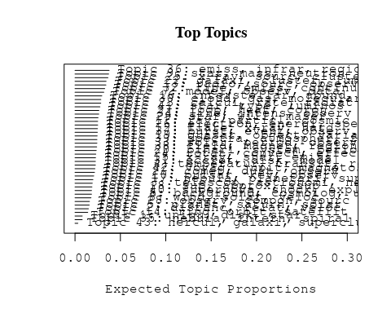

# Print the top 10 labels for each topic  
topic_labels <- labelTopics(Research_topics, n=10)  
print(topic_labels)

## Topic 1 Top Words:  
## Highest Prob: uniqu, disk, star, near, circular, ngc, optic, present, axi, color   
## FREX: uniqu, circular, ellipt, ubv, color, axi, mag, third, side, photometri   
## Lift: uniqu, ubv, circular, most, perpendicular, flatten, centrifug, photoelectr, minor, eclipt   
## Score: uniqu, asteroid, ellipt, ubv, circular, disk, ngc, mag, color, axi   
## Topic 2 Top Words:  
## Highest Prob: distanc, relat, veloc, mean, age, estim, measur, galaxi, use, local   
## FREX: distanc, age, mean, local, constant, hubbl, estim, deviat, billion, nearbi   
## Lift: deviat, billion, hubbl, superclust, age, distanc, step, nearbi, dispers, distant   
## Score: deviat, superclust, hubbl, distanc, age, galaxi, billion, local, mean, nearbi   
## Topic 3 Top Words:  
## Highest Prob: telescop, astronomi, new, time, astronom, instrument, use, first, year, univers   
## FREX: astronomi, telescop, instrument, research, y-ray, tabl, work, astronom, principl, techniqu   
## Lift: principl, equip, astronomi, nearest, research, prime, began, focal, y-ray, insight   
## Score: astronomi, principl, telescop, y-ray, astronom, instrument, research, univers, centuri, tabl   
## Topic 4 Top Words:  
## Highest Prob: temperatur, transit, region, coron, solar, measur, hole, observ, sub, use   
## FREX: transit, temperatur, coron, sub, hole, euv, radii, region, kms, quiet   
## Lift: sub, transit, euv, temperatur, coron, network, termin, hole, kms, radii   
## Score: sub, coron, transit, hole, temperatur, euv, quiet, solar, radii, skylab   
## Topic 5 Top Words:  
## Highest Prob: planet, saturn, solar, jupit, observ, system, surfac, uranus, albedo, meteorit   
## FREX: planet, meteorit, albedo, mix, saturn, uranus, jupit, asteroid, isotop, reflect   
## Lift: meteorit, planet, terrestri, nitrogen, albedo, asteroid, anomali, imp-, eddi, mix   
## Score: planet, saturn, uranus, jupit, asteroid, meteorit, albedo, isotop, imp-, mix   
## Topic 6 Top Words:  
## Highest Prob: background, cosmolog, univers, radiat, densiti, limit, distribut, mass, angular, anisotropi   
## FREX: cosmolog, background, univers, anisotropi, extragalact, count, angular, neutrino, fluctuat, intergalact   
## Lift: cosmolog, anisotropi, background, intergalact, count, neutrino, univers, isotrop, amplif, introduc   
## Score: cosmolog, background, anisotropi, univers, neutrino, quasar, extragalact, redshift, intergalact, count   
## Topic 7 Top Words:  
## Highest Prob: model, observ, data, predict, profil, use, alpha, obtain, valu, flux   
## FREX: predict, profil, alpha, model, agreement, fit, uncertainti, good, standard, occult   
## Lift: occult, non-lt, uncertainti, predict, profil, agreement, standard, discrep, agre, good   
## Score: occult, alpha, profil, predict, model, absolut, fit, standard, agreement, uncertainti   
## Topic 8 Top Words:  
## Highest Prob: wind, solar, veloc, densiti, plane, interplanetari, sun, rsub, mass, observ   
## FREX: wind, rsub, interplanetari, venus, plane, stream, cygni, million, maximum, closer   
## Lift: closer, rsub, coronagraph, venus, wind, coher, interplanetari, rsup, white-light, avoid   
## Score: wind, rsub, interplanetari, closer, venus, asteroid, plane, cygni, white-light, sun   
## Topic 9 Top Words:  
## Highest Prob: star, mass, neutron, stellar, loss, evolut, shell, model, wind, rate   
## FREX: neutron, mass, loss, evolut, red, evolutionari, evolv, star, supergi, shell   
## Lift: neutron, burn, criterion, evolv, evolutionari, main-sequ, supergi, loss, mass, msub   
## Score: neutron, star, mass, loss, msub, shell, supergi, main-sequ, stellar, massiv   
## Topic 10 Top Words:  
## Highest Prob: pulsar, kev, observ, puls, crab, energi, period, time, x-ray, data   
## FREX: pulsar, puls, crab, kev, psr, heao, arriv, vela, pulsat, polar   
## Lift: polarimet, puls, crab, pulsar, psr, spin-, arriv, kev, vela, minus   
## Score: pulsar, kev, crab, puls, psr, polarimet, heao, x-ray, period, spin-   
## Topic 11 Top Words:  
## Highest Prob: ray, particl, cosmic, energi, acceler, solar, cosmic-ray, shock, galact, gamma   
## FREX: ray, cosmic, cosmic-ray, acceler, particl, nucleon, gamma, drift, mev, shock   
## Lift: scienc, gev, nucleon, ray, cosmic-ray, balloon, drift, cosmic, acceler, gamma   
## Score: ray, cosmic, cosmic-ray, nucleon, scienc, mev, particl, shock, acceler, gev   
## Topic 12 Top Words:  
## Highest Prob: flare, x-ray, hard, solar, observ, emiss, implic, time, impuls, microwav   
## FREX: flare, implic, hard, impuls, microwav, spike, soft, spectromet, peak, phase   
## Lift: implic, flare, smm, impuls, hard, spike, microwav, gradual, crystal, delay   
## Score: flare, implic, x-ray, hard, impuls, microwav, smm, mev, kev, soft   
## Topic 13 Top Words:  
## Highest Prob: radio, sourc, observ, optic, jet, emiss, polar, frequenc, wavelength, structur   
## FREX: radio, jet, frequenc, ghz, mhz, extragalact, polar, optic, sourc, extend   
## Lift: violent, multifrequ, radio, jet, ghz, mhz, eman, vla, low-frequ, frequenc   
## Score: radio, jet, violent, sourc, mhz, ghz, polar, synchrotron, extragalact, vla   
## Topic 14 Top Words:  
## Highest Prob: ring, orbit, satellit, edg, saturn, disk, inclin, particl, torqu, eccentr   
## FREX: ring, inclin, orbit, edg, torqu, eccentr, precess, satellit, darken, pattern   
## Lift: inclin, ring, eccentr, torqu, darken, precess, orbit, edg, meter, hsup   
## Score: ring, orbit, inclin, saturn, uranus, eccentr, precess, torqu, edg, darken   
## Topic 15 Top Words:  
## Highest Prob: x-ray, star, emiss, detect, soft, observ, dwarf, white, kev, hot   
## FREX: soft, white, dwarf, tau, einstein, detect, hot, tauri, vla, x-ray   
## Lift: ceti, herculi, tauri, tau, mji, soft, short-period, white, vla, blackbodi   
## Score: x-ray, soft, dwarf, white, ceti, kev, star, tau, einstein, herculi   
## Topic 16 Top Words:  
## Highest Prob: interstellar, abund, star, hydrogen, densiti, column, observ, atom, copernicus, medium   
## FREX: interstellar, column, copernicus, extinct, abund, hydrogen, deplet, atom, neutral, element   
## Lift: hbeta, oph, zeta, deplet, column, extinct, copernicus, tabul, deuterium, interstellar   
## Score: interstellar, abund, copernicus, extinct, hbeta, deplet, column, hydrogen, atom, zeta   
## Topic 17 Top Words:  
## Highest Prob: nebula, planetari, supernova, detect, remnant, cloud, survey, one, small, known   
## FREX: planetari, nebula, remnant, smc, magellan, supernova, catalog, survey, statist, known   
## Lift: smc, magellan, millisecond, catalog, planetari, lmc, irc, brightest, remnant, overabund   
## Score: smc, nebula, supernova, magellan, remnant, planetari, catalog, cloud, lmc, survey   
## Topic 18 Top Words:  
## Highest Prob: sup, approx, ssup, cmsup, densiti, less, hsub, erg, distribut, sun   
## FREX: sup, cmsup, ssup, approx, hsub, yrsup, approxsup, erg, lsub, less   
## Lift: epsilon, yrsup, cmsup, sup, ssup, approx, hsub, approxsup, csup, lsub   
## Score: sup, cmsup, approx, ssup, hsub, yrsup, epsilon, erg, lsub, approxsup   
## Topic 19 Top Words:  
## Highest Prob: quasar, object, variabl, observ, luminos, redshift, sampl, magnitud, optic, data   
## FREX: quasar, variabl, object, lac, redshift, pks, power, seyfert, sampl, lacerta   
## Lift: pks, lacerta, quasar, lac, high-redshift, interven, short-term, frame, nine, quasi-stellar   
## Score: quasar, pks, lac, object, redshift, variabl, seyfert, lacerta, sampl, ngc   
## Topic 20 Top Words:  
## Highest Prob: binari, system, period, companion, mass, variabl, eclips, observ, x-ray, accret   
## FREX: binari, companion, eclips, system, cataclysm, secondari, transfer, period, nova, accret   
## Lift: eclips, companion, cataclysm, binari, roch, dip, secondari, cen, degener, refin   
## Score: binari, eclips, companion, cataclysm, accret, period, orbit, system, x-ray, dwarf   
## Topic 21 Top Words:  
## Highest Prob: comet, dust, observ, product, nucleus, tail, rate, cometari, near, grain   
## FREX: comet, cometari, product, tail, dust, perihelion, nucleus, coma, heliocentr, grain   
## Lift: perihelion, comet, cometari, oort, volatil, coma, axe, heliocentr, dusti, product   
## Score: comet, perihelion, cometari, dust, nucleus, tail, oort, coma, grain, heliocentr   
## Topic 22 Top Words:  
## Highest Prob: galaxi, cluster, luminos, format, spiral, present, sampl, bright, group, result   
## FREX: galaxi, cluster, abel, qsos, spiral, format, group, morpholog, rich, luminos   
## Lift: apertur, abel, galaxi, ccd, spheroid, rich, morpholog, qsos, qso, ellipt   
## Score: galaxi, cluster, abel, qsos, apertur, spiral, luminos, ellipt, sampl, qso   
## Topic 23 Top Words:  
## Highest Prob: calcul, rate, radiat, result, state, equat, approxim, model, estim, method   
## FREX: calcul, equat, numer, state, rate, applic, solv, method, transfer, solut   
## Lift: pump, solv, formul, analyt, calcul, carlo, mont, incid, collis, numer   
## Score: calcul, equat, pump, solv, transfer, solut, numer, analyt, ioniz, coeffici   
## Topic 24 Top Words:  
## Highest Prob: rotat, convect, effect, veloc, instabl, turbul, angular, stabil, scale, zone   
## FREX: convect, stabil, turbul, momentum, instabl, unstabl, perturb, rotat, zone, viscos   
## Lift: circul, brake, viscos, buoyanc, stabil, horizont, three-dimension, unstabl, momentum, viscous   
## Score: convect, circul, rotat, viscos, perturb, buoyanc, stabil, instabl, momentum, unstabl   
## Topic 25 Top Words:  
## Highest Prob: x-ray, sourc, cluster, emiss, observ, einstein, galact, optic, globular, observatori   
## FREX: globular, x-ray, einstein, sourc, counterpart, identif, observatori, cluster, collim, candid   
## Lift: uhuru, intraclust, globular, collim, counterpart, box, ariel, perseus, low-luminos, candid   
## Score: x-ray, sourc, cluster, globular, einstein, uhuru, counterpart, heao, ngc, collim   
## Topic 26 Top Words:  
## Highest Prob: electron, energi, spectrum, distribut, model, radiat, plasma, spectra, emiss, thermal   
## FREX: electron, power-law, iron, spectrum, annihil, synchrotron, relativist, beam, compton, distribut   
## Lift: annihil, power-law, cyclotron, positron, pair, electron, iron, bremsstrahlung, threshold, compton   
## Score: electron, annihil, synchrotron, energi, iron, spectrum, plasma, relativist, power-law, compton   
## Topic 27 Top Words:  
## Highest Prob: loop, heat, coron, energi, wave, flux, corona, chromospher, solar, can   
## FREX: loop, heat, tube, wave, coron, corona, sunspot, chromospher, alfven, cool   
## Lift: tube, one-dimension, loop, alfven, mhd, downward, magnetohydrodynam, static, input, grow   
## Score: loop, tube, coron, chromospher, wave, sunspot, heat, alfven, corona, downward   
## Topic 28 Top Words:  
## Highest Prob: observ, compon, sourc, measur, vlbi, rang, period, data, size, imag   
## FREX: vlbi, compon, arcsec, interferometri, imag, size, baselin, antenna, beam, improv   
## Lift: baselin, interferometri, vlbi, ascens, right, interferometr, antenna, arecibo, fine, -day   
## Score: vlbi, interferometri, baselin, pulsar, compon, arcsec, antenna, imag, binari, period   
## Topic 29 Top Words:  
## Highest Prob: star, will, maser, observ, orion, object, sio, problem, one, region   
## FREX: maser, sio, question, problem, orion, review, will, workshop, figur, refer   
## Lift: answer, talk, sio, topic, texa, familiar, workshop, maser, catalogu, demand   
## Score: maser, sio, orion, star, answer, workshop, will, question, world, catalogu   
## Topic 30 Top Words:  
## Highest Prob: cloud, gas, molecular, region, format, interstellar, densiti, dens, observ, molecul   
## FREX: cloud, molecular, gas, molecul, dens, high-veloc, orion, format, complex, chemistri   
## Lift: chemistri, monoxid, high-veloc, molecul, cloud, molecular, dens, clump, sulfur, gas   
## Score: cloud, molecular, gas, chemistri, molecul, orion, high-veloc, dens, shock, interstellar   
## Topic 31 Top Words:  
## Highest Prob: accret, disk, model, gravit, hole, black, matter, halo, collaps, radiat   
## FREX: accret, black, hole, halo, disk, collaps, gravit, matter, onto, central   
## Lift: manifest, black, accret, halo, infal, onto, disk, hole, gravit, matter   
## Score: accret, black, hole, disk, halo, collaps, gravit, manifest, matter, encount   
## Topic 32 Top Words:  
## Highest Prob: line, emiss, continuum, absorpt, observ, veloc, strong, show, broad, region   
## FREX: continuum, line, absorpt, broad, lambda, photoion, narrow, excit, iue, emiss   
## Lift: broad-lin, superpos, photoion, balmer, pup, fluoresc, broad, lambda, narrow, absorpt   
## Score: line, continuum, absorpt, emiss, broad-lin, superpos, lambda, forbidden, photoion, iue   
## Topic 33 Top Words:  
## Highest Prob: solar, period, observ, variat, chang, rotat, cycl, activ, bright, sun   
## FREX: variat, cycl, period, oscil, moon, chang, sunspot, solar, day, minimum   
## Lift: moon, season, cycl, oscil, lunar, variat, night, nonradi, date, februari   
## Score: moon, period, uranus, cycl, solar, sunspot, oscil, variat, day, rotat   
## Topic 34 Top Words:  
## Highest Prob: line, intens, observ, ratio, iii, spectra, solar, region, sun, obtain   
## FREX: iii, line, recombin, limb, intens, forbidden, ion, ratio, quiet, cell   
## Lift: silicon, nrl, recombin, slit, cell, redistribut, limb, quiet, forbidden, skylab   
## Score: line, chromospher, forbidden, limb, quiet, iii, recombin, silicon, ion, skylab   
## Topic 35 Top Words:  
## Highest Prob: nebula, intern, spiral, motion, photograph, ref, observ, astronom, discoveri, galaxi   
## FREX: ref, intern, spiral, photograph, van, letter, nebula, fwhm, discoveri, taken   
## Lift: ref, letter, recogn, van, claim, photograph, segment, furthermor, fwhm, intern   
## Score: ref, nebula, spiral, van, claim, hubbl, segment, fwhm, astronom, mev   
## Topic 36 Top Words:  
## Highest Prob: emiss, infrar, region, sourc, micron, observ, far-infrar, dust, map, nebula   
## FREX: far-infrar, infrar, map, micron, dust, arcmin, mum, center, orion, emiss   
## Lift: far-infrar, latitudin, trapezium, ridg, arcmin, mum, map, infrar, -micron, near-infrar   
## Score: far-infrar, micron, infrar, dust, orion, trapezium, map, nebula, emiss, arcmin   
## Topic 37 Top Words:  
## Highest Prob: burst, event, observ, sourc, time, transient, x-ray, gamma-ray, type, flux   
## FREX: burst, event, transient, durat, burster, gamma-ray, persist, march, locat, mxb   
## Lift: burst, burster, mxb, ise, durat, thermonuclear, transient, event, persist, march   
## Score: burst, event, gamma-ray, mxb, transient, x-ray, durat, burster, flash, gammaray   
## Topic 38 Top Words:  
## Highest Prob: field, magnet, region, line, surfac, polar, gauss, solar, flux, strength   
## FREX: magnet, field, gauss, dynamo, configur, open, strength, electr, along, polar   
## Lift: nonuniform, gauss, magnet, field, dynamo, electr, hydromagnet, open, transvers, configur   
## Score: magnet, field, dynamo, gauss, nonuniform, electr, polar, open, configur, dipol   
## Topic 39 Top Words:  
## Highest Prob: spectra, atmospher, featur, micron, wavelength, spectrum, stellar, band, temperatur, star   
## FREX: atmospher, band, micron, featur, neptun, spectra, spectrophotometri, wavelength, water, carbon   
## Lift: neptun, water, spectrophotometri, quantum, micromet, assign, atmospher, band, airborn, solid   
## Score: neptun, micron, atmospher, spectra, spectrophotometri, band, carbon, water, wavelength, grain   
## Topic 40 Top Words:  
## Highest Prob: supernova, shock, explos, remnant, medium, shell, energi, type, observ, can   
## FREX: supernova, explos, remnant, shock, expand, eject, shell, medium, adiabat, ejecta   
## Lift: blast, explos, ejecta, explod, supernova, snr, adiabat, remnant, deceler, expand   
## Score: supernova, shock, explos, remnant, blast, ejecta, shell, hydrodynam, adiabat, eject   
## Topic 41 Top Words:  
## Highest Prob: star, type, luminos, ultraviolet, stellar, chromospher, emiss, spot, giant, surfac   
## FREX: spot, chromospher, type, giant, cvn, ultraviolet, late, late-typ, star, dwarf   
## Lift: bolometr, subdwarf, cvn, spot, wolf-rayet, doublet, ori, beta, uma, late   
## Score: star, chromospher, bolometr, spot, cvn, dwarf, ultraviolet, luminos, giant, wolf-rayet   
## Topic 42 Top Words:  
## Highest Prob: voyag, jupit, magnetospher, plasma, observ, near, pioneer, saturn, jovian, electron   
## FREX: voyag, magnetospher, pioneer, jupit, torus, jovian, plasma, magnetopaus, spacecraft, saturn   
## Lift: inbound, magnetopaus, torus, trajectori, voyag, magnetospher, jovian, bow, pioneer, magnetomet   
## Score: voyag, jupit, magnetospher, saturn, jovian, torus, pioneer, magnetopaus, trajectori, plasma   
## Topic 43 Top Words:  
## Highest Prob: hercul, galaxi, superclust, cluster, sampl, mpc, contain, luminos, complet, depth   
## FREX: hercul, superclust, mpc, brighter, foreground, depth, sampl, kmsec, complet, contain   
## Lift: hercul, foreground, mpc, superclust, merg, brighter, former, despit, wider, largest   
## Score: hercul, superclust, mpc, galaxi, cluster, sampl, brighter, seyfert, foreground, msub

# Match the processed documents with the original titles  
matched_titles <- out_text$meta$original_concatenated_title_abstract  
  
# Print top 5 documents for each topic  
top_docs <- findThoughts(Research_topics, texts = matched_titles, n = 5)$docs[[1]]  
print(top_docs)

## [1] "A Circumstellar Disk Around β Pictoris A circumstellar disk has been observed optically around the fourth-magnitude star β Pictoris. First detected in the infrared by the Infrared Astronomy Satellite last year, the disk is seen to extend to more than 400 astronomical units from the star, or more than twice the distance measured in the infrared by the Infrared Astronomy Satellite. The β Pictoris disk is presented to Earth almost edgeon and is composed of solid particles in nearly coplanar orbits. The observed change in surface brightness with distance from the star implies that the mass density of the disk falls off with approximately the third power of the radius. Because the circumstellar material is in the form of a highly flattened disk rather than a spherical shell, it is presumed to be associated with planet formation. It seems likely that the system is relatively young and that planet formation either is occurring now around β Pictoris or has recently been completed."   
## [2] "A Circumstellar Disk Around β Pictoris A circumstellar disk has been observed optically around the fourth-magnitude star β Pictoris. First detected in the infrared by the Infrared Astronomy Satellite last year, the disk is seen to extend to more than 400 astronomical units from the star, or more than twice the distance measured in the infrared by the Infrared Astronomy Satellite. The β Pictoris disk is presented to Earth almost edgeon and is composed of solid particles in nearly coplanar orbits. The observed change in surface brightness with distance from the star implies that the mass density of the disk falls off with approximately the third power of the radius. Because the circumstellar material is in the form of a highly flattened disk rather than a spherical shell, it is presumed to be associated with planet formation. It seems likely that the system is relatively young and that planet formation either is occurring now around β Pictoris or has recently been completed."   
## [3] "Minor planets and related objects. XXI. Photometry of eight asteroids Light curves, UBV colors, rotational periods, phase coefficients, and absolute magnitudes are presented. The asteroids studied are (1) Ceres, (4) Vesta, (16) Psyche, (78) Diana, (281) Lucretia, (451) Patientia, (1212) Francette, and (1362) Griqua. The rotation axis of Lucretia is nearly perpendicular to the plane of the ecliptic. Ceres appears to be nearly spherical with an absolute magnitude of B(1,0)=4.42, which is 0.3 mag fainter than previously reported. The determination of the absolute magnitude for an asteroid depends on its aspect, and for each opposition there is, therefore, a different absolute magnitude."   
## [4] "Minor planets and related objects. XXI. Photometry of eight asteroids Light curves, UBV colors, rotational periods, phase coefficients, and absolute magnitudes are presented. The asteroids studied are (1) Ceres, (4) Vesta, (16) Psyche, (78) Diana, (281) Lucretia, (451) Patientia, (1212) Francette, and (1362) Griqua. The rotation axis of Lucretia is nearly perpendicular to the plane of the ecliptic. Ceres appears to be nearly spherical with an absolute magnitude of B(1,0)=4.42, which is 0.3 mag fainter than previously reported. The determination of the absolute magnitude for an asteroid depends on its aspect, and for each opposition there is, therefore, a different absolute magnitude."   
## [5] "On the Retrogradations of Planets The following note is not strictly historical, but is concerned with an old subject that is probably now of interest principally (or only) to historians of astronomy. The method of finding the stationary points in a planet's motion with respect to the Earth, and the condition for determining whether stations and retrogradations occur, were demonstrated by Apollonius of Perga (c. 200 B.C.) for circular, geocentric orbits with uniform motions. Ptolemy showed how Apollonius's Theorem, as it is called, can be extended to non-uniform motions and applied numerically, and Copernicus demonstrated that it is equally applicable to a heliocentric system. Since the orbits of the planets are very nearly circular, we shall, in what follows, initially assume circular orbits and uniform motions. In Figure 1, let rl < r2 be the radii of the orbits of any two planets A and B moving about centre e. Draw the line BA extended to meet the far side of the interior orbit at D, and bisect AD at E, designatingAE as aand BA as b. Let the angular velocities of A and B be respectively WI > W2, and thus the motion of A with respect to the direction BC, called the mean anomaly. will be their difference WI-W2' Apollonius's Theorem shows that when alb =w,}(WI-W2), (1) the planet at A will appear stationary at B and vice versa. I When A is farther from BC, alb is decreased and the apparent motion is direct. And when A is closer to BC, alb is increased and the apparent motion is retrograde. The necessary condition for retrogradation is therefore that (alb)max = rJ(r2-rl) > W,}(WI-W2) , (2) for if rJ('2-rl) :!50 W,}(Wt-W2) , there will be either no station or a single instantaneous station as A crosses Be. While it may seem obvious that an apparent retrogradation should occur any time a faster inner planet passes a slower outer planet, condition (2) is actually more specific. To consider for the moment only mean motions, it can be shown"

# Find and plot the key "thoughts" or documents for selected topics  
thoughts6 <- findThoughts(Research_topics, texts = matched_titles, n = 3, topics = 6)$docs[[1]]  
thoughts18 <- findThoughts(Research_topics, texts = matched_titles, n = 3, topics = 18)$docs[[1]]  
par(mfrow = c(1, 2), mar = c(0.5, 0.5, 1, 0.5))  
plotQuote(thoughts6, width = 30, main = "Topic 6")  
plotQuote(thoughts18, width = 30, main = "Topic 18")

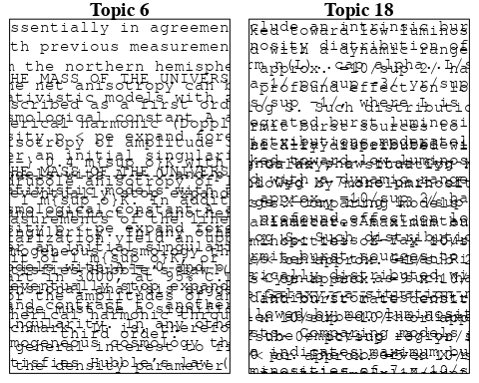

# Calculate and plot the correlation between topics  
mod.out.corr <- topicCorr(Research_topics)  
plot(mod.out.corr, cex = 1.5)  
  
  
# For each topic  
for (topic_num in 1:43) {  
 # Plot the word cloud  
 cloud(Research_topics, topic = topic_num, scale = c(2, 0.25))  
}

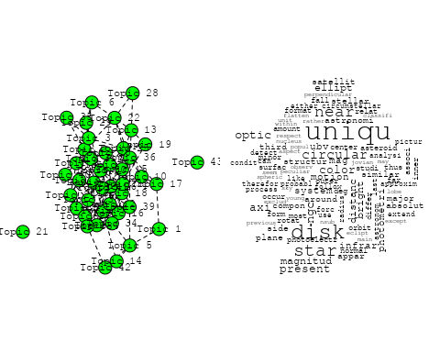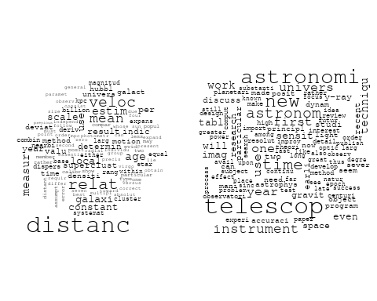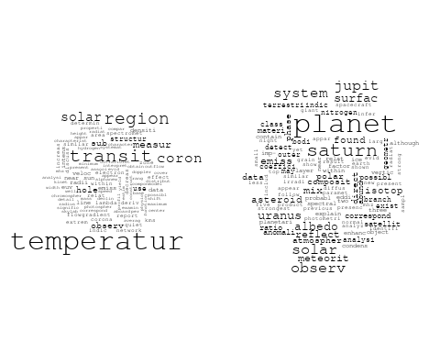

## Warning in wordcloud::wordcloud(words = vocab, freq = vec, max.words =  
## max.words, : cosmolog could not be fit on page. It will not be plotted.

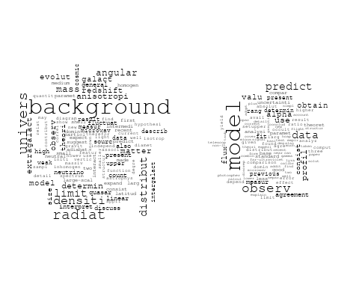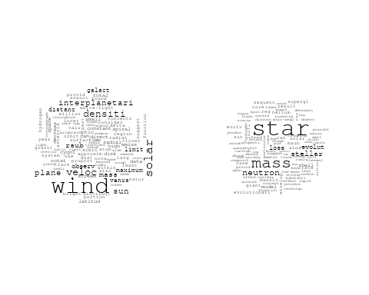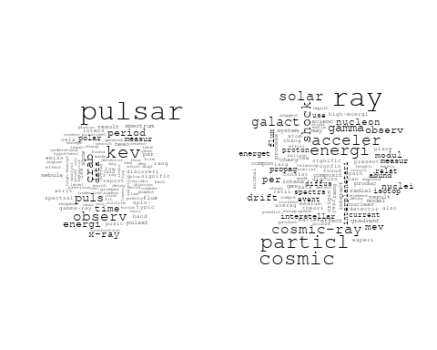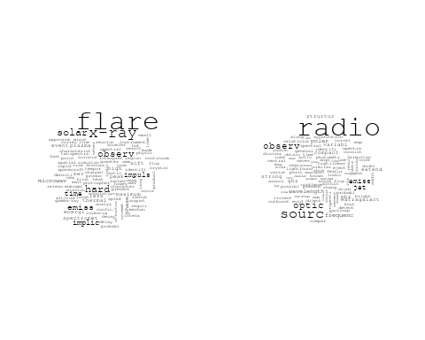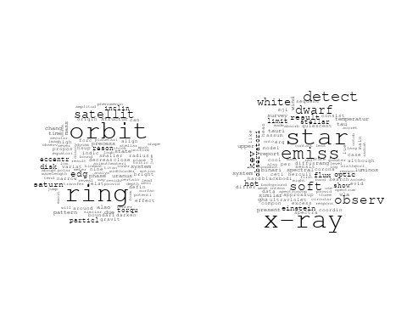

## Warning in wordcloud::wordcloud(words = vocab, freq = vec, max.words =  
## max.words, : interstellar could not be fit on page. It will not be plotted.

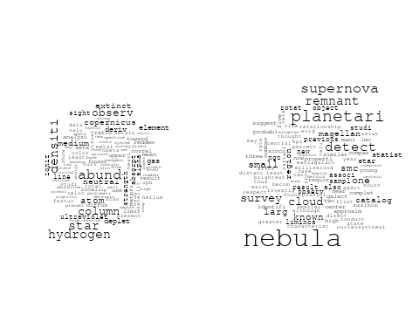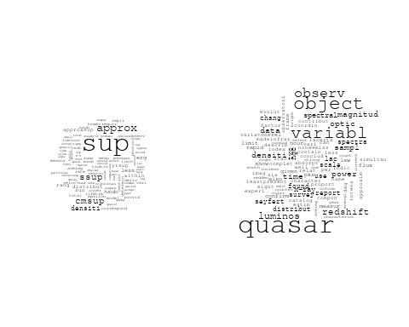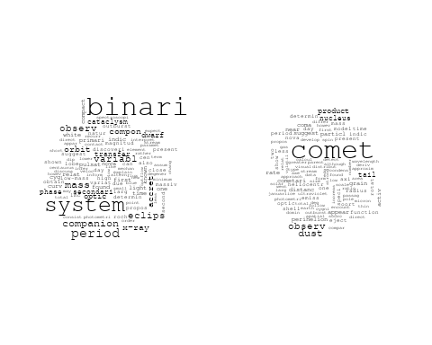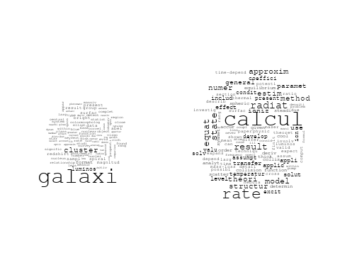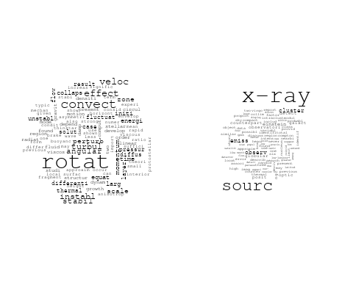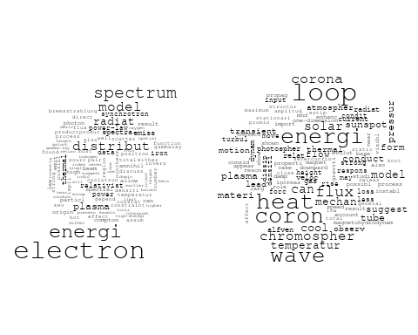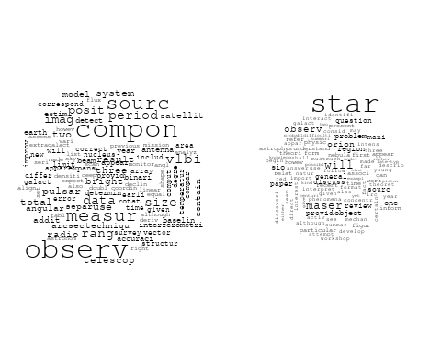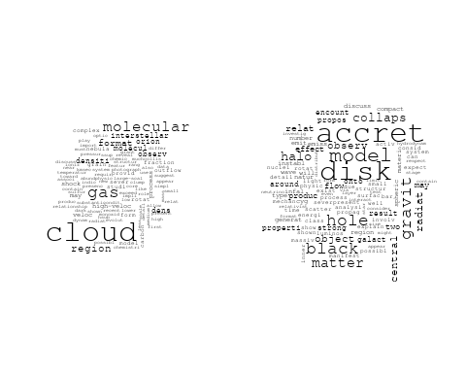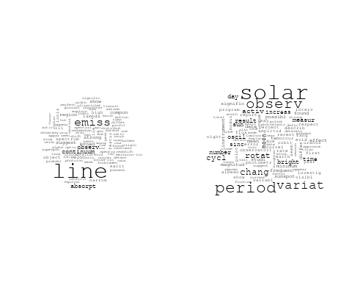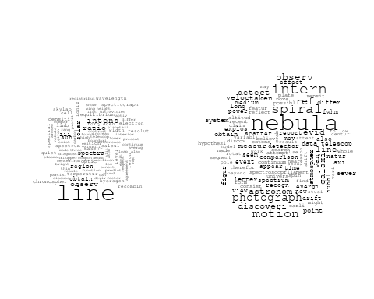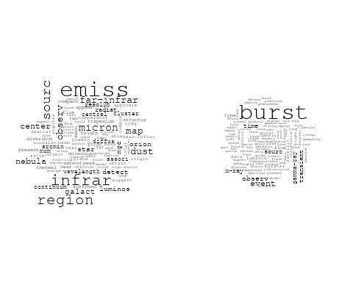

## Warning in wordcloud::wordcloud(words = vocab, freq = vec, max.words =  
## max.words, : spectra could not be fit on page. It will not be plotted.

## Warning in wordcloud::wordcloud(words = vocab, freq = vec, max.words =  
## max.words, : spectrum could not be fit on page. It will not be plotted.

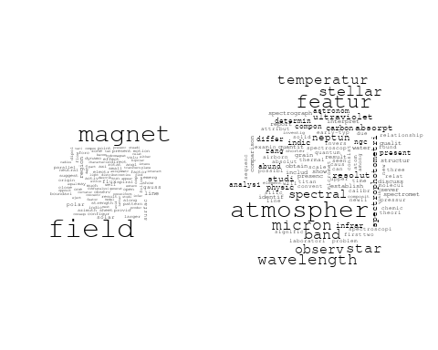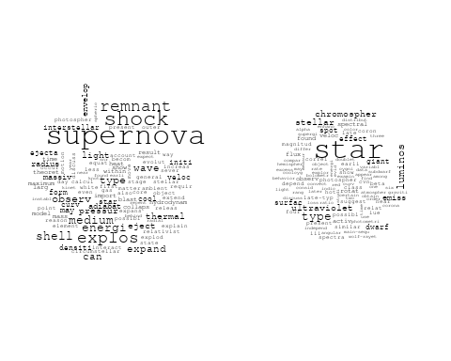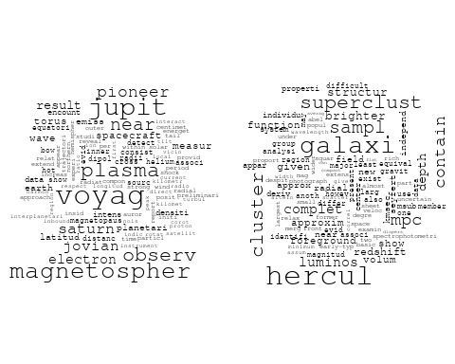

# Get the topic proportions for each document  
topic_proportions <- Research_topics$theta  
  
# Find the index of the topic with the highest proportion for each document  
# This will be the topic that each document is most likely to belong to  
max_topic_idx <- apply(topic_proportions, 1, which.max)  
  
# Add this as a new column to your data  
data_filtered$topic <- max_topic_idx  
  
  
  
  
# Create function to generate histogram  
make_histogram <- function(country_code) {  
   
 # Filter data for country with contribution of 100  
 data_100 <- data_filtered[data_filtered[[country_code]] == 100,]  
   
 # Filter data for country with contribution not equal to 0  
 data_not_0 <- data_filtered[data_filtered[[country_code]] != 0,]  
   
 # Make the first histogram  
 hist_100 <- ggplot(data_100, aes(x = topic)) +  
 geom_histogram(binwidth = 1, fill = "blue", color = "black") +  
 xlab("Topic") +  
 ylab("Count") +  
 ggtitle(paste(country_code, "Independent Contribution"))  
   
 # Make the second histogram  
 hist_not_0 <- ggplot(data_not_0, aes(x = topic)) +  
 geom_histogram(binwidth = 1, fill = "blue", color = "black") +  
 xlab("Topic") +  
 ylab("Count") +  
 ggtitle(paste(country_code, "Contributions (with collaboration)"))  
   
 # Return list of plots  
 return(list(hist_100, hist_not_0))  
}

plots <- make_histogram("US")  
print(plots[[1]])

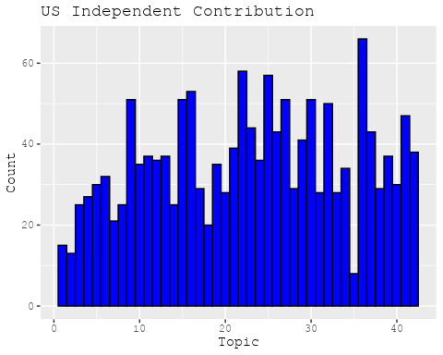

print(plots[[2]])

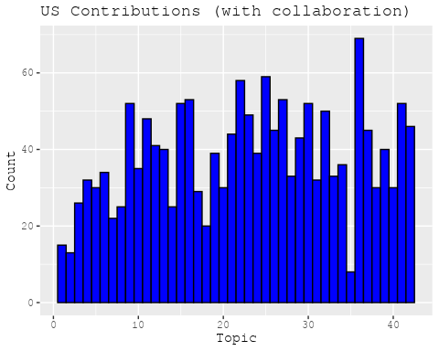

plots <- make_histogram("GB")  
print(plots[[1]])

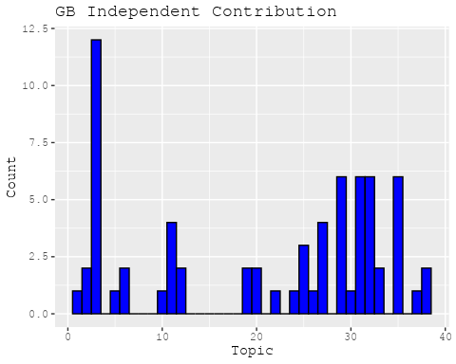

print(plots[[2]])

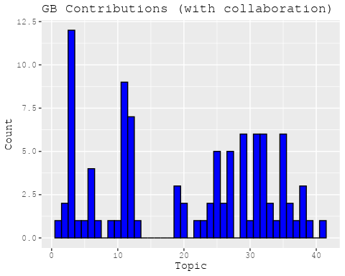

plots <- make_histogram("DE")  
print(plots[[1]])

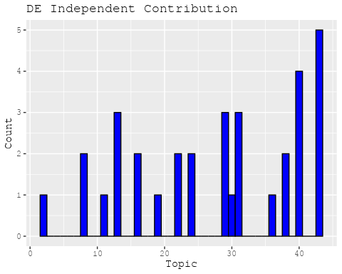

print(plots[[2]])

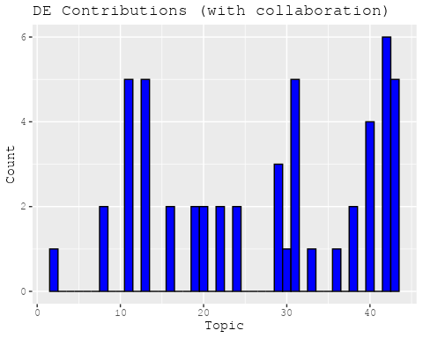

plots <- make_histogram("IT")  
print(plots[[1]])



print(plots[[2]])

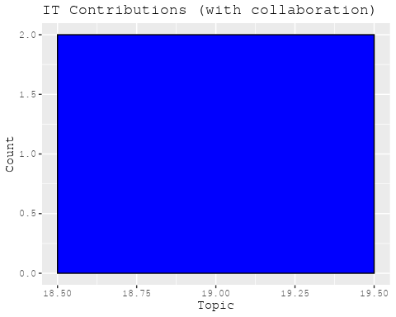

plots <- make_histogram("AU")  
print(plots[[1]])

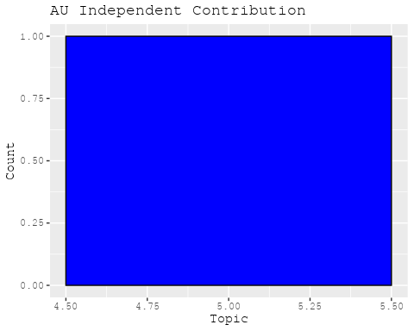

print(plots[[2]])

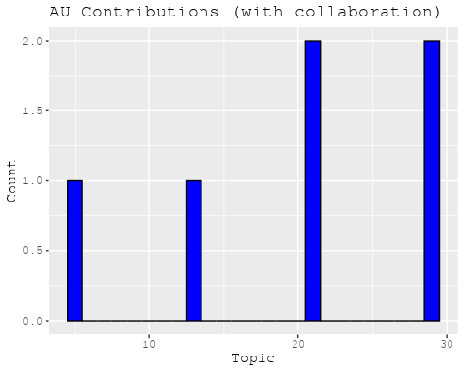

plots <- make_histogram("CA")  
print(plots[[1]])

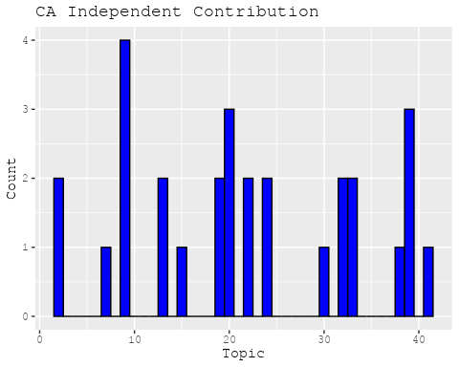

print(plots[[2]])

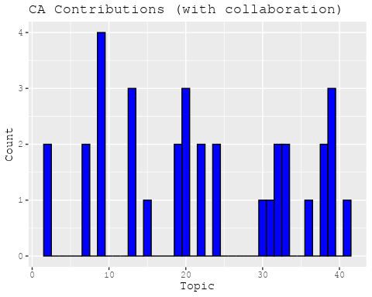

plots <- make_histogram("JP")  
print(plots[[1]])

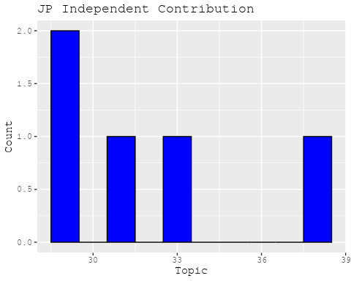

print(plots[[2]])

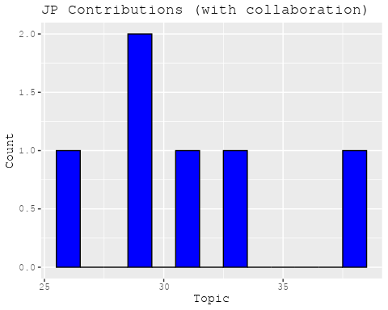

plots <- make_histogram("CN")  
print(plots[[1]])

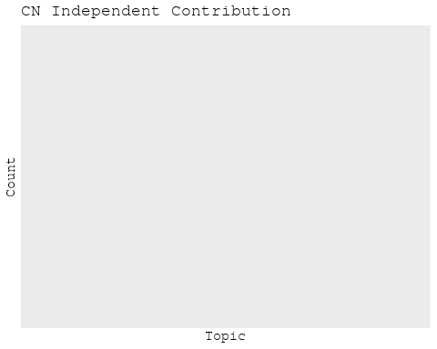

print(plots[[2]])

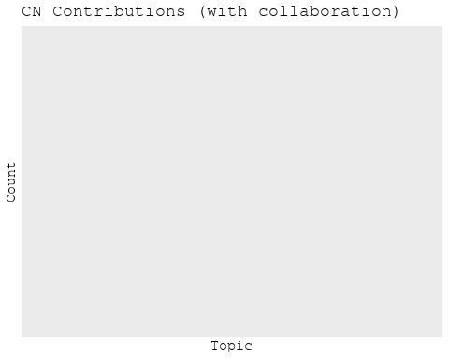

plots <- make_histogram("NL")  
print(plots[[1]])

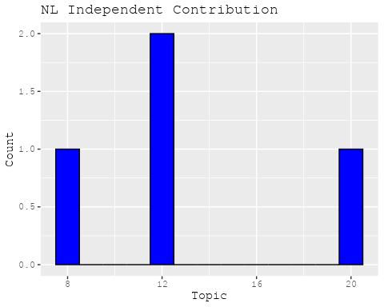

print(plots[[2]])

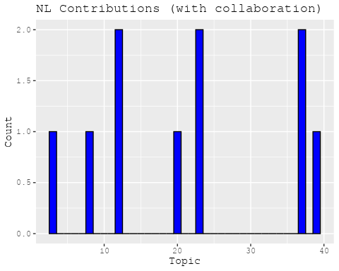

plots <- make_histogram("FR")  
print(plots[[1]])

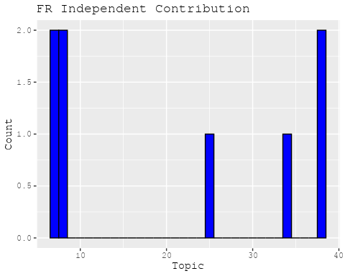

print(plots[[2]])

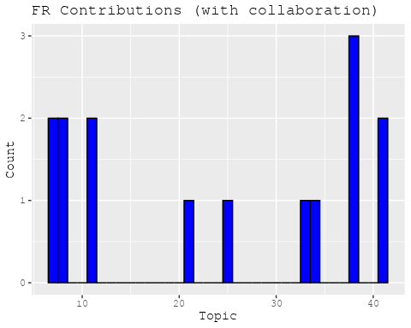

plots <- make_histogram("RU")  
print(plots[[1]])

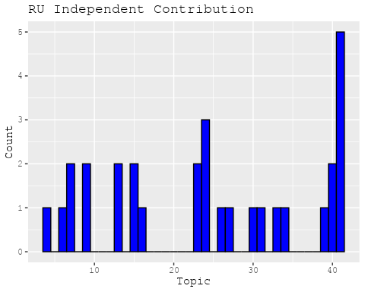

print(plots[[2]])

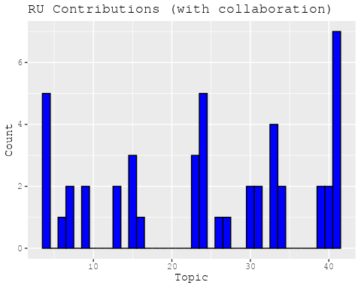

plots <- make_histogram("ES")  
print(plots[[1]])

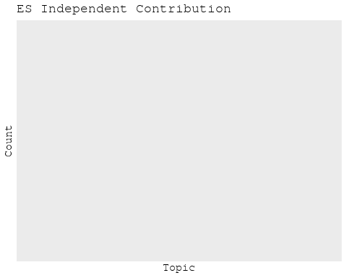

print(plots[[2]])

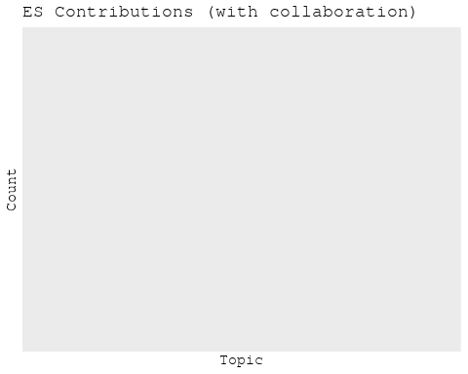

plots <- make_histogram("IN")  
print(plots[[1]])

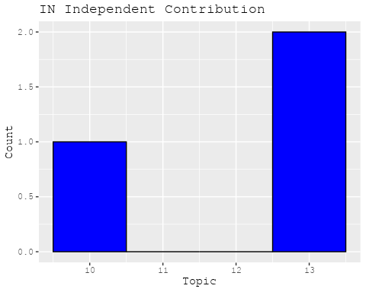

print(plots[[2]])

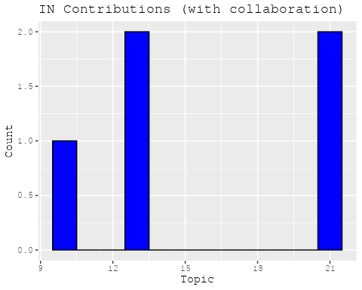

plots <- make_histogram("IL")  
print(plots[[1]])

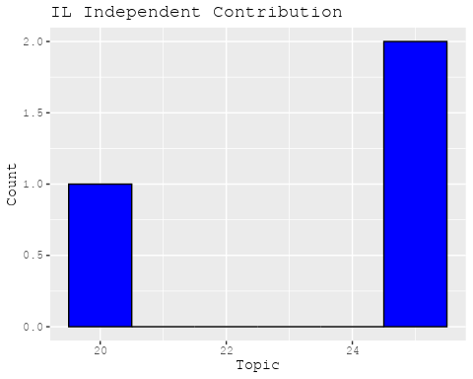

print(plots[[2]])

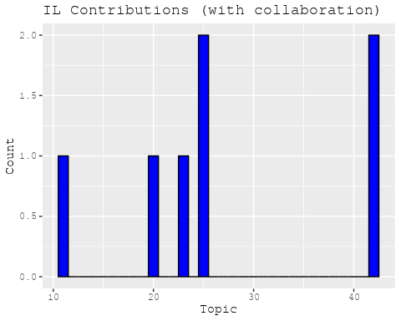

plots <- make_histogram("CH")  
print(plots[[1]])

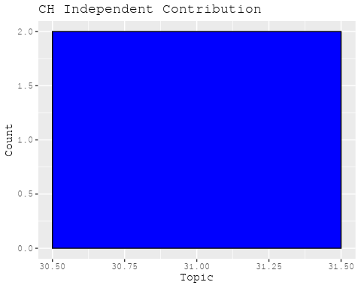

print(plots[[2]])

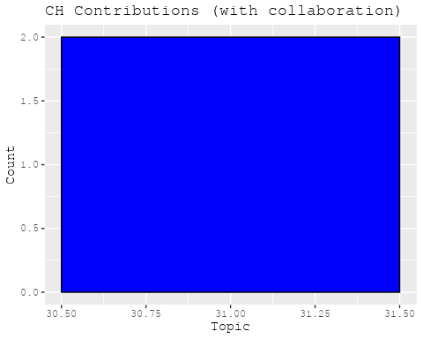

plots <- make_histogram("Americas")  
print(plots[[1]])

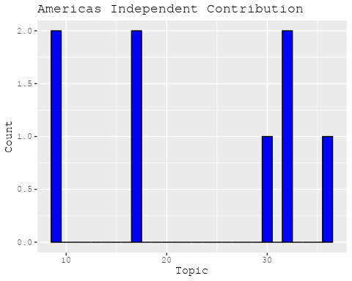

print(plots[[2]])

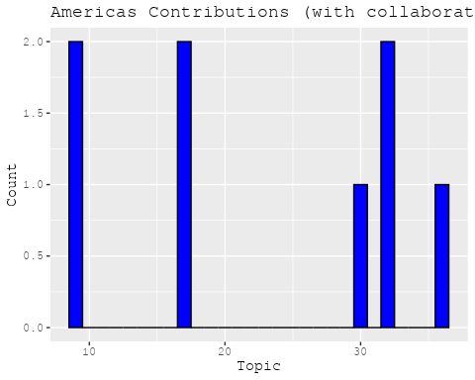

plots <- make_histogram("Europe")  
print(plots[[1]])

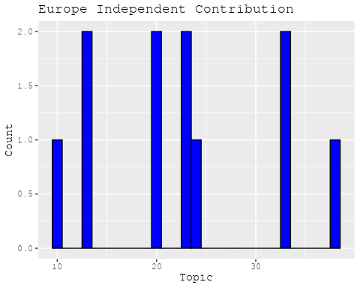

print(plots[[2]])

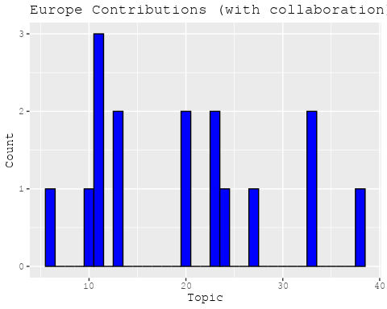

plots <- make_histogram("Africa")  
print(plots[[1]])



print(plots[[2]])

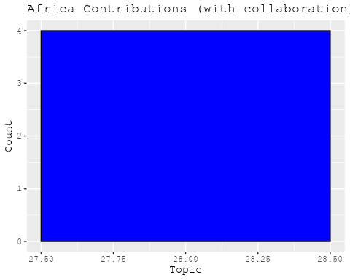

plots <- make_histogram("AsiaAndOceania")  
print(plots[[1]])

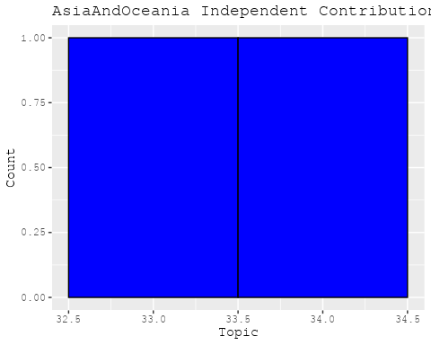

print(plots[[2]])

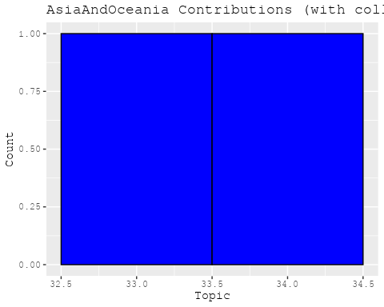

# Filter data for the publication interval 1965 to 1974  
data_filtered <- data[data[["pub_interval_1965_1974"]] == 1, ]  
  
# Save the original title data for future use  
data_filtered$original_concatenated_title_abstract <- data_filtered$concatenated_title_abstract  
  
#pre-processing the titles using textProcessor from the stm package  
processed_text <- textProcessor(data_filtered$concatenated_title_abstract, metadata = data_filtered)

## Building corpus...   
## Converting to Lower Case...   
## Removing punctuation...   
## Removing stopwords...   
## Removing numbers...   
## Stemming...   
## Creating Output...

# Further prepare the data by removing low-frequency terms  
out_text <- prepDocuments(processed_text$documents, processed_text$vocab, processed_text$meta)

## Removing 1761 of 4484 terms (1761 of 27729 tokens) due to frequency   
## Your corpus now has 472 documents, 2723 terms and 25968 tokens.

docs_text <- out_text$documents  
vocab_text <- out_text$vocab  
meta_text <- out_text$meta  
  
  
#Prepare data  
plotRemoved(processed_text$documents, lower.thresh = seq(1, 200, by = 100))

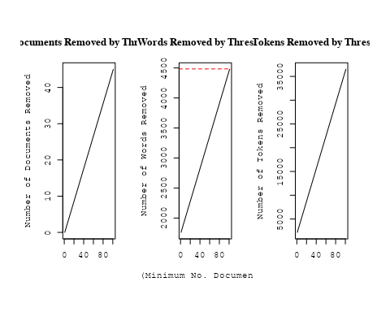

out_text <- prepDocuments(processed_text$documents, processed_text$vocab, processed_text$meta, lower.thresh = 8)

## Removing 3706 of 4484 terms (8304 of 27729 tokens) due to frequency   
## Your corpus now has 472 documents, 778 terms and 19425 tokens.

# Initialize an empty formula string  
prevalence_formula_str <- "~US "  
  
  
# Add each country variable to the formula string  
for (i in 10:27) {  
 prevalence_formula_str <- paste(prevalence_formula_str, "+", names(data)[i])  
}  
  
  
# Convert the string to a formula  
prevalence_formula <- as.formula(prevalence_formula_str)  
print(prevalence_formula)

## ~US + IN + DE + CH + GB + CN + FR + IT + RU + CA + NL + AU +   
## JP + ES + IL + Americas + Europe + Africa + AsiaAndOceania

# Run STM model  
Research_topics <- stm(documents = out_text$documents,   
 vocab = out_text$vocab,   
 K = 40,   
 prevalence = prevalence_formula,   
 data = out_text$meta,   
 init.type = "Spectral",  
 max.em.its = 1000,  
 gamma.prior = 'L1')

## Beginning Spectral Initialization   
## Calculating the gram matrix...  
## Finding anchor words...  
## ........................................  
## Recovering initialization...  
## .......  
## Initialization complete.  
## ......................................................................................................................  
## Completed E-Step (0 seconds).   
## Completed M-Step.   
## Completing Iteration 1 (approx. per word bound = -5.889)   
## ......................................................................................................................  
## Completed E-Step (0 seconds).   
## Completed M-Step.   
## Completing Iteration 2 (approx. per word bound = -5.633, relative change = 4.355e-02)   
## ......................................................................................................................  
## Completed E-Step (0 seconds).   
## Completed M-Step.   
## Completing Iteration 3 (approx. per word bound = -5.521, relative change = 1.986e-02)   
## ......................................................................................................................  
## Completed E-Step (0 seconds).   
## Completed M-Step.   
## Completing Iteration 4 (approx. per word bound = -5.465, relative change = 1.024e-02)   
## ......................................................................................................................  
## Completed E-Step (0 seconds).   
## Completed M-Step.   
## Completing Iteration 5 (approx. per word bound = -5.429, relative change = 6.444e-03)   
## Topic 1: star, evolut, stellar, mass, helium   
## Topic 2: solar, observ, corona, magnet, field   
## Topic 3: interstellar, temperatur, densiti, distanc, medium   
## Topic 4: gas, cloud, ioniz, densiti, hydrogen   
## Topic 5: binari, eclips, effect, determin, small   
## Topic 6: variabl, pulsat, hypothesi, observ, variat   
## Topic 7: nebula, supernova, crab, vela, x-ray   
## Topic 8: ultraviolet, angstrom, observ, alpha, carbon   
## Topic 9: system, will, space, cours, one   
## Topic 10: star, loss, lumin, magnitud, line   
## Topic 11: rate, process, reaction, interact, model   
## Topic 12: radio, sourc, x-ray, detect, second   
## Topic 13: model, amplitud, calcul, observ, present   
## Topic 14: line, emiss, radiat, spectrum, gamma-ray   
## Topic 15: compon, whether, two, radio, phase   
## Topic 16: gravit, neutron, star, radiat, wave   
## Topic 17: observ, infrar, variat, period, time   
## Topic 18: field, magnet, cosmic, galact, ray   
## Topic 19: x-ray, sourc, optic, observ, identif   
## Topic 20: function, mass, rotat, core, gravit   
## Topic 21: flux, observ, ngc, measur, wavelength   
## Topic 22: tabl, astronom, mean, problem, equat   
## Topic 23: galaxi, quasar, imag, cluster, size   
## Topic 24: x-ray, sourc, black, energi, power   
## Topic 25: x-ray, sourc, spectral, observ, energi   
## Topic 26: solar, mass, profil, present, atmospher   
## Topic 27: way, milki, first, natur, mani   
## Topic 28: sourc, object, x-ray, catalog, uhuru   
## Topic 29: galaxi, background, compon, quasar, sourc   
## Topic 30: jupit, observ, atmospher, venus, absorpt   
## Topic 31: pulsar, support, observ, star, rotat   
## Topic 32: theori, star, format, mechan, grain   
## Topic 33: stellar, astronomi, astrophys, astronom, develop   
## Topic 34: magnitud, dwarf, color, show, obtain   
## Topic 35: energi, per, sun, year, nuclei   
## Topic 36: star, disk, gaseous, structur, around   
## Topic 37: field, scan, region, result, research   
## Topic 38: possibl, galact, diffus, scale, background   
## Topic 39: earli, star, analysi, abund, can   
## Topic 40: sourc, x-ray, period, hercul, puls   
## ......................................................................................................................  
## Completed E-Step (0 seconds).   
## Completed M-Step.   
## Completing Iteration 6 (approx. per word bound = -5.407, relative change = 4.159e-03)   
## ......................................................................................................................  
## Completed E-Step (0 seconds).   
## Completed M-Step.   
## Completing Iteration 7 (approx. per word bound = -5.391, relative change = 2.876e-03)   
## ......................................................................................................................  
## Completed E-Step (0 seconds).   
## Completed M-Step.   
## Completing Iteration 8 (approx. per word bound = -5.378, relative change = 2.380e-03)   
## ......................................................................................................................  
## Completed E-Step (0 seconds).   
## Completed M-Step.   
## Completing Iteration 9 (approx. per word bound = -5.368, relative change = 1.925e-03)   
## ......................................................................................................................  
## Completed E-Step (0 seconds).   
## Completed M-Step.   
## Completing Iteration 10 (approx. per word bound = -5.360, relative change = 1.519e-03)   
## Topic 1: star, evolut, stellar, mass, helium   
## Topic 2: solar, observ, corona, magnet, field   
## Topic 3: interstellar, densiti, distanc, temperatur, observ   
## Topic 4: gas, cloud, ioniz, molecular, densiti   
## Topic 5: binari, eclips, effect, small, determin   
## Topic 6: variabl, hypothesi, observatori, observ, pulsat   
## Topic 7: nebula, supernova, crab, x-ray, vela   
## Topic 8: observ, angstrom, ultraviolet, alpha, hydrogen   
## Topic 9: system, will, space, cours, one   
## Topic 10: star, line, lumin, emiss, loss   
## Topic 11: rate, process, reaction, model, neutron   
## Topic 12: radio, sourc, x-ray, detect, cygnus   
## Topic 13: model, present, calcul, use, amplitud   
## Topic 14: line, emiss, radiat, spectrum, gamma-ray   
## Topic 15: compon, whether, two, radio, phase   
## Topic 16: gravit, neutron, radiat, star, wave   
## Topic 17: observ, infrar, variat, period, burst   
## Topic 18: field, magnet, cosmic, galact, ray   
## Topic 19: x-ray, observ, optic, identif, sourc   
## Topic 20: function, rotat, mass, gravit, core   
## Topic 21: flux, observ, ngc, two, sourc   
## Topic 22: tabl, astronom, one, problem, earth   
## Topic 23: galaxi, quasar, imag, cluster, size   
## Topic 24: x-ray, sourc, black, energi, hole   
## Topic 25: x-ray, sourc, observ, spectral, energi   
## Topic 26: solar, mass, data, planet, composit   
## Topic 27: way, milki, nebula, first, natur   
## Topic 28: sourc, object, catalog, x-ray, associ   
## Topic 29: upper, limit, background, sourc, galaxi   
## Topic 30: jupit, observ, atmospher, venus, absorpt   
## Topic 31: pulsar, star, support, observ, neutron   
## Topic 32: star, mechan, grain, format, cool   
## Topic 33: stellar, astronomi, theori, astrophys, astronom   
## Topic 34: magnitud, dwarf, color, quasar, show   
## Topic 35: energi, per, sun, nuclei, year   
## Topic 36: structur, star, disk, gaseous, motion   
## Topic 37: field, region, magnet, scan, earth   
## Topic 38: possibl, diffus, galact, scale, present   
## Topic 39: star, earli, can, analysi, abund   
## Topic 40: sourc, x-ray, period, intens, hercul   
## ......................................................................................................................  
## Completed E-Step (0 seconds).   
## Completed M-Step.   
## Completing Iteration 11 (approx. per word bound = -5.352, relative change = 1.441e-03)   
## ......................................................................................................................  
## Completed E-Step (0 seconds).   
## Completed M-Step.   
## Completing Iteration 12 (approx. per word bound = -5.345, relative change = 1.253e-03)   
## ......................................................................................................................  
## Completed E-Step (0 seconds).   
## Completed M-Step.   
## Completing Iteration 13 (approx. per word bound = -5.340, relative change = 1.103e-03)   
## ......................................................................................................................  
## Completed E-Step (0 seconds).   
## Completed M-Step.   
## Completing Iteration 14 (approx. per word bound = -5.335, relative change = 9.154e-04)   
## ......................................................................................................................  
## Completed E-Step (0 seconds).   
## Completed M-Step.   
## Completing Iteration 15 (approx. per word bound = -5.330, relative change = 8.155e-04)   
## Topic 1: star, evolut, stellar, mass, helium   
## Topic 2: solar, observ, corona, magnet, field   
## Topic 3: interstellar, densiti, distanc, observ, absorpt   
## Topic 4: gas, cloud, ioniz, molecular, hydrogen   
## Topic 5: binari, eclips, small, determin, effect   
## Topic 6: variabl, observatori, hypothesi, observ, pulsat   
## Topic 7: nebula, supernova, x-ray, crab, vela   
## Topic 8: observ, angstrom, ultraviolet, alpha, hydrogen   
## Topic 9: will, space, cours, system, one   
## Topic 10: star, line, lumin, emiss, veloc   
## Topic 11: rate, process, reaction, model, neutron   
## Topic 12: radio, sourc, x-ray, detect, galact   
## Topic 13: model, calcul, present, use, evolut   
## Topic 14: line, emiss, radiat, spectrum, temperatur   
## Topic 15: compon, whether, two, radio, known   
## Topic 16: gravit, neutron, radiat, star, wave   
## Topic 17: observ, infrar, variat, period, burst   
## Topic 18: cosmic, field, magnet, galact, ray   
## Topic 19: x-ray, observ, optic, identif, sourc   
## Topic 20: function, rotat, core, flow, convect   
## Topic 21: flux, observ, ngc, two, measur   
## Topic 22: tabl, astronom, one, problem, equat   
## Topic 23: galaxi, quasar, imag, cluster, size   
## Topic 24: x-ray, sourc, black, hole, energi   
## Topic 25: x-ray, sourc, observ, energi, rocket   
## Topic 26: solar, mass, system, data, planet   
## Topic 27: way, milki, nebula, first, natur   
## Topic 28: sourc, object, catalog, x-ray, associ   
## Topic 29: limit, upper, background, sourc, galaxi   
## Topic 30: jupit, observ, atmospher, venus, temperatur   
## Topic 31: pulsar, support, star, neutron, observ   
## Topic 32: mechan, star, grain, cool, format   
## Topic 33: stellar, theori, astronomi, astrophys, astronom   
## Topic 34: magnitud, dwarf, color, quasar, show   
## Topic 35: energi, per, sun, nuclei, year   
## Topic 36: structur, star, disk, gaseous, motion   
## Topic 37: field, magnet, scan, earth, region   
## Topic 38: diffus, possibl, galact, scale, present   
## Topic 39: star, earli, can, abund, analysi   
## Topic 40: sourc, x-ray, period, intens, observ   
## ......................................................................................................................  
## Completed E-Step (0 seconds).   
## Completed M-Step.   
## Completing Iteration 16 (approx. per word bound = -5.326, relative change = 7.388e-04)   
## ......................................................................................................................  
## Completed E-Step (0 seconds).   
## Completed M-Step.   
## Completing Iteration 17 (approx. per word bound = -5.323, relative change = 6.326e-04)   
## ......................................................................................................................  
## Completed E-Step (0 seconds).   
## Completed M-Step.   
## Completing Iteration 18 (approx. per word bound = -5.320, relative change = 5.707e-04)   
## ......................................................................................................................  
## Completed E-Step (0 seconds).   
## Completed M-Step.   
## Completing Iteration 19 (approx. per word bound = -5.317, relative change = 5.617e-04)   
## ......................................................................................................................  
## Completed E-Step (0 seconds).   
## Completed M-Step.   
## Completing Iteration 20 (approx. per word bound = -5.314, relative change = 5.985e-04)   
## Topic 1: star, stellar, evolut, mass, helium   
## Topic 2: solar, observ, corona, magnet, field   
## Topic 3: interstellar, densiti, observ, distanc, absorpt   
## Topic 4: gas, ioniz, cloud, molecular, hydrogen   
## Topic 5: binari, eclips, small, graviti, determin   
## Topic 6: variabl, observatori, observ, hypothesi, pulsat   
## Topic 7: nebula, x-ray, supernova, crab, pulsar   
## Topic 8: observ, angstrom, hydrogen, alpha, atom   
## Topic 9: will, space, cours, one, system   
## Topic 10: star, line, lumin, emiss, veloc   
## Topic 11: rate, process, reaction, neutron, model   
## Topic 12: radio, sourc, x-ray, detect, galact   
## Topic 13: model, calcul, use, present, evolut   
## Topic 14: line, emiss, radiat, spectrum, gamma-ray   
## Topic 15: compon, whether, radius, two, radio   
## Topic 16: gravit, neutron, radiat, star, wave   
## Topic 17: observ, infrar, variat, period, burst   
## Topic 18: cosmic, field, magnet, ray, galact   
## Topic 19: x-ray, observ, optic, identif, sourc   
## Topic 20: function, rotat, convect, core, gravit   
## Topic 21: flux, observ, ngc, two, measur   
## Topic 22: tabl, astronom, problem, equat, present   
## Topic 23: galaxi, quasar, imag, cluster, size   
## Topic 24: x-ray, sourc, black, hole, energi   
## Topic 25: x-ray, sourc, observ, energi, rocket   
## Topic 26: solar, mass, system, data, planet   
## Topic 27: way, milki, nebula, natur, galact   
## Topic 28: sourc, object, catalog, x-ray, quasi-stellar   
## Topic 29: limit, upper, background, galaxi, sourc   
## Topic 30: atmospher, observ, jupit, venus, temperatur   
## Topic 31: pulsar, neutron, star, support, observ   
## Topic 32: mechan, star, grain, cool, format   
## Topic 33: stellar, theori, astrophys, astronomi, studi   
## Topic 34: magnitud, dwarf, color, quasar, effect   
## Topic 35: energi, per, sun, nuclei, year   
## Topic 36: structur, star, disk, gaseous, motion   
## Topic 37: field, magnet, scan, earth, region   
## Topic 38: diffus, possibl, galact, scale, present   
## Topic 39: star, earli, can, abund, analysi   
## Topic 40: sourc, x-ray, period, intens, observ   
## ......................................................................................................................  
## Completed E-Step (0 seconds).   
## Completed M-Step.   
## Completing Iteration 21 (approx. per word bound = -5.311, relative change = 5.815e-04)   
## ......................................................................................................................  
## Completed E-Step (0 seconds).   
## Completed M-Step.   
## Completing Iteration 22 (approx. per word bound = -5.308, relative change = 4.842e-04)   
## ......................................................................................................................  
## Completed E-Step (0 seconds).   
## Completed M-Step.   
## Completing Iteration 23 (approx. per word bound = -5.306, relative change = 4.006e-04)   
## ......................................................................................................................  
## Completed E-Step (0 seconds).   
## Completed M-Step.   
## Completing Iteration 24 (approx. per word bound = -5.304, relative change = 3.561e-04)   
## ......................................................................................................................  
## Completed E-Step (0 seconds).   
## Completed M-Step.   
## Completing Iteration 25 (approx. per word bound = -5.302, relative change = 3.115e-04)   
## Topic 1: star, stellar, evolut, mass, helium   
## Topic 2: solar, observ, corona, magnet, field   
## Topic 3: interstellar, densiti, observ, absorpt, medium   
## Topic 4: gas, ioniz, cloud, molecular, hydrogen   
## Topic 5: binari, eclips, small, graviti, observ   
## Topic 6: variabl, observatori, observ, hypothesi, star   
## Topic 7: nebula, x-ray, supernova, pulsar, crab   
## Topic 8: observ, angstrom, hydrogen, alpha, atom   
## Topic 9: will, space, cours, one, planet   
## Topic 10: star, line, emiss, lumin, veloc   
## Topic 11: rate, reaction, process, neutron, model   
## Topic 12: radio, sourc, x-ray, detect, galact   
## Topic 13: model, calcul, use, present, evolut   
## Topic 14: line, emiss, radiat, spectrum, gamma-ray   
## Topic 15: compon, whether, radius, two, radio   
## Topic 16: gravit, neutron, radiat, star, puls   
## Topic 17: observ, infrar, variat, period, burst   
## Topic 18: cosmic, field, magnet, ray, galact   
## Topic 19: x-ray, observ, optic, identif, sourc   
## Topic 20: function, rotat, convect, core, zone   
## Topic 21: observ, flux, ngc, two, sourc   
## Topic 22: tabl, astronom, problem, equat, present   
## Topic 23: galaxi, quasar, imag, cluster, size   
## Topic 24: x-ray, sourc, black, hole, energi   
## Topic 25: x-ray, sourc, observ, energi, rocket   
## Topic 26: solar, mass, system, planet, data   
## Topic 27: way, milki, nebula, natur, galact   
## Topic 28: sourc, object, catalog, x-ray, quasi-stellar   
## Topic 29: limit, upper, background, galaxi, sourc   
## Topic 30: atmospher, observ, jupit, venus, temperatur   
## Topic 31: pulsar, neutron, star, support, observ   
## Topic 32: mechan, star, grain, cool, format   
## Topic 33: stellar, theori, astrophys, studi, develop   
## Topic 34: magnitud, dwarf, color, quasar, effect   
## Topic 35: energi, per, sun, nuclei, year   
## Topic 36: structur, star, disk, gaseous, around   
## Topic 37: field, magnet, scan, region, earth   
## Topic 38: diffus, possibl, galact, scale, present   
## Topic 39: star, earli, can, abund, analysi   
## Topic 40: sourc, x-ray, period, intens, observ   
## ......................................................................................................................  
## Completed E-Step (0 seconds).   
## Completed M-Step.   
## Completing Iteration 26 (approx. per word bound = -5.301, relative change = 3.086e-04)   
## ......................................................................................................................  
## Completed E-Step (0 seconds).   
## Completed M-Step.   
## Completing Iteration 27 (approx. per word bound = -5.299, relative change = 3.255e-04)   
## ......................................................................................................................  
## Completed E-Step (0 seconds).   
## Completed M-Step.   
## Completing Iteration 28 (approx. per word bound = -5.298, relative change = 3.019e-04)   
## ......................................................................................................................  
## Completed E-Step (0 seconds).   
## Completed M-Step.   
## Completing Iteration 29 (approx. per word bound = -5.296, relative change = 2.676e-04)   
## ......................................................................................................................  
## Completed E-Step (0 seconds).   
## Completed M-Step.   
## Completing Iteration 30 (approx. per word bound = -5.295, relative change = 2.545e-04)   
## Topic 1: star, evolut, stellar, mass, helium   
## Topic 2: solar, observ, magnet, corona, field   
## Topic 3: interstellar, observ, densiti, absorpt, medium   
## Topic 4: gas, cloud, ioniz, molecular, hydrogen   
## Topic 5: binari, eclips, small, graviti, observ   
## Topic 6: variabl, observatori, observ, hypothesi, star   
## Topic 7: nebula, x-ray, crab, pulsar, vela   
## Topic 8: observ, angstrom, hydrogen, alpha, atom   
## Topic 9: will, cours, space, astronomi, planet   
## Topic 10: star, line, emiss, lumin, veloc   
## Topic 11: rate, reaction, process, neutron, model   
## Topic 12: radio, sourc, x-ray, detect, optic   
## Topic 13: model, use, calcul, present, evolut   
## Topic 14: line, emiss, spectrum, radiat, gamma-ray   
## Topic 15: compon, whether, radius, two, radio   
## Topic 16: gravit, neutron, radiat, star, puls   
## Topic 17: observ, infrar, variat, period, burst   
## Topic 18: cosmic, field, magnet, ray, galact   
## Topic 19: x-ray, observ, optic, identif, sourc   
## Topic 20: rotat, function, convect, core, zone   
## Topic 21: observ, flux, ngc, two, measur   
## Topic 22: tabl, astronom, problem, equat, present   
## Topic 23: galaxi, quasar, imag, cluster, size   
## Topic 24: x-ray, sourc, black, hole, energi   
## Topic 25: x-ray, sourc, observ, energi, rocket   
## Topic 26: solar, mass, system, planet, data   
## Topic 27: way, milki, nebula, natur, first   
## Topic 28: sourc, object, catalog, x-ray, quasi-stellar   
## Topic 29: limit, upper, background, galaxi, luminos   
## Topic 30: atmospher, observ, jupit, venus, temperatur   
## Topic 31: pulsar, neutron, star, support, observ   
## Topic 32: mechan, star, grain, cool, format   
## Topic 33: stellar, theori, astrophys, studi, develop   
## Topic 34: magnitud, dwarf, color, quasar, effect   
## Topic 35: energi, per, sun, nuclei, year   
## Topic 36: structur, star, disk, gaseous, around   
## Topic 37: field, magnet, scan, region, earth   
## Topic 38: diffus, possibl, galact, scale, present   
## Topic 39: star, earli, can, abund, analysi   
## Topic 40: sourc, x-ray, period, intens, observ   
## ......................................................................................................................  
## Completed E-Step (0 seconds).   
## Completed M-Step.   
## Completing Iteration 31 (approx. per word bound = -5.293, relative change = 2.869e-04)   
## ......................................................................................................................  
## Completed E-Step (0 seconds).   
## Completed M-Step.   
## Completing Iteration 32 (approx. per word bound = -5.292, relative change = 2.476e-04)   
## ......................................................................................................................  
## Completed E-Step (0 seconds).   
## Completed M-Step.   
## Completing Iteration 33 (approx. per word bound = -5.291, relative change = 1.983e-04)   
## ......................................................................................................................  
## Completed E-Step (0 seconds).   
## Completed M-Step.   
## Completing Iteration 34 (approx. per word bound = -5.290, relative change = 2.391e-04)   
## ......................................................................................................................  
## Completed E-Step (0 seconds).   
## Completed M-Step.   
## Completing Iteration 35 (approx. per word bound = -5.288, relative change = 2.433e-04)   
## Topic 1: star, evolut, stellar, mass, helium   
## Topic 2: solar, observ, corona, magnet, field   
## Topic 3: interstellar, observ, densiti, absorpt, medium   
## Topic 4: gas, cloud, ioniz, molecular, hydrogen   
## Topic 5: binari, eclips, small, graviti, observ   
## Topic 6: variabl, observ, observatori, star, hypothesi   
## Topic 7: nebula, x-ray, crab, vela, pulsar   
## Topic 8: observ, angstrom, hydrogen, alpha, atom   
## Topic 9: will, cours, astronomi, space, planet   
## Topic 10: star, line, emiss, lumin, interstellar   
## Topic 11: rate, reaction, process, neutron, model   
## Topic 12: radio, sourc, x-ray, detect, optic   
## Topic 13: model, use, evolut, calcul, present   
## Topic 14: line, emiss, spectrum, radiat, gamma-ray   
## Topic 15: compon, whether, radius, two, radio   
## Topic 16: gravit, neutron, radiat, star, puls   
## Topic 17: observ, infrar, variat, period, burst   
## Topic 18: cosmic, field, magnet, ray, particl   
## Topic 19: x-ray, observ, optic, identif, sourc   
## Topic 20: rotat, galact, core, function, zone   
## Topic 21: observ, flux, ngc, two, measur   
## Topic 22: tabl, astronom, problem, equat, present   
## Topic 23: galaxi, quasar, imag, size, cluster   
## Topic 24: x-ray, sourc, black, energi, sco   
## Topic 25: x-ray, sourc, observ, energi, rocket   
## Topic 26: solar, system, mass, planet, data   
## Topic 27: way, milki, nebula, natur, first   
## Topic 28: sourc, object, catalog, x-ray, quasi-stellar   
## Topic 29: limit, upper, background, galaxi, luminos   
## Topic 30: atmospher, observ, jupit, venus, temperatur   
## Topic 31: pulsar, neutron, star, support, observ   
## Topic 32: mechan, star, grain, cool, format   
## Topic 33: stellar, theori, astrophys, studi, develop   
## Topic 34: magnitud, dwarf, color, quasar, effect   
## Topic 35: energi, per, sun, nuclei, year   
## Topic 36: structur, star, disk, gaseous, around   
## Topic 37: field, magnet, scan, region, earth   
## Topic 38: diffus, galact, possibl, scale, present   
## Topic 39: star, earli, can, abund, analysi   
## Topic 40: sourc, x-ray, period, intens, observ   
## ......................................................................................................................  
## Completed E-Step (0 seconds).   
## Completed M-Step.   
## Completing Iteration 36 (approx. per word bound = -5.287, relative change = 2.298e-04)   
## ......................................................................................................................  
## Completed E-Step (0 seconds).   
## Completed M-Step.   
## Completing Iteration 37 (approx. per word bound = -5.286, relative change = 1.927e-04)   
## ......................................................................................................................  
## Completed E-Step (0 seconds).   
## Completed M-Step.   
## Completing Iteration 38 (approx. per word bound = -5.285, relative change = 1.576e-04)   
## ......................................................................................................................  
## Completed E-Step (0 seconds).   
## Completed M-Step.   
## Completing Iteration 39 (approx. per word bound = -5.284, relative change = 1.547e-04)   
## ......................................................................................................................  
## Completed E-Step (0 seconds).   
## Completed M-Step.   
## Completing Iteration 40 (approx. per word bound = -5.284, relative change = 1.483e-04)   
## Topic 1: star, evolut, stellar, mass, helium   
## Topic 2: solar, observ, corona, magnet, field   
## Topic 3: interstellar, star, observ, densiti, absorpt   
## Topic 4: gas, cloud, ioniz, densiti, temperatur   
## Topic 5: binari, eclips, small, graviti, observ   
## Topic 6: variabl, star, observ, observatori, hypothesi   
## Topic 7: nebula, x-ray, crab, pulsar, vela   
## Topic 8: observ, angstrom, hydrogen, alpha, atom   
## Topic 9: will, astronomi, cours, space, planet   
## Topic 10: star, line, emiss, lumin, interstellar   
## Topic 11: rate, reaction, process, neutron, model   
## Topic 12: radio, sourc, x-ray, detect, optic   
## Topic 13: model, use, evolut, calcul, present   
## Topic 14: line, emiss, spectrum, radiat, gamma-ray   
## Topic 15: compon, whether, radius, radio, two   
## Topic 16: gravit, neutron, radiat, star, puls   
## Topic 17: observ, infrar, variat, period, burst   
## Topic 18: cosmic, field, magnet, ray, particl   
## Topic 19: x-ray, observ, optic, identif, sourc   
## Topic 20: rotat, core, galact, function, zone   
## Topic 21: observ, flux, ngc, two, measur   
## Topic 22: tabl, astronom, problem, equat, present   
## Topic 23: galaxi, quasar, imag, size, cluster   
## Topic 24: x-ray, sourc, black, energi, sco   
## Topic 25: x-ray, sourc, observ, energi, rocket   
## Topic 26: solar, system, mass, planet, data   
## Topic 27: way, milki, nebula, natur, first   
## Topic 28: sourc, object, catalog, x-ray, statist   
## Topic 29: limit, upper, galaxi, background, luminos   
## Topic 30: atmospher, observ, jupit, venus, temperatur   
## Topic 31: pulsar, neutron, star, support, observ   
## Topic 32: mechan, star, grain, cool, format   
## Topic 33: stellar, theori, astrophys, studi, develop   
## Topic 34: magnitud, dwarf, color, quasar, effect   
## Topic 35: energi, per, sun, nuclei, year   
## Topic 36: structur, star, disk, gaseous, around   
## Topic 37: field, magnet, scan, region, earth   
## Topic 38: diffus, galact, possibl, scale, present   
## Topic 39: star, earli, can, abund, analysi   
## Topic 40: sourc, x-ray, period, intens, observ   
## ......................................................................................................................  
## Completed E-Step (0 seconds).   
## Completed M-Step.   
## Completing Iteration 41 (approx. per word bound = -5.283, relative change = 1.579e-04)   
## ......................................................................................................................  
## Completed E-Step (0 seconds).   
## Completed M-Step.   
## Completing Iteration 42 (approx. per word bound = -5.282, relative change = 1.476e-04)   
## ......................................................................................................................  
## Completed E-Step (0 seconds).   
## Completed M-Step.   
## Completing Iteration 43 (approx. per word bound = -5.281, relative change = 1.538e-04)   
## ......................................................................................................................  
## Completed E-Step (0 seconds).   
## Completed M-Step.   
## Completing Iteration 44 (approx. per word bound = -5.281, relative change = 1.360e-04)   
## ......................................................................................................................  
## Completed E-Step (0 seconds).   
## Completed M-Step.   
## Completing Iteration 45 (approx. per word bound = -5.280, relative change = 1.389e-04)   
## Topic 1: star, evolut, stellar, mass, helium   
## Topic 2: solar, observ, corona, magnet, field   
## Topic 3: interstellar, star, observ, densiti, absorpt   
## Topic 4: gas, cloud, ioniz, densiti, temperatur   
## Topic 5: binari, eclips, small, graviti, observ   
## Topic 6: variabl, star, observatori, observ, hypothesi   
## Topic 7: nebula, x-ray, pulsar, crab, vela   
## Topic 8: observ, angstrom, hydrogen, alpha, atom   
## Topic 9: astronomi, will, cours, space, planet   
## Topic 10: star, line, emiss, lumin, interstellar   
## Topic 11: rate, reaction, process, neutron, model   
## Topic 12: radio, sourc, x-ray, detect, galact   
## Topic 13: model, use, evolut, calcul, structur   
## Topic 14: line, emiss, spectrum, gamma-ray, radiat   
## Topic 15: compon, whether, radius, radio, solar   
## Topic 16: gravit, neutron, radiat, star, puls   
## Topic 17: observ, infrar, variat, period, burst   
## Topic 18: cosmic, field, magnet, ray, particl   
## Topic 19: x-ray, observ, optic, identif, sourc   
## Topic 20: rotat, core, galact, function, zone   
## Topic 21: observ, ngc, flux, two, measur   
## Topic 22: tabl, astronom, problem, equat, present   
## Topic 23: galaxi, quasar, imag, size, cluster   
## Topic 24: x-ray, sourc, black, energi, sco   
## Topic 25: x-ray, sourc, observ, energi, rocket   
## Topic 26: solar, system, mass, planet, data   
## Topic 27: way, milki, nebula, natur, first   
## Topic 28: object, sourc, catalog, x-ray, statist   
## Topic 29: limit, upper, galaxi, background, luminos   
## Topic 30: atmospher, observ, jupit, venus, temperatur   
## Topic 31: pulsar, neutron, star, support, observ   
## Topic 32: mechan, star, grain, cool, format   
## Topic 33: stellar, theori, astrophys, studi, develop   
## Topic 34: magnitud, dwarf, color, quasar, effect   
## Topic 35: energi, per, sun, nuclei, year   
## Topic 36: structur, star, disk, gaseous, around   
## Topic 37: field, magnet, scan, region, earth   
## Topic 38: diffus, galact, possibl, scale, present   
## Topic 39: star, earli, can, abund, analysi   
## Topic 40: sourc, x-ray, period, intens, observ   
## ......................................................................................................................  
## Completed E-Step (0 seconds).   
## Completed M-Step.   
## Completing Iteration 46 (approx. per word bound = -5.279, relative change = 1.589e-04)   
## ......................................................................................................................  
## Completed E-Step (0 seconds).   
## Completed M-Step.   
## Completing Iteration 47 (approx. per word bound = -5.278, relative change = 1.461e-04)   
## ......................................................................................................................  
## Completed E-Step (0 seconds).   
## Completed M-Step.   
## Completing Iteration 48 (approx. per word bound = -5.277, relative change = 1.462e-04)   
## ......................................................................................................................  
## Completed E-Step (0 seconds).   
## Completed M-Step.   
## Completing Iteration 49 (approx. per word bound = -5.277, relative change = 1.163e-04)   
## ......................................................................................................................  
## Completed E-Step (0 seconds).   
## Completed M-Step.   
## Completing Iteration 50 (approx. per word bound = -5.276, relative change = 1.192e-04)   
## Topic 1: star, evolut, stellar, mass, helium   
## Topic 2: solar, observ, corona, magnet, field   
## Topic 3: interstellar, star, observ, absorpt, densiti   
## Topic 4: gas, cloud, ioniz, densiti, temperatur   
## Topic 5: binari, eclips, small, graviti, observ   
## Topic 6: variabl, star, observatori, observ, hypothesi   
## Topic 7: nebula, x-ray, pulsar, crab, vela   
## Topic 8: observ, angstrom, hydrogen, alpha, atom   
## Topic 9: astronomi, will, cours, space, planet   
## Topic 10: star, line, emiss, lumin, interstellar   
## Topic 11: rate, reaction, process, neutron, model   
## Topic 12: radio, sourc, x-ray, detect, galact   
## Topic 13: model, use, evolut, calcul, structur   
## Topic 14: line, emiss, spectrum, gamma-ray, region   
## Topic 15: compon, whether, radius, radio, solar   
## Topic 16: gravit, neutron, radiat, star, puls   
## Topic 17: observ, infrar, variat, period, burst   
## Topic 18: cosmic, field, magnet, ray, electron   
## Topic 19: x-ray, observ, optic, identif, sourc   
## Topic 20: rotat, core, galact, function, zone   
## Topic 21: observ, ngc, flux, two, measur   
## Topic 22: tabl, astronom, problem, equat, present   
## Topic 23: galaxi, quasar, imag, size, cluster   
## Topic 24: x-ray, sourc, energi, sco, power   
## Topic 25: x-ray, sourc, observ, rocket, energi   
## Topic 26: solar, system, mass, planet, data   
## Topic 27: way, milki, nebula, natur, first   
## Topic 28: object, sourc, catalog, x-ray, statist   
## Topic 29: limit, upper, galaxi, luminos, background   
## Topic 30: atmospher, observ, jupit, venus, temperatur   
## Topic 31: pulsar, neutron, star, support, observ   
## Topic 32: mechan, star, grain, cool, discuss   
## Topic 33: stellar, theori, astrophys, star, studi   
## Topic 34: magnitud, dwarf, color, quasar, effect   
## Topic 35: energi, per, sun, nuclei, year   
## Topic 36: structur, star, disk, gaseous, around   
## Topic 37: field, magnet, scan, region, earth   
## Topic 38: diffus, galact, possibl, scale, present   
## Topic 39: star, earli, can, abund, analysi   
## Topic 40: sourc, x-ray, period, intens, observ   
## ......................................................................................................................  
## Completed E-Step (0 seconds).   
## Completed M-Step.   
## Completing Iteration 51 (approx. per word bound = -5.275, relative change = 1.320e-04)   
## ......................................................................................................................  
## Completed E-Step (0 seconds).   
## Completed M-Step.   
## Completing Iteration 52 (approx. per word bound = -5.275, relative change = 1.219e-04)   
## ......................................................................................................................  
## Completed E-Step (0 seconds).   
## Completed M-Step.   
## Completing Iteration 53 (approx. per word bound = -5.274, relative change = 1.220e-04)   
## ......................................................................................................................  
## Completed E-Step (0 seconds).   
## Completed M-Step.   
## Completing Iteration 54 (approx. per word bound = -5.274, relative change = 1.169e-04)   
## ......................................................................................................................  
## Completed E-Step (0 seconds).   
## Completed M-Step.   
## Completing Iteration 55 (approx. per word bound = -5.273, relative change = 1.345e-04)   
## Topic 1: star, evolut, stellar, mass, helium   
## Topic 2: solar, observ, corona, magnet, field   
## Topic 3: interstellar, star, observ, absorpt, medium   
## Topic 4: gas, cloud, ioniz, densiti, temperatur   
## Topic 5: binari, eclips, small, hole, black   
## Topic 6: variabl, star, observatori, hypothesi, observ   
## Topic 7: nebula, x-ray, pulsar, crab, vela   
## Topic 8: angstrom, observ, hydrogen, alpha, atom   
## Topic 9: astronomi, will, cours, space, planet   
## Topic 10: star, line, emiss, lumin, interstellar   
## Topic 11: rate, reaction, process, neutron, model   
## Topic 12: sourc, radio, x-ray, detect, optic   
## Topic 13: model, use, evolut, calcul, observ   
## Topic 14: line, emiss, spectrum, gamma-ray, spectral   
## Topic 15: compon, whether, binari, radius, radio   
## Topic 16: gravit, neutron, radiat, hole, star   
## Topic 17: observ, infrar, variat, period, burst   
## Topic 18: cosmic, field, magnet, ray, electron   
## Topic 19: x-ray, observ, optic, identif, sourc   
## Topic 20: rotat, core, galact, function, zone   
## Topic 21: observ, ngc, flux, two, measur   
## Topic 22: tabl, astronom, problem, equat, present   
## Topic 23: galaxi, quasar, imag, size, cluster   
## Topic 24: x-ray, sourc, energi, power, spectra   
## Topic 25: x-ray, sourc, observ, rocket, energi   
## Topic 26: solar, system, mass, planet, data   
## Topic 27: way, milki, nebula, natur, first   
## Topic 28: object, sourc, catalog, x-ray, statist   
## Topic 29: limit, upper, galaxi, luminos, background   
## Topic 30: atmospher, observ, jupit, venus, solar   
## Topic 31: pulsar, neutron, star, support, observ   
## Topic 32: star, mechan, grain, cool, discuss   
## Topic 33: stellar, theori, astrophys, star, studi   
## Topic 34: magnitud, dwarf, color, quasar, effect   
## Topic 35: energi, per, sun, nuclei, year   
## Topic 36: structur, star, disk, gaseous, motion   
## Topic 37: field, magnet, scan, region, earth   
## Topic 38: diffus, galact, possibl, scale, present   
## Topic 39: star, earli, can, abund, analysi   
## Topic 40: sourc, x-ray, period, intens, pulsat   
## ......................................................................................................................  
## Completed E-Step (0 seconds).   
## Completed M-Step.   
## Completing Iteration 56 (approx. per word bound = -5.272, relative change = 1.326e-04)   
## ......................................................................................................................  
## Completed E-Step (0 seconds).   
## Completed M-Step.   
## Completing Iteration 57 (approx. per word bound = -5.272, relative change = 8.552e-05)   
## ......................................................................................................................  
## Completed E-Step (0 seconds).   
## Completed M-Step.   
## Completing Iteration 58 (approx. per word bound = -5.271, relative change = 9.853e-05)   
## ......................................................................................................................  
## Completed E-Step (0 seconds).   
## Completed M-Step.   
## Completing Iteration 59 (approx. per word bound = -5.271, relative change = 1.150e-04)   
## ......................................................................................................................  
## Completed E-Step (0 seconds).   
## Completed M-Step.   
## Completing Iteration 60 (approx. per word bound = -5.270, relative change = 1.037e-04)   
## Topic 1: star, evolut, stellar, mass, helium   
## Topic 2: solar, observ, magnet, corona, field   
## Topic 3: interstellar, galaxi, star, observ, absorpt   
## Topic 4: gas, cloud, ioniz, densiti, observ   
## Topic 5: binari, eclips, small, hole, black   
## Topic 6: variabl, star, observatori, hypothesi, observ   
## Topic 7: nebula, x-ray, pulsar, crab, vela   
## Topic 8: angstrom, observ, hydrogen, alpha, atom   
## Topic 9: astronomi, will, cours, space, planet   
## Topic 10: star, line, emiss, lumin, interstellar   
## Topic 11: rate, process, reaction, neutron, electron   
## Topic 12: sourc, radio, x-ray, detect, optic   
## Topic 13: model, use, evolut, calcul, observ   
## Topic 14: line, emiss, spectrum, spectral, gamma-ray   
## Topic 15: compon, binari, whether, radius, radio   
## Topic 16: gravit, neutron, radiat, hole, star   
## Topic 17: observ, infrar, variat, period, burst   
## Topic 18: cosmic, field, magnet, ray, particl   
## Topic 19: x-ray, observ, optic, identif, sourc   
## Topic 20: rotat, core, galact, function, zone   
## Topic 21: observ, ngc, flux, two, measur   
## Topic 22: tabl, astronom, problem, present, equat   
## Topic 23: galaxi, quasar, imag, size, cluster   
## Topic 24: x-ray, sourc, energi, spectra, power   
## Topic 25: x-ray, sourc, observ, rocket, object   
## Topic 26: solar, system, mass, planet, data   
## Topic 27: milki, way, nebula, natur, first   
## Topic 28: object, sourc, catalog, statist, quasi-stellar   
## Topic 29: limit, upper, galaxi, luminos, background   
## Topic 30: atmospher, observ, jupit, venus, solar   
## Topic 31: pulsar, neutron, star, support, observ   
## Topic 32: star, mechan, grain, discuss, cool   
## Topic 33: stellar, theori, astrophys, star, studi   
## Topic 34: magnitud, dwarf, color, effect, quasar   
## Topic 35: energi, per, sun, nuclei, year   
## Topic 36: structur, star, disk, gaseous, motion   
## Topic 37: field, magnet, scan, region, earth   
## Topic 38: diffus, galact, possibl, scale, present   
## Topic 39: star, earli, can, abund, analysi   
## Topic 40: sourc, x-ray, period, intens, pulsat   
## ......................................................................................................................  
## Completed E-Step (0 seconds).   
## Completed M-Step.   
## Completing Iteration 61 (approx. per word bound = -5.270, relative change = 6.920e-05)   
## ......................................................................................................................  
## Completed E-Step (0 seconds).   
## Completed M-Step.   
## Completing Iteration 62 (approx. per word bound = -5.269, relative change = 6.557e-05)   
## ......................................................................................................................  
## Completed E-Step (0 seconds).   
## Completed M-Step.   
## Completing Iteration 63 (approx. per word bound = -5.269, relative change = 7.260e-05)   
## ......................................................................................................................  
## Completed E-Step (0 seconds).   
## Completed M-Step.   
## Completing Iteration 64 (approx. per word bound = -5.268, relative change = 8.364e-05)   
## ......................................................................................................................  
## Completed E-Step (0 seconds).   
## Completed M-Step.   
## Completing Iteration 65 (approx. per word bound = -5.268, relative change = 9.331e-05)   
## Topic 1: star, evolut, stellar, mass, helium   
## Topic 2: solar, observ, magnet, corona, field   
## Topic 3: interstellar, galaxi, star, observ, medium   
## Topic 4: gas, cloud, densiti, ioniz, observ   
## Topic 5: binari, eclips, small, black, hole   
## Topic 6: variabl, star, observatori, hypothesi, observ   
## Topic 7: nebula, x-ray, pulsar, crab, vela   
## Topic 8: angstrom, observ, hydrogen, alpha, atom   
## Topic 9: astronomi, will, cours, space, scienc   
## Topic 10: star, line, emiss, lumin, interstellar   
## Topic 11: rate, process, reaction, neutron, electron   
## Topic 12: sourc, radio, x-ray, detect, galact   
## Topic 13: model, use, evolut, calcul, observ   
## Topic 14: line, emiss, spectrum, spectral, gamma-ray   
## Topic 15: binari, compon, whether, radius, radio   
## Topic 16: gravit, neutron, radiat, hole, star   
## Topic 17: observ, infrar, variat, period, burst   
## Topic 18: cosmic, field, magnet, ray, particl   
## Topic 19: x-ray, observ, optic, identif, sourc   
## Topic 20: rotat, core, galact, function, zone   
## Topic 21: observ, ngc, flux, two, measur   
## Topic 22: tabl, astronom, problem, present, equat   
## Topic 23: galaxi, quasar, imag, size, cluster   
## Topic 24: x-ray, sourc, energi, spectra, power   
## Topic 25: x-ray, sourc, observ, rocket, object   
## Topic 26: solar, system, mass, planet, data   
## Topic 27: milki, way, nebula, natur, first   
## Topic 28: object, catalog, sourc, statist, quasi-stellar   
## Topic 29: limit, upper, galaxi, luminos, background   
## Topic 30: atmospher, observ, jupit, venus, solar   
## Topic 31: pulsar, neutron, support, star, observ   
## Topic 32: star, mechan, grain, discuss, cool   
## Topic 33: stellar, theori, astrophys, star, studi   
## Topic 34: magnitud, dwarf, color, effect, quasar   
## Topic 35: energi, per, sun, nuclei, year   
## Topic 36: structur, star, disk, gaseous, motion   
## Topic 37: field, magnet, scan, region, earth   
## Topic 38: diffus, galact, possibl, scale, present   
## Topic 39: star, earli, can, abund, studi   
## Topic 40: sourc, x-ray, period, intens, pulsat   
## ......................................................................................................................  
## Completed E-Step (0 seconds).   
## Completed M-Step.   
## Completing Iteration 66 (approx. per word bound = -5.268, relative change = 6.742e-05)   
## ......................................................................................................................  
## Completed E-Step (0 seconds).   
## Completed M-Step.   
## Completing Iteration 67 (approx. per word bound = -5.267, relative change = 8.804e-05)   
## ......................................................................................................................  
## Completed E-Step (0 seconds).   
## Completed M-Step.   
## Completing Iteration 68 (approx. per word bound = -5.267, relative change = 9.979e-05)   
## ......................................................................................................................  
## Completed E-Step (0 seconds).   
## Completed M-Step.   
## Completing Iteration 69 (approx. per word bound = -5.266, relative change = 1.098e-04)   
## ......................................................................................................................  
## Completed E-Step (0 seconds).   
## Completed M-Step.   
## Completing Iteration 70 (approx. per word bound = -5.266, relative change = 1.097e-04)   
## Topic 1: star, evolut, stellar, mass, helium   
## Topic 2: solar, observ, magnet, corona, field   
## Topic 3: interstellar, galaxi, star, observ, medium   
## Topic 4: gas, cloud, densiti, ioniz, observ   
## Topic 5: binari, eclips, black, small, hole   
## Topic 6: variabl, star, observatori, hypothesi, observ   
## Topic 7: nebula, x-ray, pulsar, crab, vela   
## Topic 8: angstrom, observ, hydrogen, alpha, atom   
## Topic 9: astronomi, will, cours, space, scienc   
## Topic 10: star, line, emiss, lumin, interstellar   
## Topic 11: rate, process, reaction, neutron, electron   
## Topic 12: sourc, radio, x-ray, galact, detect   
## Topic 13: model, use, evolut, observ, calcul   
## Topic 14: line, emiss, spectrum, spectral, gamma-ray   
## Topic 15: binari, compon, whether, radius, radio   
## Topic 16: gravit, neutron, radiat, hole, star   
## Topic 17: observ, infrar, variat, period, burst   
## Topic 18: cosmic, field, magnet, ray, particl   
## Topic 19: x-ray, observ, optic, identif, sourc   
## Topic 20: rotat, core, galact, function, zone   
## Topic 21: observ, ngc, flux, two, measur   
## Topic 22: tabl, astronom, problem, present, equat   
## Topic 23: galaxi, quasar, imag, size, cluster   
## Topic 24: x-ray, sourc, energi, spectra, power   
## Topic 25: x-ray, sourc, observ, rocket, object   
## Topic 26: solar, system, mass, planet, data   
## Topic 27: way, milki, nebula, natur, first   
## Topic 28: object, catalog, statist, quasi-stellar, associ   
## Topic 29: limit, upper, galaxi, background, luminos   
## Topic 30: atmospher, observ, jupit, venus, solar   
## Topic 31: pulsar, neutron, star, support, observ   
## Topic 32: star, mechan, grain, discuss, cool   
## Topic 33: stellar, theori, astrophys, star, studi   
## Topic 34: magnitud, dwarf, color, effect, quasar   
## Topic 35: energi, per, sun, nuclei, year   
## Topic 36: structur, star, disk, gaseous, motion   
## Topic 37: field, magnet, scan, region, earth   
## Topic 38: diffus, galact, scale, possibl, present   
## Topic 39: star, earli, can, radio, abund   
## Topic 40: sourc, x-ray, period, pulsat, intens   
## ......................................................................................................................  
## Completed E-Step (0 seconds).   
## Completed M-Step.   
## Completing Iteration 71 (approx. per word bound = -5.265, relative change = 1.093e-04)   
## ......................................................................................................................  
## Completed E-Step (0 seconds).   
## Completed M-Step.   
## Completing Iteration 72 (approx. per word bound = -5.264, relative change = 1.265e-04)   
## ......................................................................................................................  
## Completed E-Step (0 seconds).   
## Completed M-Step.   
## Completing Iteration 73 (approx. per word bound = -5.264, relative change = 1.276e-04)   
## ......................................................................................................................  
## Completed E-Step (0 seconds).   
## Completed M-Step.   
## Completing Iteration 74 (approx. per word bound = -5.263, relative change = 1.044e-04)   
## ......................................................................................................................  
## Completed E-Step (0 seconds).   
## Completed M-Step.   
## Completing Iteration 75 (approx. per word bound = -5.263, relative change = 7.439e-05)   
## Topic 1: star, evolut, stellar, mass, helium   
## Topic 2: solar, observ, magnet, corona, field   
## Topic 3: interstellar, galaxi, star, observ, medium   
## Topic 4: gas, cloud, densiti, ioniz, abund   
## Topic 5: binari, eclips, black, small, hole   
## Topic 6: variabl, star, observatori, hypothesi, observ   
## Topic 7: nebula, x-ray, pulsar, crab, vela   
## Topic 8: angstrom, observ, hydrogen, alpha, atom   
## Topic 9: astronomi, will, cours, space, scienc   
## Topic 10: star, line, emiss, lumin, interstellar   
## Topic 11: rate, process, reaction, neutron, electron   
## Topic 12: sourc, x-ray, radio, galact, detect   
## Topic 13: model, use, evolut, observ, note   
## Topic 14: line, emiss, spectrum, spectral, gamma-ray   
## Topic 15: binari, compon, whether, radius, two   
## Topic 16: gravit, neutron, radiat, hole, star   
## Topic 17: observ, infrar, variat, period, burst   
## Topic 18: cosmic, field, ray, magnet, particl   
## Topic 19: x-ray, observ, optic, identif, sourc   
## Topic 20: rotat, core, galact, function, zone   
## Topic 21: observ, ngc, flux, two, measur   
## Topic 22: tabl, astronom, problem, present, equat   
## Topic 23: galaxi, quasar, imag, size, cluster   
## Topic 24: x-ray, sourc, energi, spectra, power   
## Topic 25: x-ray, sourc, observ, rocket, object   
## Topic 26: solar, system, mass, planet, data   
## Topic 27: way, milki, nebula, natur, first   
## Topic 28: object, catalog, statist, quasi-stellar, associ   
## Topic 29: limit, upper, galaxi, quasar, luminos   
## Topic 30: atmospher, observ, jupit, venus, solar   
## Topic 31: pulsar, neutron, star, support, observ   
## Topic 32: star, mechan, grain, discuss, cool   
## Topic 33: stellar, theori, astrophys, star, studi   
## Topic 34: magnitud, dwarf, color, effect, quasar   
## Topic 35: energi, per, sun, nuclei, year   
## Topic 36: structur, star, disk, gaseous, motion   
## Topic 37: field, magnet, scan, region, earth   
## Topic 38: diffus, galact, scale, possibl, present   
## Topic 39: star, earli, radio, can, detect   
## Topic 40: sourc, x-ray, period, pulsat, intens   
## ......................................................................................................................  
## Completed E-Step (0 seconds).   
## Completed M-Step.   
## Completing Iteration 76 (approx. per word bound = -5.262, relative change = 7.412e-05)   
## ......................................................................................................................  
## Completed E-Step (0 seconds).   
## Completed M-Step.   
## Completing Iteration 77 (approx. per word bound = -5.262, relative change = 7.992e-05)   
## ......................................................................................................................  
## Completed E-Step (0 seconds).   
## Completed M-Step.   
## Completing Iteration 78 (approx. per word bound = -5.261, relative change = 7.770e-05)   
## ......................................................................................................................  
## Completed E-Step (0 seconds).   
## Completed M-Step.   
## Completing Iteration 79 (approx. per word bound = -5.261, relative change = 6.430e-05)   
## ......................................................................................................................  
## Completed E-Step (0 seconds).   
## Completed M-Step.   
## Completing Iteration 80 (approx. per word bound = -5.261, relative change = 5.994e-05)   
## Topic 1: star, stellar, evolut, mass, helium   
## Topic 2: solar, observ, magnet, corona, field   
## Topic 3: interstellar, galaxi, star, observ, medium   
## Topic 4: gas, cloud, densiti, ioniz, abund   
## Topic 5: binari, eclips, black, small, hole   
## Topic 6: variabl, star, observatori, hypothesi, observ   
## Topic 7: nebula, x-ray, pulsar, crab, vela   
## Topic 8: angstrom, observ, hydrogen, alpha, atom   
## Topic 9: astronomi, will, cours, space, scienc   
## Topic 10: star, line, emiss, lumin, interstellar   
## Topic 11: rate, process, reaction, neutron, electron   
## Topic 12: sourc, x-ray, radio, galact, optic   
## Topic 13: model, use, evolut, note, structur   
## Topic 14: line, emiss, spectrum, spectral, gamma-ray   
## Topic 15: binari, compon, whether, radius, two   
## Topic 16: gravit, neutron, radiat, hole, star   
## Topic 17: observ, infrar, variat, period, burst   
## Topic 18: cosmic, field, ray, magnet, particl   
## Topic 19: x-ray, observ, optic, identif, sourc   
## Topic 20: rotat, core, galact, function, zone   
## Topic 21: observ, ngc, flux, two, measur   
## Topic 22: tabl, astronom, problem, present, equat   
## Topic 23: galaxi, quasar, imag, size, cluster   
## Topic 24: x-ray, sourc, energi, spectra, power   
## Topic 25: x-ray, sourc, observ, rocket, object   
## Topic 26: solar, system, mass, planet, data   
## Topic 27: way, milki, nebula, natur, first   
## Topic 28: object, catalog, statist, quasi-stellar, associ   
## Topic 29: limit, upper, galaxi, quasar, luminos   
## Topic 30: atmospher, observ, jupit, venus, solar   
## Topic 31: pulsar, neutron, star, support, observ   
## Topic 32: star, mechan, grain, discuss, cool   
## Topic 33: stellar, star, astrophys, theori, studi   
## Topic 34: magnitud, dwarf, color, effect, quasar   
## Topic 35: energi, per, sun, nuclei, year   
## Topic 36: structur, star, disk, gaseous, motion   
## Topic 37: field, magnet, region, scan, earth   
## Topic 38: diffus, galact, scale, possibl, present   
## Topic 39: star, radio, earli, can, detect   
## Topic 40: sourc, x-ray, period, pulsat, intens   
## ......................................................................................................................  
## Completed E-Step (0 seconds).   
## Completed M-Step.   
## Completing Iteration 81 (approx. per word bound = -5.260, relative change = 6.752e-05)   
## ......................................................................................................................  
## Completed E-Step (0 seconds).   
## Completed M-Step.   
## Completing Iteration 82 (approx. per word bound = -5.260, relative change = 6.418e-05)   
## ......................................................................................................................  
## Completed E-Step (0 seconds).   
## Completed M-Step.   
## Completing Iteration 83 (approx. per word bound = -5.260, relative change = 6.583e-05)   
## ......................................................................................................................  
## Completed E-Step (0 seconds).   
## Completed M-Step.   
## Completing Iteration 84 (approx. per word bound = -5.259, relative change = 6.281e-05)   
## ......................................................................................................................  
## Completed E-Step (0 seconds).   
## Completed M-Step.   
## Completing Iteration 85 (approx. per word bound = -5.259, relative change = 5.667e-05)   
## Topic 1: star, stellar, evolut, mass, helium   
## Topic 2: solar, observ, magnet, corona, field   
## Topic 3: interstellar, galaxi, star, observ, medium   
## Topic 4: gas, cloud, densiti, ioniz, abund   
## Topic 5: binari, eclips, black, small, hole   
## Topic 6: variabl, star, observatori, observ, hypothesi   
## Topic 7: nebula, x-ray, pulsar, crab, vela   
## Topic 8: angstrom, observ, hydrogen, alpha, atom   
## Topic 9: astronomi, will, cours, space, scienc   
## Topic 10: star, line, emiss, lumin, interstellar   
## Topic 11: rate, process, reaction, neutron, electron   
## Topic 12: sourc, x-ray, radio, galact, optic   
## Topic 13: model, use, evolut, structur, note   
## Topic 14: line, emiss, spectral, spectrum, gamma-ray   
## Topic 15: binari, compon, whether, radius, two   
## Topic 16: gravit, neutron, radiat, hole, star   
## Topic 17: observ, infrar, variat, period, burst   
## Topic 18: cosmic, field, ray, magnet, particl   
## Topic 19: x-ray, observ, optic, identif, sourc   
## Topic 20: rotat, core, galact, function, zone   
## Topic 21: observ, ngc, flux, two, measur   
## Topic 22: tabl, astronom, problem, present, equat   
## Topic 23: galaxi, quasar, imag, size, cluster   
## Topic 24: x-ray, sourc, energi, spectra, power   
## Topic 25: x-ray, sourc, observ, rocket, object   
## Topic 26: solar, system, mass, planet, data   
## Topic 27: way, milki, nebula, natur, first   
## Topic 28: object, catalog, statist, quasi-stellar, associ   
## Topic 29: limit, upper, galaxi, luminos, quasar   
## Topic 30: atmospher, observ, jupit, venus, solar   
## Topic 31: pulsar, neutron, star, support, observ   
## Topic 32: star, mechan, grain, discuss, cool   
## Topic 33: stellar, star, astrophys, theori, studi   
## Topic 34: magnitud, dwarf, color, effect, quasar   
## Topic 35: energi, per, sun, nuclei, year   
## Topic 36: structur, star, disk, gaseous, motion   
## Topic 37: field, magnet, region, scan, earth   
## Topic 38: diffus, scale, possibl, galact, present   
## Topic 39: star, radio, earli, can, detect   
## Topic 40: sourc, x-ray, period, pulsat, intens   
## ......................................................................................................................  
## Completed E-Step (0 seconds).   
## Completed M-Step.   
## Completing Iteration 86 (approx. per word bound = -5.259, relative change = 5.107e-05)   
## ......................................................................................................................  
## Completed E-Step (0 seconds).   
## Completed M-Step.   
## Completing Iteration 87 (approx. per word bound = -5.259, relative change = 4.811e-05)   
## ......................................................................................................................  
## Completed E-Step (0 seconds).   
## Completed M-Step.   
## Completing Iteration 88 (approx. per word bound = -5.258, relative change = 4.541e-05)   
## ......................................................................................................................  
## Completed E-Step (0 seconds).   
## Completed M-Step.   
## Completing Iteration 89 (approx. per word bound = -5.258, relative change = 3.710e-05)   
## ......................................................................................................................  
## Completed E-Step (0 seconds).   
## Completed M-Step.   
## Completing Iteration 90 (approx. per word bound = -5.258, relative change = 4.428e-05)   
## Topic 1: star, stellar, evolut, mass, helium   
## Topic 2: solar, observ, magnet, corona, field   
## Topic 3: interstellar, galaxi, star, observ, medium   
## Topic 4: gas, cloud, densiti, ioniz, abund   
## Topic 5: binari, eclips, black, small, hole   
## Topic 6: variabl, star, observatori, observ, hypothesi   
## Topic 7: nebula, x-ray, pulsar, crab, vela   
## Topic 8: angstrom, observ, hydrogen, alpha, atom   
## Topic 9: astronomi, will, cours, space, scienc   
## Topic 10: star, line, emiss, lumin, interstellar   
## Topic 11: rate, process, reaction, neutron, electron   
## Topic 12: sourc, x-ray, radio, galact, optic   
## Topic 13: model, use, evolut, note, structur   
## Topic 14: line, emiss, spectral, spectrum, gamma-ray   
## Topic 15: binari, compon, whether, radius, two   
## Topic 16: gravit, neutron, radiat, hole, star   
## Topic 17: observ, infrar, variat, period, burst   
## Topic 18: cosmic, field, ray, magnet, particl   
## Topic 19: x-ray, observ, optic, identif, sourc   
## Topic 20: rotat, core, galact, function, zone   
## Topic 21: observ, ngc, flux, two, measur   
## Topic 22: tabl, astronom, problem, present, equat   
## Topic 23: galaxi, quasar, imag, size, cluster   
## Topic 24: x-ray, sourc, energi, spectra, power   
## Topic 25: x-ray, sourc, observ, rocket, object   
## Topic 26: solar, system, mass, planet, data   
## Topic 27: way, milki, nebula, natur, first   
## Topic 28: object, catalog, statist, quasi-stellar, associ   
## Topic 29: limit, upper, galaxi, luminos, quasar   
## Topic 30: atmospher, observ, jupit, venus, solar   
## Topic 31: pulsar, neutron, star, support, observ   
## Topic 32: star, mechan, grain, discuss, cool   
## Topic 33: stellar, star, astrophys, theori, studi   
## Topic 34: magnitud, dwarf, color, effect, quasar   
## Topic 35: energi, per, sun, nuclei, year   
## Topic 36: structur, star, disk, gaseous, motion   
## Topic 37: field, magnet, region, scan, earth   
## Topic 38: diffus, scale, possibl, present, galact   
## Topic 39: radio, star, earli, can, detect   
## Topic 40: sourc, x-ray, period, pulsat, intens   
## ......................................................................................................................  
## Completed E-Step (0 seconds).   
## Completed M-Step.   
## Completing Iteration 91 (approx. per word bound = -5.258, relative change = 4.097e-05)   
## ......................................................................................................................  
## Completed E-Step (0 seconds).   
## Completed M-Step.   
## Completing Iteration 92 (approx. per word bound = -5.258, relative change = 2.742e-05)   
## ......................................................................................................................  
## Completed E-Step (0 seconds).   
## Completed M-Step.   
## Completing Iteration 93 (approx. per word bound = -5.257, relative change = 3.149e-05)   
## ......................................................................................................................  
## Completed E-Step (0 seconds).   
## Completed M-Step.   
## Completing Iteration 94 (approx. per word bound = -5.257, relative change = 3.191e-05)   
## ......................................................................................................................  
## Completed E-Step (0 seconds).   
## Completed M-Step.   
## Completing Iteration 95 (approx. per word bound = -5.257, relative change = 2.903e-05)   
## Topic 1: star, stellar, evolut, mass, helium   
## Topic 2: solar, observ, magnet, corona, field   
## Topic 3: interstellar, galaxi, star, observ, medium   
## Topic 4: gas, cloud, densiti, ioniz, abund   
## Topic 5: binari, eclips, black, small, hole   
## Topic 6: variabl, star, observatori, observ, hypothesi   
## Topic 7: nebula, x-ray, pulsar, crab, vela   
## Topic 8: angstrom, observ, hydrogen, alpha, atom   
## Topic 9: astronomi, will, cours, space, scienc   
## Topic 10: star, line, emiss, lumin, interstellar   
## Topic 11: rate, process, reaction, neutron, electron   
## Topic 12: sourc, x-ray, radio, galact, flux   
## Topic 13: model, use, evolut, observ, note   
## Topic 14: line, emiss, spectral, spectrum, gamma-ray   
## Topic 15: binari, compon, whether, radius, two   
## Topic 16: gravit, neutron, radiat, hole, star   
## Topic 17: observ, infrar, variat, period, burst   
## Topic 18: cosmic, field, ray, magnet, particl   
## Topic 19: x-ray, observ, optic, identif, sourc   
## Topic 20: rotat, core, galact, function, zone   
## Topic 21: observ, ngc, flux, two, measur   
## Topic 22: tabl, astronom, problem, present, equat   
## Topic 23: galaxi, quasar, imag, size, cluster   
## Topic 24: x-ray, sourc, spectra, energi, power   
## Topic 25: x-ray, sourc, observ, rocket, object   
## Topic 26: solar, system, mass, planet, data   
## Topic 27: way, milki, nebula, natur, first   
## Topic 28: object, catalog, statist, quasi-stellar, associ   
## Topic 29: limit, upper, galaxi, luminos, quasar   
## Topic 30: atmospher, observ, jupit, venus, solar   
## Topic 31: pulsar, neutron, star, support, observ   
## Topic 32: star, mechan, grain, discuss, cool   
## Topic 33: stellar, star, astrophys, theori, studi   
## Topic 34: magnitud, dwarf, color, effect, quasar   
## Topic 35: energi, per, sun, nuclei, year   
## Topic 36: structur, star, disk, gaseous, motion   
## Topic 37: field, magnet, region, scan, earth   
## Topic 38: diffus, scale, present, possibl, articl   
## Topic 39: radio, star, earli, can, detect   
## Topic 40: sourc, x-ray, period, pulsat, intens   
## ......................................................................................................................  
## Completed E-Step (0 seconds).   
## Completed M-Step.   
## Completing Iteration 96 (approx. per word bound = -5.257, relative change = 2.994e-05)   
## ......................................................................................................................  
## Completed E-Step (0 seconds).   
## Completed M-Step.   
## Completing Iteration 97 (approx. per word bound = -5.257, relative change = 3.664e-05)   
## ......................................................................................................................  
## Completed E-Step (0 seconds).   
## Completed M-Step.   
## Completing Iteration 98 (approx. per word bound = -5.257, relative change = 3.847e-05)   
## ......................................................................................................................  
## Completed E-Step (0 seconds).   
## Completed M-Step.   
## Completing Iteration 99 (approx. per word bound = -5.256, relative change = 3.495e-05)   
## ......................................................................................................................  
## Completed E-Step (0 seconds).   
## Completed M-Step.   
## Completing Iteration 100 (approx. per word bound = -5.256, relative change = 2.641e-05)   
## Topic 1: star, stellar, evolut, mass, helium   
## Topic 2: solar, observ, magnet, corona, field   
## Topic 3: interstellar, galaxi, star, observ, medium   
## Topic 4: gas, cloud, densiti, ioniz, abund   
## Topic 5: binari, eclips, black, small, hole   
## Topic 6: variabl, star, observatori, observ, hypothesi   
## Topic 7: nebula, x-ray, pulsar, crab, vela   
## Topic 8: angstrom, observ, hydrogen, alpha, atom   
## Topic 9: astronomi, will, cours, space, scienc   
## Topic 10: star, line, emiss, lumin, interstellar   
## Topic 11: rate, process, reaction, neutron, electron   
## Topic 12: sourc, x-ray, radio, galact, flux   
## Topic 13: model, use, evolut, observ, note   
## Topic 14: line, emiss, spectral, gamma-ray, spectrum   
## Topic 15: binari, compon, whether, radius, two   
## Topic 16: gravit, neutron, radiat, hole, star   
## Topic 17: observ, infrar, variat, period, burst   
## Topic 18: cosmic, field, ray, magnet, particl   
## Topic 19: x-ray, observ, optic, identif, sourc   
## Topic 20: rotat, core, galact, function, zone   
## Topic 21: observ, ngc, flux, two, radiat   
## Topic 22: tabl, astronom, problem, present, equat   
## Topic 23: galaxi, quasar, imag, size, cluster   
## Topic 24: x-ray, sourc, spectra, energi, power   
## Topic 25: x-ray, observ, sourc, rocket, object   
## Topic 26: solar, system, mass, planet, data   
## Topic 27: way, milki, nebula, natur, first   
## Topic 28: object, catalog, statist, associ, quasi-stellar   
## Topic 29: limit, upper, galaxi, luminos, quasar   
## Topic 30: atmospher, observ, jupit, venus, solar   
## Topic 31: pulsar, neutron, star, support, observ   
## Topic 32: star, mechan, grain, discuss, cool   
## Topic 33: stellar, star, astrophys, theori, studi   
## Topic 34: magnitud, dwarf, color, effect, quasar   
## Topic 35: energi, per, sun, nuclei, year   
## Topic 36: structur, star, disk, gaseous, motion   
## Topic 37: field, magnet, region, scan, earth   
## Topic 38: diffus, scale, present, possibl, articl   
## Topic 39: radio, star, earli, can, detect   
## Topic 40: sourc, x-ray, period, pulsat, intens   
## ......................................................................................................................  
## Completed E-Step (0 seconds).   
## Completed M-Step.   
## Completing Iteration 101 (approx. per word bound = -5.256, relative change = 1.956e-05)   
## ......................................................................................................................  
## Completed E-Step (0 seconds).   
## Completed M-Step.   
## Completing Iteration 102 (approx. per word bound = -5.256, relative change = 1.988e-05)   
## ......................................................................................................................  
## Completed E-Step (0 seconds).   
## Completed M-Step.   
## Completing Iteration 103 (approx. per word bound = -5.256, relative change = 1.982e-05)   
## ......................................................................................................................  
## Completed E-Step (0 seconds).   
## Completed M-Step.   
## Completing Iteration 104 (approx. per word bound = -5.256, relative change = 1.941e-05)   
## ......................................................................................................................  
## Completed E-Step (0 seconds).   
## Completed M-Step.   
## Completing Iteration 105 (approx. per word bound = -5.256, relative change = 2.437e-05)   
## Topic 1: star, stellar, evolut, mass, helium   
## Topic 2: solar, observ, magnet, corona, field   
## Topic 3: interstellar, galaxi, star, observ, medium   
## Topic 4: gas, cloud, densiti, ioniz, abund   
## Topic 5: binari, eclips, black, small, hole   
## Topic 6: variabl, star, observatori, observ, hypothesi   
## Topic 7: nebula, x-ray, pulsar, crab, vela   
## Topic 8: angstrom, observ, hydrogen, alpha, atom   
## Topic 9: astronomi, will, cours, space, scienc   
## Topic 10: star, line, emiss, lumin, interstellar   
## Topic 11: rate, process, reaction, neutron, electron   
## Topic 12: sourc, x-ray, radio, galact, flux   
## Topic 13: model, use, evolut, observ, note   
## Topic 14: line, emiss, spectral, gamma-ray, spectrum   
## Topic 15: binari, compon, whether, radius, two   
## Topic 16: gravit, neutron, radiat, hole, star   
## Topic 17: observ, infrar, variat, period, burst   
## Topic 18: cosmic, field, ray, magnet, particl   
## Topic 19: x-ray, observ, optic, identif, sourc   
## Topic 20: rotat, core, galact, function, zone   
## Topic 21: observ, ngc, flux, two, radiat   
## Topic 22: tabl, astronom, problem, present, equat   
## Topic 23: galaxi, quasar, imag, size, cluster   
## Topic 24: x-ray, sourc, energi, spectra, power   
## Topic 25: x-ray, observ, sourc, rocket, object   
## Topic 26: solar, system, mass, planet, data   
## Topic 27: way, milki, nebula, natur, first   
## Topic 28: object, catalog, statist, associ, quasi-stellar   
## Topic 29: limit, upper, galaxi, luminos, quasar   
## Topic 30: atmospher, observ, jupit, venus, solar   
## Topic 31: pulsar, neutron, star, support, observ   
## Topic 32: star, mechan, grain, discuss, cool   
## Topic 33: stellar, star, astrophys, theori, studi   
## Topic 34: magnitud, dwarf, color, effect, quasar   
## Topic 35: energi, sun, per, nuclei, solar   
## Topic 36: structur, star, disk, gaseous, motion   
## Topic 37: field, magnet, region, scan, earth   
## Topic 38: diffus, scale, present, possibl, articl   
## Topic 39: radio, star, earli, can, detect   
## Topic 40: sourc, x-ray, period, pulsat, intens   
## ......................................................................................................................  
## Completed E-Step (0 seconds).   
## Completed M-Step.   
## Completing Iteration 106 (approx. per word bound = -5.256, relative change = 2.726e-05)   
## ......................................................................................................................  
## Completed E-Step (0 seconds).   
## Completed M-Step.   
## Completing Iteration 107 (approx. per word bound = -5.255, relative change = 2.716e-05)   
## ......................................................................................................................  
## Completed E-Step (0 seconds).   
## Completed M-Step.   
## Completing Iteration 108 (approx. per word bound = -5.255, relative change = 2.908e-05)   
## ......................................................................................................................  
## Completed E-Step (0 seconds).   
## Completed M-Step.   
## Completing Iteration 109 (approx. per word bound = -5.255, relative change = 2.899e-05)   
## ......................................................................................................................  
## Completed E-Step (0 seconds).   
## Completed M-Step.   
## Completing Iteration 110 (approx. per word bound = -5.255, relative change = 3.359e-05)   
## Topic 1: star, stellar, evolut, mass, helium   
## Topic 2: solar, observ, magnet, corona, field   
## Topic 3: interstellar, galaxi, star, observ, medium   
## Topic 4: gas, cloud, densiti, ioniz, abund   
## Topic 5: binari, eclips, black, small, hole   
## Topic 6: variabl, star, observatori, observ, hypothesi   
## Topic 7: nebula, x-ray, pulsar, crab, vela   
## Topic 8: angstrom, observ, hydrogen, alpha, atom   
## Topic 9: astronomi, will, cours, space, scienc   
## Topic 10: star, line, emiss, lumin, interstellar   
## Topic 11: rate, process, reaction, neutron, electron   
## Topic 12: sourc, x-ray, radio, galact, flux   
## Topic 13: model, use, evolut, observ, note   
## Topic 14: line, emiss, spectral, gamma-ray, temperatur   
## Topic 15: compon, binari, whether, radius, two   
## Topic 16: gravit, neutron, radiat, hole, star   
## Topic 17: observ, infrar, variat, period, burst   
## Topic 18: cosmic, field, ray, magnet, particl   
## Topic 19: x-ray, observ, optic, identif, sourc   
## Topic 20: rotat, core, galact, function, zone   
## Topic 21: observ, ngc, flux, two, radiat   
## Topic 22: tabl, astronom, problem, present, equat   
## Topic 23: galaxi, quasar, imag, size, cluster   
## Topic 24: x-ray, sourc, energi, spectra, power   
## Topic 25: x-ray, observ, sourc, rocket, object   
## Topic 26: solar, system, mass, planet, data   
## Topic 27: way, milki, nebula, natur, first   
## Topic 28: object, catalog, statist, associ, quasi-stellar   
## Topic 29: limit, upper, galaxi, luminos, quasar   
## Topic 30: atmospher, observ, jupit, venus, solar   
## Topic 31: pulsar, neutron, star, support, observ   
## Topic 32: star, mechan, grain, discuss, cool   
## Topic 33: stellar, star, astrophys, theori, studi   
## Topic 34: magnitud, dwarf, effect, quasar, color   
## Topic 35: energi, sun, per, nuclei, solar   
## Topic 36: structur, star, disk, gaseous, motion   
## Topic 37: field, magnet, region, scan, earth   
## Topic 38: diffus, scale, present, possibl, articl   
## Topic 39: radio, star, earli, can, detect   
## Topic 40: sourc, x-ray, period, pulsat, intens   
## ......................................................................................................................  
## Completed E-Step (0 seconds).   
## Completed M-Step.   
## Completing Iteration 111 (approx. per word bound = -5.255, relative change = 3.703e-05)   
## ......................................................................................................................  
## Completed E-Step (0 seconds).   
## Completed M-Step.   
## Completing Iteration 112 (approx. per word bound = -5.254, relative change = 3.756e-05)   
## ......................................................................................................................  
## Completed E-Step (0 seconds).   
## Completed M-Step.   
## Completing Iteration 113 (approx. per word bound = -5.254, relative change = 2.675e-05)   
## ......................................................................................................................  
## Completed E-Step (0 seconds).   
## Completed M-Step.   
## Completing Iteration 114 (approx. per word bound = -5.254, relative change = 2.274e-05)   
## ......................................................................................................................  
## Completed E-Step (0 seconds).   
## Completed M-Step.   
## Completing Iteration 115 (approx. per word bound = -5.254, relative change = 2.030e-05)   
## Topic 1: star, stellar, evolut, mass, helium   
## Topic 2: solar, observ, magnet, corona, field   
## Topic 3: interstellar, galaxi, star, observ, medium   
## Topic 4: gas, cloud, densiti, ioniz, abund   
## Topic 5: binari, eclips, black, small, hole   
## Topic 6: variabl, star, observatori, observ, hypothesi   
## Topic 7: nebula, x-ray, pulsar, crab, vela   
## Topic 8: angstrom, observ, hydrogen, alpha, atom   
## Topic 9: astronomi, will, cours, space, scienc   
## Topic 10: star, line, emiss, lumin, interstellar   
## Topic 11: rate, process, reaction, neutron, electron   
## Topic 12: sourc, x-ray, radio, galact, flux   
## Topic 13: model, use, sourc, evolut, observ   
## Topic 14: line, emiss, spectral, gamma-ray, temperatur   
## Topic 15: compon, binari, whether, radius, two   
## Topic 16: gravit, neutron, radiat, hole, star   
## Topic 17: observ, infrar, variat, period, burst   
## Topic 18: cosmic, field, ray, magnet, particl   
## Topic 19: x-ray, observ, optic, identif, sourc   
## Topic 20: rotat, core, galact, function, zone   
## Topic 21: observ, ngc, flux, two, radiat   
## Topic 22: tabl, astronom, problem, present, equat   
## Topic 23: galaxi, quasar, imag, size, cluster   
## Topic 24: x-ray, sourc, energi, spectra, power   
## Topic 25: x-ray, observ, sourc, rocket, object   
## Topic 26: solar, system, mass, planet, data   
## Topic 27: way, milki, nebula, natur, first   
## Topic 28: object, catalog, statist, associ, quasi-stellar   
## Topic 29: limit, upper, galaxi, luminos, quasar   
## Topic 30: atmospher, observ, jupit, venus, solar   
## Topic 31: pulsar, neutron, star, support, observ   
## Topic 32: star, mechan, discuss, grain, cool   
## Topic 33: stellar, star, astrophys, theori, studi   
## Topic 34: magnitud, dwarf, effect, quasar, color   
## Topic 35: energi, sun, per, nuclei, solar   
## Topic 36: structur, star, disk, gaseous, motion   
## Topic 37: field, magnet, region, scan, earth   
## Topic 38: diffus, scale, present, possibl, articl   
## Topic 39: radio, star, earli, can, detect   
## Topic 40: sourc, x-ray, period, pulsat, intens   
## ......................................................................................................................  
## Completed E-Step (0 seconds).   
## Completed M-Step.   
## Completing Iteration 116 (approx. per word bound = -5.254, relative change = 1.991e-05)   
## ......................................................................................................................  
## Completed E-Step (0 seconds).   
## Completed M-Step.   
## Completing Iteration 117 (approx. per word bound = -5.254, relative change = 2.551e-05)   
## ......................................................................................................................  
## Completed E-Step (0 seconds).   
## Completed M-Step.   
## Completing Iteration 118 (approx. per word bound = -5.254, relative change = 3.326e-05)   
## ......................................................................................................................  
## Completed E-Step (0 seconds).   
## Completed M-Step.   
## Completing Iteration 119 (approx. per word bound = -5.254, relative change = 2.627e-05)   
## ......................................................................................................................  
## Completed E-Step (0 seconds).   
## Completed M-Step.   
## Completing Iteration 120 (approx. per word bound = -5.253, relative change = 1.808e-05)   
## Topic 1: star, stellar, evolut, mass, helium   
## Topic 2: solar, observ, magnet, corona, field   
## Topic 3: interstellar, galaxi, star, observ, medium   
## Topic 4: gas, cloud, densiti, ioniz, abund   
## Topic 5: binari, eclips, black, small, hole   
## Topic 6: variabl, star, observatori, observ, hypothesi   
## Topic 7: nebula, x-ray, pulsar, crab, vela   
## Topic 8: angstrom, observ, hydrogen, alpha, atom   
## Topic 9: astronomi, will, cours, space, scienc   
## Topic 10: star, line, emiss, lumin, interstellar   
## Topic 11: rate, process, reaction, neutron, electron   
## Topic 12: sourc, x-ray, galact, radio, flux   
## Topic 13: model, use, sourc, observ, evolut   
## Topic 14: line, emiss, spectral, gamma-ray, temperatur   
## Topic 15: compon, binari, whether, radius, two   
## Topic 16: gravit, neutron, radiat, hole, star   
## Topic 17: observ, infrar, variat, period, burst   
## Topic 18: cosmic, field, ray, magnet, particl   
## Topic 19: x-ray, observ, optic, identif, sourc   
## Topic 20: rotat, core, galact, function, zone   
## Topic 21: observ, ngc, flux, two, radiat   
## Topic 22: tabl, astronom, problem, present, equat   
## Topic 23: galaxi, quasar, imag, size, cluster   
## Topic 24: x-ray, sourc, energi, spectra, power   
## Topic 25: x-ray, observ, sourc, rocket, object   
## Topic 26: solar, system, mass, planet, data   
## Topic 27: way, milki, nebula, natur, first   
## Topic 28: object, catalog, statist, associ, quasi-stellar   
## Topic 29: limit, upper, galaxi, luminos, quasar   
## Topic 30: atmospher, observ, jupit, venus, solar   
## Topic 31: pulsar, neutron, star, support, observ   
## Topic 32: star, mechan, discuss, grain, cool   
## Topic 33: stellar, star, astrophys, theori, studi   
## Topic 34: magnitud, dwarf, effect, quasar, color   
## Topic 35: energi, sun, per, nuclei, solar   
## Topic 36: star, structur, disk, gaseous, motion   
## Topic 37: field, magnet, region, scan, earth   
## Topic 38: diffus, scale, present, possibl, articl   
## Topic 39: radio, star, earli, can, detect   
## Topic 40: sourc, x-ray, period, pulsat, intens   
## ......................................................................................................................  
## Completed E-Step (0 seconds).   
## Completed M-Step.   
## Completing Iteration 121 (approx. per word bound = -5.253, relative change = 2.141e-05)   
## ......................................................................................................................  
## Completed E-Step (0 seconds).   
## Completed M-Step.   
## Completing Iteration 122 (approx. per word bound = -5.253, relative change = 2.371e-05)   
## ......................................................................................................................  
## Completed E-Step (0 seconds).   
## Completed M-Step.   
## Completing Iteration 123 (approx. per word bound = -5.253, relative change = 1.269e-05)   
## ......................................................................................................................  
## Completed E-Step (0 seconds).   
## Completed M-Step.   
## Completing Iteration 124 (approx. per word bound = -5.253, relative change = 2.421e-05)   
## ......................................................................................................................  
## Completed E-Step (0 seconds).   
## Completed M-Step.   
## Completing Iteration 125 (approx. per word bound = -5.253, relative change = 2.668e-05)   
## Topic 1: star, stellar, evolut, mass, helium   
## Topic 2: solar, observ, magnet, corona, field   
## Topic 3: interstellar, galaxi, star, medium, observ   
## Topic 4: gas, cloud, densiti, ioniz, abund   
## Topic 5: binari, eclips, black, small, hole   
## Topic 6: variabl, star, observatori, observ, hypothesi   
## Topic 7: nebula, x-ray, pulsar, crab, vela   
## Topic 8: angstrom, observ, hydrogen, alpha, atom   
## Topic 9: astronomi, will, cours, space, scienc   
## Topic 10: star, line, emiss, lumin, interstellar   
## Topic 11: rate, process, reaction, neutron, electron   
## Topic 12: sourc, x-ray, galact, radio, flux   
## Topic 13: model, use, sourc, observ, evolut   
## Topic 14: line, emiss, spectral, gamma-ray, temperatur   
## Topic 15: compon, binari, whether, radius, two   
## Topic 16: gravit, neutron, radiat, hole, star   
## Topic 17: observ, infrar, variat, period, burst   
## Topic 18: cosmic, field, ray, magnet, particl   
## Topic 19: x-ray, observ, optic, sourc, identif   
## Topic 20: rotat, core, galact, function, zone   
## Topic 21: observ, ngc, flux, two, radiat   
## Topic 22: tabl, astronom, problem, present, equat   
## Topic 23: galaxi, quasar, imag, size, cluster   
## Topic 24: x-ray, sourc, energi, spectra, power   
## Topic 25: x-ray, observ, sourc, rocket, object   
## Topic 26: solar, system, mass, planet, data   
## Topic 27: milki, way, nebula, natur, first   
## Topic 28: object, catalog, statist, associ, quasi-stellar   
## Topic 29: limit, upper, galaxi, luminos, quasar   
## Topic 30: atmospher, observ, jupit, venus, solar   
## Topic 31: pulsar, neutron, star, support, observ   
## Topic 32: star, mechan, discuss, grain, cool   
## Topic 33: stellar, star, astrophys, theori, studi   
## Topic 34: magnitud, dwarf, effect, quasar, color   
## Topic 35: energi, sun, per, nuclei, solar   
## Topic 36: star, structur, disk, gaseous, motion   
## Topic 37: field, magnet, region, scan, earth   
## Topic 38: diffus, scale, present, possibl, articl   
## Topic 39: radio, star, earli, can, detect   
## Topic 40: sourc, x-ray, period, pulsat, intens   
## ......................................................................................................................  
## Completed E-Step (0 seconds).   
## Completed M-Step.   
## Completing Iteration 126 (approx. per word bound = -5.253, relative change = 2.536e-05)   
## ......................................................................................................................  
## Completed E-Step (0 seconds).   
## Completed M-Step.   
## Completing Iteration 127 (approx. per word bound = -5.253, relative change = 2.440e-05)   
## ......................................................................................................................  
## Completed E-Step (0 seconds).   
## Completed M-Step.   
## Completing Iteration 128 (approx. per word bound = -5.253, relative change = 2.758e-05)   
## ......................................................................................................................  
## Completed E-Step (0 seconds).   
## Completed M-Step.   
## Completing Iteration 129 (approx. per word bound = -5.252, relative change = 2.517e-05)   
## ......................................................................................................................  
## Completed E-Step (0 seconds).   
## Completed M-Step.   
## Completing Iteration 130 (approx. per word bound = -5.252, relative change = 2.071e-05)   
## Topic 1: star, stellar, evolut, mass, helium   
## Topic 2: solar, observ, magnet, corona, field   
## Topic 3: interstellar, galaxi, star, medium, observ   
## Topic 4: gas, cloud, densiti, ioniz, temperatur   
## Topic 5: binari, eclips, black, small, hole   
## Topic 6: variabl, star, observatori, observ, hypothesi   
## Topic 7: nebula, x-ray, pulsar, crab, vela   
## Topic 8: angstrom, observ, hydrogen, alpha, atom   
## Topic 9: astronomi, will, cours, space, scienc   
## Topic 10: star, line, emiss, lumin, interstellar   
## Topic 11: rate, process, reaction, neutron, electron   
## Topic 12: sourc, x-ray, galact, radio, flux   
## Topic 13: model, use, sourc, observ, note   
## Topic 14: line, emiss, spectral, gamma-ray, temperatur   
## Topic 15: compon, binari, whether, radius, two   
## Topic 16: gravit, neutron, radiat, hole, star   
## Topic 17: observ, infrar, variat, period, burst   
## Topic 18: cosmic, field, ray, magnet, particl   
## Topic 19: x-ray, observ, optic, sourc, identif   
## Topic 20: rotat, core, galact, function, zone   
## Topic 21: observ, ngc, flux, two, radiat   
## Topic 22: tabl, astronom, problem, present, equat   
## Topic 23: galaxi, quasar, imag, size, cluster   
## Topic 24: x-ray, sourc, energi, spectra, power   
## Topic 25: x-ray, observ, sourc, rocket, object   
## Topic 26: solar, system, mass, planet, data   
## Topic 27: milki, way, nebula, natur, first   
## Topic 28: object, catalog, statist, associ, quasi-stellar   
## Topic 29: limit, upper, galaxi, luminos, quasar   
## Topic 30: atmospher, observ, jupit, venus, solar   
## Topic 31: pulsar, neutron, star, support, observ   
## Topic 32: star, mechan, discuss, grain, cool   
## Topic 33: stellar, star, astrophys, theori, studi   
## Topic 34: magnitud, dwarf, effect, quasar, color   
## Topic 35: energi, sun, per, nuclei, solar   
## Topic 36: star, structur, disk, gaseous, motion   
## Topic 37: field, magnet, region, scan, earth   
## Topic 38: diffus, scale, present, possibl, articl   
## Topic 39: radio, star, earli, can, detect   
## Topic 40: sourc, x-ray, period, pulsat, intens   
## ......................................................................................................................  
## Completed E-Step (0 seconds).   
## Completed M-Step.   
## Completing Iteration 131 (approx. per word bound = -5.252, relative change = 1.708e-05)   
## ......................................................................................................................  
## Completed E-Step (0 seconds).   
## Completed M-Step.   
## Completing Iteration 132 (approx. per word bound = -5.252, relative change = 1.639e-05)   
## ......................................................................................................................  
## Completed E-Step (0 seconds).   
## Completed M-Step.   
## Completing Iteration 133 (approx. per word bound = -5.252, relative change = 1.888e-05)   
## ......................................................................................................................  
## Completed E-Step (0 seconds).   
## Completed M-Step.   
## Completing Iteration 134 (approx. per word bound = -5.252, relative change = 3.342e-05)   
## ......................................................................................................................  
## Completed E-Step (0 seconds).   
## Completed M-Step.   
## Completing Iteration 135 (approx. per word bound = -5.252, relative change = 2.396e-05)   
## Topic 1: star, stellar, evolut, mass, helium   
## Topic 2: solar, observ, magnet, corona, field   
## Topic 3: interstellar, galaxi, star, observ, medium   
## Topic 4: gas, cloud, densiti, ioniz, temperatur   
## Topic 5: binari, eclips, black, small, hole   
## Topic 6: variabl, star, observatori, observ, hypothesi   
## Topic 7: nebula, x-ray, pulsar, crab, vela   
## Topic 8: angstrom, observ, hydrogen, alpha, atom   
## Topic 9: astronomi, will, cours, space, scienc   
## Topic 10: star, line, emiss, lumin, observ   
## Topic 11: rate, process, reaction, neutron, electron   
## Topic 12: sourc, x-ray, galact, radio, flux   
## Topic 13: model, use, sourc, observ, note   
## Topic 14: line, emiss, spectral, gamma-ray, temperatur   
## Topic 15: compon, binari, whether, radius, two   
## Topic 16: gravit, neutron, radiat, hole, star   
## Topic 17: observ, infrar, variat, period, burst   
## Topic 18: cosmic, field, ray, magnet, particl   
## Topic 19: x-ray, observ, optic, sourc, identif   
## Topic 20: rotat, core, galact, function, zone   
## Topic 21: observ, ngc, flux, two, radiat   
## Topic 22: tabl, astronom, problem, present, equat   
## Topic 23: galaxi, quasar, imag, size, cluster   
## Topic 24: x-ray, sourc, energi, spectra, power   
## Topic 25: x-ray, observ, sourc, rocket, object   
## Topic 26: solar, system, mass, planet, data   
## Topic 27: milki, way, nebula, natur, first   
## Topic 28: object, catalog, associ, statist, quasi-stellar   
## Topic 29: limit, upper, galaxi, luminos, quasar   
## Topic 30: atmospher, observ, jupit, venus, solar   
## Topic 31: pulsar, neutron, star, support, observ   
## Topic 32: star, mechan, discuss, grain, cool   
## Topic 33: stellar, star, astrophys, theori, studi   
## Topic 34: magnitud, dwarf, effect, quasar, color   
## Topic 35: energi, sun, per, nuclei, solar   
## Topic 36: star, structur, disk, gaseous, motion   
## Topic 37: field, magnet, region, scan, earth   
## Topic 38: diffus, scale, present, possibl, articl   
## Topic 39: radio, star, earli, can, detect   
## Topic 40: sourc, x-ray, period, pulsat, intens   
## ......................................................................................................................  
## Completed E-Step (0 seconds).   
## Completed M-Step.   
## Completing Iteration 136 (approx. per word bound = -5.252, relative change = 1.710e-05)   
## ......................................................................................................................  
## Completed E-Step (0 seconds).   
## Completed M-Step.   
## Completing Iteration 137 (approx. per word bound = -5.252, relative change = 1.587e-05)   
## ......................................................................................................................  
## Completed E-Step (0 seconds).   
## Completed M-Step.   
## Completing Iteration 138 (approx. per word bound = -5.251, relative change = 1.677e-05)   
## ......................................................................................................................  
## Completed E-Step (0 seconds).   
## Completed M-Step.   
## Completing Iteration 139 (approx. per word bound = -5.251, relative change = 1.977e-05)   
## ......................................................................................................................  
## Completed E-Step (0 seconds).   
## Completed M-Step.   
## Completing Iteration 140 (approx. per word bound = -5.251, relative change = 1.058e-05)   
## Topic 1: star, stellar, evolut, mass, helium   
## Topic 2: solar, observ, magnet, corona, field   
## Topic 3: interstellar, galaxi, star, observ, medium   
## Topic 4: gas, cloud, densiti, ioniz, temperatur   
## Topic 5: binari, eclips, black, small, hole   
## Topic 6: variabl, star, observatori, observ, hypothesi   
## Topic 7: nebula, x-ray, pulsar, crab, vela   
## Topic 8: angstrom, observ, hydrogen, alpha, atom   
## Topic 9: astronomi, will, cours, space, scienc   
## Topic 10: star, line, emiss, lumin, observ   
## Topic 11: rate, process, reaction, neutron, electron   
## Topic 12: sourc, x-ray, galact, radio, flux   
## Topic 13: model, use, sourc, observ, note   
## Topic 14: line, emiss, spectral, gamma-ray, temperatur   
## Topic 15: compon, binari, whether, radius, two   
## Topic 16: gravit, neutron, radiat, hole, star   
## Topic 17: observ, variat, infrar, period, burst   
## Topic 18: cosmic, field, ray, magnet, particl   
## Topic 19: x-ray, observ, optic, sourc, identif   
## Topic 20: rotat, core, galact, function, zone   
## Topic 21: observ, ngc, flux, two, radiat   
## Topic 22: tabl, astronom, problem, present, equat   
## Topic 23: galaxi, quasar, imag, size, cluster   
## Topic 24: sourc, x-ray, energi, spectra, power   
## Topic 25: x-ray, observ, sourc, rocket, object   
## Topic 26: solar, system, mass, planet, data   
## Topic 27: milki, way, nebula, natur, first   
## Topic 28: object, catalog, associ, statist, quasi-stellar   
## Topic 29: limit, upper, galaxi, luminos, quasar   
## Topic 30: atmospher, observ, jupit, venus, solar   
## Topic 31: pulsar, neutron, star, support, observ   
## Topic 32: star, mechan, discuss, grain, cool   
## Topic 33: stellar, star, astrophys, theori, studi   
## Topic 34: magnitud, dwarf, effect, quasar, color   
## Topic 35: energi, sun, per, nuclei, solar   
## Topic 36: star, structur, disk, gaseous, motion   
## Topic 37: field, magnet, region, scan, earth   
## Topic 38: diffus, scale, present, possibl, articl   
## Topic 39: radio, star, earli, can, detect   
## Topic 40: sourc, x-ray, period, pulsat, intens   
## ......................................................................................................................  
## Completed E-Step (0 seconds).   
## Completed M-Step.   
## Model Converged

# Plot the STM model summary  
plot(Research_topics, type = "summary", xlim = c(0, 0.3))

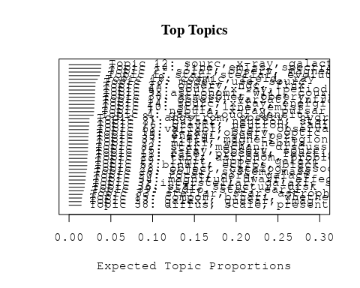

# Print the top 10 labels for each topic  
topic_labels <- labelTopics(Research_topics, n=10)  
print(topic_labels)

## Topic 1 Top Words:  
## Highest Prob: star, stellar, evolut, mass, helium, model, may, burn, observ, studi   
## FREX: evolut, helium, burn, stellar, mass, comput, envelop, star, companion, low   
## Lift: burn, helium, comput, companion, evolut, envelop, basi, sequenc, layer, massiv   
## Score: burn, evolut, helium, star, stellar, companion, envelop, mass, comput, hydrogen   
## Topic 2 Top Words:  
## Highest Prob: solar, observ, magnet, corona, field, coron, wind, photospher, structur, region   
## FREX: corona, coron, wind, solar, photospher, magnet, chromospher, lunar, structur, limb   
## Lift: wind, coron, photospher, corona, lunar, chromospher, limb, preliminari, extent, magnet   
## Score: wind, coron, corona, magnet, photospher, solar, chromospher, limb, lunar, field   
## Topic 3 Top Words:  
## Highest Prob: interstellar, galaxi, star, observ, medium, chemic, materi, radiat, molecul, neutral   
## FREX: interstellar, chemic, medium, molecul, neutral, materi, galaxi, level, among, identif   
## Lift: chemic, interstellar, molecul, collis, medium, neutral, irregular, call, applic, among   
## Score: interstellar, chemic, galaxi, medium, molecul, materi, irregular, neutral, interact, gravit   
## Topic 4 Top Words:  
## Highest Prob: gas, cloud, densiti, ioniz, temperatur, abund, observ, molecular, line, hydrogen   
## FREX: gas, cloud, ioniz, molecular, domin, densiti, abund, cluster, hydrogen, cool   
## Lift: domin, molecular, gas, cloud, ioniz, intergalact, cool, equilibrium, soft, molecul   
## Score: gas, domin, molecular, cloud, ioniz, cluster, hydrogen, abund, intergalact, cool   
## Topic 5 Top Words:  
## Highest Prob: binari, eclips, black, small, hole, observ, graviti, mass, determin, effect   
## FREX: eclips, binari, black, graviti, hole, small, spectroscop, error, bodi, analys   
## Lift: eclips, graviti, analys, black, binari, spectroscop, hole, photometr, primari, bodi   
## Score: eclips, binari, black, graviti, hole, photometr, analys, spectroscop, bodi, small   
## Topic 6 Top Words:  
## Highest Prob: variabl, star, observatori, observ, hypothesi, radial, calcul, envelop, strong, supernova   
## FREX: observatori, radial, variabl, hypothesi, envelop, supernova, photometr, mode, calcul, pulsat   
## Lift: radial, observatori, mode, photometr, hypothesi, envelop, photometri, oao-, ground, variabl   
## Score: radial, variabl, envelop, observatori, photometr, hypothesi, pulsat, photometri, mode, supernova   
## Topic 7 Top Words:  
## Highest Prob: nebula, x-ray, pulsar, crab, vela, supernova, remnant, polar, pulsat, puls   
## FREX: nebula, vela, crab, remnant, pulsar, supernova, polar, pulsat, puls, angl   
## Lift: vela, remnant, crab, polar, angl, nebula, supernova, synchrotron, pulsar, pulsat   
## Score: vela, nebula, crab, pulsar, remnant, x-ray, supernova, pulsat, polar, angl   
## Topic 8 Top Words:  
## Highest Prob: angstrom, observ, hydrogen, alpha, atom, absorpt, ultraviolet, carbon, line, also   
## FREX: angstrom, alpha, atom, hydrogen, carbon, lyman, ultraviolet, absorpt, squar, comet   
## Lift: angstrom, lyman, alpha, carbon, squar, ultraviolet, atom, hydrogen, surround, vicin   
## Score: angstrom, ultraviolet, alpha, carbon, hydrogen, atom, absorpt, lyman, rocket, comet   
## Topic 9 Top Words:  
## Highest Prob: astronomi, will, cours, space, scienc, laboratori, one, mission, planet, system   
## FREX: cours, scienc, mission, astronomi, laboratori, answer, space, planet, scientif, will   
## Lift: answer, mission, situat, cours, laboratori, futur, scienc, world, scientif, astronomi   
## Score: cours, answer, mission, scienc, laboratori, astronomi, will, planet, explor, scientif   
## Topic 10 Top Words:  
## Highest Prob: star, line, emiss, lumin, observ, interstellar, veloc, infrar, redden, ultraviolet   
## FREX: lumin, star, redden, circumstellar, dispers, veloc, ultraviolet, minus, infrar, excess   
## Lift: lumin, redden, circumstellar, immedi, dispers, slope, surround, minus, excess, analys   
## Score: lumin, star, infrar, redden, circumstellar, ultraviolet, line, excess, minus, veloc   
## Topic 11 Top Words:  
## Highest Prob: rate, process, reaction, neutron, electron, solar, model, occur, continu, state   
## FREX: rate, reaction, process, continu, electron, percent, nuclear, occur, neutron, state   
## Lift: reaction, rate, nuclear, percent, continu, slow, excit, mode, process, becom   
## Score: reaction, rate, neutron, nuclear, process, electron, slow, percent, continu, interact   
## Topic 12 Top Words:  
## Highest Prob: sourc, x-ray, galact, radio, flux, observ, optic, cygnus, cosmic, detect   
## FREX: sourc, galact, cygnus, x-ray, search, coincid, radio, optic, flux, plane   
## Lift: coincid, centimet, search, aerobe, cygnus, sourc, erg, plane, galact, survey   
## Score: x-ray, sourc, coincid, galact, radio, cygnus, cosmic, search, plane, aerobe   
## Topic 13 Top Words:  
## Highest Prob: model, use, sourc, observ, note, present, evolut, structur, calcul, result   
## FREX: model, note, cosmolog, physic, interact, method, individu, includ, calcul, evolut   
## Lift: note, cosmolog, fit, individu, applic, regard, model, appropri, interact, shell   
## Score: note, model, cosmolog, evolut, quasar, interact, equat, method, expans, individu   
## Topic 14 Top Words:  
## Highest Prob: line, emiss, spectral, gamma-ray, temperatur, spectrum, region, decay, radiat, spectromet   
## FREX: gamma-ray, decay, line, spectral, spectromet, emiss, chromospher, continuum, transit, spectrum   
## Lift: decay, gamma-ray, spectromet, continuum, apollo, transit, chromospher, flare, line, quiet   
## Score: decay, gamma-ray, line, emiss, spectromet, chromospher, spectral, continuum, spectrum, emit   
## Topic 15 Top Words:  
## Highest Prob: compon, binari, whether, radius, two, solar, radio, phase, known, close   
## FREX: whether, radius, compon, binari, flow, assumpt, phase, research, perhap, basic   
## Lift: whether, neglig, becom, flow, radius, compon, binari, assumpt, actual, basic   
## Score: whether, binari, compon, radius, flow, basic, research, perhap, assumpt, cycl   
## Topic 16 Top Words:  
## Highest Prob: gravit, neutron, radiat, hole, star, black, puls, wave, rotat, possibl   
## FREX: gravit, hole, neutron, wave, black, formula, puls, astrophys, radiat, explos   
## Lift: formula, gravit, hole, wave, explos, black, mention, electromagnet, typic, neutron   
## Score: gravit, formula, neutron, hole, black, puls, astrophys, wave, rotat, radiat   
## Topic 17 Top Words:  
## Highest Prob: observ, variat, infrar, period, burst, emiss, variabl, time, type, radio   
## FREX: infrar, burst, variat, period, cyg, type, variabl, although, cover, behavior   
## Lift: cover, burst, cyg, infrar, intrins, although, type, shell, behavior, variat   
## Score: infrar, burst, cover, cyg, variat, variabl, period, correl, micron, radio   
## Topic 18 Top Words:  
## Highest Prob: cosmic, field, ray, magnet, particl, electron, observ, radiat, use, measur   
## FREX: cosmic, ray, particl, magnet, field, electron, extragalact, mean, depend, enhanc   
## Lift: ray, cosmic, particl, extragalact, enhanc, stage, magnet, mean, electron, field   
## Score: ray, cosmic, magnet, particl, field, extragalact, electron, galact, dust, mean   
## Topic 19 Top Words:  
## Highest Prob: x-ray, observ, optic, sourc, identif, pulsar, system, puls, star, resembl   
## FREX: optic, identif, resembl, telescop, oso-, x-ray, puls, refer, june, pulsar   
## Lift: resembl, june, oso-, identif, optic, illustr, telescop, slow, descript, refer   
## Score: resembl, x-ray, optic, pulsar, june, identif, oso-, puls, telescop, refer   
## Topic 20 Top Words:  
## Highest Prob: rotat, core, galact, function, zone, gravit, mass, model, simpl, convect   
## FREX: core, zone, function, rotat, convect, simpl, differenti, gravit, sequenc, forc   
## Lift: zone, core, slight, empir, sequenc, differenti, convect, forc, function, evolv   
## Score: zone, core, gravit, rotat, galact, convect, function, empir, opac, flow   
## Topic 21 Top Words:  
## Highest Prob: observ, ngc, flux, two, radiat, sourc, measur, wavelength, time, amplitud   
## FREX: ngc, flux, minimum, amplitud, wavelength, -micron, two, chang, polar, radiat   
## Lift: ngc, minimum, amplitud, -micron, speed, interferomet, flux, contrast, outburst, rough   
## Score: ngc, -micron, amplitud, flux, outburst, quasar, nebula, infrar, micron, minimum   
## Topic 22 Top Words:  
## Highest Prob: tabl, astronom, problem, present, equat, earth, studi, one, level, materi   
## FREX: tabl, astronom, perform, problem, equat, major, list, level, materi, mean   
## Lift: tabl, name, perform, without, list, briefli, techniqu, pictur, respons, implic   
## Score: tabl, astronom, equat, materi, problem, astrophys, name, perform, earth, improv   
## Topic 23 Top Words:  
## Highest Prob: galaxi, quasar, imag, size, cluster, faint, seen, recent, present, star   
## FREX: galaxi, imag, quasar, faint, size, seen, cluster, giant, idea, recent   
## Lift: faint, imag, galaxi, size, quasar, idea, good, giant, seen, cluster   
## Score: galaxi, quasar, imag, faint, cluster, size, see, seen, nuclei, idea   
## Topic 24 Top Words:  
## Highest Prob: sourc, x-ray, energi, spectra, power, sco, spectrum, may, bremsstrahlung, kev   
## FREX: sco, bremsstrahlung, power, spectra, kev, energi, hard, spectrum, accret, locat   
## Lift: sco, bremsstrahlung, hard, kev, accret, power, locat, scorpius, spectra, cyg   
## Score: bremsstrahlung, sco, kev, x-ray, spectra, energi, cyg, hard, scorpius, power   
## Topic 25 Top Words:  
## Highest Prob: x-ray, observ, sourc, rocket, object, energi, hot, radiat, spectral, sun   
## FREX: rocket, hot, scorpius, spectral, volt, mount, plasma, detector, x-ray, carri   
## Lift: mount, volt, rocket, scorpius, balloon, discret, hot, million, detector, plasma   
## Score: rocket, x-ray, mount, volt, scorpius, hot, plasma, discret, balloon, energi   
## Topic 26 Top Words:  
## Highest Prob: solar, system, mass, planet, data, bodi, temperatur, distanc, sun, outburst   
## FREX: planet, bodi, outburst, reson, solar, amount, system, terrestri, composit, mass   
## Lift: reson, terrestri, bodi, amount, outburst, planet, neighbor, white, pressur, composit   
## Score: reson, outburst, planet, solar, system, bodi, terrestri, oxygen, mass, carbon   
## Topic 27 Top Words:  
## Highest Prob: milki, way, nebula, natur, first, instrument, astronom, spiral, one, signific   
## FREX: milki, way, spiral, instrument, centuri, long, natur, nebula, attempt, describ   
## Lift: milki, put, way, explan, upon, long, centuri, immedi, thought, actual   
## Score: milki, way, nebula, spiral, centuri, put, astronom, long, instrument, work   
## Topic 28 Top Words:  
## Highest Prob: object, catalog, associ, statist, quasi-stellar, result, distanc, point, valu, signific   
## FREX: catalog, statist, quasi-stellar, object, associ, sampl, uhuru, distanc, select, count   
## Lift: catalog, quasi-stellar, statist, analyz, real, count, sampl, associ, select, object   
## Score: catalog, quasi-stellar, object, uhuru, statist, sampl, associ, count, distanc, cluster   
## Topic 29 Top Words:  
## Highest Prob: limit, upper, galaxi, luminos, quasar, sourc, resolv, densiti, dust, background   
## FREX: upper, limit, resolv, dust, intergalact, red, shift, content, luminos, quasar   
## Lift: resolv, upper, sight, intergalact, dust, limit, shift, independ, turn, content   
## Score: resolv, quasar, upper, dust, intergalact, red, shift, limit, galaxi, luminos   
## Topic 30 Top Words:  
## Highest Prob: atmospher, observ, jupit, venus, solar, temperatur, absorpt, spectra, limb, measur   
## FREX: jupit, venus, atmospher, jovian, limb, presenc, -micron, disk, absorpt, oao-   
## Lift: jovian, venus, jupit, oao-, limb, presenc, atmospher, signal, fluctuat, -micron   
## Score: jupit, venus, jovian, limb, atmospher, -micron, occult, absorpt, disk, oao-   
## Topic 31 Top Words:  
## Highest Prob: pulsar, neutron, star, support, observ, rotat, interior, stellar, sky, provid   
## FREX: support, pulsar, interior, sky, neutron, behavior, celesti, rotat, test, frequenc   
## Lift: support, sky, behavior, celesti, test, interior, pulsar, display, speed, coupl   
## Score: support, pulsar, neutron, interior, rotat, behavior, sky, test, celesti, frequenc   
## Topic 32 Top Words:  
## Highest Prob: star, mechan, discuss, grain, cool, format, diffus, cloud, consist, dust   
## FREX: mechan, grain, cool, format, dust, cloud, conduct, diffus, discuss, product   
## Lift: grain, cool, product, dust, conduct, mechan, format, solut, ground, current   
## Score: grain, format, cool, dust, cloud, mechan, product, gas, conduct, diffus   
## Topic 33 Top Words:  
## Highest Prob: stellar, star, astrophys, theori, studi, develop, interior, theoret, subject, principl   
## FREX: astrophys, principl, interior, theori, develop, subject, stellar, centuri, research, theoret   
## Lift: principl, astrophys, effort, serious, realiz, empir, rise, opac, theori, interior   
## Score: principl, astrophys, stellar, interior, theori, develop, research, centuri, opac, astronom   
## Topic 34 Top Words:  
## Highest Prob: magnitud, dwarf, effect, quasar, color, temperatur, absorpt, show, galaxi, appar   
## FREX: dwarf, color, magnitud, cosmolog, brightest, quasar, absorpt, micron, scatter, effect   
## Lift: dwarf, color, brightest, member, cosmolog, magnitud, photometri, diagram, plot, intrins   
## Score: dwarf, quasar, color, magnitud, brightest, micron, cosmolog, infrar, absorpt, diagram   
## Topic 35 Top Words:  
## Highest Prob: energi, sun, per, nuclei, solar, year, cosmic-ray, corona, sourc, two   
## FREX: nuclei, per, cosmic-ray, sun, energi, corona, year, sampl, billion, unit   
## Lift: cosmic-ray, nuclei, billion, unit, per, convert, sampl, lunar, sun, energi   
## Score: cosmic-ray, nuclei, energi, sun, billion, corona, per, sampl, lunar, oxygen   
## Topic 36 Top Words:  
## Highest Prob: star, structur, disk, gaseous, motion, around, distribut, system, profil, stellar   
## FREX: gaseous, disk, motion, around, structur, profil, integr, spiral, distribut, compact   
## Lift: gaseous, integr, disk, motion, compact, around, width, profil, structur, spiral   
## Score: gaseous, disk, around, integr, motion, spiral, profil, structur, compact, distribut   
## Topic 37 Top Words:  
## Highest Prob: field, magnet, region, scan, earth, head, plasma, form, result, solar   
## FREX: scan, head, field, plasma, earth, rapid, magnet, comet, basi, valu   
## Lift: head, scan, influenc, rapid, plasma, tho, fluctuat, experiment, basi, flare   
## Score: head, field, magnet, scan, comet, plasma, earth, tho, burst, fluctuat   
## Topic 38 Top Words:  
## Highest Prob: diffus, scale, present, possibl, articl, measur, peak, relationship, background, ion   
## FREX: articl, diffus, peak, relationship, scale, ion, profil, metal, reason, background   
## Lift: articl, peak, ion, presum, pure, relationship, metal, diffus, radii, sight   
## Score: articl, peak, scale, diffus, relationship, ion, excess, metal, oxygen, pure   
## Topic 39 Top Words:  
## Highest Prob: radio, star, earli, can, detect, abund, studi, use, make, well   
## FREX: earli, radio, sensit, abund, class, detect, can, make, equip, well   
## Lift: earli, equip, sensit, primarili, radio, prove, class, alway, realiz, make   
## Score: earli, radio, star, abund, equip, sensit, astronomi, detect, make, well   
## Topic 40 Top Words:  
## Highest Prob: sourc, x-ray, period, pulsat, intens, observ, due, hercul, variat, day   
## FREX: hercul, pulsat, period, intens, day, uhuru, -day, occult, due, sourc   
## Lift: hercul, -day, occult, uhuru, pulsat, day, cycl, sec, shape, intens   
## Score: hercul, pulsat, uhuru, occult, -day, x-ray, binari, day, period, intens

# Match the processed documents with the original titles  
matched_titles <- out_text$meta$original_concatenated_title_abstract  
  
# Print top 5 documents for each topic  
top_docs <- findThoughts(Research_topics, texts = matched_titles, n = 5)$docs[[1]]  
print(top_docs)

## [1] "THE NATURE OF LOW-MASS COMPANIONS OF STARS IN THE SOLAR NEIGHBORHOOD The problem of the evolution of stars of very low mass has recently been studied by the author (Kumar, 1963a, b; 1964a, b; 1967), and a review of this work will be given in Section 11. In Section I11 we shall be concerned with the observational data on the stars of very low mass and the low-mass companions of stars of very low mass in the solar neighborhood. Finally, in Section IV we shall give an interpretation of the observed data on low-mass companions. We shall conclude the paper by making some general remarks on the question of the existence of planetary systems in the Galaxy."  
## [2] "THE NATURE OF LOW-MASS COMPANIONS OF STARS IN THE SOLAR NEIGHBORHOOD The problem of the evolution of stars of very low mass has recently been studied by the author (Kumar, 1963a, b; 1964a, b; 1967), and a review of this work will be given in Section 11. In Section I11 we shall be concerned with the observational data on the stars of very low mass and the low-mass companions of stars of very low mass in the solar neighborhood. Finally, in Section IV we shall give an interpretation of the observed data on low-mass companions. We shall conclude the paper by making some general remarks on the question of the existence of planetary systems in the Galaxy."  
## [3] "HELIUM DEFICIENCY IN OLD HALO B STARS. Calculations show that in old halo B stars most helium will have diffused below the photosphere and therefore will not be detected spectroscopically. This may account for the low abundances of helium observed in these stars."   
## [4] "HELIUM DEFICIENCY IN OLD HALO B STARS. Calculations show that in old halo B stars most helium will have diffused below the photosphere and therefore will not be detected spectroscopically. This may account for the low abundances of helium observed in these stars."   
## [5] "Evolution of O Stars. III. Helium Burning Stellar evolution for star of 30 solar masses during helium ignition, depletion and exhaustion"

# Find and plot the key "thoughts" or documents for selected topics  
thoughts6 <- findThoughts(Research_topics, texts = matched_titles, n = 3, topics = 6)$docs[[1]]  
thoughts18 <- findThoughts(Research_topics, texts = matched_titles, n = 3, topics = 18)$docs[[1]]  
par(mfrow = c(1, 2), mar = c(0.5, 0.5, 1, 0.5))  
plotQuote(thoughts6, width = 30, main = "Topic 6")  
plotQuote(thoughts18, width = 30, main = "Topic 18")

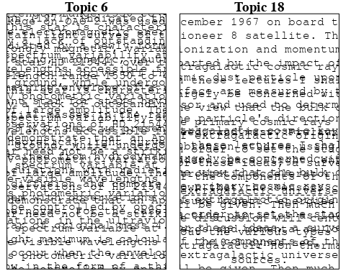

# Calculate and plot the correlation between topics  
mod.out.corr <- topicCorr(Research_topics)  
plot(mod.out.corr, cex = 1.5)  
  
  
# For each topic  
for (topic_num in 1:40) {  
 # Plot the word cloud  
 cloud(Research_topics, topic = topic_num, scale = c(2, 0.25))  
}

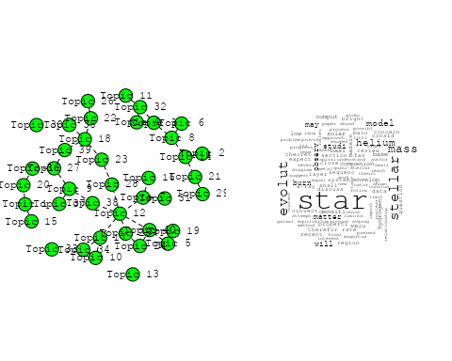

## Warning in wordcloud::wordcloud(words = vocab, freq = vec, max.words =  
## max.words, : interstellar could not be fit on page. It will not be plotted.

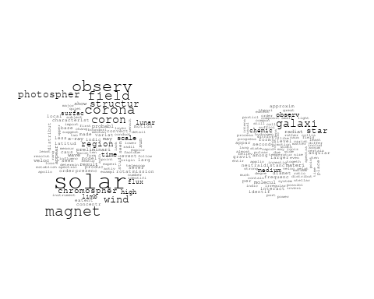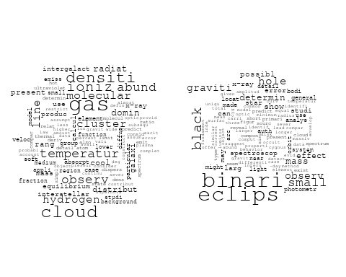

## Warning in wordcloud::wordcloud(words = vocab, freq = vec, max.words =  
## max.words, : variabl could not be fit on page. It will not be plotted.

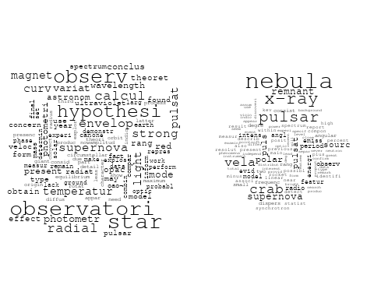

## Warning in wordcloud::wordcloud(words = vocab, freq = vec, max.words =  
## max.words, : alpha could not be fit on page. It will not be plotted.

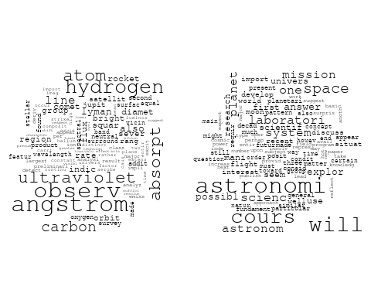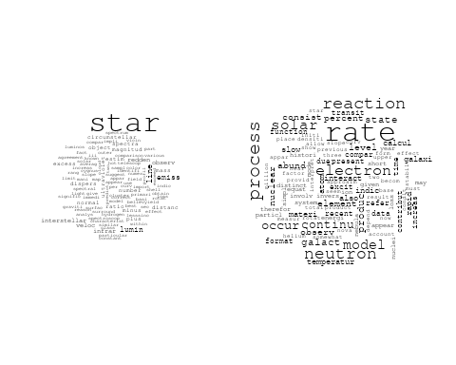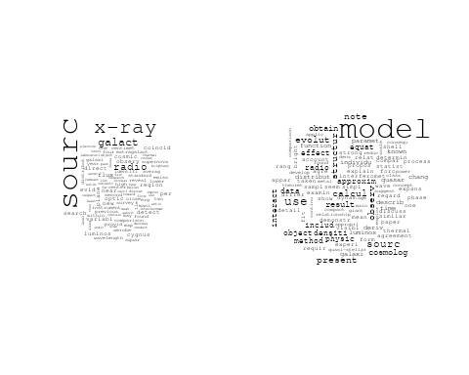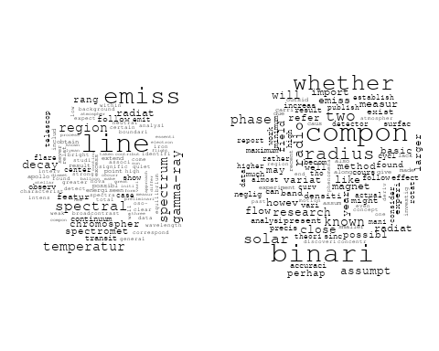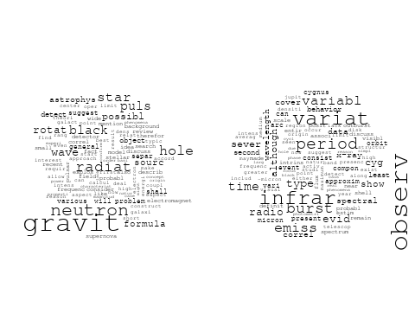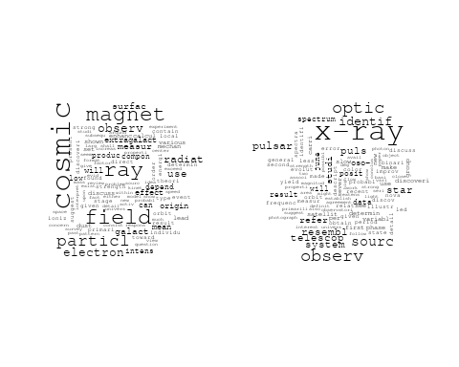

## Warning in wordcloud::wordcloud(words = vocab, freq = vec, max.words =  
## max.words, : gravit could not be fit on page. It will not be plotted.

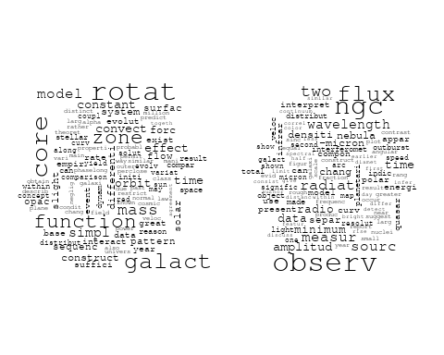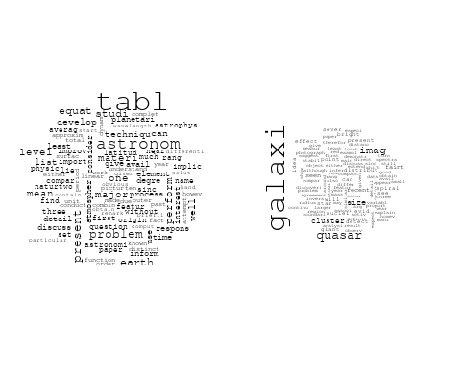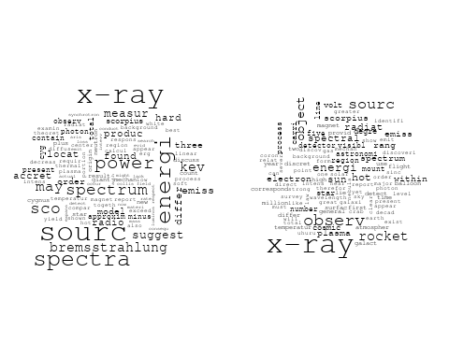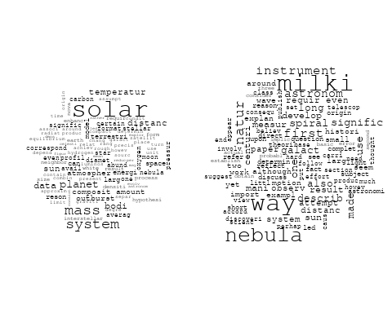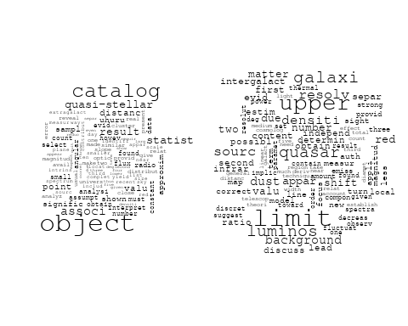

## Warning in wordcloud::wordcloud(words = vocab, freq = vec, max.words =  
## max.words, : observ could not be fit on page. It will not be plotted.

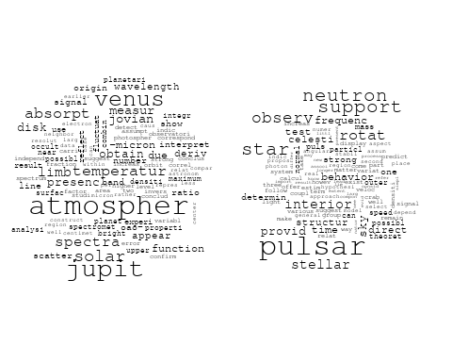

## Warning in wordcloud::wordcloud(words = vocab, freq = vec, max.words =  
## max.words, : diffus could not be fit on page. It will not be plotted.

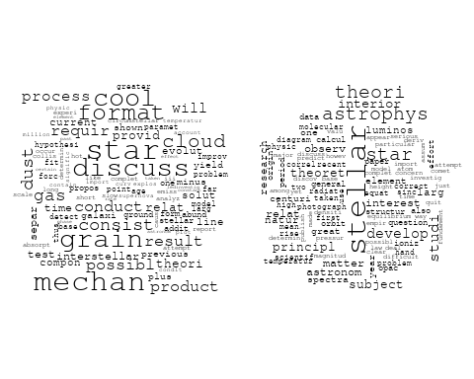

## Warning in wordcloud::wordcloud(words = vocab, freq = vec, max.words =  
## max.words, : effect could not be fit on page. It will not be plotted.

## Warning in wordcloud::wordcloud(words = vocab, freq = vec, max.words =  
## max.words, : galaxi could not be fit on page. It will not be plotted.

## Warning in wordcloud::wordcloud(words = vocab, freq = vec, max.words =  
## max.words, : dwarf could not be fit on page. It will not be plotted.

## Warning in wordcloud::wordcloud(words = vocab, freq = vec, max.words =  
## max.words, : show could not be fit on page. It will not be plotted.

## Warning in wordcloud::wordcloud(words = vocab, freq = vec, max.words =  
## max.words, : brightest could not be fit on page. It will not be plotted.

## Warning in wordcloud::wordcloud(words = vocab, freq = vec, max.words =  
## max.words, : scatter could not be fit on page. It will not be plotted.

## Warning in wordcloud::wordcloud(words = vocab, freq = vec, max.words =  
## max.words, : photometri could not be fit on page. It will not be plotted.

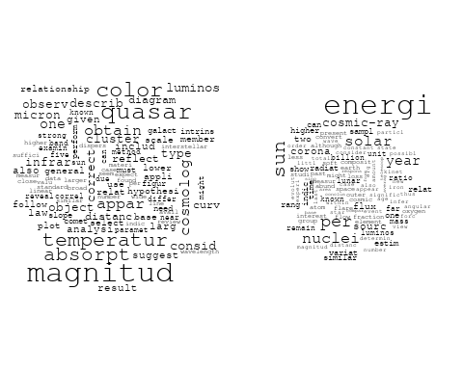

## Warning in wordcloud::wordcloud(words = vocab, freq = vec, max.words =  
## max.words, : profil could not be fit on page. It will not be plotted.

## Warning in wordcloud::wordcloud(words = vocab, freq = vec, max.words =  
## max.words, : gaseous could not be fit on page. It will not be plotted.

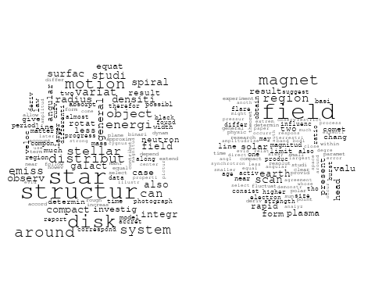

## Warning in wordcloud::wordcloud(words = vocab, freq = vec, max.words =  
## max.words, : diffus could not be fit on page. It will not be plotted.

## Warning in wordcloud::wordcloud(words = vocab, freq = vec, max.words =  
## max.words, : scale could not be fit on page. It will not be plotted.

## Warning in wordcloud::wordcloud(words = vocab, freq = vec, max.words =  
## max.words, : relationship could not be fit on page. It will not be plotted.

## Warning in wordcloud::wordcloud(words = vocab, freq = vec, max.words =  
## max.words, : articl could not be fit on page. It will not be plotted.

## Warning in wordcloud::wordcloud(words = vocab, freq = vec, max.words =  
## max.words, : measur could not be fit on page. It will not be plotted.

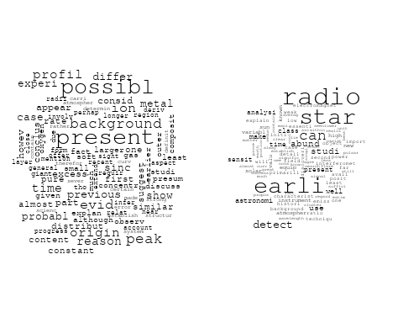

# Get the topic proportions for each document  
topic_proportions <- Research_topics$theta  
  
# Find the index of the topic with the highest proportion for each document  
# This will be the topic that each document is most likely to belong to  
max_topic_idx <- apply(topic_proportions, 1, which.max)  
  
# Add this as a new column to your data  
data_filtered$topic <- max_topic_idx  
  
  
  
  
# Create function to generate histogram  
make_histogram <- function(country_code) {  
   
 # Filter data for country with contribution of 100  
 data_100 <- data_filtered[data_filtered[[country_code]] == 100,]  
   
 # Filter data for country with contribution not equal to 0  
 data_not_0 <- data_filtered[data_filtered[[country_code]] != 0,]  
   
 # Make the first histogram  
 hist_100 <- ggplot(data_100, aes(x = topic)) +  
 geom_histogram(binwidth = 1, fill = "blue", color = "black") +  
 xlab("Topic") +  
 ylab("Count") +  
 ggtitle(paste(country_code, "Independent Contribution"))  
   
 # Make the second histogram  
 hist_not_0 <- ggplot(data_not_0, aes(x = topic)) +  
 geom_histogram(binwidth = 1, fill = "blue", color = "black") +  
 xlab("Topic") +  
 ylab("Count") +  
 ggtitle(paste(country_code, "Contributions (with collaboration)"))  
   
 # Return list of plots  
 return(list(hist_100, hist_not_0))  
}

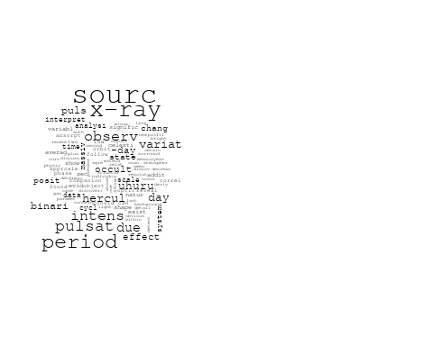

plots <- make_histogram("US")  
print(plots[[1]])

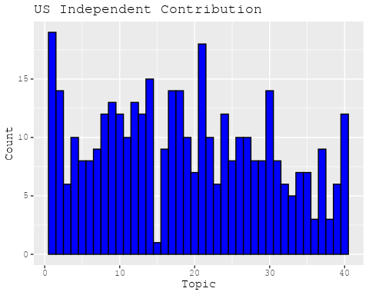

print(plots[[2]])

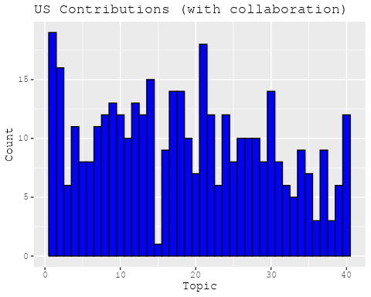

plots <- make_histogram("GB")  
print(plots[[1]])

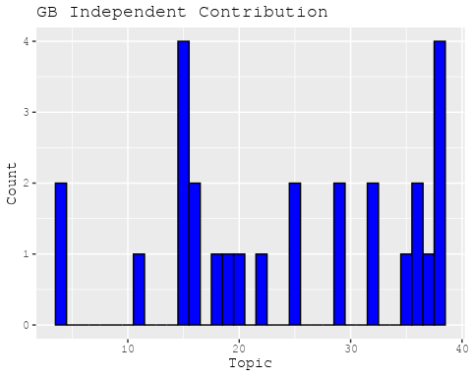

print(plots[[2]])

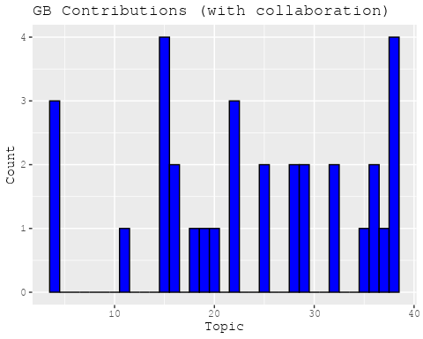

plots <- make_histogram("DE")  
print(plots[[1]])

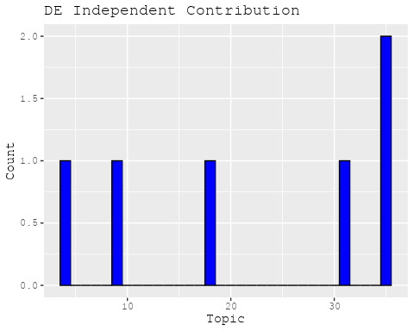

print(plots[[2]])

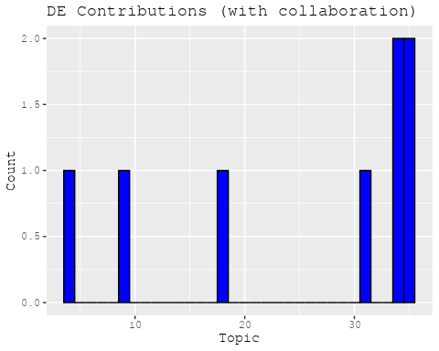

plots <- make_histogram("IT")  
print(plots[[1]])



print(plots[[2]])

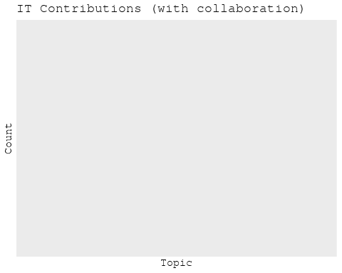

plots <- make_histogram("AU")  
print(plots[[1]])

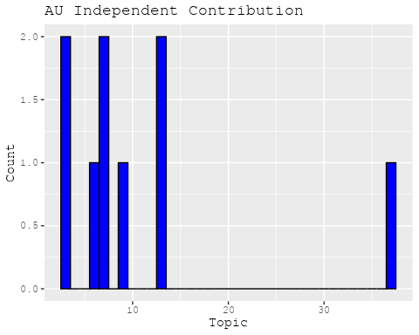

print(plots[[2]])

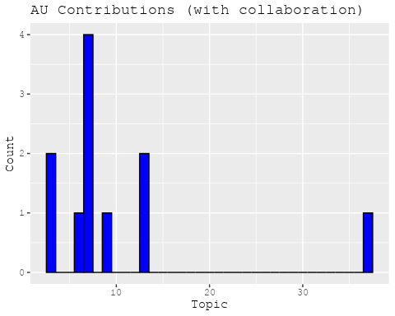

plots <- make_histogram("CA")  
print(plots[[1]])

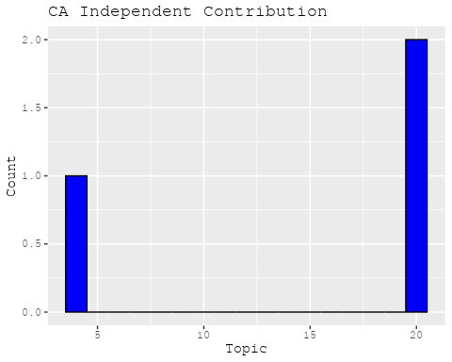

print(plots[[2]])

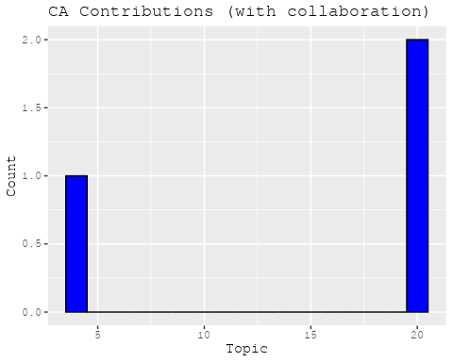

plots <- make_histogram("JP")  
print(plots[[1]])



print(plots[[2]])

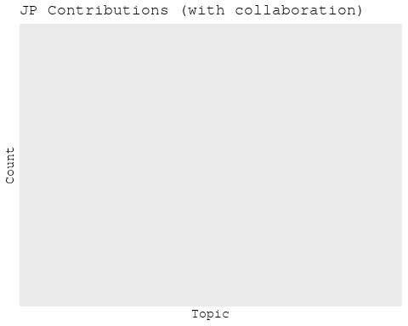

plots <- make_histogram("CN")  
print(plots[[1]])



print(plots[[2]])



plots <- make_histogram("NL")  
print(plots[[1]])

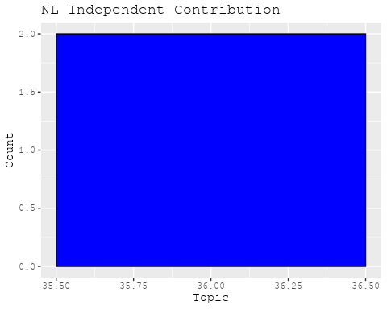

print(plots[[2]])

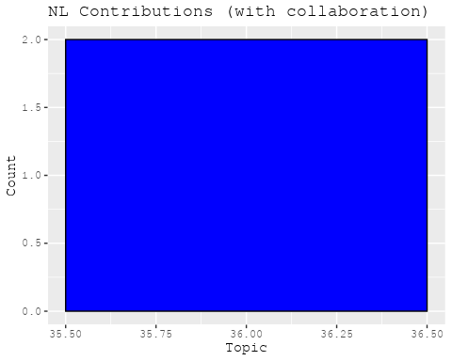

plots <- make_histogram("FR")  
print(plots[[1]])

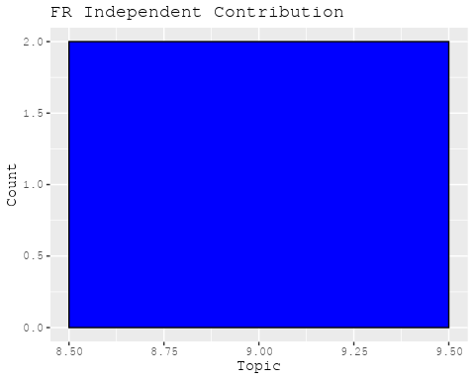

print(plots[[2]])

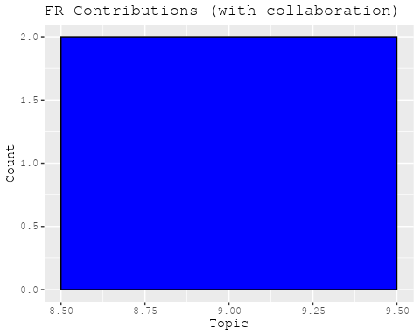

plots <- make_histogram("RU")  
print(plots[[1]])

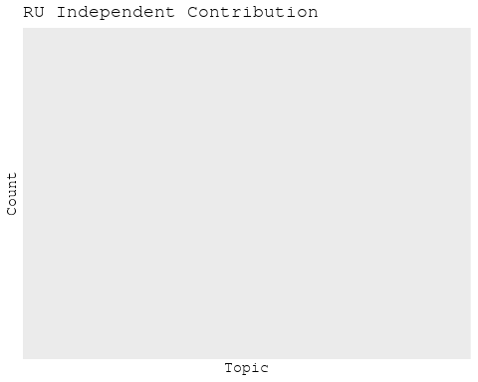

print(plots[[2]])

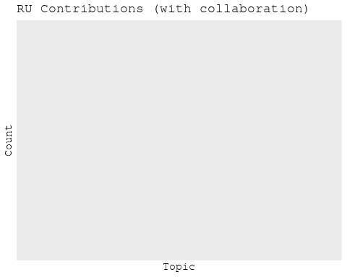

plots <- make_histogram("ES")  
print(plots[[1]])



print(plots[[2]])



plots <- make_histogram("IN")  
print(plots[[1]])

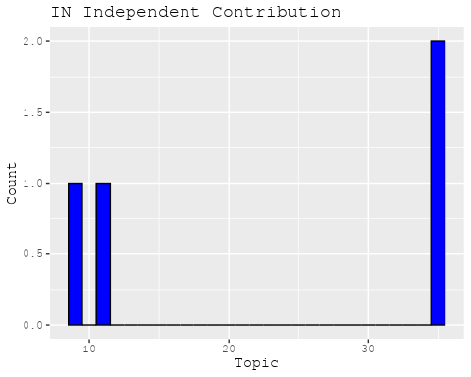

print(plots[[2]])

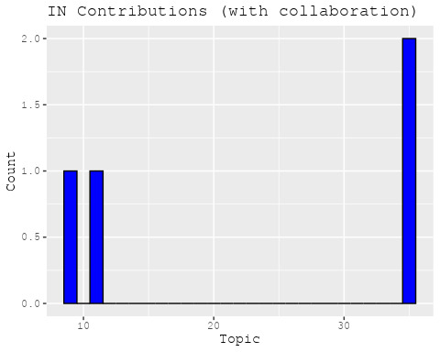

plots <- make_histogram("IL")  
print(plots[[1]])



print(plots[[2]])

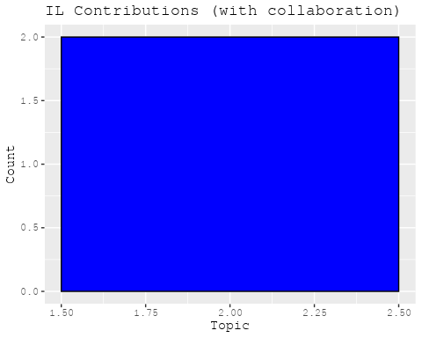

plots <- make_histogram("CH")  
print(plots[[1]])



print(plots[[2]])

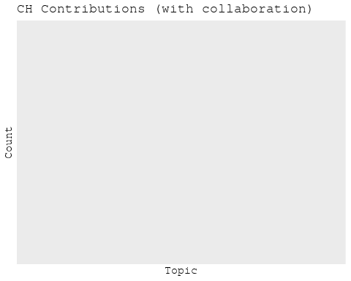

plots <- make_histogram("Americas")  
print(plots[[1]])

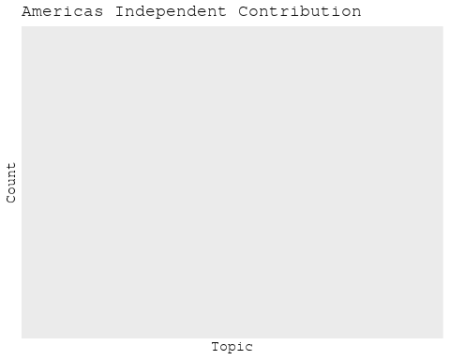

print(plots[[2]])

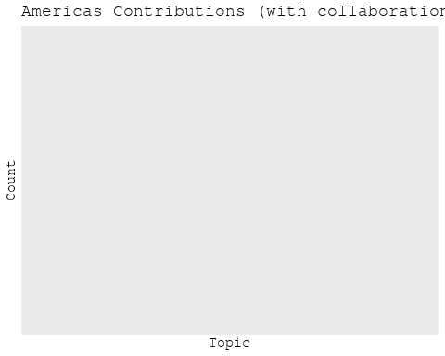

plots <- make_histogram("Europe")  
print(plots[[1]])

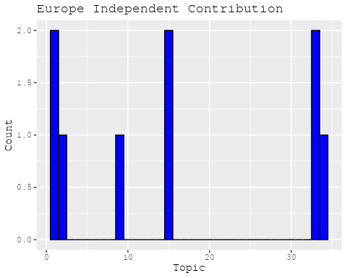

print(plots[[2]])

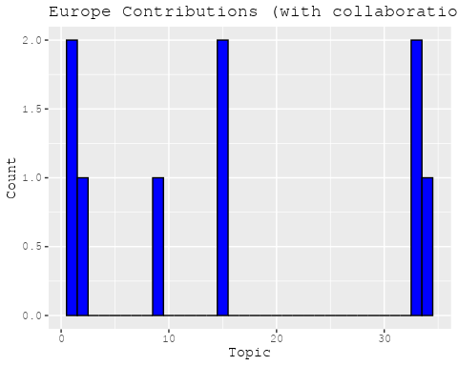

plots <- make_histogram("Africa")  
print(plots[[1]])

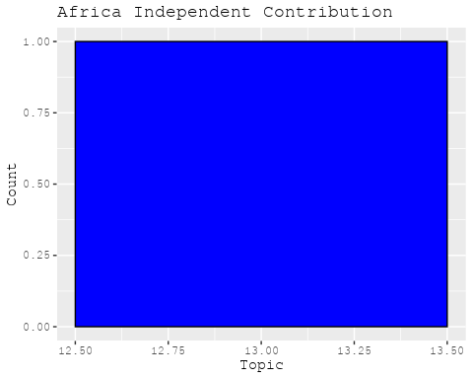

print(plots[[2]])

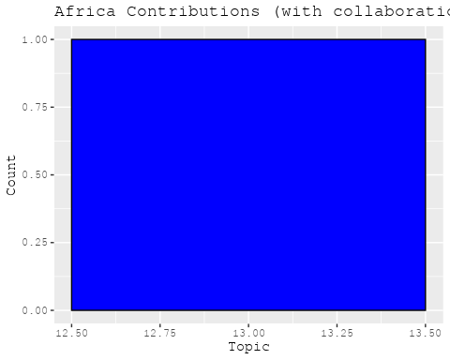

plots <- make_histogram("AsiaAndOceania")  
print(plots[[1]])



print(plots[[2]])

